Shri Ramdeobaba College of Engineering and Management

Name : Gaurav Kedia

Branch : AIML

Roll No. : E-39

Subject : Computer Networks(Lab)

Topic : Practical 4

Aim : Implementation of packet capturing and analyse several protocol information using Wireshark Tool.

WireShark Inteface:-

Selected: enpos3

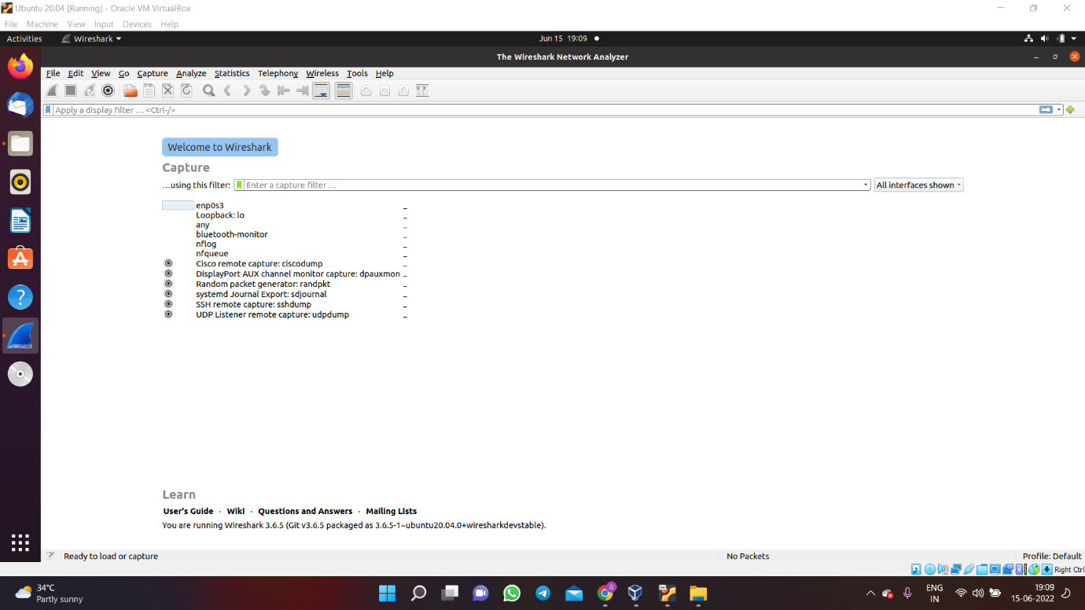

As we start browsing and packet capturing start we can check out and analyse different packets:

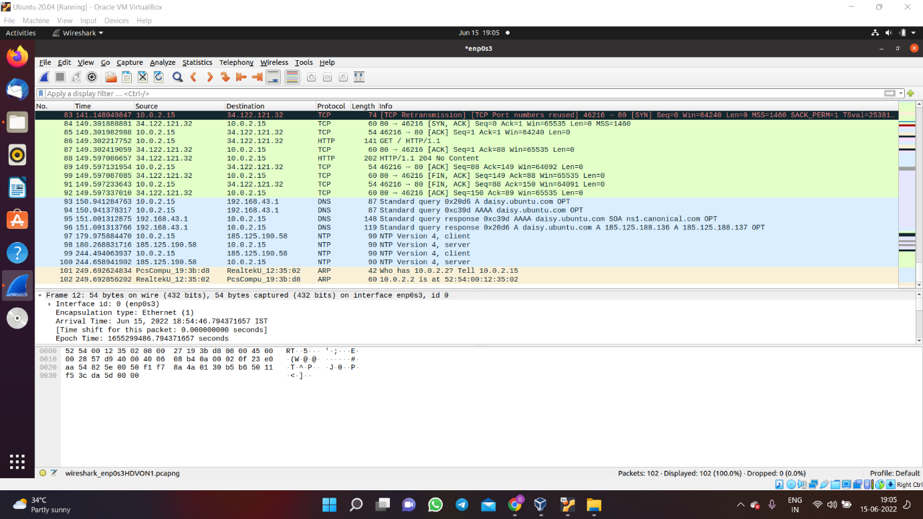

TCP:

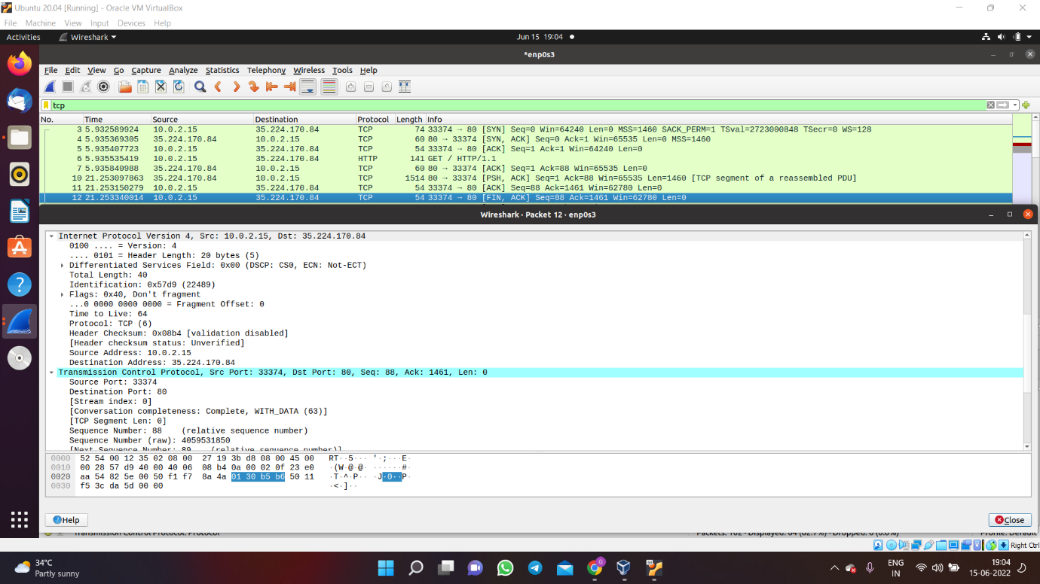

UDP :

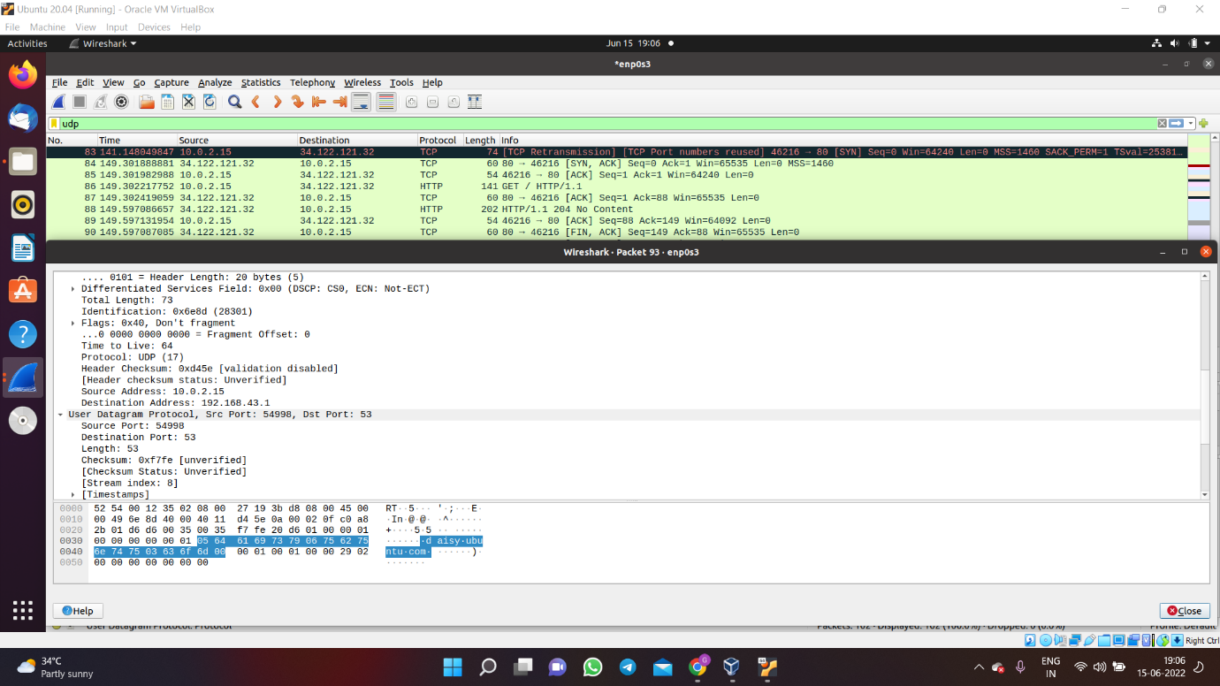

DNS:

