Shri Ramdeobaba College of Engineering and Management

Name : Gaurav Kedia

Branch : AIML

Roll No. : E-39

Subject : Computer Networks(Lab)

Topic : Practical 8

Aim : **Implement the data link layer framing methods such as character count, character stuffing and bit stuffing.**

Bit Stuffing Program :

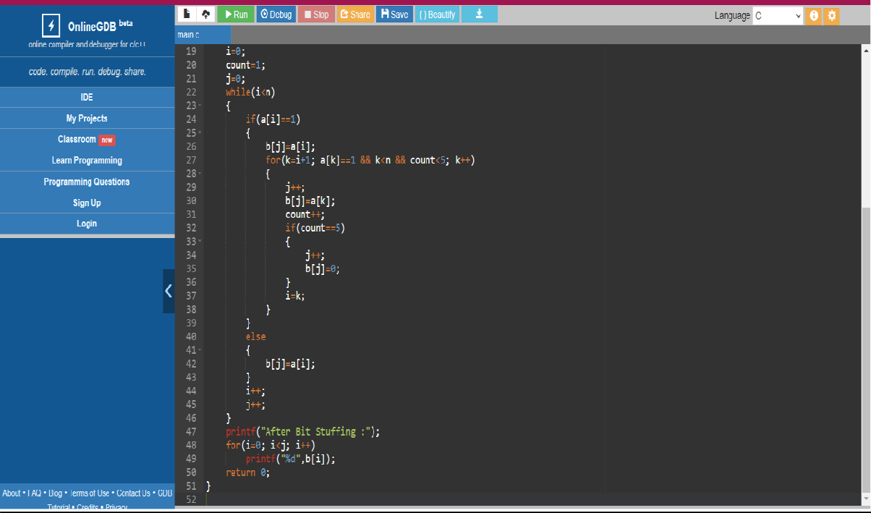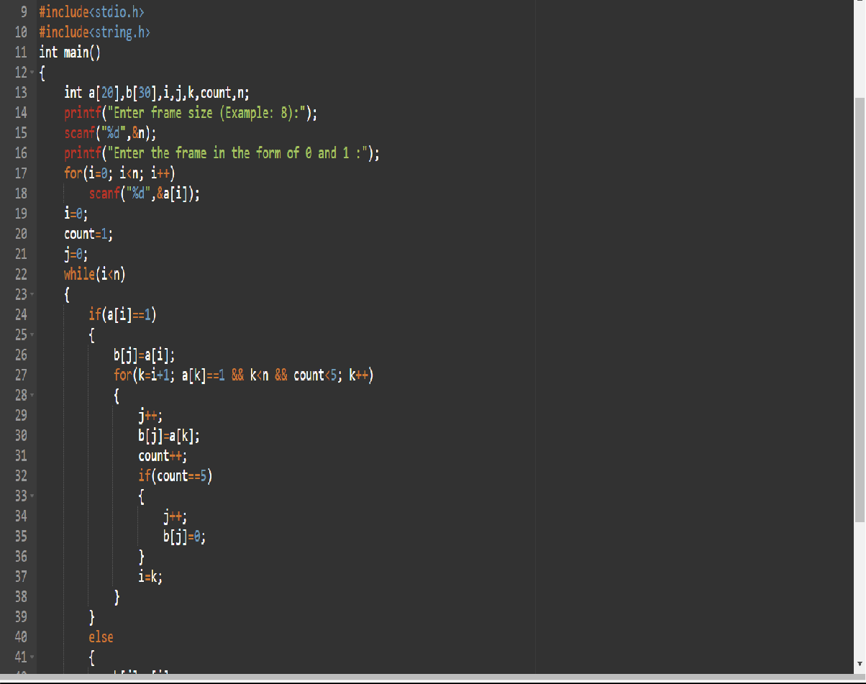

**Output:**

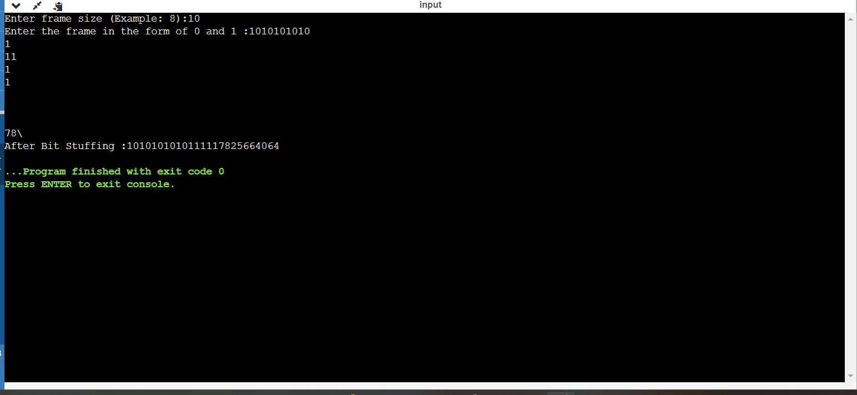

**Flag Byte stuffing:**

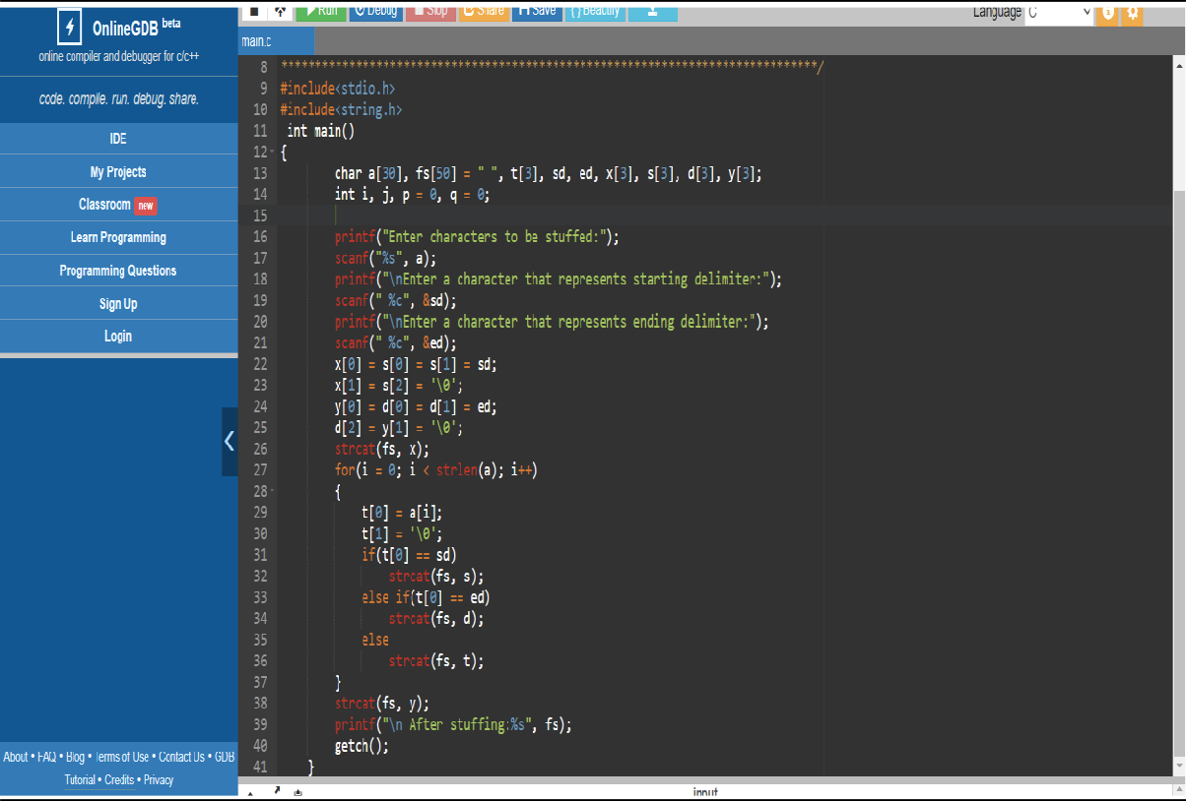

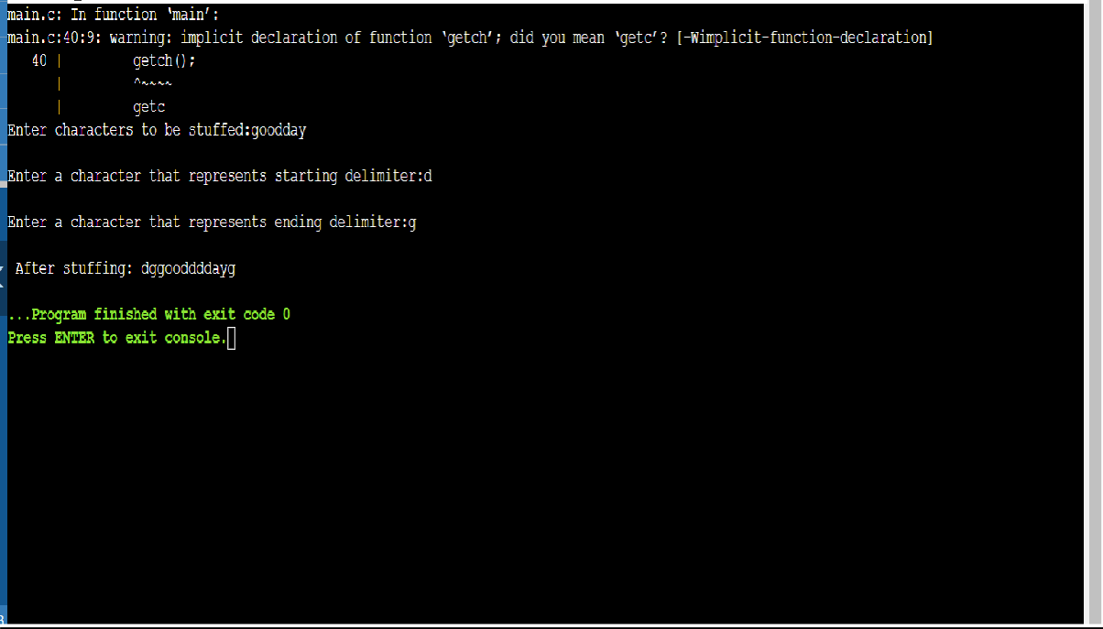

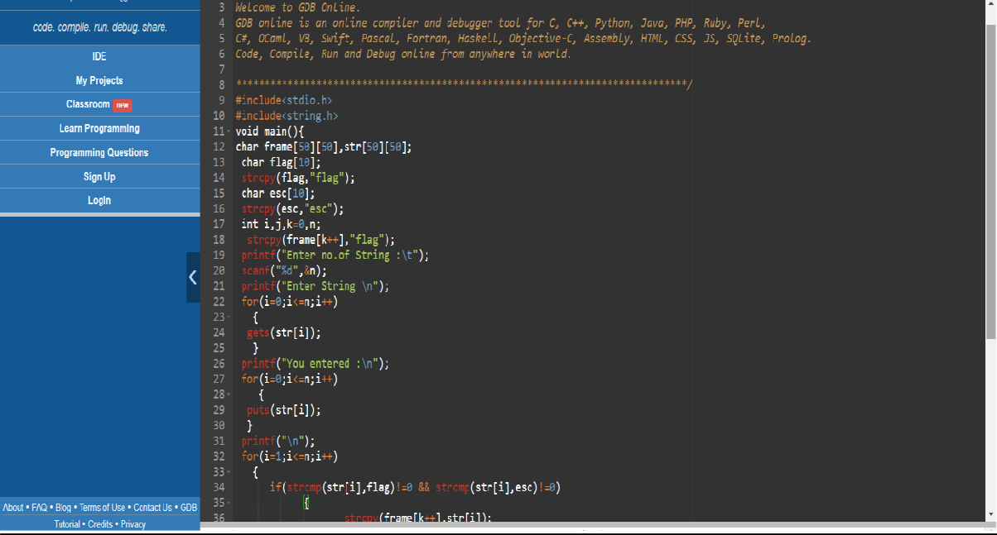**Character count**