Shri Ramdeobaba College of Engineering and Management

Name : Gaurav Kedia

Branch : AIML

Roll No. : E-39

Subject : Computer Networks(Lab)

Topic : Practical 9

Aim : Implement Dijkstra’s algorithm to compute the shortest path thru a graph Take an example subnet graph with weights indicating delay between nodes, now obtain Routing table for each node using distance vector routing algorithm, Take subnet of hosts as an example. Obtain broadcast tree for it.

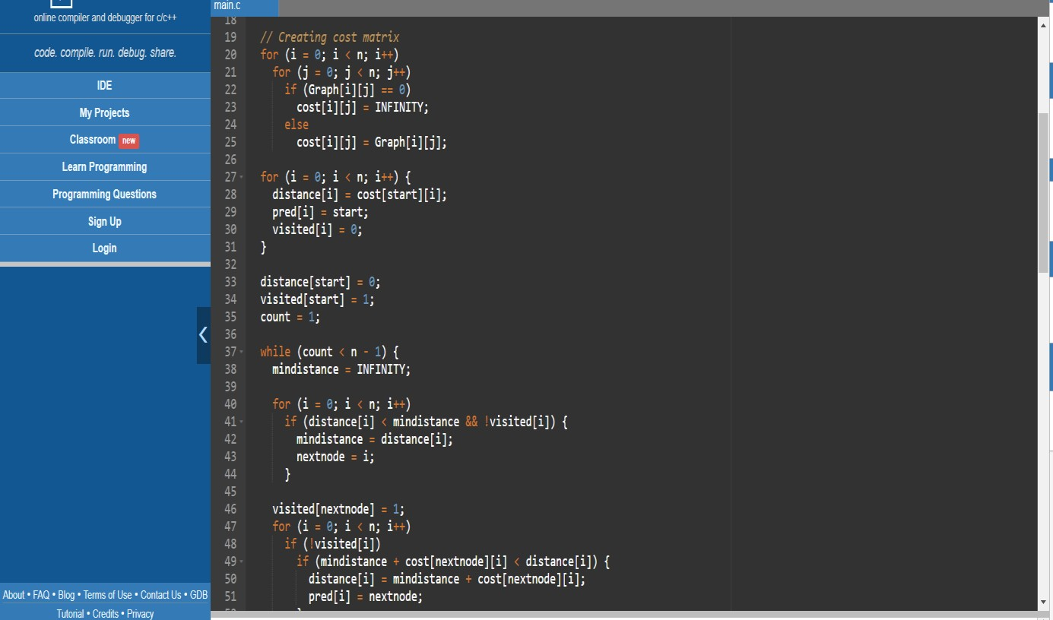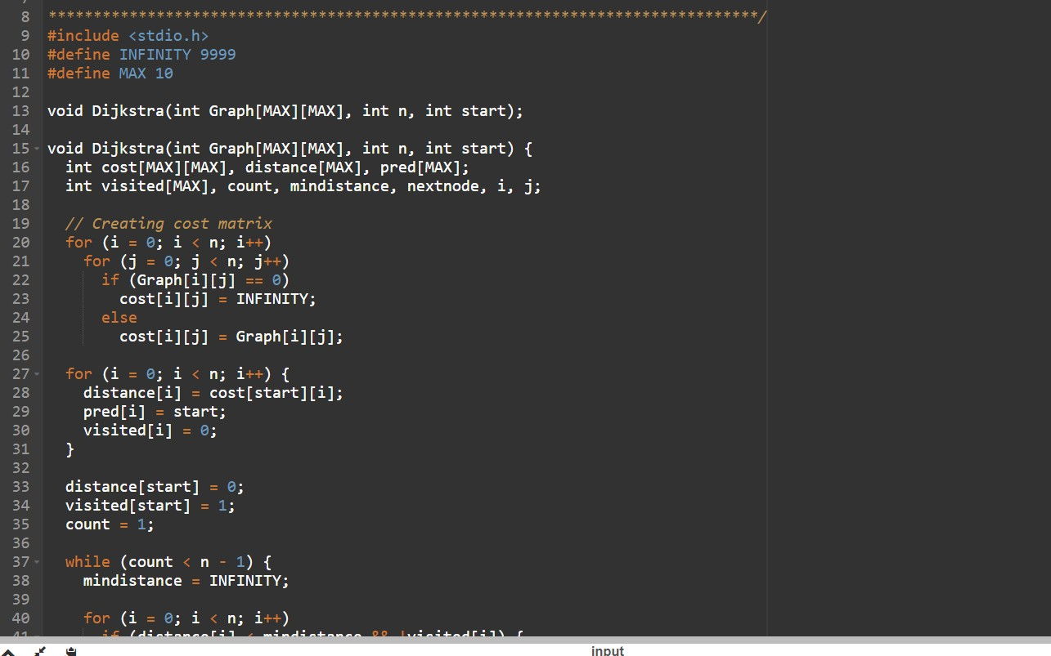 **Code:**

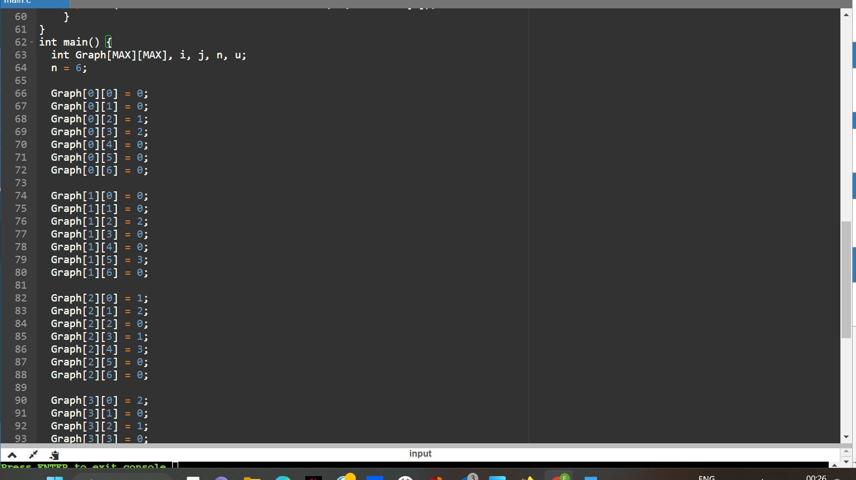

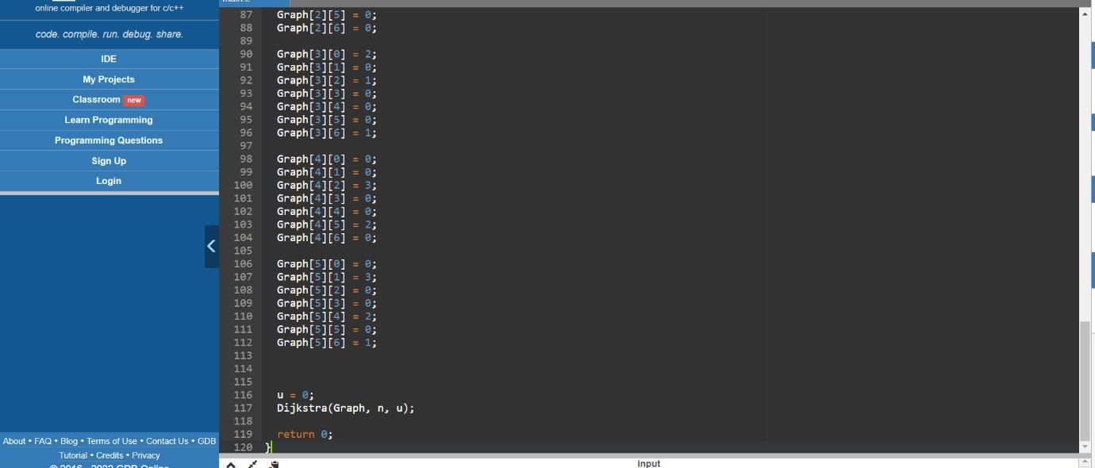

**Output :**

