**Prolog**

**Facts and Statement:**

**male(dashrath).**

**male(lakshman).**

**male(ram).**

**male(bharat).**

**male(shatrughan).**

**male(hanuman).**

**female(sumitra).**

**female(kaikeyi).**

**female(sita).**

**female(kausalya).**

**parent(dashrath,ram).**

**parent(dashrath,lakshman).**

**parent(dashrath,bharat).**

**parent(dashrath,shatrughan).**

**parent(kausalya,ram).**

**parent(sumitra,lakshman).**

**parent(sumitra,shatrughan).**

**parent(kaikeyi,bharat).**

**wife(sita,ram).**

**wife(dashrath,kausalya).**

**wife(dashrath,kaikeyi).**

**wife(dashrath,sumitra).**

**brother(X,Y):-**

**father(Z,X),father(Z,Y),X\==Y.**

**father(X,Y):- parent(X,Y), male(X).**

**mother(X,Y):- parent(X,Y), female(X).**

**father_in_law(M,N):-**

**male(M),female(N),father(M,Y),wife(N,Y),Y==ram.**

**mother_in_law(M,N):- female(M),female(N),male(Y),mother(M,Y),wife(N,Y).**

**Questions :**

1: dashrath is father of ram, lakshman, bharat, shatrughan?

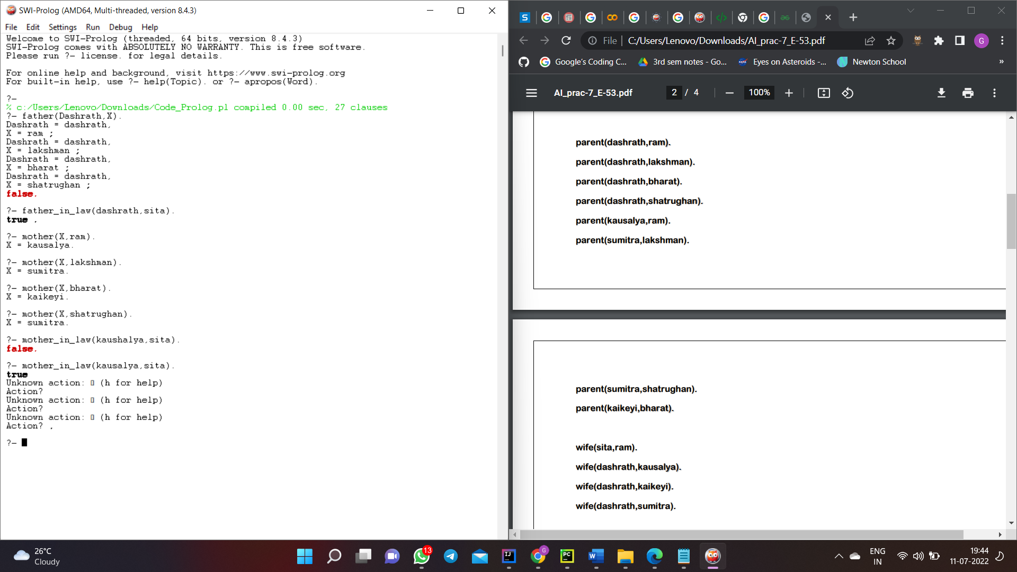

2: dashrath is father in law of sita



3: find mother of all ram, lakshman, bharat, shatrughan.



4: Kausalya is mother in law of sita

