**CMPE 275 - Lab 2 - REST and Persistence**

**Gaurav Misra**

**Server DNS:**

|  |
| --- |
| **ec2-52-53-244-181.us-west-1.compute.amazonaws.com** |
|  |

**Port : 8080**

**DB : MySQL**

**Tables: Player, Sponsor, Opponents**

1. **Create a player**

<http://ec2-52-53-244-181.us-west-1.compute.amazonaws.com:8080/player?firstname=Bob&lastname=Smith&email=Bob@abc.com&description=Student&street=ABC&city=XYZ&state=LMN&zip=234>

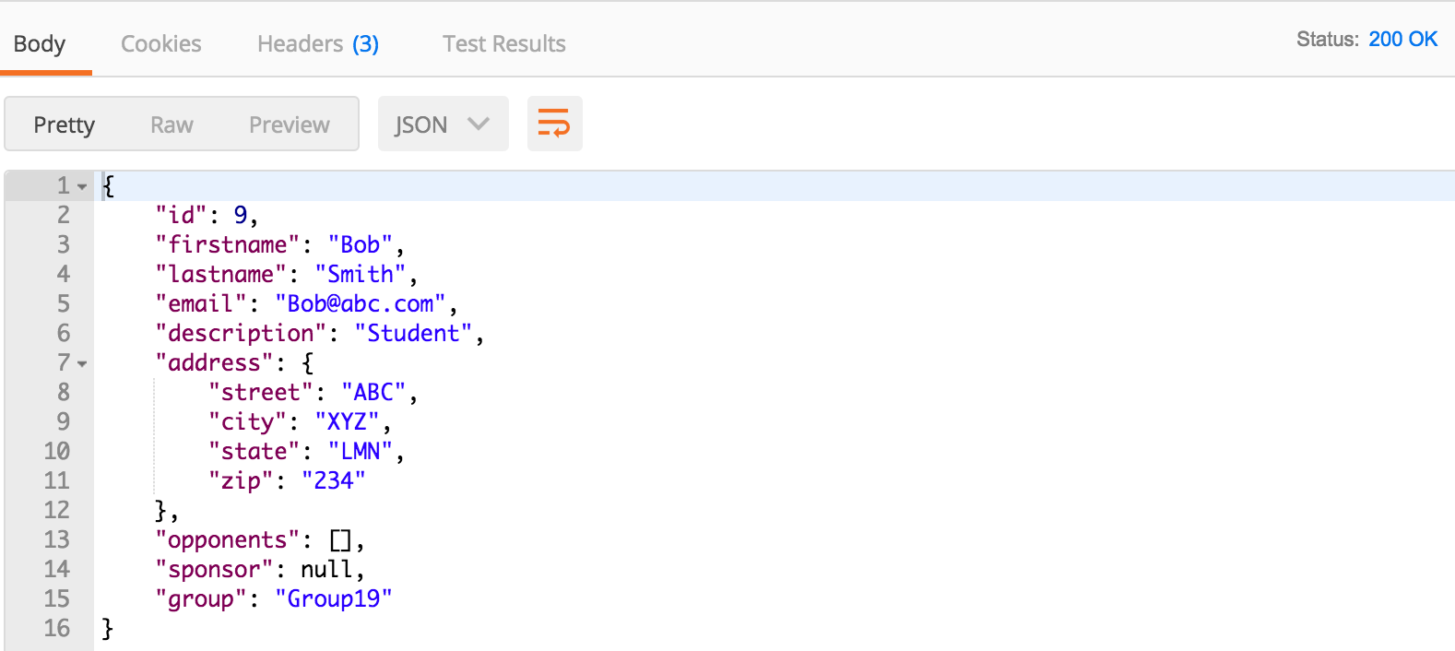

1. **Create a player with sponsor**

http://ec2-52-53-244-181.us-west-1.compute.amazonaws.com:8080/player?firstname=Francis&lastname=Smith&email=Francis@abc.com&description=Student&street=ABC&city=XYZ&state=LMN&zip=234&sponsor=5

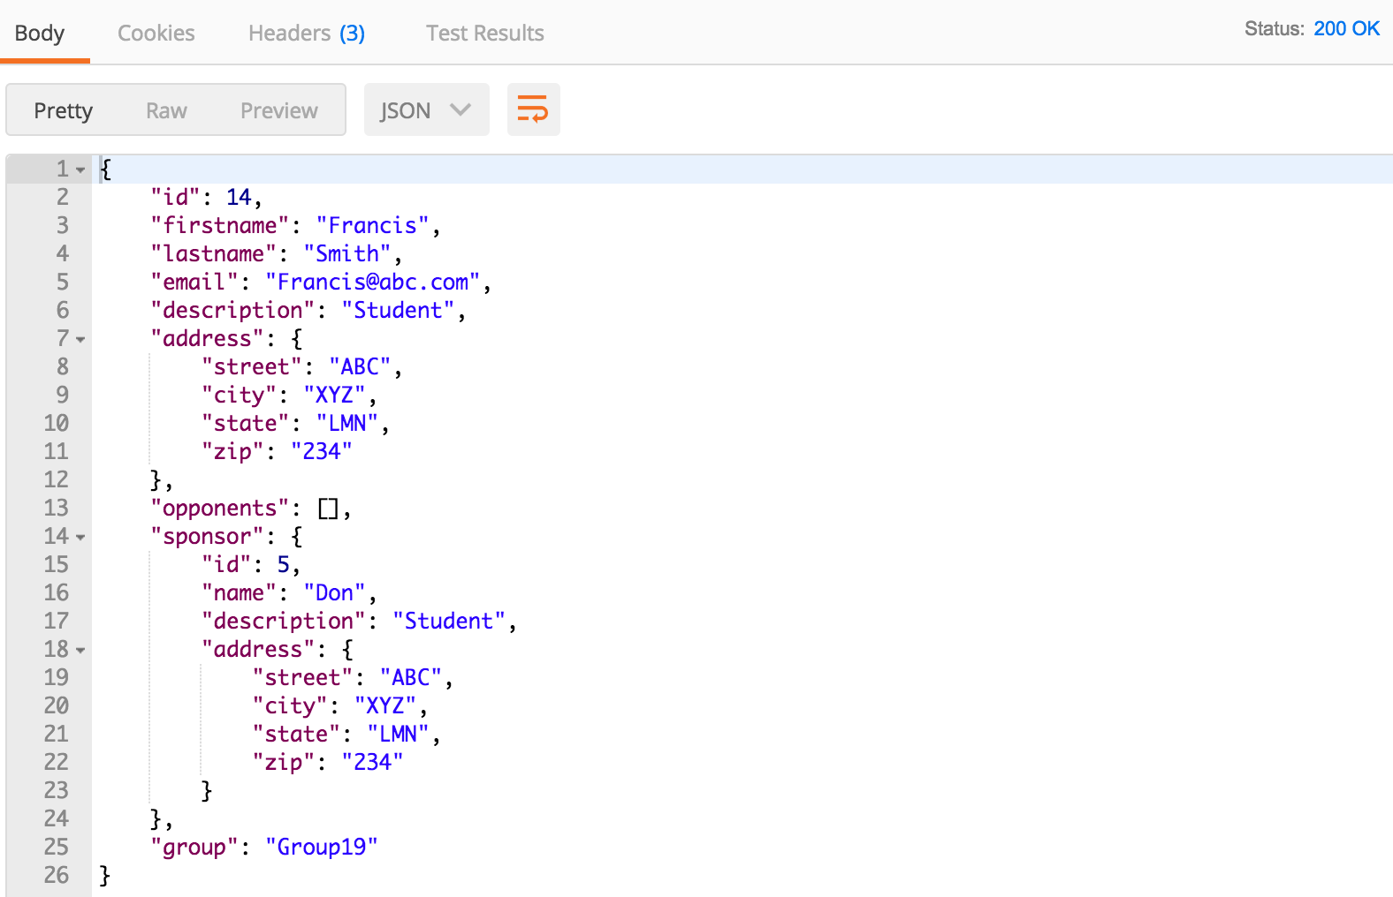

1. **Get a player**

<http://ec2-52-53-244-181.us-west-1.compute.amazonaws.com:8080/player/9>

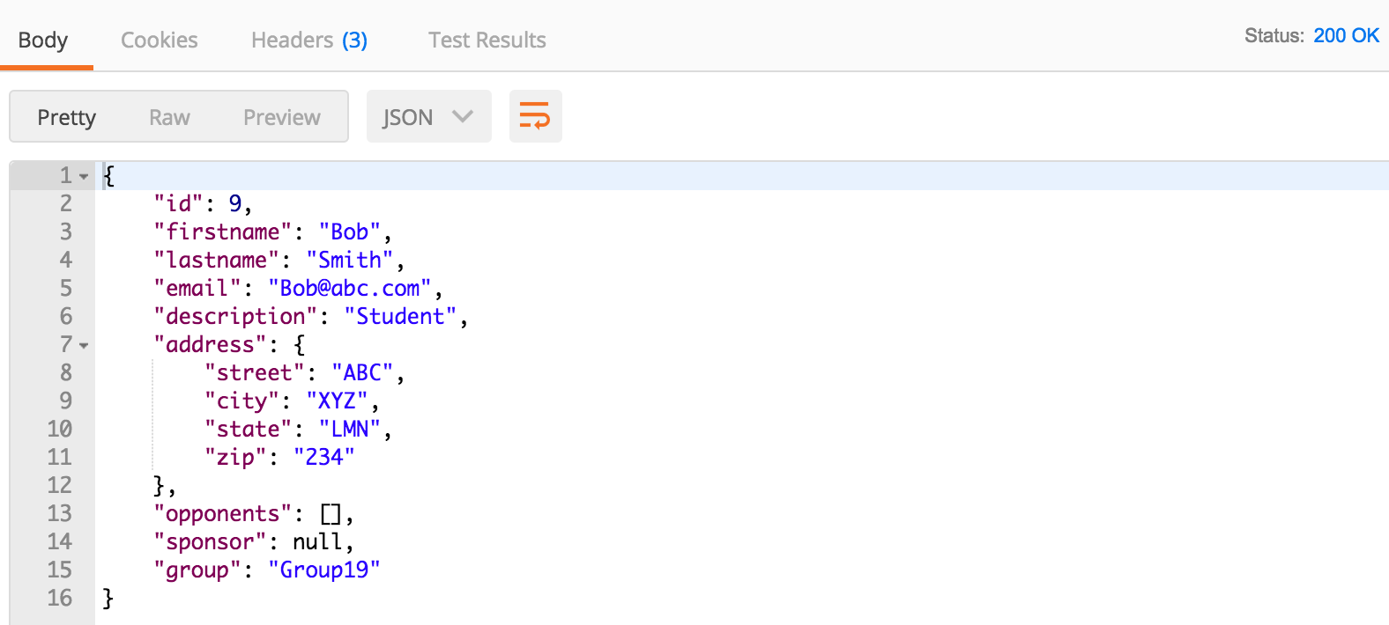

1. **Update a player**

<http://ec2-52-53-244-181.us-west-1.compute.amazonaws.com:8080/player/9?firstname=Bob&lastname=Williams&email=Bob@abc.com&description=Student&street=ABC&city=XYZ&state=LMN&zip=1234>

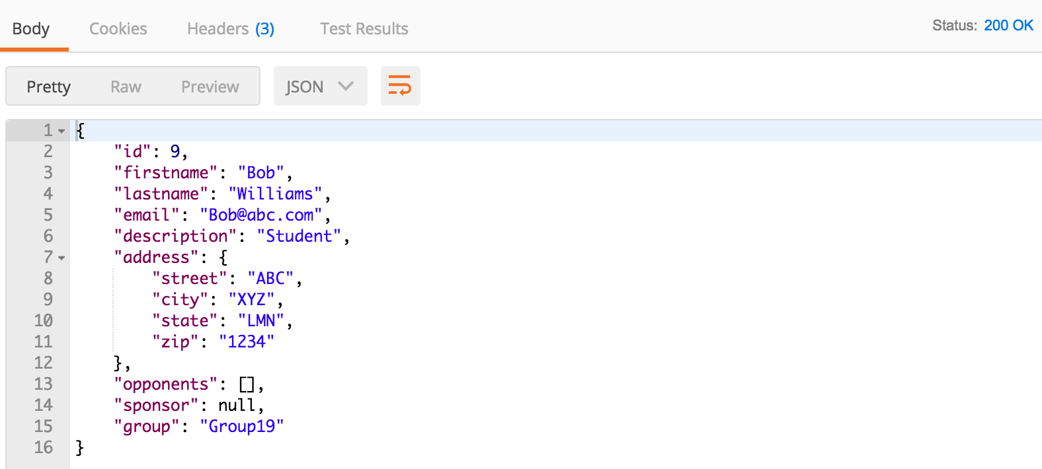

1. **Delete a player**

<http://ec2-52-53-244-181.us-west-1.compute.amazonaws.com:8080/player/9>

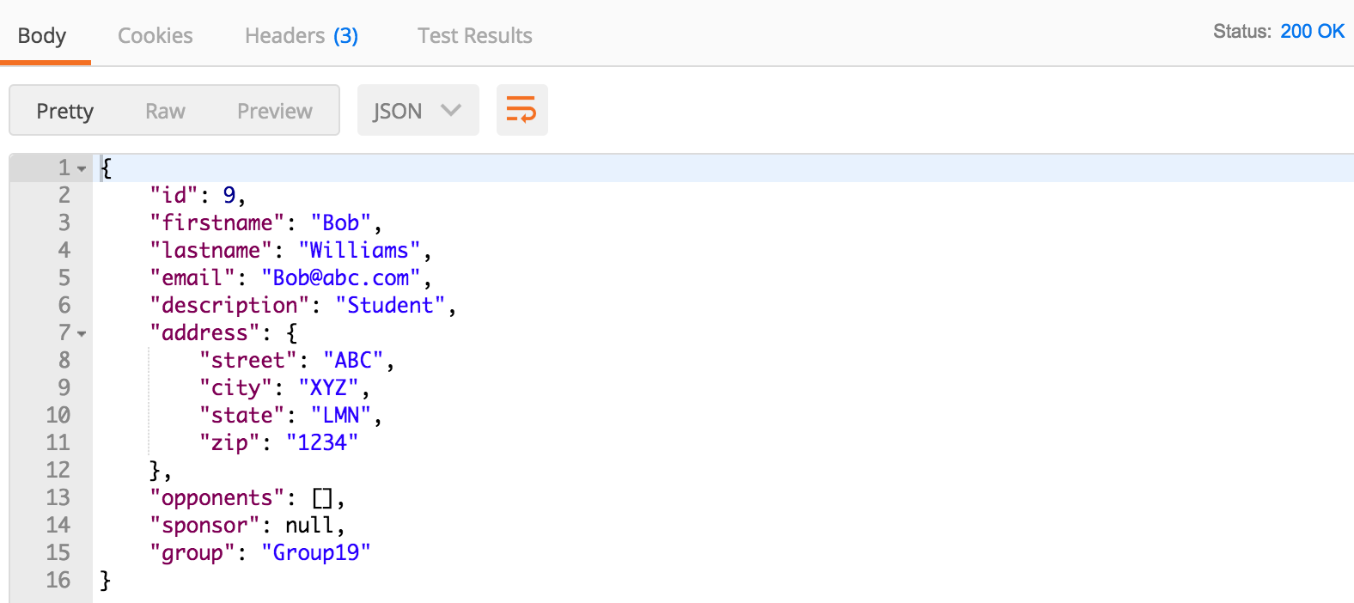

1. **Create a sponsor**

<http://ec2-52-53-244-181.us-west-1.compute.amazonaws.com:8080/sponsor?name=Alice&description=Student&street=ABC&city=XYZ&state=LMN&zip=234>

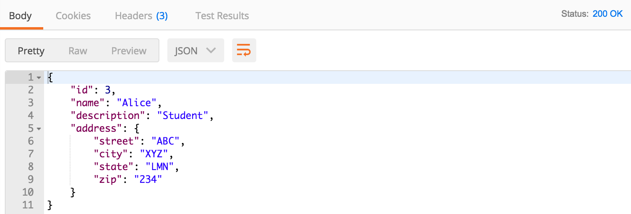

1. **Get a sponsor**

<http://ec2-52-53-244-181.us-west-1.compute.amazonaws.com:8080/sponsor/6>

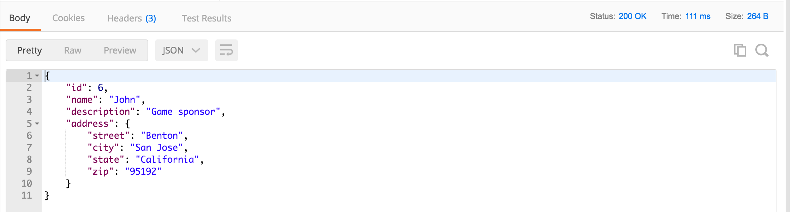

1. **Update a sponsor**

<http://ec2-52-53-244-181.us-west-1.compute.amazonaws.com:8080/sponsor/4?name=AliceJohnson&description=Student&street=ABC&city=XYZ&state=LMN&zip=234>

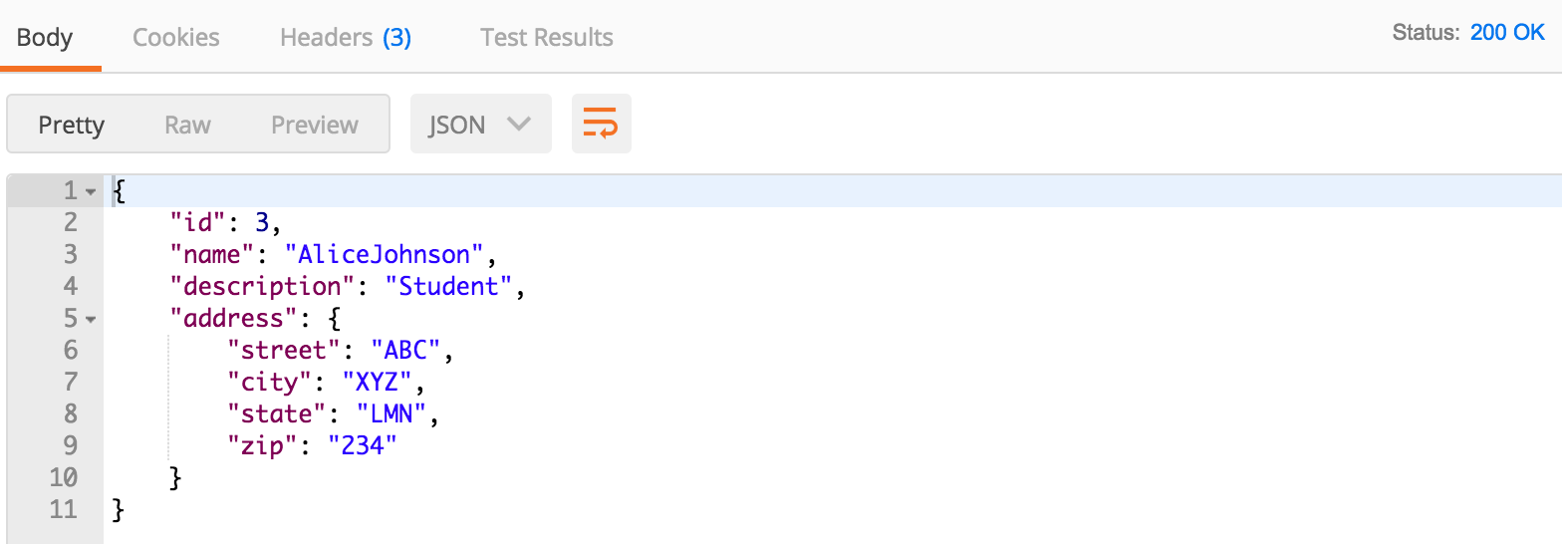

1. **Delete a sponsor**

<http://ec2-52-53-244-181.us-west-1.compute.amazonaws.com:8080/sponsor/3>

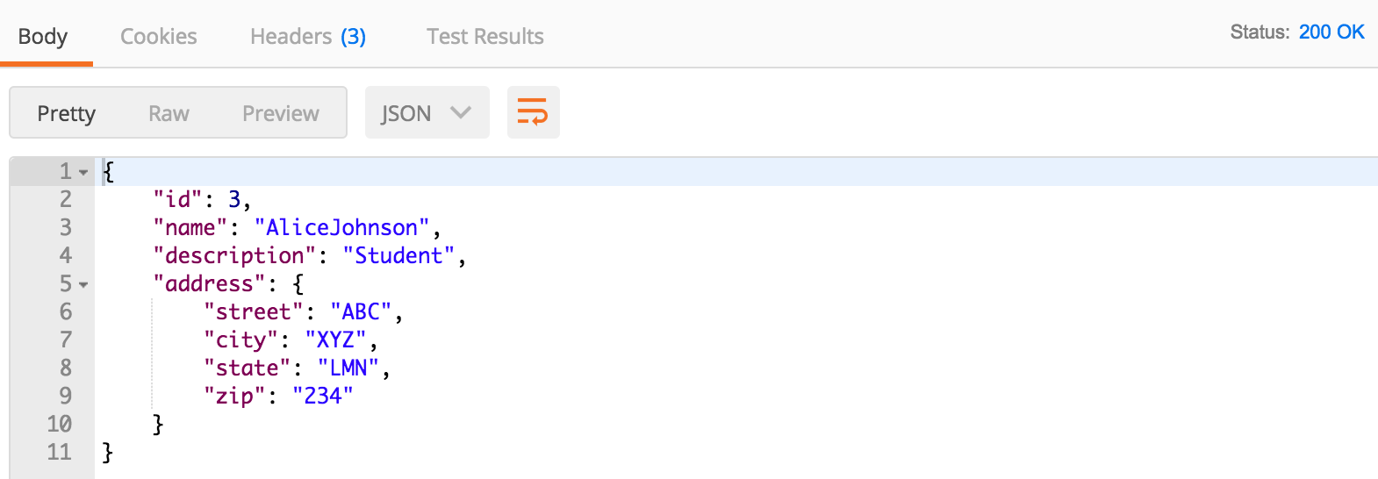

1. **Add an Opponent**

<http://ec2-52-53-244-181.us-west-1.compute.amazonaws.com:8080/opponents/9/14>

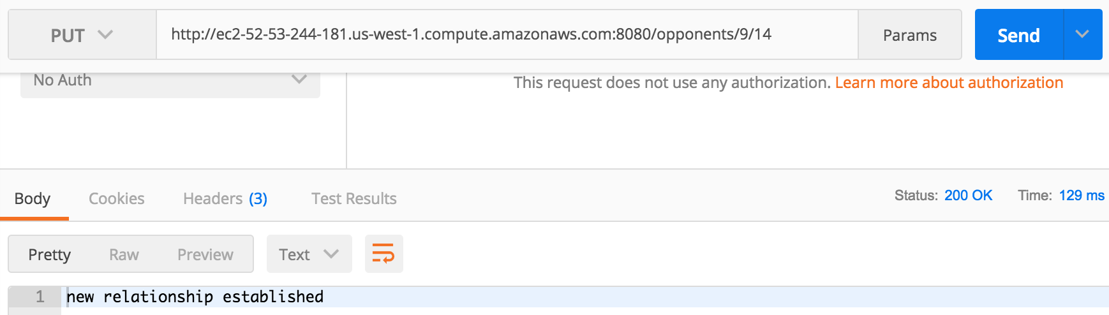

1. **Delete opponents**

<http://ec2-52-53-244-181.us-west-1.compute.amazonaws.com:8080/opponents/9/14>

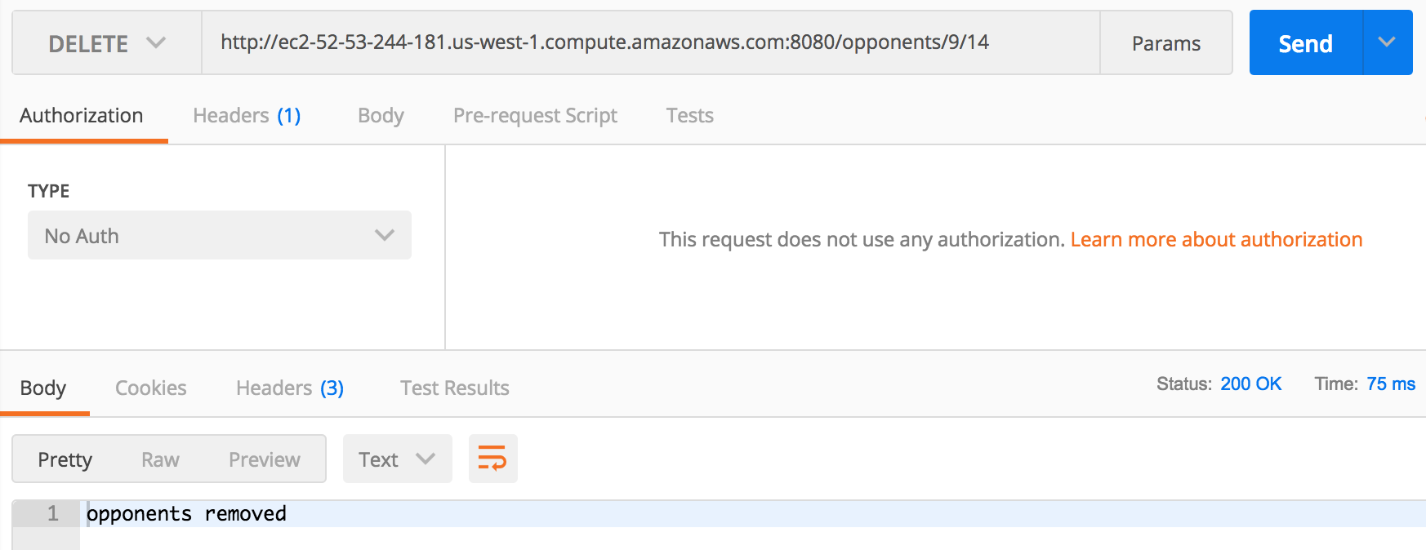

1. **PUT request if opponents already exist**

ec2-52-53-244-181.us-west-1.compute.amazonaws.com:8080/opponents/14/16

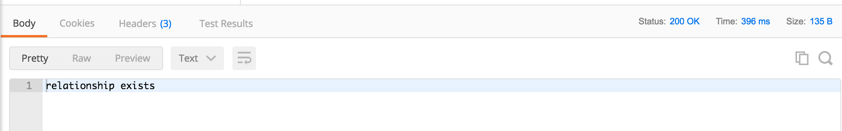

1. **PUT request if one of the players does not exist**

ec2-52-53-244-181.us-west-1.compute.amazonaws.com:8080/opponents/14/19

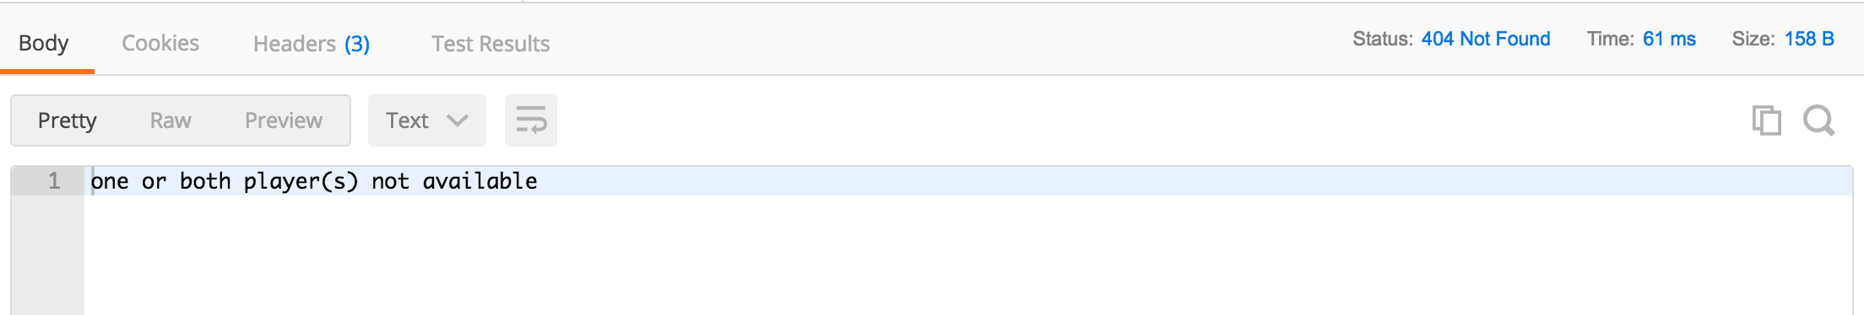

1. **Get player after adding opponent**

http://ec2-52-53-244-181.us-west-1.compute.amazonaws.com:8080/player/9

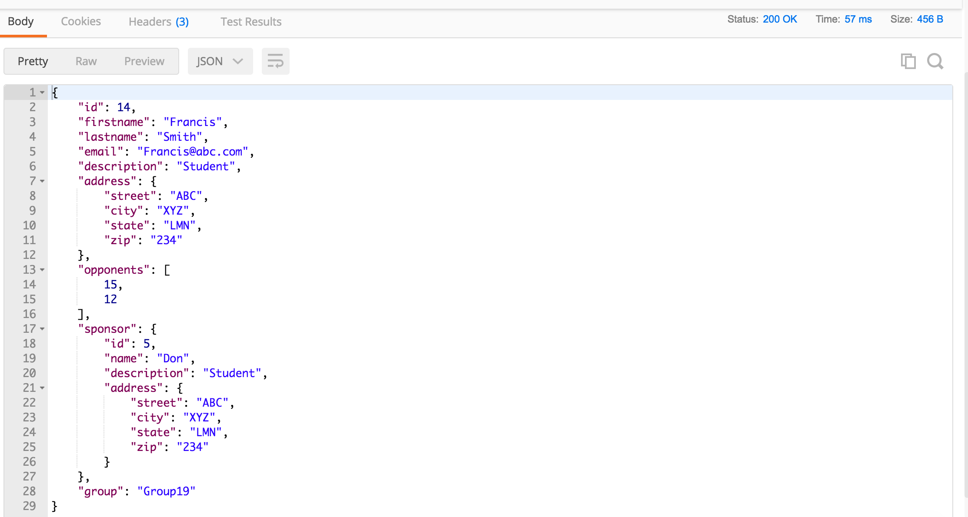

1. **Invalid create player request - missing required parameters**

<http://ec2-52-53-244-181.us-west-1.compute.amazonaws.com:8080/player?lastname=Smith&email=Bob@abc.com&description=Student&street=ABC&city=XYZ&state=LMN&zip=234>

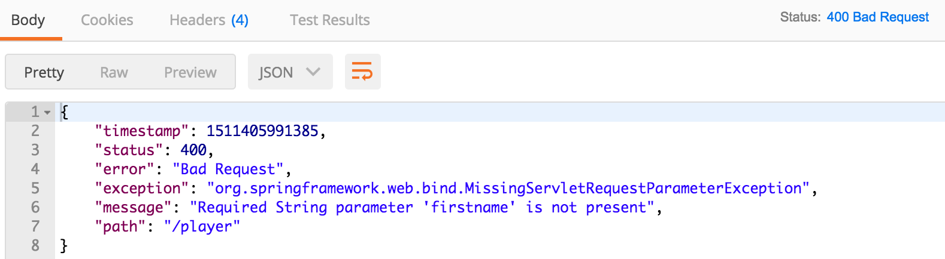

1. **GET request if player does not exist**

<http://ec2-52-53-244-181.us-west-1.compute.amazonaws.com:8080/player/16>

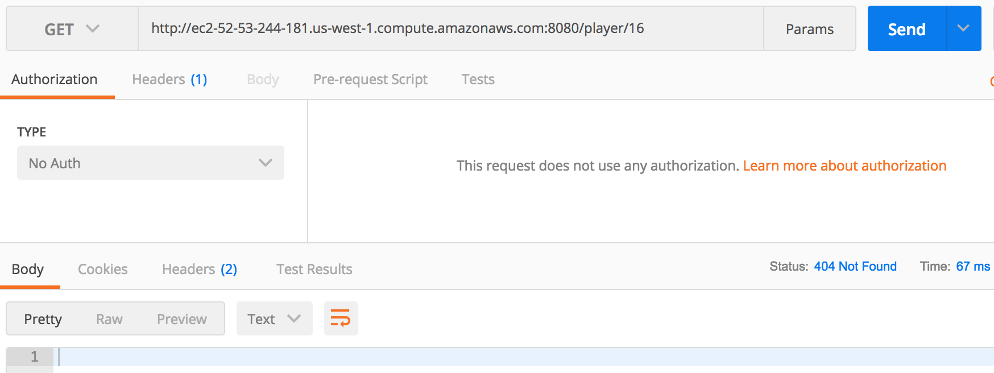

1. **Check for Email-Id uniqueness**

<http://ec2-52-53-244-181.us-west-1.compute.amazonaws.com:8080/player?firstname=Elisa&lastname=Smith&email=Bob@abc.com&description=Student&street=ABC&city=XYZ&state=LMN&zip=234>

