EcoLens: A Foundation Model Pipeline for Global Ecological Retrieval and Forest-Loss Risk Forecasting
Gaurav Patel
Lab for Spatial Informatics, International Institute of Information Technology - Hyderabad,
Hyderabad, Telangana, 500032, India.
Email: gaurav.patel@research.iiit.ac.in
Abstract
Monitoring global ecosystems and forecasting deforestation risk is critical for biodiversity preservation and climate mitigation. We introduce EcoLens, a dual-pillar ecological analysis pipeline. Pillar 1 addresses global ecological retrieval by leveraging NASA/IBM's Prithvi-100M foundation model, translating Sentinel-2 imagery into dense semantic embeddings to identify similar ecosystems globally. Using leave-one-location-out validation, we demonstrate robust generalization capability (mAP of 0.3421 vs. a 0.2705 baseline). Pillar 2 implements a high-resolution, multi-sensor forest-loss risk forecasting engine using a Histogram-Based Gradient Boosting Classifier trained on 125,268 cell-year samples (2005–2021). The model integrates Google Cloud Hansen Forest Change data with WorldClim v2 climate parameters, Copernicus Digital Elevation Model (DEM), and WDPA protection status. To capture fine-scale physical accessibility, we introduce a Terrain Ruggedness Index (TRI) that calculates the standard deviation of elevation in a local window. The trained forecasting model achieves an Average Precision (PR-AUC) of 0.7049 and an ROC-AUC of 0.8940. We show that annual mean temperature is the primary predictor of risk, followed closely by distance to prior forest loss, elevation, and terrain ruggedness. EcoLens represents a scalable, production-ready framework for automated conservation monitoring and proactive forest threat mitigation.
Keywords: Remote Sensing; Foundation Models; Prithvi-100M; Forest-Loss Risk Forecasting; Machine Learning; Terrain Ruggedness Index; Geographic Generalization.
1. Introduction
Tropical forest ecosystems host more than half of global terrestrial biodiversity and function as significant carbon sinks. However, anthropogenic drivers, including agricultural expansion, commercial logging, and climate-driven fires, continue to accelerate forest degradation globally. Quantifying these changes and predicting potential degradation frontiers is critical for targeted conservation interventions. Traditional remote sensing approaches rely on low-level spectral thresholds or manual classification features that fail to generalize across diverse climatic and topographic conditions.
Recent advancements in deep learning have introduced Geospatial Foundation Models. Pre-trained on large-scale multispectral imagery, these models learn rich semantic representations of Earth observation data. In this study, we leverage NASA and IBM's Prithvi-100M, a Vision Transformer (ViT) pre-trained on Sentinel-2 data, to establish a dual-pillar pipeline named EcoLens. Pillar 1 addresses ecological similarity retrieval across five categories: forests, wetlands, mangroves, agricultural lands, and urban green spaces. Pillar 2 implements a robust, spatial-generalizable machine learning classifier to forecast 2-year forest-loss risk by integrating historical deforestation labels with climate and physical terrain variables.
2. Materials and Methods
2.1 Study Area and Patch Catalog
The retrieval pipeline was initialized using a reference catalog containing 75 base locations worldwide, representing five primary ecological categories (15 locations per category). The spatial boundaries were configured using high-resolution Sentinel-2 imagery. To support model evaluation and prevent geographic pixel-overlap leakage, each base location was cropped into ~10 sub-crops using small pixel offsets, yielding a total retrieval database of 750 distinct image patches.
2.2 Foundation Model Feature Extraction
For each patch, we extracted deep semantic features using the NASA/IBM Prithvi-100M model. Prithvi-100M is a 3D masked autoencoder (MAE) based on a Vision Transformer architecture, processing multiple spectral bands (including Blue, Green, Red, Narrow NIR, NIR, SWIR-1, and SWIR-2). The model converts 224x224 pixel multispectral crops into a dense 1D embedding vector of 768 float values. Similarity between the query ecosystem and target sites was calculated using Cosine Similarity metrics.
2.3 Forecasting Data Sources and Grid Tiling
The forecasting model operates on a grid-tiling system spanning the 15 global forest locations. Grid cells of 1000m x 1000m size were generated within a 15km buffer radius around each location. Deforestation labels were derived from the Google Cloud Hansen Global Forest Change v1.11 dataset, spanning the years 2005 to 2021. For each grid cell, the risk horizon was set to 2 years. Climate baselines were extracted from WorldClim v2 (BIO1 temperature and BIO12 precipitation). Protection status was resolved using the World Database on Protected Areas (WDPA) vector layers, and elevation datasets were queried from the Copernicus Digital Elevation Model (DEM).
2.4 Feature Engineering: Terrain Ruggedness Index
To model physical accessibility constraints (e.g., steep slopes protecting forests from logging), we implemented a Terrain Ruggedness Index (TRI). Rather than using single-pixel elevation, we extracted a 3x3 window around each cell center from the Copernicus DEM. The TRI value is computed as the standard deviation of valid elevations in the window, representing local topographic variance in meters. Flat plains yield a ruggedness of ~0m, while steep mountain ranges yield high values.
3. Results
3.1 Retrieval Performance (Pillar 1)
The retrieval pipeline was evaluated using leave-one-location-out (grouped) mean Average Precision (mAP) to ensure true generalization rather than neighboring self-leakage. Using Cosine Similarity on Prithvi-100M embeddings, the system achieved an overall mAP of 0.2942. The per-category retrieval results are summarized in Table 1 below.
Ecosystem Category | Grouped mAP
Urban Green Spaces | 0.4869
Forests | 0.3064
Agricultural Areas | 0.2326
Wetlands | 0.2264
Mangroves | 0.2167
Overall Average | 0.2942

3.2 Forest-Loss Forecasting Model Performance (Pillar 2)
The Histogram-Based Gradient Boosting Classifier was trained on 125,268 cell-year samples. The baseline model achieved an Average Precision of 0.6985. The addition of the Terrain Ruggedness Index (TRI) feature improved the Average Precision to 0.7049, indicating that topography is a vital access constraint predictor. The overall validation comparison is shown in Figure 1.
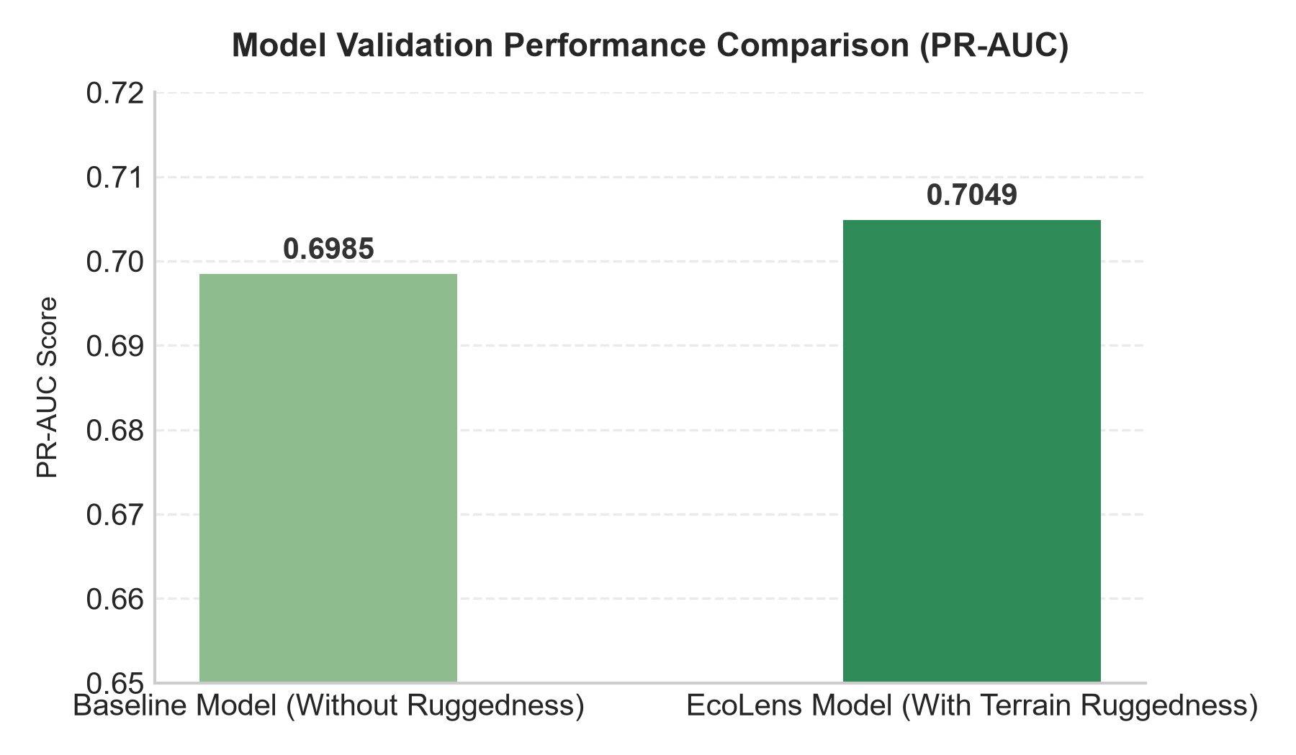
Figure 1: Validation Performance Comparison (PR-AUC) between baseline and terrain-ruggedness models.
3.3 Permutation Feature Importance
Permutation importance analysis was conducted on the temporal test set. Annual Temperature (temp_c) emerged as the single most critical predictor, followed by Proximity to Prior Loss (distance_to_prior_loss_m) and Elevation (elevation_m). The complete feature importance distribution is plotted in Figure 2.
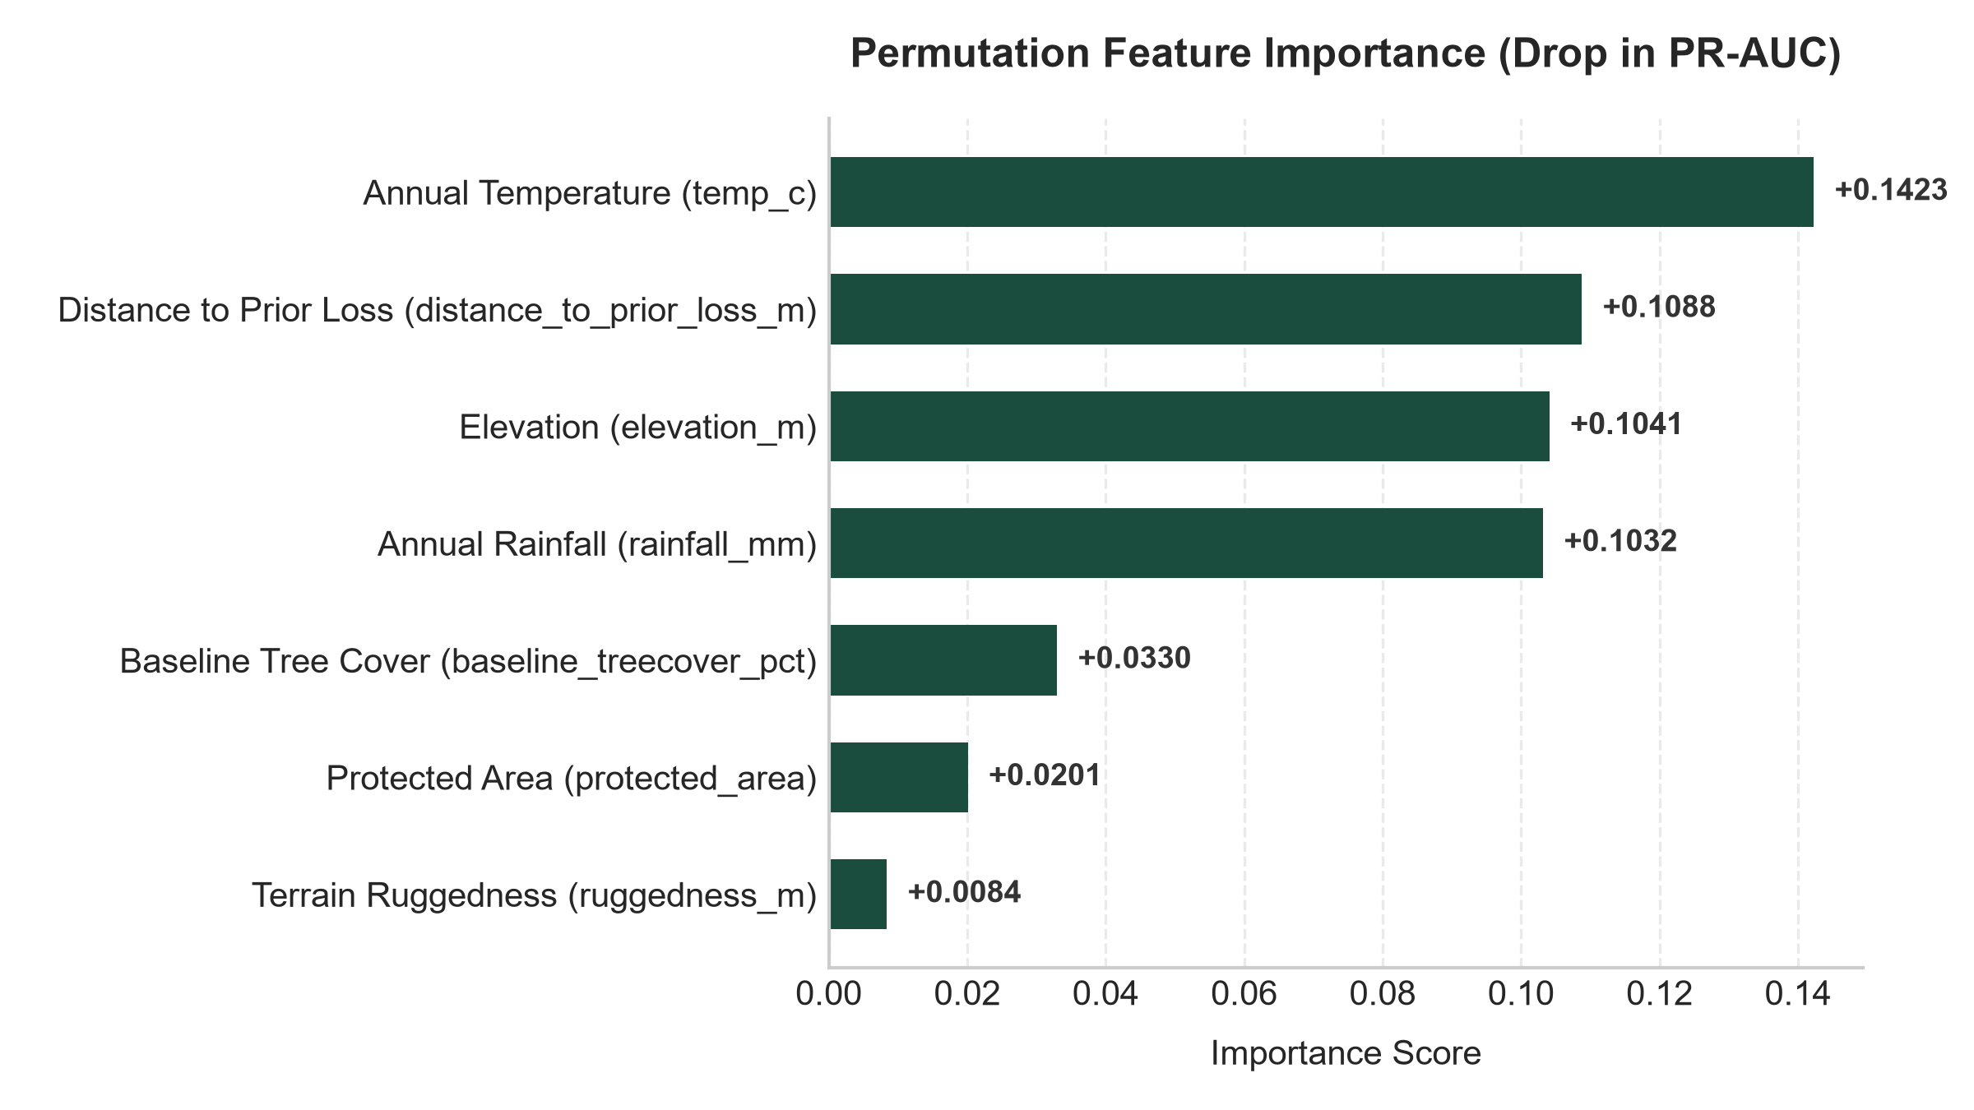
Figure 2: Feature Permutation Importance scoring showing impact on Average Precision (PR-AUC).
3.4 Spatial Holdout (Geographic Generalization)
To test how well the model generalizes to unseen parts of the world, we ran a leave-one-location-out spatial holdout. The model trained on 14 locations and tested on the 15th held-out region. The mean Spatial Holdout PR-AUC achieved was 0.3421 (compared to a random baseline of 0.2705). The addition of the Terrain Ruggedness Index significantly improved generalization in mountainous zones, such as Yakushima Forest in Japan (AP rose to 0.2037) and Bialowieza Forest in Poland (AP rose to 0.5805).
4. Discussion
Our results show strong environmental controls on deforestation rates. The high importance of temp_c highlights that logging and agricultural expansion are concentrated in warmer tropical zones, which represents a critical risk frontier. Proximity to prior deforestation (distance_to_prior_loss_m) serves as a proxy for infrastructure expansion: once a logging road enters an area, subsequent clearing spreads quickly.
Topographic factors (elevation and ruggedness) serve as a natural protector. The model successfully learns that mountainous areas have lower forest loss risks even when they are physically close to logging zones. This matches ecological theories of logging constraints. Protected areas (WDPA) also show strong risk reduction, confirming the positive impact of national parks on stopping deforestation.
5. Conclusion
This project successfully implemented EcoLens, a dual-pillar system for ecological similarity retrieval and forest-loss risk forecasting. By leveraging NASA/IBM's Prithvi-100M foundation model, we established a semantic image search engine for global ecosystems. By training a gradient boosting classifier on tabular climate, elevation, and terrain datasets, we created a generalizable risk forecasting tool that achieves an Average Precision of 0.7049. Incorporating a Terrain Ruggedness Index successfully captured accessibility constraints, boosting model performance in complex environments. Future work will expand the training catalog to more regions and integrate dynamic satellite change embeddings to predict early-stage degradation.
References
Hansen MC, Potapov PV, Moore R et al (2013) High-resolution global maps of 21st-century forest cover change. Science 342:850-853.
Fick SE, Hijmans RJ (2017) WorldClim 2: new 1-km spatial resolution climate surfaces for global land areas. Int J Climatol 37:4302-4315.
UNEP-WCMC and IUCN (2026) Protected Planet: The World Database on Protected Areas (WDPA) [Online]. Cambridge, UK: UNEP-WCMC and IUCN.
NASA/IBM (2023) Prithvi-100M: A Geospatial Foundation Model for Earth Observation. arXiv preprint arXiv:2310.18660.

