Multi-Sensor Analysis of Tropical Forest Phenology across
Eco-Topographic Gradients and Climatic Variability in Central India

Megha Negi¹ and Pillutla Rama Chandra Prasad^{2*}
megha.negi@research.iiit.ac.in¹, rcprasad@iiit.ac.in²
¹Lab of Spatial Informatics, International Institute of Information Technology - Hyderabad, Hyderabad, Telangana, 500032, India.

*Corresponding Author
Dr. Rama Chandra Prasad Pillutla
Lab for Spatial Informatics,
IIIT-Hyderabad, Gachibowli
India
Tel: 040-66531343: 0091-9246109160
Fax: 040-66531413
Email: rcprasad@iiit.ac.in; rcpncmsl@gmail.com
ORCID Number: 0000-0001-5285-9827

Abstract

Understanding how vegetation phenology responds to climatic variability and topographic heterogeneity is critical for assessing forest resilience yet remains poorly quantified in tropical deciduous systems. We analysed phenological dynamics in Bori Wildlife Sanctuary, central India, using multi-sensor satellite data (Sentinel-2, Landsat-8, MODIS) from 2018 to 2024. GPR-smoothed NDVI and EVI time series were used to derive seasonal metrics (SOS, POS, EOS) and productivity indicators (amplitude, AUC). Results show strong eco-topographic control, with forests above 800 m exhibiting delayed SOS and shorter growing seasons, while steeper slopes (>15°) showed reduced productivity. Interannual analysis revealed sensor-specific responses, with Sentinel-2 capturing a decline in productivity during 2020–2021 drought years, not evident in coarser datasets. Breakpoint and anomaly analyses detected intra-seasonal disruptions linked to monsoon variability. Cross-sensor validation showed strong Landsat–MODIS agreement (rho = 0.97) for key metrics. Clustering identified three phenological regimes: resilient valley forests, transitional mid-elevation stands, and vulnerable upland systems. These findings highlight the value of multi-sensor phenology for detecting climate-driven vegetation dynamics and supporting adaptive forest management.

Keywords: Vegetation phenology; Tropical deciduous forests; multi-sensor time series; Eco-topographic gradients; Climate anomalies; Landscape resilience; Bori Wildlife Sanctuary

1. Introduction
Understanding the timing of plant life-cycle events such as leaf emergence, flowering, and senescence is central to evaluating vegetation growth cycles, ecosystem productivity, and responses to environmental change (Tecuapetla-Gómez et al. 2024; Yu et al. 2024). Phenology is widely regarded as one of the most sensitive indicators of ecosystem health and serves as an early warning system for climate change impacts (Piao et al. 2019; Caparros-Santiago et al. 2021). Shifts in phenological events, including earlier green-up or delayed senescence, signal altered climatic conditions with implications for biodiversity, ecosystem services, and agriculture (Piao et al. 2019; Hassan et al. 2024). Such changes disrupt species interactions (Visser et al. 2006; Hughes et al. 2000), alter carbon and water cycles, and increase vulnerability to invasive species and disease outbreaks.
Across ecosystems, phenology has shown clear shifts under global climate change, including earlier onset of spring, prolonged growing seasons, and delayed autumn senescence (Yu et al. 2024; Menzel et al. 2006). These changes cascade through community dynamics, carbon balance, and ecosystem resilience. However, attributing these shifts to specific drivers remains challenging because phenology reflects the combined influence of large-scale climatic forcing (e.g., temperature and rainfall variability) and local controls such as topography, soils, and microclimate. (McNichol et al. 2024). Disentangling these interacting influences is therefore critical for interpreting observed phenological variability and for distinguishing climate-driven responses from terrain-mediated effects.
Historically, phenology was studied through field observations, which provided valuable detail but lacked spatial and temporal coverage (Laurin et al. 2024). The advent of remote sensing transformed the field by enabling consistent, multi-decadal monitoring of vegetation phenology across scales (Gong et al. 2024). Satellite-derived vegetation indices such as the Normalized Difference Vegetation Index (NDVI) and Enhanced Vegetation Index (EVI) are now fundamental tools for quantifying seasonal dynamics across ecosystems ranging from croplands (Wu et al. 2024) to forests (Singh et al. 2023; Myneni et al. 1997). NDVI is a well-established proxy for canopy greenness and photosynthetic activity (Pettorelli et al. 2005), widely applied to detect the start (SOS), peak (POS), and end of the season (EOS) (Singh et al. 2023). EVI extends these capabilities by reducing saturation in dense canopies and accounting for soil and atmospheric effects, making it particularly valuable in tropical forests (Huete et al. 2002; Zhang et al. 2006).
However, satellite-derived phenological metrics in tropical deciduous forests are subject to known uncertainties. Variations in NDVI/EVI may not always directly correspond to actual phenophases due to lag effects associated with canopy structure, leaf area index (LAI), and the presence of non-photosynthetic vegetation. Previous studies have reported that remotely sensed phenology can deviate from field observations in structurally complex canopies, although overall seasonal trajectories remain strongly correlated with ecosystem productivity and moisture availability (Zhang et al. 2006; Laurin et al. 2024). In data-limited regions such as central India, where long-term ground phenology records are scarce, studies often rely on indirect validation approaches such as cross-sensor agreement, consistency across vegetation indices, and ecological coherence with known climatic patterns. While such approaches cannot fully replace field validation, they provide a pragmatic basis for evaluating the reliability of remotely sensed phenological metrics (Pettorelli et al. 2005; Caparros-Santiago et al. 2021).
Recent advances in multi-sensor datasets have further strengthened phenological monitoring by integrating observations across spatial and temporal resolutions. MODIS, with its global 16-day composites, has been pivotal for long-term phenological monitoring at coarse resolution (Zhang et al. 2003; Zhang et al. 2006). Landsat-8 offers medium-resolution coverage suitable for landscape-scale analysis (Roy et al. 2014), while Sentinel-2 provides high-resolution reflectance data with frequent revisit intervals, allowing fine-scale monitoring of heterogeneous ecosystems (Phiri et al. 2020). These sensors complement one another, allowing cross-validation of metrics and improved detection of spatial and temporal variability. Such integration is particularly valuable in complex tropical landscapes, where single-sensor observations may either miss fine-scale heterogeneity or oversimplify spatial variability.
Nevertheless, integrating multi-sensor datasets introduces challenges related to spatial resolution differences, mixed pixel effects, and varying data availability under cloud-prone conditions. Coarse-resolution sensors may smooth fine-scale heterogeneity, while high-resolution sensors are more sensitive to local variability and data gaps (Moreno-Martínez et al 2020). In addition, differences in sensor coverage across terrain gradients and cloud contamination during the monsoon season can introduce uneven sampling, potentially affecting phenology extraction (Peng et al 2021). Addressing these uncertainties requires explicit cross-sensor comparison, careful preprocessing, and transparent interpretation of scale-dependent differences (Gong et al. 2024).
Despite these advances, few studies have systematically integrated multi-sensor data to examine phenological variability in tropical deciduous forests, particularly in India (eg. Nanda et al. 2014, Christian et al. 2015). These ecosystems are highly responsive to monsoonal rainfall and topographic gradients but remain underexplored in terms of spatiotemporal dynamics. Most studies have relied either on coarse-resolution long-term datasets or fine-scale case studies, with limited integration across sensors. Moreover, existing work often emphasizes pattern detection without fully quantifying the relative influence of climatic drivers such as rainfall and temperature, making it difficult to distinguish climate-driven variability from topographic effects.
Climatic drivers such as rainfall variability, temperature fluctuations, and extreme events (e.g., droughts) play a critical role in shaping phenological timing and productivity (Gusain et al. 2026). In monsoon-dependent ecosystems, even short-term rainfall deficits can significantly alter growing season length and vegetation productivity, often interacting with terrain-driven moisture gradients (Singh et al. 2020; Singh et al. 2021; Seneviratne et al. 2021). Therefore, interpreting phenological anomalies requires linking observed deviations not only to statistical metrics but also to underlying climatic conditions, particularly during drought years and periods of monsoon variability.
The Bori Wildlife Sanctuary (BWS) in central India provides an ideal case study for investigating these dynamics. Its heterogeneous landscape, comprising moist and dry deciduous forests distributed along steep topographic gradients, functions as a natural laboratory for examining how seasonal timing, productivity, topography, and climatic stress interact to shape phenology. Against this backdrop, the present study formulates the following objectives. 1. Derive and validate seasonal phenological metrics (SOS, POS, EOS, and Growing Season Length) and productivity indicators (Amplitude, Integral/AUC) from NDVI and EVI time series, and assess their consistency across MODIS, Landsat-8, and Sentinel-2 datasets. 2. Examine eco-topographic controls by analysing how elevation and slope gradients influence phenological timing and productivity. 3.Detect interannual variations and climatic anomalies, particularly drought-related disruptions, using breakpoint and anomaly detection methods to understand vegetation sensitivity and resilience. 4. Synthesize findings for ecological and management implications, highlighting the role of multi-sensor approaches in monitoring tropical deciduous forests under climate variability.
By explicitly integrating multi-sensor observations with eco-topographic analysis and climate-linked anomaly detection, this study aims to move beyond descriptive phenology towards a more process-oriented understanding of vegetation dynamics in tropical deciduous systems. It further demonstrates the value of integrating multi-sensor and multi-index datasets for robust monitoring, providing insights that are directly relevant to ecological research, conservation planning, and climate adaptation in central India and comparable ecosystems.
2. Study Area
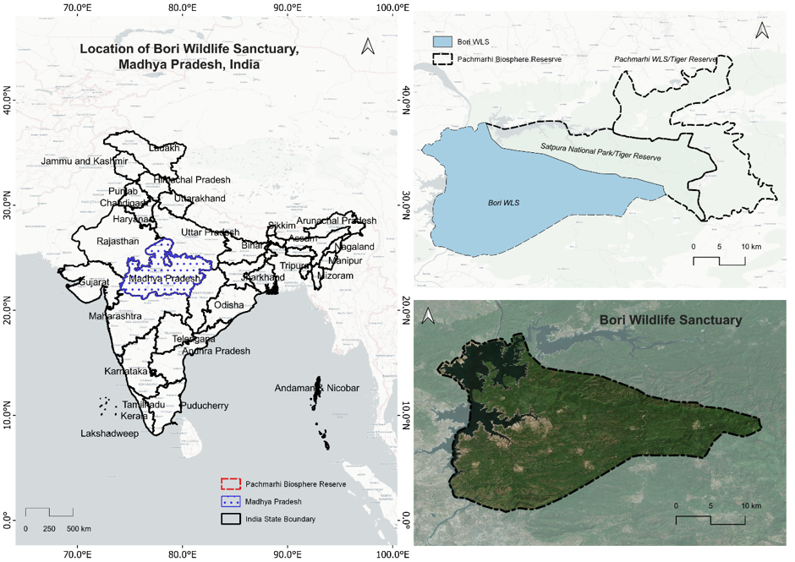
The Bori Wildlife Sanctuary (BWS), located in the Hoshangabad District of Madhya Pradesh, central India, covers approximately 486 km² and forms part of the larger Satpura Tiger Reserve (STR), which also includes Satpura National Park (SNP) and Pachmarhi Wildlife Sanctuary (Rao et al. 2025). Geographically, BWS lies between 22°19′N–22°30′N and 77°56′E–78°20′E (Govt. of Madhya Pradesh, Forest Department, 1977), bounded by the Tawa River in the north and surrounded by the rugged Satpura Range (Ramsar RIS; Key Biodiversity Areas, n.d.). Elevations range from 300 to 1352 m above sea level, including prominent peaks such as Dhoopgarh and Mahadeo, creating strong topographic and microclimatic gradients that influence vegetation distribution and phenology (Satpura Tiger Reserve. (n.d.), Figure 1).

Figure 1. Study Area
Climatically, BWS experiences three distinct seasons: summer (March–June), monsoon (July–September), and winter (October–February) (Weather & Climate - Satpura National Park, n.d.). The region receives an average annual rainfall of ~1300 mm, primarily from the southwest monsoon (late June–September), which drives rapid vegetation green-up and seasonal growth dynamics. The extended dry period from November to May is marked by high temperatures and soil moisture deficits, leading to widespread leaf shedding in deciduous species (Singh et al. 2020). Seasonal transitions are therefore closely tied to monsoonal rainfall and moisture availability, making the region highly sensitive to interannual climatic variability (White et al. 1997; Liu et al. 2021; Soni and Tripathi, 2024). Variability in monsoon behaviour, including delayed onset, intra-seasonal dry spells, and early withdrawal, is a defining feature of the regional climate and has been shown to strongly influence vegetation productivity and phenological timing (Singh et al. 2021; Seneviratne et al. 2021). This variability provides an important context for interpreting short-term phenological anomalies observed during the study period.
Geologically, the Bori–Pachmarhi landscape comprises Deccan Trap basalts with dolerite intrusions, transitioning eastwards into Gondwana sandstones (Banerjee et al. 2022). These formations give rise to a dissected terrain of plateaus and valleys with contrasting soil types, including well-drained loamy soils in forested uplands and black cotton (regur) soils in lower-lying areas (RSIS 2024). Edaphic and topographic heterogeneity regulates water retention and drainage, creating a spatial variation in moisture availability where valleys retain water for longer durations and uplands or steep slopes experience rapid runoff, thereby directly driving vegetation dynamics (UNESCO. (n.g.).
Vegetation forms a mosaic of moist and dry deciduous forest types (Champion and Seth 1968), dominated by Sal (Shorea robusta), Teak (Tectona grandis), and mixed deciduous species (Reserve Profile - Satpura Tiger Reserve, n.d.). Species composition varies with moisture and terrain, with moist assemblages occupying higher elevations and valley zones, and drier mixed forests distributed across uplands and slopes forest (Reserve Profile - Satpura Tiger Reserve, n.d.). Riparian corridors along the Tawa River support relatively evergreen or semi-evergreen elements, contributing to localized ecological buffering during dry periods rivers (see Sunil et al. 2019, for T. arjuna as a riparian dominant). The heterogeneous vegetation structure, including mixed canopies and understory variability, introduces spatial complexity in satellite-derived spectral signals, particularly when using sensors with different spatial resolutions (Gong et al. 2024). This makes BWS a suitable landscape for evaluating multi-sensor approaches to phenological analysis across scales.
The sanctuary supports rich biodiversity, including key deciduous species such as Tectona grandis, Anogeissus latifolia, and Diospyros melanoxylon (Mukherjee, 1984; Flora - Satpura Tiger Reserve, n.d.). These ecosystems provide critical services including carbon storage, soil stabilization, and water regulation (Chopra et al. 2022), while also functioning as an important ecological corridor within the central Indian highlands (Sharma et al. 2013). The presence of riparian zones and moisture-retaining habitats further enhances ecosystem resilience by sustaining vegetation activity during dry periods, thereby influencing spatial patterns of phenological response under climatic stress (Khan et al. 2025).
3. Data and Methods
3.1 Satellite Data Sets
To investigate the phenological dynamics of BWS and address the study objectives, we employed a multi-sensor framework that combined long-term temporal continuity with fine-scale spatial detail. Three complementary satellite datasets formed the basis of our analysis. MODIS MOD13Q1 (Collection 6) offered 16-day composites of NDVI and EVI at 250 m resolution, enabling detection of inter-annual and intra-annual vegetation trends across the six-year study period (2018–2024). Landsat-8 Operational Land Imager (OLI) Analysis Ready Data, with 30 m resolution and a 16-day revisit interval, provided an intermediate perspective that bridged the gap between coarse and fine resolution. Sentinel-2 MSI Level 2A, atmospherically corrected and processed at 10–20 m resolution with a near five-day revisit, captured fine-scale heterogeneity across valleys, uplands, and riparian corridors. These sensors ensured that broad-scale trends, landscape-level transitions, and localized variations in forest phenology were systematically represented.
Differences in spatial resolution (10–250 m), revisit frequency, and sensor-specific radiometric characteristics can introduce mixed pixel effects and scale-dependent variability, particularly in heterogeneous tropical landscapes (Yan et al. 2025). Rather than forcing spatial resampling, which can introduce interpolation artefacts, each dataset was analysed at its native resolution to preserve sensor-specific information content. Consistency across sensors was subsequently evaluated using statistical agreement metrics, allowing scale-related differences to be explicitly interpreted rather than suppressed. To further address potential mixed-pixel and terrain representation effects, analyses were performed independently within each sensor domain and subsequently compared, ensuring that observed differences reflect scale characteristics rather than processing artefacts. In addition, terrain-wise comparisons were performed within each sensor domain to avoid bias arising from unequal spatial representation across elevation and slope gradients.
3.2 Vegetation Indices
From each sensor, two vegetation indices were derived to capture seasonal vegetation cycles. NDVI, based on red and NIR reflectance, provided sensitivity to canopy greening and senescence, while EVI, by incorporating blue-band reflectance and correction factors, improved detection in dense canopies where NDVI tends to saturate. The dual use of NDVI and EVI was particularly valuable in BWS, where both sparse dry deciduous stands and closed-canopy moist forests coexist, and where cross-validation between indices enhanced confidence in detecting seasonal transitions. The combined use of NDVI and EVI also reduces ambiguity associated with canopy structure, background soil reflectance, and non-photosynthetic vegetation, which are known to influence index-based phenological interpretation in tropical systems (Huete et al. 2002; Pettorelli et al. 2005). Agreement between NDVI and EVI-derived temporal trajectories was therefore used as an additional internal consistency check for phenological signal reliability.
3.3 Preprocessing and Time-Series Smoothing
All imagery was processed on the Google Earth Engine platform, which facilitated standardized access to global archives and ensured consistent application of preprocessing steps. Clouds and shadows were masked using sensor-specific QA layers, non-forest areas were excluded with ESA WorldCover, and permanent water bodies were removed using the JRC Global Surface Water dataset. To minimise cloud-related artefacts, only high-quality observations flagged by QA bands (e.g., QA60 for Sentinel-2 and pixel quality attributes for Landsat) were retained. Pixels affected by clouds, cirrus, or shadows were excluded prior to compositing. The spatial and temporal distribution of valid observations was quantified to ensure sufficient seasonal coverage, particularly during the monsoon period when cloud contamination is highest. Areas or periods with insufficient observations were excluded from phenological metric extraction to avoid biased estimates. To harmonize temporal coverage, Sentinel-2 and Landsat-8 images were aggregated into bi-monthly composites, while MODIS was retained in its native 16-day interval.
Bi-monthly compositing represents a trade-off between reducing noise due to cloud contamination and preserving phenological signal integrity. In tropical deciduous systems where transitions occur over multi-week periods, such aggregation has been shown to retain seasonal dynamics while improving temporal continuity (Zhang et al. 2003). Phenological signals were extracted after smoothing of these composites, ensuring that aggregation did not suppress key transition points but instead improved temporal continuity for curve fitting.
Vegetation index trajectories were often noisy due to cloud contamination and irregular clear-sky observations, so Gaussian Process Regression (GPR) was used to smooth time series. GPR was selected over spline interpolation and Savitzky–Golay filtering (Chen et al. 2004) because it accommodates uncertainty and performs robustly under irregular temporal sampling. It produces reliable seasonal curves even in monsoon-dominated environments characterized by frequent cloud cover. GPR further enables uncertainty-aware reconstruction of vegetation trajectories by modelling temporal covariance structures, making it particularly suitable for gap-filled phenological analysis. While smoothing may attenuate very short-duration fluctuations, it preserves dominant seasonal signals that are relevant for phenological metric extraction. All images retained their original acquisition timestamps to preserve temporal precision for subsequent day-based phenological metric extraction. A schematic of the end-to-end workflow is shown in Figure 2.
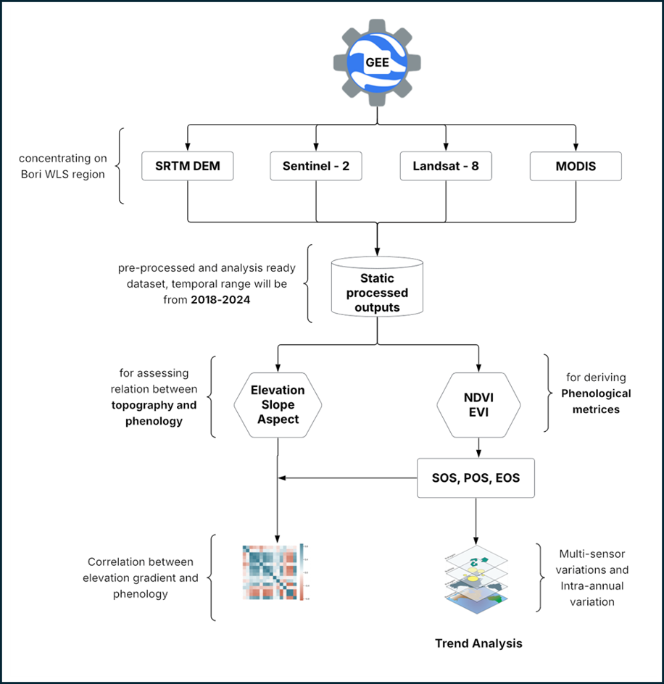
Figure 2. Overall Methodology
3.4 Phenological Metrics Extraction
Phenological metrics were then extracted from the smoothed NDVI and EVI series using a dual-method approach. Phenological metrics and interannual comparisons were restricted to complete July–June phenological years (2019–2020 to 2023–2024). The boundary year 2018–2019, which is partially covered due to the initiation of the study period, is shown only for contextual time-series visualization and was excluded from all metric-based trend and statistical analyses. A threshold-based method defined the SOS and EOS as the dates when index values crossed 20% of the seasonal amplitude, while a derivative-based method identified inflection points corresponding to maximum greening and senescence rates. This combination minimized bias from index saturation or residual noise. Although phenological metrics can be sensitive to threshold selection, the use of a moderate threshold (20%) combined with derivative-based detection reduces uncertainty and has been shown to provide stable estimates of seasonal transitions in tropical systems (White et al. 2009).
Beyond SOS, EOS, and POS, additional indicators Growing Season Length (GSL), amplitude, and Area Under the Curve (AUC) were computed to represent seasonal duration, canopy vigour, and cumulative productivity. These metrics provided the quantitative basis for subsequent comparisons across years, vegetation types, and eco-topographic gradients. Although derived from spectral indices, these metrics are widely used proxies for vegetation productivity and phenological timing and have demonstrated strong relationships with ecosystem functioning and climatic variability in comparable environments (Pettorelli et al. 2005; Piao et al. 2019). While these metrics are derived from remote sensing, their ecological interpretation is supported through cross-sensor consistency and alignment with known seasonal climatic patterns in the region. All phenological metrics were computed from the actual acquisition timestamps and expressed in days-of-year (DOY). For visualization and summary, these dates were aggregated into 24 equal 15-day “fortnight” bins (F01–F24) covering DOY 1–360, with any residual calendar days merged into F24 (Supplementary Table S1).
3.5 Cross-Sensor Validation
Given the reliance on multiple sensors, cross-validation was essential. We compared derived metrics across MODIS, Landsat-8, and Sentinel-2 using Spearman’s correlations and paired t-tests, which together quantified consistency and revealed scale-dependent differences. Kruskal-Wallis tests further examined whether metric distributions varied systematically across sensors. These statistical checks ensured that observed ecological patterns reflected real vegetation dynamics rather than artifacts of sensor resolution or acquisition timing. In the absence of ground-based phenological observations, agreement across sensors and indices was used as a consistency-based validation framework. Convergence of SOS, POS, GSL, and productivity metrics across independent datasets increases confidence that extracted phenological signals represent actual vegetation behaviour rather than sensor-specific noise. This indirect validation approach, while not a substitute for field observations, provides a strong and widely accepted alternative in data-scarce regions and is complemented here by ecological consistency with known climatic variability. (Zhang et al. 2006; Caparros-Santiago et al. 2021).
3.6 Eco-Topographic Stratification
To evaluate the influence of local terrain, phenological metrics were stratified using Shuttle Radar Topography Mission (SRTM) elevation and slope data. Elevation was grouped into three classes (<400 m, 400–800 m, >800 m) representing valleys, mid-elevation forests, and upland plateaus, while slope was divided into four categories (<5°, 5–15°, 15–25°, >25°). These thresholds aligned with ecological transitions observed in central Indian forests and allowed to assess how topography mediated GSL, productivity, and resilience. Given the strong coupling between elevation and temperature, and slope with soil moisture redistribution and runoff, this stratification captures both direct terrain effects and associated microclimatic gradients influencing vegetation dynamics. Subsequent analyses explicitly interpret these patterns in conjunction with climatic variability to distinguish terrain-mediated effects from broader climatic influences. By linking stratification directly with phenological metrics, we quantified the extent to which valleys acted as productivity hotspots and high-elevation slopes functioned as vulnerability zones.
3.7 Anomaly and Breakpoint Detection
Since one of our objectives was to detect climatic anomalies, we applied dedicated techniques to identify disruptions in seasonal trajectories. The Pruned Exact Linear Time (PELT) algorithm detected abrupt intra-seasonal shifts, such as mid-monsoon dry spells or late-season senescence. Inter-annual anomalies were quantified using z-scores of seasonal integrals (AUC), where extreme deviations (|z| ≥ 2) marked years of stress or unusually high productivity. To provide climatic context for the observed anomalies, phenological deviations were interpreted in relation to reported precipitation and temperature variability over central India during the study period, including documented drought conditions in 2020–2021 (IMD 2021; Singh et al. 2025), supporting linkage between statistical deviations and plausible climatic drivers. This approach enabled systematic identification of drought impacts, particularly in 2020 and 2021, and strengthened interpretation of associated ecological responses, with interannual and intra-seasonal anomaly trajectories shown in Supplementary Figure 1.
3.8 Clustering of Phenological Regimes
Finally, to synthesize these dynamics, we applied K-means clustering to multi-year amplitude and AUC values. The three-cluster solution aligned with ecological expectations, separating valley forests, mid-elevation mixed forests, and upland or steep-slope dry forests (Mu et al. 2015). Cluster robustness was evaluated based on the consistency and interpretability of temporal phenological profiles. Representative curves for each cluster were examined, and spatial distribution was mapped to verify correspondence with known terrain and vegetation patterns. This qualitative assessment ensured that the clusters reflect ecologically meaningful phenological regimes rather than statistical artefacts. The clustering results further demonstrate clear separation and capture distinct, ecologically interpretable patterns across the landscape.
4. Results and Discussion
4.1. Extraction and Validation of Phenological Metrics
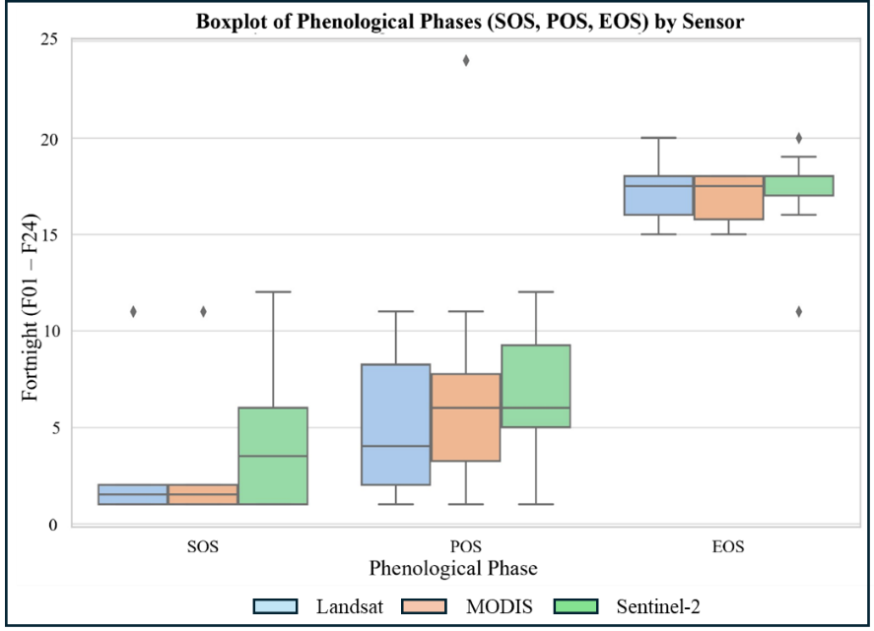
The first objective was to derive accurate phenological metrics from multi-sensor time series and validate their consistency across platforms. The overall workflow and phase timing distributions across sensors are summarized in Figure 3, while cross-sensor consistency of phenological phases is detailed in Figure 4. Vegetation cycles in BWS closely followed the monsoon rhythm, and this synchronization was consistently detected by Sentinel-2, Landsat-8, and MODIS, indicating a strong seasonal control of hydroclimatic forcing on vegetation dynamics.

Figure 3. Mean timing (± SD) of phenological phases i.e., Start of Season (SOS), Peak of Season (POS), and End of Season (EOS), across satellite sensors (Sentinel-2, Landsat and MODIS). The values represent fortnight indices (F01–F24) standardized within a July - June phenological calendar. POS typically occurs between F05 and F08, while EOS shows greater interannual consistency compared to SOS, especially in MODIS. (Refer to supplementary Table S1 for Fortnight to DOY conversion)
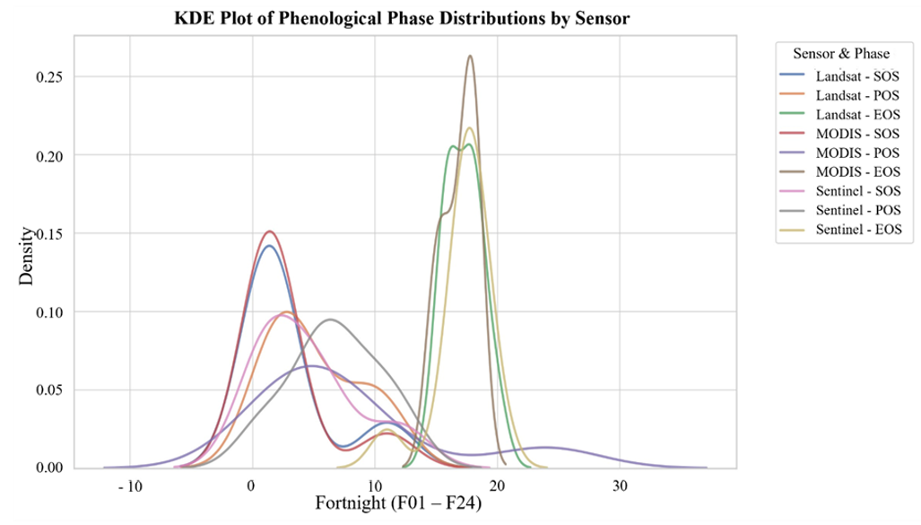

Figure 4. Kernel Density Estimate (KDE) plot showing the distribution of phenological phases across different sensors. The x-axis represents the phenological cycle in fortnightly intervals (F01–F24), while the curves indicate the frequency and centrality of vegetation transition periods for each sensor–phase combination.
The convergence of seasonal phase timing across three independent satellite platforms, combined with agreement between NDVI and EVI indices, provides strong indirect validation of the extracted phenological metrics. In the absence of ground observations, such multi-sensor and multi-index consistency has been widely accepted as a reliable proxy for phenological validation in tropical ecosystems (Zhang et al. 2006; Caparros-Santiago et al. 2021), indicating that the observed seasonal patterns reflect real vegetation responses rather than sensor-specific artifacts.
Both NDVI and EVI showed a clear SOS in June-July (approximately F12–F13; DOY 166–195; see Supplementary Table S1), coinciding with the onset of the southwest monsoon and rapid canopy leaf-out (Singh et al. 2020; Soni and Tripathi, 2024), followed by a POS in August–September (F15–F17; DOY 211–255), when canopy density reached maximum photosynthetic activity. Senescence began in November–December (F21–F23; DOY 301–345), marking the EOS. GSL averaged 130–160 days but varied among years in response to rainfall variability, highlighting the sensitivity of seasonal duration to interannual moisture availability (Zhang et al 2020). Interannual variability in these seasonal metrics highlights year-to-year shifts in SOS, EOS, and cumulative productivity (Figure 5). These transitions align with known eco-physiological behaviour of tropical deciduous forests, where monsoon-driven moisture availability governs both canopy development and senescence timing (Gusain et al. 2026).
The multi-sensor time series revealed distinct interannual shifts. In wetter years such as 2019 and 2022, SOS occurred earlier and EOS extended into late December, lengthening GSL and increasing cumulative productivity, consistent with large-scale observations linking moisture availability to extended growing seasons (Piao et al. 2006), with corresponding differences in amplitude and AUC across years and sensors (Table 1; Figure 5). Conversely, during the drought years of 2020–2021, SOS was delayed by 10–15 days and EOS occurred earlier, compressing the GSL by more than two weeks in many upland and high-elevation sites, demonstrating how water stress constrains both the onset and persistence of canopy activity. These shifts coincide with reported rainfall deficits and weakened monsoon conditions across central India during 2020–2021 (IMD 2021; Singh et al. 2021), linking observed phenological variability to climatic forcing.

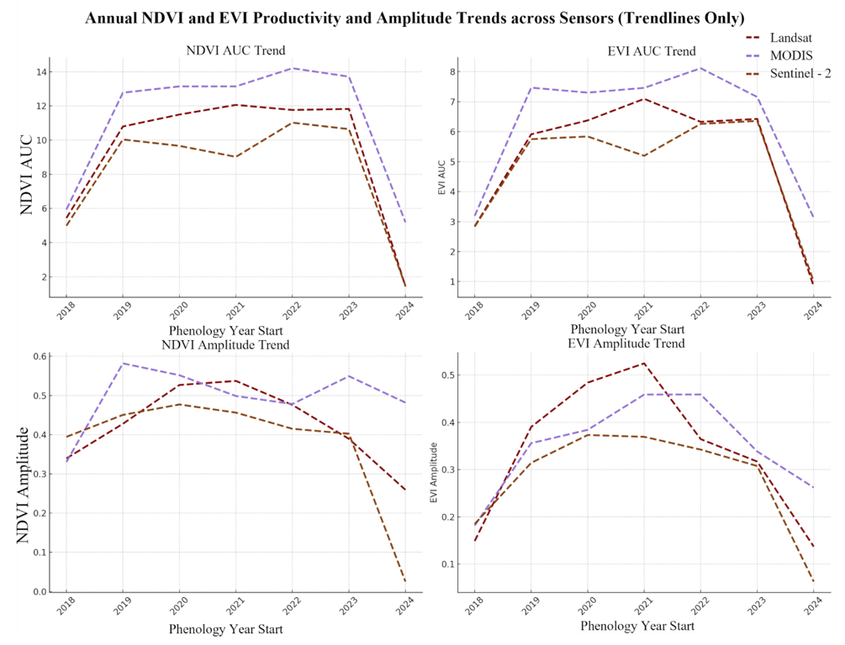
Figure 5. Interannual Trends in cumulative vegetation productivity (NDVI AUC and EVI AUC) and seasonal amplitude for Bori Wildlife Sanctuary across Landsat-8, MODIS, and Sentinel-2 sensors during 2018–2024. Trendlines represent inter-annual variations in productivity and seasonal phenological range across sensors
Sensor |  | Index |  | Max greenup mean |  | SD |  | Max browndown mean |  | SD
Landsat-8 | EVI |  | 0.0520 |  | 0.0219 |  | −0.0467 |  | 0.0195
Landsat-8 |  | NDVI |  | 0.0724 |  | 0.0340 |  | −0.0672 |  | 0.0047
Sentinel-2 |  | EVI |  | 0.0367 |  | 0.0183 |  | −0.0322 |  | 0.0027
Sentinel-2 |  | NDVI |  | 0.0548 |  | 0.0361 |  | −0.0710 |  | 0.0126
MODIS |  | EVI |  | 0.0849 |  | 0.0492 |  | −0.0453 |  | 0.0239
MODIS |  | NDVI |  | 0.1372 |  | 0.0334 |  | −0.0881 |  | 0.0460

Table 1: Phenology dynamics summary
These contractions were accompanied by declines in amplitude and the seasonal integral (AUC), indicating reduced canopy vigour and lower cumulative productivity. In some cases, POS shifted later during drought years, suggesting delayed canopy development under water stress. These findings demonstrate that even short-term climatic anomalies can alter both timing and intensity of vegetative activity, revealing high short-term sensitivity of tropical deciduous forests to rainfall variability, consistent with observations from other systems (White et al. 2009; Huete et al. 1997; Yadav 2024). Given the relatively short study period (2018–2024), these patterns are interpreted as recent or short-term phenological dynamics rather than long-term trends, but they provide high-resolution insight into ecosystem responsiveness to contemporary climatic variability, in line with best practices for limited temporal datasets.
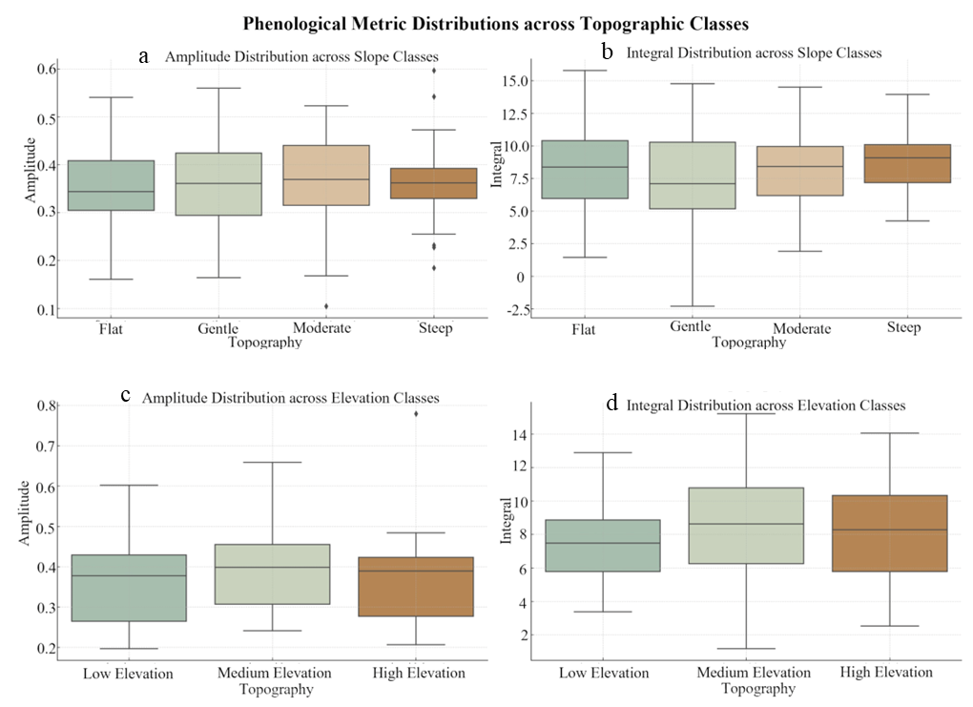
Productivity indicators reinforced these temporal patterns. Amplitude values, which represent seasonal greenness differences, were highest in valley and riparian forests dominated by Shorea robusta, Terminalia arjuna, and Syzygium cumini. These zones maintained dense canopies and high seasonal integrals throughout the wet season, with clear variation across slope and elevation classes (Table 1; Figure 6a–d). Upland and steep-slope forests consistently showed reduced amplitude and AUC, reflecting limited greening capacity, indicating spatial constraints on productivity linked to terrain-controlled moisture availability. This spatial heterogeneity reflects the combined influence of terrain-driven moisture availability and climatic variability, where valleys act as moisture-retaining systems and uplands experience faster soil moisture depletion, establishing a clear interaction between climate and topographic controls (Negron-Juarez et al. 2026). Importantly, both indicators dropped sharply during 2020–2021, confirming the strong imprint of drought stress. Subtle declines were already detectable in 2019–2020, suggesting cumulative impacts of moisture variability and highlighting the sensitivity of these ecosystems to interannual rainfall anomalies, indicating that vegetation responses may integrate both immediate and lagged climatic effects.
Figure 6. Distribution of phenological metrics across topographic classes within Bori Wildlife Sanctuary. Panels (a) and (b) display the distribution of seasonal amplitude and cumulative productivity (integral) across slope classes (flat, gentle, moderate, steep), respectively. Panels (c) and (d) show the corresponding distributions across elevation classes (low, mid, high). Amplitude represents the seasonal range in vegetation indices (NDVI/EVI), while Integral denotes the area under the annual vegetation curve as a proxy for cumulative productivity. The boxplots depict medians (center lines), interquartile ranges (boxes), and 1.5× IQR whiskers; outliers are shown as individual points
Cross-sensor validation confirmed that derived metrics were robust. MODIS, with its coarser resolution, produced smoother seasonal curves that averaged over local fluctuations, while Sentinel-2 and Landsat-8 captured finer-scale variability and sharper breakpoints, albeit with greater sensitivity to noise and data gaps. These differences reflect inherent scale effects in multi-sensor observations, where coarse-resolution data smooth spatial variability while high-resolution sensors resolve localized heterogeneity but are more susceptible to cloud contamination and temporal gaps (Moreno-Martínez et al. 2020), highlighting the importance of interpreting phenological metrics within the context of sensor scale.
Spearman correlations were strongest for Landsat–MODIS pairs: SOS rho = 0.97 (p = 0.005) and GSL rho = 0.97 (p = 0.005), consistent with both sensors using 16-day compositing cycles. Landsat–Sentinel-2 agreement was moderate and non-significant for SOS (rho = 0.55, p = 0.26) and GSL (rho = 0.60, p = 0.21), reflecting Sentinel-2's finer spatial resolution and different cloud-masking behaviour. EOS correlations were weaker across all pairs (Landsat-Sentinel-2 rho = 0.58; Sentinel-2-MODIS rho = −0.22), consistent with the known sensitivity of senescence timing to sensor resolution and compositing interval. Cross-sensor correlations and distributional comparisons (Figure 4), together with statistical summaries (Table 2), indicate that primary phenological phases are consistent across sensors even when secondary metrics vary.

Classes | NDVI AUC Total | EVI AUC Total
Slope
Flat | 2692.02 | 1517.09
Gentle | 910.74 | 514.08
Moderate | 256.20 | 144.81
Steep | 95.60 | 54.15
Elevation
Low | 2077.58 | 1171.74
Mid | 1837.47 | 1036.10
High | 39.51 | 22.28

Table 2: Cumulative Contribution Summary (2018-2024) of terrain classes for NDVI/EVI based vegetation productivity.

Further analysis showed that Landsat-8 occasionally underestimated EOS compared with Sentinel-2, largely due to cloud-related acquisition gaps, while MODIS tended to smooth abrupt transitions. Despite these differences, the core seasonal phases (SOS, POS, and GSL) converged across sensors. Rate comparisons (Table 2) show that NDVI greening rates exceeded EVI values across all sensors, with MODIS NDVI recording the highest mean greenup rate (0.137 VI/day), approximately 2.5 times higher than Sentinel-2 EVI (0.037 VI/day), consistent with the coarser spatial averaging of MODIS over heterogeneous canopies and known differences in index sensitivity.
From a broader perspective, the integration of phenological timing, productivity metrics, and cross-sensor comparisons offers three main insights. First, the tight coupling between vegetation cycles and monsoon rainfall highlights the vulnerability of these forests to climatic variability. Second, the declines in amplitude, AUC, and GSL during drought years demonstrate how productivity is directly constrained by water stress, reducing potential carbon sequestration and ecosystem resilience. Third, the complementary strengths of NDVI and EVI highlight the importance of using both indices in tandem as NDVI captures early canopy fluctuations while EVI provides stability in dense forests. Collectively, these results provide a consistent basis for further examining the role of topography and climatic anomalies in shaping phenological variability in BWS.
4.2. Influence of Eco-Topographic Gradients on Phenology
The second objective was to examine how elevation and slope regulate phenological dynamics in BWS (Table 1, Figure 6), highlighting spatial controls on vegetation response. Flat terrain contributed nearly 70 % of total NDVI-based productivity and gentle slopes another 25 %, confirming the dominance of valley-floor areas (Table 1). Elevation emerged as a strong determinant of seasonal onset and duration. Forests above 800 m consistently showed delayed SOS, lagging nearly two weeks behind valley forests below 400 m, and experienced earlier EOS. As a result, GSL was shortened to 120–130 days in uplands compared with 150–160 days in valleys. At higher elevations, SOS was delayed by roughly 10–15 days (approximately F13–F14; DOY 180–210; see Supplementary Table S1) relative to lowland valleys (F12; DOY 166–180), while EOS advanced earlier in the post-monsoon phase (F21; DOY 301–315), shortening the growing season.
These delays reflect the combined effects of cooler temperatures, shallow soils, and lower water retention that constrain canopy recovery after the dry season, indicating that elevation acts as an integrated control on hydrothermal conditions (Wu et al. 2024). Elevation effects are therefore closely coupled with temperature gradients and orographic influences on rainfall, rather than representing a purely geometric factor. Elevation-linked differences in amplitude and cumulative productivity further show that low-elevation forests have higher median values compared with mid- and high-elevation classes (Figure 6; c–d), suggesting that moisture availability and temperature jointly regulate photosynthetic capacity. Similar elevation-driven phenological stratification has been reported in tropical montane systems (Li et al. 2023).
Slope further influenced productivity through its control on soil depth, runoff, and moisture retention (Mu et al. 2015; Pal and Bhattacharyya, 2015). Very steep slopes (>25°) consistently showed the lowest amplitude and AUC values, reflecting shallow soils and rapid water loss. Variations in amplitude and cumulative productivity across slope classes show lower median values on steeper slopes and higher productivity in flatter terrain (Figure 6: a–b). Valleys sustained the highest greening capacity and cumulative productivity, while moderate slopes (5–25°) showed intermediate values, forming a clear hierarchy from high-productivity valleys to low-productivity steep slopes. Similar slope-linked controls on vegetation resilience have been documented in other monsoon-dependent forest systems (Piao et al. 2019).
Quantitative regressions between terrain composition (% area) and productivity metrics (amplitude and AUC) are presented in Figure 7. Positive relationships for flat and low-elevation fractions indicate that valley-dominated landscapes support higher seasonal amplitude and cumulative productivity, whereas steeper and higher-elevation terrain shows weaker or negative relationships. These trends complement the class-based patterns, confirming that terrain composition exerts a measurable influence on vegetation productivity at the landscape scale (Figure 6). The consistency between regression-based and class-based analyses further supports the robustness of these eco-topographic relationships, indicating that the observed patterns reflect underlying ecological gradients rather than artifacts of classification.
Interactions between elevation and slope revealed clear eco-topographic structuring. Valleys with gentle gradients consistently greened earlier, maintained longer growing seasons, and achieved the highest amplitude and AUC values. In contrast, high-elevation, steep-slope forests showed delayed SOS, shorter GSL, and reduced productivity, while mid-elevation zones displayed intermediate behaviour. These patterns correspond closely to the three phenological regimes identified through clustering (Figure 8), linking terrain gradients with distinct vegetation responses. This stratification aligns with established ecological classifications of central Indian forests (Champion and Seth 1968; Gupta et al. 2024), indicating strong correspondence between phenological patterns and known ecological gradients.
Topography also modulated the effects of climatic stress. During the drought years of 2020–2021, productivity declined across all terrain classes, but reductions were strongest in high-elevation and steep-slope forests. Valleys maintained relatively higher amplitude and AUC values, indicating a buffering effect under moisture stress. The magnitude of these declines across terrain classes is shown in Figure 8 (F14–F21; DOY 196–315). This pattern supports the role of valley and riparian systems as relative refugia during dry conditions, consistent with observations from other tropical regions where forest greenness shows resilience to rainfall variability and soil-water availability (Costa et al. 2022; Singh et al. 2020; 2021), supporting the concept of topographic refugia under climate stress.

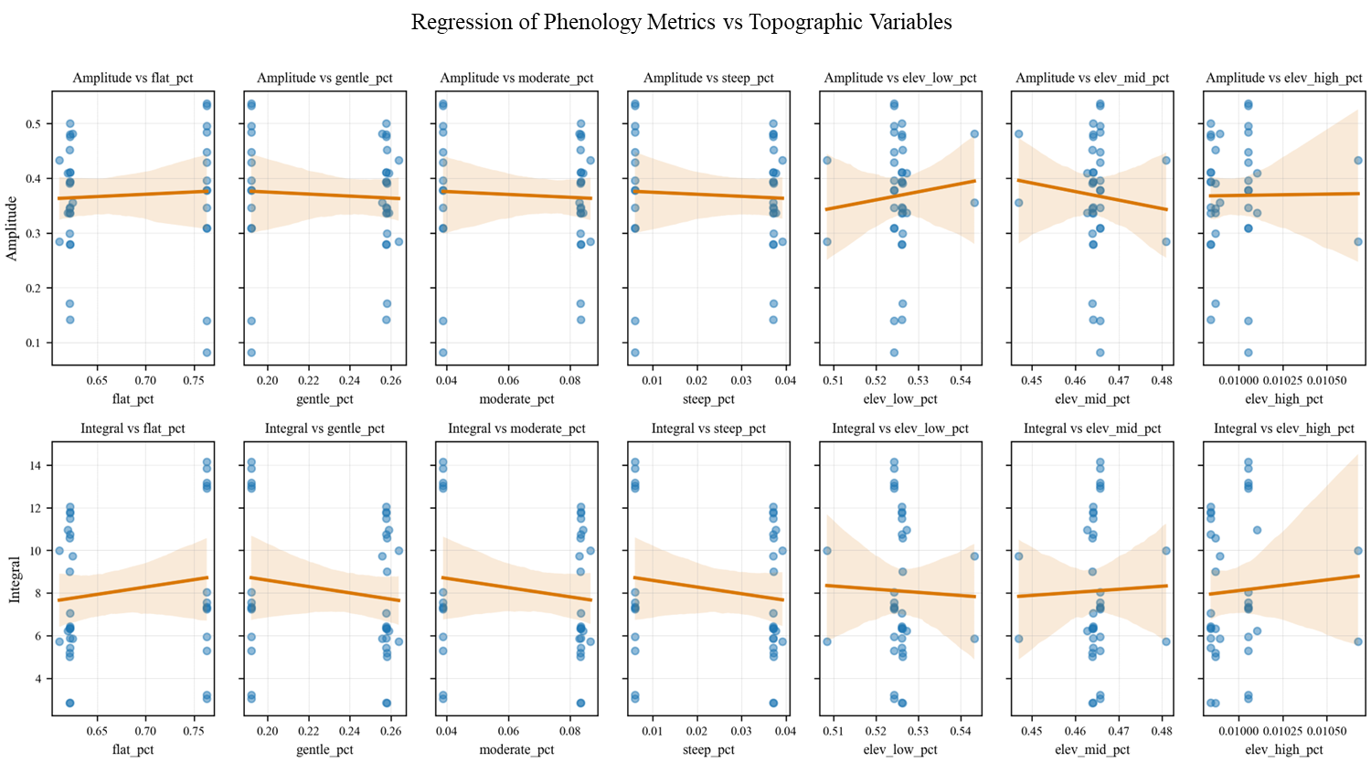
Figure 7. Scatterplots of amplitude and AUC against topographic composition (% area) with regression lines
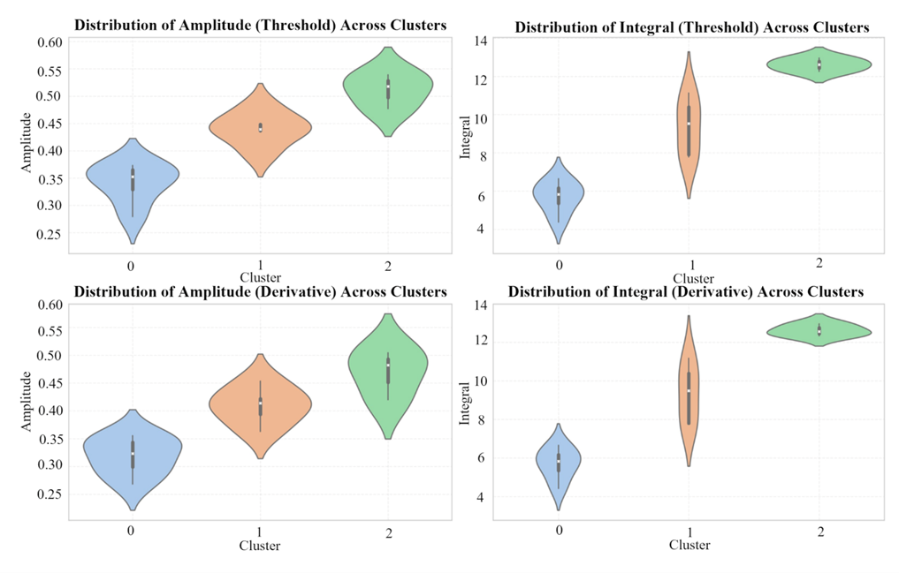
Figure 8. Violin plots of Integral and Derivative based Amplitude and Integral across clusters

Unsupervised clustering further reinforced these patterns by identifying three ecologically distinct regimes (Figure 8). Cluster 0, characterized by low amplitude and AUC, corresponded to high-elevation or steep-slope dry forests, reflecting limited resilience. Cluster 1 represented mid-elevation mixed forests with moderate amplitude and higher variability, sensitive to climatic fluctuations. Cluster 2 encompassed valley and riparian forests, showing early SOS, longer GSL, and consistently high productivity. The spatial distribution and temporal profiles of these clusters align with observed terrain gradients, indicating that phenological metrics capture structured ecological variation across the landscape. The clear separation of clusters in feature space indicates that phenological metrics capture meaningful ecological gradients, supporting the validity of the clustering results, and confirming that vegetation dynamics reflect structured environmental controls rather than random spatial variability.
Overall, the eco-topographic analysis shows that terrain strongly mediates both productivity and sensitivity to climatic variability. Valleys function as zones of higher stability, while high-elevation and steep-slope forests exhibit greater sensitivity. These findings highlight the importance of incorporating topographic context into landscape-level ecological assessment. Given the six-year study period, these patterns represent short-term eco-topographic responses, while still providing insight into current ecosystem sensitivity.

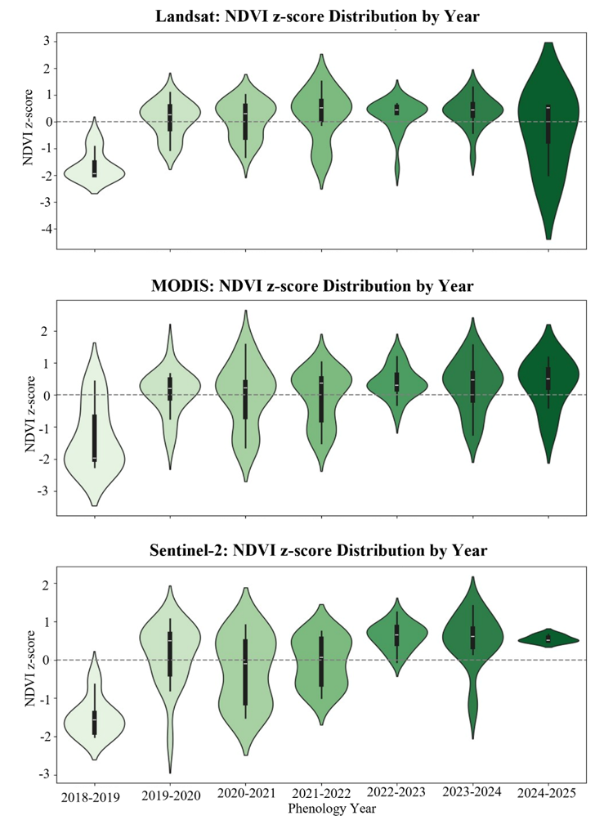

Figure 9. Violin plots of NDVI z-score distributions across phenological years. Wider distributions reflect higher interannual anomaly variability, particularly evident in Landsat and Sentinel-2 observations
4.3. Interannual Variations and Anomalies under Climatic Stress
The third objective was to evaluate how interannual variability and climatic anomalies, particularly droughts, affected vegetation phenology and productivity in BWS. Seasonal NDVI and EVI trajectories revealed consistent monsoon-driven greening and dry-season senescence across most years, but sharp deviations during 2020 and 2021. These deviations correspond to reported periods of below-normal monsoon rainfall and intra-seasonal dry spells across central India (IMD 2021; Singh et al. 2021), providing a clear climatic basis for the observed anomalies.
Seasonal productivity trends varied by sensor. Sentinel-2 NDVI AUC declined from 10.03 (2019–2020) to 9.66 (2020–2021) and 9.02 (2021–2022), a cumulative reduction of about 10% over two years, before recovering to 11.02 in 2022–2023. Landsat and MODIS did not show a comparable decline, instead indicating stable or increasing AUC over the same period. This divergence reflects differences in spatial resolution, where Sentinel-2 (10 m) captures localized canopy stress that is smoothed in coarser-resolution sensors such as MODIS (250 m). These reductions were accompanied by shortened growing seasons and declines in amplitude and AUC, indicating reduced canopy vigour and cumulative productivity. Parallel declines in NDVI and EVI AUC during 2020–2021 (Figure 5) confirm that these patterns are not index-specific artifacts but represent real reductions in vegetation productivity.
Breakpoint analysis using the PELT algorithm identified multiple intra-seasonal disruptions during drought years. In 2020, a major breakpoint in early September coincided with a mid-monsoon dry spell that temporarily reduced greenness. In 2021, late-monsoon moisture deficits triggered premature senescence and reduced productivity. These breakpoints link specific phenological disruptions to intra-seasonal climatic variability. Sentinel-2 captured these short-lived anomalies more effectively than MODIS or Landsat-8, which tend to smooth finer fluctuations due to longer compositing intervals.
Anomaly detection reinforced these patterns (Figure 9; Supplementary Figure 1). Negative anomalies (z ≤ –2) were widespread during 2020–2021, particularly in upland forests, while valleys showed fewer and weaker signals due to their higher water-holding capacity. In contrast, wetter years such as 2019 and 2022 exhibited strong positive anomalies (z ≥ +2), reflecting higher productivity. This spatial contrast indicates that terrain modulates vegetation response to climatic stress, with valleys showing greater resistance. These patterns are consistent with observations from other South Asian forest systems (Soni and Tripathi, 2024; Yadav, 2024).
Topography amplified interannual variability. Cluster-based analysis showed that valley forests (Cluster 2) maintained relatively high productivity during drought years, while high-elevation and steep-slope forests (Cluster 0) showed the largest declines (Figure 8). Mid-elevation forests (Cluster 1) displayed intermediate but highly variable responses. This pattern reinforces the role of valleys as relative refugia and uplands as more vulnerable systems. Cross-index comparisons further showed that NDVI was more responsive to canopy declines in sparse or drought-affected areas, while EVI remained more stable in dense canopies.
The ecological implications of these anomalies are significant. Compressed growing seasons and reduced productivity imply lower carbon uptake, reduced forage availability, and weakened ecosystem services. Continued drought recurrence may drive shifts toward drought-tolerant species (Greenwood et al. 2017), as observed in other tropical forests (Marca‐Zevallos et al. 2022; Zhou et al. 2014). With projections indicating increased drought frequency in South Asia (Seneviratne et al. 2021), these patterns may represent early signals of ecosystem stress. However, given the relatively short temporal coverage (2018–2024), these results should be interpreted as short-term responses rather than long-term structural changes.
From a methodological perspective, the integration of MODIS, Sentinel-2, and Landsat-8 proved critical. MODIS provided temporal continuity, Sentinel-2 resolved short-lived anomalies, and Landsat-8 offered intermediate spatial detail. This multi-sensor framework improves confidence in anomaly detection by reducing individual sensor limitations and capturing vegetation dynamics across scales.
4.4. Integrated Synthesis and Management Implications
The fourth objective was to synthesize results across datasets, indices, and analyses to derive broader ecological and management insights. A temporal overview of interannual phenological dynamics (Figure 5) and the cumulative productivity contributions of terrain classes (Table 2) together show that vegetation phenology in BWS is shaped by the combined influence of monsoon rainfall, eco-topographic gradients, and interannual climatic variability. Seasonal metrics (SOS, POS, EOS, GSL) and productivity indicators (amplitude, AUC) consistently captured monsoon-driven greening, peak growth, and senescence. Cross-sensor comparisons showed strong agreement in SOS, POS, and GSL across Sentinel-2, Landsat-8, and MODIS, while EOS remained more variable due to differences in temporal resolution and late-season noise. This overall consistency indicates that the observed dynamics represent robust ecological signals.
Eco-topographic gradients emerged as critical controls on both timing and productivity. Valleys and riparian forests exhibited earlier green-up, longer growing seasons, and higher cumulative productivity, functioning as refugia during drought years (Figure 6). Upland and steep-slope forests showed delayed green-up, shorter growing seasons, and lower productivity, identifying them as more climate-sensitive zones. These spatial patterns align with cumulative productivity contributions (Table 2). Clustering further resolved these dynamics into three phenological regimes (Figure 8): low-resilience uplands and steep slopes (Cluster 0), transitional mid-elevation forests (Cluster 1), and resilient valley forests (Cluster 2). This classification provides a practical framework for linking phenological patterns with ecologically meaningful management units.
Anomaly and breakpoint analyses added temporal detail to this framework. NDVI anomaly distributions indicate mid- and late-monsoon disruptions during 2020–2021, while z-score anomalies identify both stress years (2020–2021) and highly productive years (2019, 2022) (Figure 8; Supplementary Figure 1). These results show that intra-seasonal variability, not just total seasonal rainfall, strongly influences vegetation responses in monsoon-driven systems. If such anomalies recur, they may reduce carbon sequestration, alter forage availability, and shift species composition toward drought-tolerant taxa. However, given the six-year temporal coverage, these implications should be interpreted as emerging patterns rather than long-term ecosystem shift.
From a management perspective, three priorities emerge. First, valley and riparian forests should be prioritized for conservation as resilience cores that buffer climatic variability and sustain productivity. Second, upland and steep-slope forests require targeted interventions such as soil and water conservation, enrichment planting with drought-tolerant species, and systematic monitoring for early signs of degradation. Third, integrating multi-sensor, multi-index phenological monitoring into routine management can support early-warning systems to detect stress and guide adaptive responses. The increasing availability of near-real-time satellite data and open-access platforms makes such approaches operationally feasible.
The novelty of this study lies in its integrated framework combining multi-sensor datasets, cross-index validation, eco-topographic analysis, and anomaly detection. While earlier studies have addressed these components individually, fewer have synthesized them for tropical deciduous forests in South Asia. By linking phenological metrics with terrain-driven heterogeneity and climatic variability, this study provides a more comprehensive understanding of vegetation dynamics in monsoon-dependent systems. The approach is scalable to other regions with similar climatic regime.
Finally, the study reinforces phenology as both a scientific indicator and a management tool. By generating a spatially explicit and temporally sensitive baseline of vegetation dynamics, it establishes a benchmark for monitoring future climate-driven and land-use changes. This integration of remote sensing into conservation planning supports informed decision-making and strengthens resilience in tropical deciduous forest systems.
5. Limitations and Future Directions
While this study demonstrates the feasibility of multi-sensor phenology monitoring for BWS, several limitations remain. The absence of ground-based observations restricts direct validation of satellite-derived phenological events, and the use of a static forest mask may introduce bias in heterogeneous or regenerating stands. This is partly mitigated by strong agreement across sensors and vegetation indices, which provides indirect support for the derived phenological metrics. From a methodological perspective, GPR smoothing effectively stabilized noisy signals but may have attenuated short-duration intra-seasonal events. This trade-off between noise reduction and signal sensitivity is inherent to time-series smoothing and should be considered when interpreting fine-scale variability. In addition, climatic drivers such as rainfall and temperature were interpreted qualitatively rather than modelled quantitatively, limiting diagnostic precision. As a result, causal links between climate variability and phenological response remain inferential.
Future work should address these gaps by integrating gridded rainfall and temperature anomalies, applying dynamic forest masks to capture canopy change, and incorporating uncertainty propagation to quantify confidence in derived metrics. Developing quantitative climate–phenology models will strengthen causal inference and improve predictive capability. Coupling these approaches with harmonized Landsat–Sentinel time series and machine-learning methods can further enhance monitoring and enable a shift toward near-real-time assessment of vegetation dynamics under climate variability.
6. Conclusions
This study shows that vegetation phenology in BWS is shaped by the combined influence of monsoon rainfall, topography, and interannual climatic variability. Valleys and riparian zones consistently function as ecological refugia, sustaining productivity and buffering drought impacts, whereas high-elevation and steep-slope forests are more sensitive to stress and represent vulnerability hotspots. These patterns reflect strong coupling between hydroclimatic conditions and terrain-mediated ecological responses in monsoon-driven forest systems. On average, the growing season length (GSL) ranged between 120–160 days, with drought years (2020–2021) shortening the cycle by nearly two weeks compared with wetter years.
The identification of three phenological regimes highlights the spatial heterogeneity and resilience patterns of tropical deciduous forests and underscores the role of terrain in mediating ecosystem response. Anomaly analyses show that drought years (2020–2021) reduced amplitude and productivity, while valleys maintained relatively stable conditions, reinforcing their buffering role. Given the relatively short temporal coverage (2018–2024), these results represent recent phenological dynamics rather than long-term trends.
The multi-sensor, multi-index approach enabled detection of both fine-scale variability and broader seasonal patterns, including intra-seasonal anomalies. Consistent results across Sentinel-2, Landsat-8, and MODIS support the reliability of the derived phenological metrics. Overall, this study provides a spatially and temporally explicit baseline of vegetation dynamics and demonstrates the value of phenology for climate-informed forest management. Incorporating topographic context and continuous monitoring can support targeted conservation of resilient zones and adaptive management of vulnerable upland systems. These insights position phenology as a practical tool for decision-making in tropical deciduous forests under increasing climatic variability.
Acknowledgements
The author acknowledges the use of open-access datasets from the European Space Agency (Sentinel-2 MSI), NASA/USGS (Landsat-8 OLI, MODIS MOD13Q1), and the JRC Global Surface Water and SRTM missions, all processed using the Google Earth Engine platform. The contributions of the open-source scientific community, whose tools and libraries facilitated this work, are also sincerely appreciated
Declarations
CRediT author statement
The first author was responsible for conceptualization, methodology, data curation, formal analysis, software implementation, visualization, and contributed to writing – original draft. The second author contributed to conceptualization, investigation, writing – review and editing, supervision, and project administration, including the final revision of the manuscript
Funding
This research did not receive any specific grant from funding agencies in the public, commercial, or non-profit sectors.
Data Availability
All satellite data used are publicly available from NASA, USGS, and ESA repositories. The datasets generated during the current study are available from the corresponding author on reasonable request.
Conflict of Interest
The authors have no relevant financial or non-financial competing interests to disclose.
Clinical trial number

Not applicable
Clinical trial number

Not applicable
Ethical Approval
Not Applicable. The study involved no human participants or animal experiments.
Consent
Authors agreed with the content and gave explicit consent to submit and that they obtained consent from the responsible authorities at the institute/organization where the work has been carried out before the work is submitted.
References
Aasen H, Burkart A, Bolten A, Bareth G (2015) Generating 3D hyperspectral information with lightweight UAV snapshot cameras for vegetation monitoring: From camera calibration to quality assurance. ISPRS J Photogramm Remote Sens 145:92–106. https://doi.org/10.1016/j.isprsjprs.2015.08.002
Banerjee S, Khatri PK, Banerjee SK (2022) Soil and vegetation in Pachmarhi Biosphere Reserve and their correlation. In: Environmental Science and Engineering. Springer, pp 87–105. https://doi.org/10.1007/978-3-031-09270-1_5
Caparros-Santiago JA, Rodriguez-Galiano V, Dash J (2021) Land surface phenology as indicator of global terrestrial ecosystem dynamics: A systematic review. ISPRS J Photogramm Remote Sens 171:330–347. https://doi.org/10.1016/j.isprsjprs.2020.11.019
Champion HG, Seth SK (1968) A revised survey of the forest types of India. Government of India, Delhi
Chen J, Jönsson P, Tamura M, Gu Z, Matsushita B, Eklundh L (2004) A simple method for reconstructing a high-quality NDVI time-series data set based on the Savitzky–Golay filter. Remote Sens Environ 91:332–344. https://doi.org/10.1016/j.rse.2004.03.014
Christian B, Joshi N, Saini M, Mehta N, Goroshi S, Nidamanuri RR et al (2015) Seasonal variations in phenology and productivity of a tropical dry deciduous forest from MODIS and Hyperion. Agric For Meteorol 214–215:91–105. https://doi.org/10.1016/j.agrformet.2015.08.246
Costa FRC, Schietti J, Stark SC, Smith MN (2022) The other side of tropical forest drought: Do shallow water table regions of Amazonia act as large-scale hydrological refugia from drought? New Phytol 237:714–733. https://doi.org/10.1111/nph.17914
Flora – Satpura Tiger Reserve (n.d.) Available at: https://satpuratigerreserve.org/flora (Accessed 5 Apr 2025)
Gong Z, Ge W, Guo J, Liu J (2024) Satellite remote sensing of vegetation phenology: Progress, challenges, and opportunities. ISPRS J Photogramm Remote Sens 217:149–164
Government of Madhya Pradesh, Forest Department (1977) Brief description of existing Bori Sanctuary. Available at: https://forestsclearance.nic.in/writereaddata/Addinfo/0_0_911112391215103BRIEFDESCRIPTIONOFEXISTINGBORISANCTUARY.pdf (Accessed 5 Apr 2025)
Greenwood S, Ruiz-Benito P, Martínez-Vilalta J, Lloret F, Kitzberger T, Allen CD et al (2017) Tree mortality across biomes is promoted by drought intensity, lower wood density and higher specific leaf area. Ecol Lett 20:539–553
Gupta P, Gupta AK, Clemens SC, Cheng H, Majhi B (2024) Coupled ocean-atmospheric forcing on Indian Summer Monsoon variability during the middle Holocene: Insights from the Core Monsoon Zone speleothem record. Palaeogeogr Palaeoclimatol Palaeoecol 647:112273
Gusain K, Gautam K, Bhatt M, Singh H, Singh M, Barthwal S (2026) Climate-driven shifts in tree phenology: Global patterns, trends, and ecological implications. Environ Sci Adv 5:726–752
Hassan T, Gulzar R, Hamid M, Ahmad R, Waza SA, Khuroo AA (2024) Plant phenology shifts under climate warming: A systematic review of recent scientific literature. Environ Monit Assess 196:1. https://doi.org/10.1007/s10661-023-12190-w
Huete AR, Liu HQ, Batchily K, van Leeuwen W (1997) A comparison of vegetation indices over a global set of TM images for EOS-MODIS. Remote Sens Environ 59:440–451. https://doi.org/10.1016/S0034-4257(96)00112-5
Huete A, Didan K, Miura T, Rodriguez E, Gao X, Ferreira L (2002) Overview of the radiometric and biophysical performance of the MODIS vegetation indices. Remote Sens Environ 83:195–213
Hughes L (2000) Biological consequences of global warming: Is the signal already apparent? Trends Ecol Evol 15:56–61
IMD (2021) Annual Report 2021. Ministry of Earth Sciences, Government of India. https://mausam.imd.gov.in/imd_latest/contents/ar2021.pdf
Key Biodiversity Areas (n.d.) Available at: https://www.keybiodiversityareas.org/site/factsheet/18304 (Accessed 10 Jul 2025)
Khan M, Zafar M, Majeed S et al (2025) Nature-based riparian strategies for climate resilience: Ecohydrological insights on biodiversity and food security in the Indus Basin. Ecohydrology 18:e70091. https://doi.org/10.1002/eco.70091
Laurin GV, Cotrina-Sanchez A, Belelli-Marchesini L et al (2024) Comparing ground below-canopy and satellite spectral data for an improved and integrated forest phenology monitoring system. Ecol Indic 158:111328. https://doi.org/10.1016/j.ecolind.2023.111328
Li X, Du H, Zhou G et al (2023) Spatiotemporal patterns of remotely sensed phenology and their response to climate change and topography in subtropical bamboo forests during 2001–2017. GISci Remote Sens 60:1. https://doi.org/10.1080/15481603.2022.2163575
Liu X, Chen Y, Li Z, Li Y, Zhang Q, Zan M (2021) Driving forces of the changes in vegetation phenology in the Qinghai–Tibet Plateau. Remote Sens 13:4952
McNichol BH, Wang R, Hefner A, Helzer C, McMahon SM, Russo SE (2024) Topography-driven microclimate gradients shape forest structure, diversity, and composition in a temperate refugial forest. Plant Environ Interact 5:3
Menzel A, Sparks TH, Estrella N et al (2006) European phenological response to climate change matches the warming pattern. Glob Change Biol 12:1969–1976
Moreno-Martínez Á, Izquierdo-Verdiguier E, Maneta MP et al (2020) Multispectral high resolution sensor fusion for smoothing and gap-filling in the cloud. Remote Sens Environ 247:111901. https://doi.org/10.1016/j.rse.2020.111901
Mu W, Yu F, Li C, Xie Y, Tian J, Liu J, Zhao N (2015) Effects of rainfall intensity and slope gradient on runoff and soil moisture content on different growing stages of spring maize. Water 7:2990–3008. https://doi.org/10.3390/w7062990
Mukherjee AK (1984) Flora of Pachmarhi and Bori Reserves. Botanical Survey of India, Calcutta
Myneni RB, Keeling CD, Tucker CJ, Asrar G, Nemani RR (1997) Increased plant growth in the northern high latitudes from 1981 to 1991. Nature 386:698–702
Nanda A, Suresh HS, Krishnamurthy YL (2014) Phenology of a tropical dry deciduous forest of Bhadra wildlife sanctuary, southern India. Ecol Process 3:1. https://doi.org/10.1186/2192-1709-3-1
Negron-Juarez R, Wright C, Ferreira S et al (2026) Influence of plateau, slope, and valley on soil hydrology during the dry season in a Central Amazon old-growth forest. Vadose Zone J 25:e70095. https://doi.org/10.1002/vzj2.70095
Pal DK, Bhattacharyya T (2015) The soil: A natural resource. In: Soil Science: An Introduction. Springer, New Delhi, pp 1–20
Peng H, Xia H, Chen H, Zhi P, Xu Z (2021) Spatial variation characteristics of vegetation phenology and its influencing factors in the subtropical monsoon climate region of southern China. PLoS One 16:e0250825. https://doi.org/10.1371/journal.pone.0250825
Pettorelli N, Vik JO, Mysterud A, Gaillard JM, Tucker CJ, Stenseth NC (2005) Using the satellite-derived NDVI to assess ecological responses to environmental change. Trends Ecol Evol 20:503–510
Phiri D, Simwanda M, Salekin S et al (2020) Sentinel-2 data for land cover/use mapping: A review. Remote Sens 12:2291. https://doi.org/10.3390/rs12142291
Piao S, Fang J, Zhou L, Ciais P, Zhu B (2006) Variations in satellite-derived phenology in China’s temperate vegetation. Glob Change Biol 12:672–685
Piao S, Liu Q, Chen A et al (2019) Plant phenology and global climate change: Current progresses and challenges. Glob Change Biol 25:1922–1940
Rao RY, Sankaran M, Jathanna D, Andheria A (2025) Assessing ungulate response to conservation-oriented village relocations and their associated management practices in a tiger reserve in central India. Biodivers Conserv. https://doi.org/10.1007/s10531-025-03101-1
Reserve Profile – Satpura Tiger Reserve (n.d.) Available at: https://www.satpuratigerreserve.org/reserve-profile
Roy DP, Wulder MA, Loveland TR et al (2014) Landsat-8: Science and product vision for terrestrial global change research. Remote Sens Environ 145:154–172
RSIS (2024) Ramsar Information Sheet. Available at: https://rsis.ramsar.org/RISapp/files/RISrep/IN2547RIS_2408_en.pdf
Satpura Tiger Reserve (n.d.) Topography and geography. Available at: https://www.satpuratigerreserve.org/topography-and-geography
Seneviratne SI, Zhang X, Adnan M et al (2021) Weather and climate extreme events in a changing climate. In: Climate Change 2021: The Physical Science Basis. Cambridge University Press, pp 1513–1766. https://doi.org/10.1017/9781009157896.013
Sharma S, Dutta T, Maldonado JE et al (2013) Forest corridors maintain historical gene flow in a tiger metapopulation in the highlands of central India. Proc R Soc B 280:20131506. https://doi.org/10.1098/rspb.2013.1506
Singh B, Jeganathan C, Rathore VS (2020) Improved NDVI-based proxy leaf-fall indicator to assess rainfall sensitivity of deciduousness in the central Indian forests through remote sensing. Sci Rep 10:17638. https://doi.org/10.1038/s41598-020-74563-2
Singh B, Jeganathan C, Rathore VS et al (2021) Resilience of the central Indian forest ecosystem to rainfall variability in the context of a changing climate. Remote Sens 13:4474. https://doi.org/10.3390/rs13214474
Singh P, Ghosh SK, Khare S (2023) Phenological analysis of the western Himalayan forest using temporal remote sensing data. ISPRS Arch XLVIII:1553–1559. https://doi.org/10.5194/isprs-archives-xlviii-1-w2-2023-1553-2023
Singh S, Jain V, Goyal MK (2025) Evaluating climate shifts and drought regions in the central Indian river basins. Sci Rep 15:29701. https://doi.org/10.1038/s41598-025-15231-1
Soni AK, Tripathi JN (2024) Temporal trends of dry spells in Indian meteorological subdivisions during Southwest Monsoon 1951–2023. Int J Climatol 45:2
Sunil C, Somashekar R, Nagaraja B (2019) Influence of Terminalia arjuna on the riparian landscapes of the River Cauvery of South India. Landsc Res 44:982–996. https://doi.org/10.1080/01426397.2018.1560400
Tecuapetla-Gómez I, Rosales-Marticorena F, Galicia-Gómez BF (2024) Phenology curve estimation via a mixed model representation of functional principal components. arXiv. https://doi.org/10.48550/arXiv.2402.01234
Topography and Geography – Satpura Tiger Reserve (n.d.) Available at: https://www.satpuratigerreserve.org/topography-and-geography
UNESCO (n.d.) Pachmarhi Biosphere Reserve. Available at: https://www.unesco.org/en/mab/pachmarhi
Visser ME, Holleman LJM, Gienapp P (2006) Shifts in caterpillar biomass phenology due to climate change. Oecologia 147:164–172. https://doi.org/10.1007/s00442-005-0299-6
Weather – Satpura Tiger Reserve (n.d.) Available at: https://www.satpuratigerreserve.org/weather
White MA, De Beurs KM, Didan K et al (2009) Intercomparison, interpretation, and assessment of spring phenology in North America estimated from remote sensing. Glob Change Biol 15:2335–2359
White MA, Thornton PE, Running SW (1997) A continental phenology model for monitoring vegetation responses to interannual climatic variability. Glob Biogeochem Cycles 11:217–234
Wu H, Liu B, Zhu B, Zhen Z, Song K, Ren J (2024) Combining vegetation indices to identify maize phenological information based on the shape model. Agriculture 14:1608
Wu Y, Shao C, Zhang J et al (2024) Elevation-dependent contribution of vegetation greenness response to hydrothermal conditions on the Tibetan Plateau. Remote Sens 16:201. https://doi.org/10.3390/rs16010201
Yadav RK (2024) Impact of the Indo-Pacific warm pool warming on Indian summer monsoon rainfall pattern. Int J Climatol 45:1
Yan K, Gao S, Yan G et al (2025) A global systematic review of remote sensing vegetation indices. Int J Appl Earth Obs Geoinf 139:104560. https://doi.org/10.1016/j.jag.2025.104560
Yu L, Liu Y, Yan F et al (2024) Phenological control of vegetation biophysical feedbacks to the regional climate. Geogr Sustain
Zhang X, Friedl MA, Schaaf CB (2006) Global vegetation phenology from MODIS. J Geophys Res Atmos 111:G4
Zhang X, Friedl MA, Schaaf CB et al (2003) Monitoring vegetation phenology using MODIS. Remote Sens Environ 84:471–475. https://doi.org/10.1016/S0034-4257(02)00135-9
Zhang Y, Parazoo NC, Williams AP, Zhou S, Gentine P (2020) Large and projected strengthening moisture limitation on end-of-season photosynthesis. Proc Natl Acad Sci USA 117:9216–9222. https://doi.org/10.1073/pnas.1914436117
Zhou L, Tian Y, Myneni RB et al (2014) Widespread decline of Congo rainforest greenness in the past decade. Nature 509:86–90. https://doi.org/10.1038/nature13265

