**Strategy for Property purchase**

Gaurav Pudasaini

Data 300: Data Driven Decision Making

Professor Acharya

Westcliff University

December 24, 2024

**Strategy for Property purchase**

Glenn Foreman, the president of the Oceanview Development Corporation, has thought about bidding for a piece of land at the county tax foreclosure sale with a bid offered of $5 million. The property is currently designated for use for single attached residences; however, luxurious condominiums can be developed if there is change of zone measure. A market research survey seems to present a way of increasing the precision of the probability of approval. The decision is made by considering the bid costs, achievable profits and potential loss of deposit.

**1.**

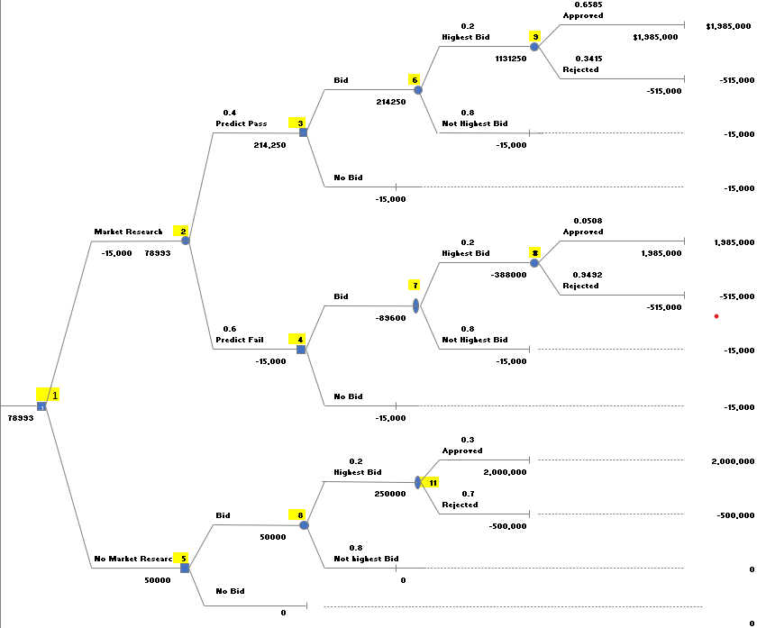

The chart used here is decision tree which will assist Glenn Foreman in making a decision as whether to undertake the market research or go without it. Glenn has two options he can choose to conduct market research, which costs $15,000 upfront, to improve prediction of zoning likelihood of approval or proceed without research. If Glenn conducts market research, he receives two predictions: Predict pass (*p*(*s1*) = 0.41) or rejection (*p*(*s1*) = 0.59), and then submits a bid based on prior probabilities.

**Predict Pass(s1):**

The result is based upon on the zoning approval or rejection, approved (*p*(*A*|*s*1) = 0.6585) or rejected (*p*(*A*|*s*2) = 0.3415). If zoning change approved (*p*(*A*|*s*1), Glenn can build luxury condominiums and earn profit of $1,985,000 (‘Profit’ – ‘Market Research’) and if not approved (*p*(*A*|*s*2) Glenn will forfeit 10% bid deposit of $5,000,000 and Market Research cost (-$515,000).

**Predict Fail(𝑠2):**

The outcome depends on the probability that the zoning is approved p(A|s1) = 0.0508 and if the zoning is rejected then p(A|s2) = 0.9492. If approved, glens earn $1,985,000, but this is very unlikely. If not approved, Glenn forfeits the $500,000 deposit and market research (-$515,000).

**No Market Research:**

Glenn submits the bid based on prior probabilities: P(Approval) = 0.3 and P (Not Approved) = 0.7. If approved, Glenn will build condominiums which has a profit of $2,000, 000 and will not affect the research cost. If not, Glenn loses the $500,000 deposit because the zoning change did not allow.

**2.**

If Oceanview submits a bid without market research, there are two probabilistic outcomes based on probabilities: There is like 20% chance that bid would be accepted and if bid is accepted, there will be a 30% chance that the zoning will have to be changed to allow for the construction of condominiums. If zoning change is not approved then, forfeit the $500k and not complete the purchase of property. As we can see in the Figure:

**Node 11 EV** = $250,000

**Node 8 EV**= $50,000

Each node has positive expected outcomes, implying a reasonable chance of net benefits for Oceanview. EV of Node 11 shows that construction of condos outweighs the risk of losing $500,000, while Node 8 presents the risk-reward ratio taking into account the 20% from bid proposal being likely to be accepted. However, the potential profit of $2 million outweighs the potential loss of the 10% deposit ($500,000).

**3.**

If market research predicts zoning approval, the expected value (EV) of bidding is positive:

**EV (9) = 0.9(1,985,000) + 0.2(-515,000) = $1,683,500**

**EV (6) = 0.21($1,683,500) + 0.8(-15,000) = $324,700** suggesting that bidding is advisable.

If zoning is predicted to fail, the EV becomes negative:

**EV (10) = 0.1(1,985,000) + 0.8(-515,0000) = -$213,000**

**EV (7) = 0.2(-213,000) + 0.8(-15,000) = -$438,000**, indicating bidding is not advisable.  
  
If Zoning measure is to pass, bid is advisable. However, if fail, then not advisable.

**4.**   
The EVSI (Expected Value of Sample Information) is the difference between the market research with expected value ($324,700) and without it ($50,000), which results in $274,700. This represents the additional value that Oceanview would gain from using the market research. Since the total expense required to conduct the survey is $15000, while the total value return looks like $274,700, Oceanview Development Corporation should hire the market research firm.

**Conclusion**

The above decision tree also shows that, conducting market research gives a higher EMV. If Glenn goes ahead and decide to conducts market research and predicts zoning approval, he is more likely to proceed with the bid and potentially earn $1,985,000. If he skips market research, he relies on prior probabilities, he can have as lower EMV of $50,000. The decision chart presents the overall decision matrix of all possible outcomes, likelihood, cost and revenue so to assist. Glenn maximizes on his profit while minimizing on risks.