Extract data used from website https://www.worldometers.info/coronavirus/ to create Tableau worksheets and dashboards for better understanding of the Covid situation across the world as on 28th of May, 2020.

1). Heat map
This heat map shows the covid 19 spread across the world country-wise. Filtration can be done based on count of cases and/or count of deaths.
The size of the individual countries are based on the number of cases in the countries while the death count is represented by the color intensity.
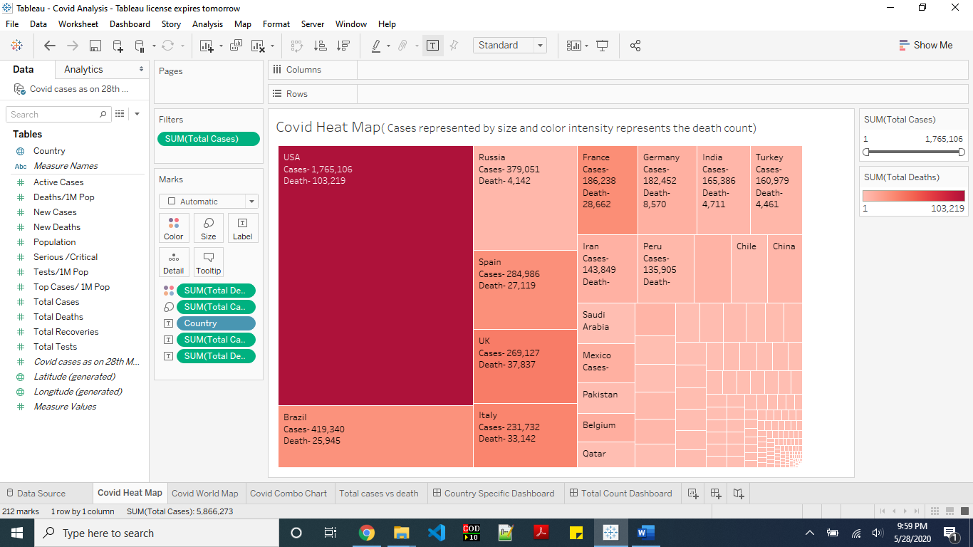
2). World map dashboard
This dashboard is an interactive dashboard wherein we have the circles representing the Covid infection in various countries. The larger the circle the larger are the number of cases of infection in these countries while the color intensity of the circles represent the number of deaths till now in these countries.
The world map is used as a filter tool as well here. Suppose we want to check the cases in the south america, we can do so by selecting that particular region while the worksheet at the bottom filters those specific countries and give such country specific bar graphs showing the required counts.
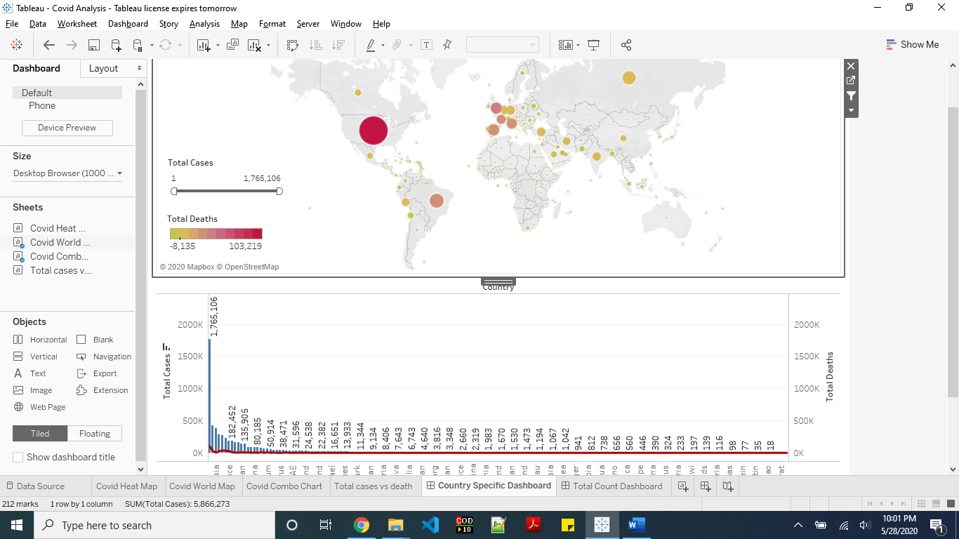
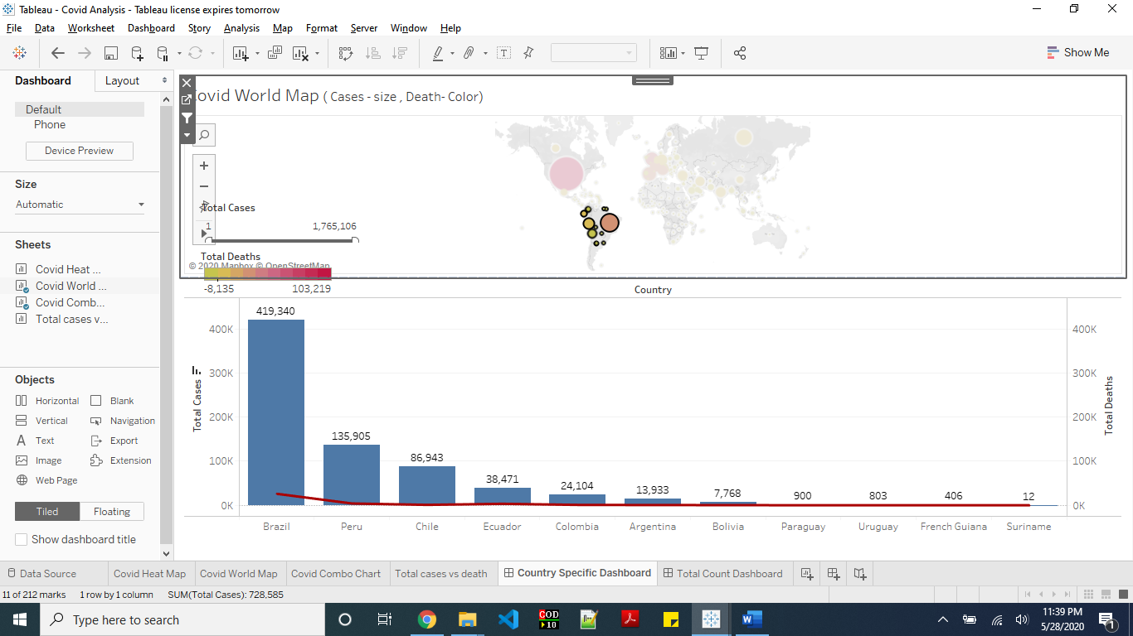

3). Total count world map dashboard
While the above dashboard shows the country wise break ups as an interactive dashboard, we may need a summation of cases from the selection.
This dashboard has the world map same as above dashboard while the bottom worksheet shows the summation of cases rather than the individual country counts.
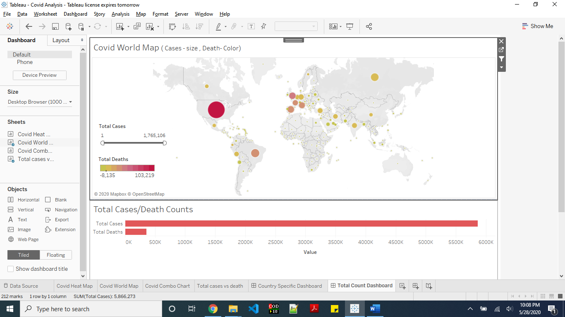
4). Combined Dashboard
Below is a combined dashboard with all three worksheet views. We are using the map as filter and other two worksheets are the target.
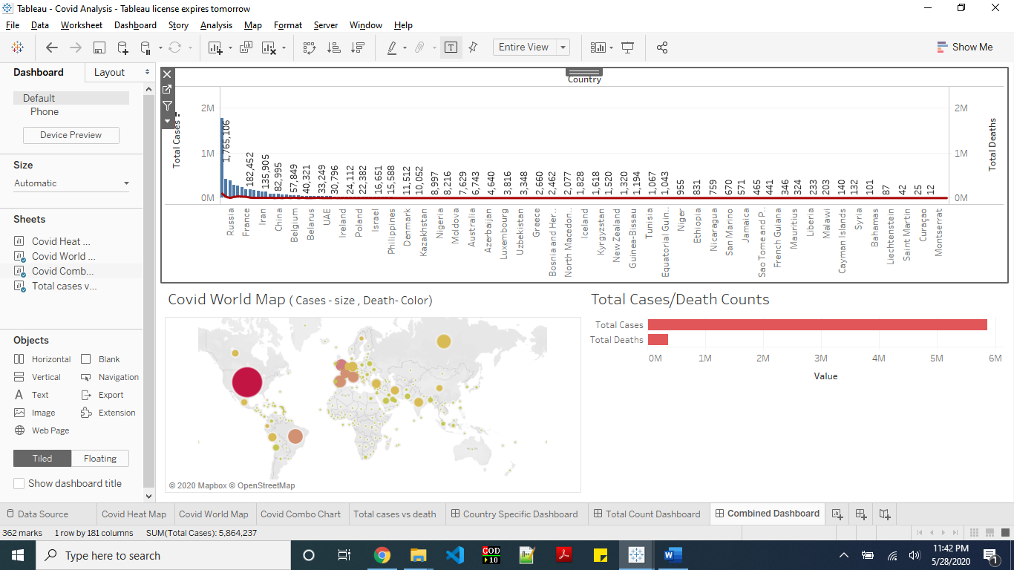
We can filter any country of group of country to get the desired view specific to those countries. Below is example of selection of Africa continent.
