**ANSIBLE SAMPLE TESTS**

***Command line input:***   
python AnsibleProgram.py args.json  
  
***Tests***:   
  
**1.** To successfully run the program by providing all the module parameters to it from json file.   
  
***Input json parameters***:   
{

"ANSIBLE_MODULE_ARGS": {

"name":"Ansible DownloadZip,Extract and Copy module",

"url":"https://raw.githubusercontent.com/GauravPurohit/AnsibleTestRepo/master/ansible.zip",

"message":"<Optional message goes here>",

"success":""

}

}  
  
***Output***:

{"name": "Ansible DownloadZip,Extract and Copy module", "success": "Download,Extract,Copy completed.", "url": "https://raw.githubusercontent.com/GauravPurohit/AnsibleTestRepo/master/ansible.zip", "changed": false, "msg": "Exports complete!", "invocation": {"module_args": {"url": "https://raw.githubusercontent.com/GauravPurohit/AnsibleTestRepo/master/ansible.zip", "message": "<Optional message goes here>", "name": "Ansible DownloadZip,Extract and Copy module", "success": ""}}, "message": "<Optional message goes here>"}  
  
***Snapshot***:   
   
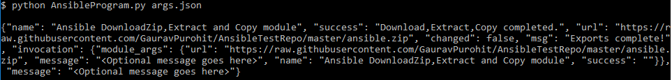

**2.** To ensure that program runs successfully after changing the download URL argument from my GitHub repo to my Google Drive repo (highlighted in red):  
  
***Input json parameters***:  
{

"ANSIBLE_MODULE_ARGS": {

"name":"Ansible DownloadZip,Extract and Copy module",

"url":"https://drive.google.com/uc?export=download&id=0B326NJlpA7W7VEZNQnNrUHhDYms",

"message":"<Optional message goes here>",

"success":""

}

}  
  
***Output***:

{"name": "Ansible DownloadZip,Extract and Copy module", "success": "Download,Extract,Copy completed.", "url": "https://drive.google.com/uc?export=download&id=0B326NJlpA7W7VEZNQnNrUHhDYms", "changed": false, "msg": "Exports complete!", "invocation": {"module_args": {"url": "https://drive.google.com/uc?export=download&id=0B326NJlpA7W7VEZNQnNrUHhDYms", "message": "<Optional message goes here>", "name": "Ansible DownloadZip,Extract and Copy module", "success": ""}}, "message": "<Optional message goes here>"}  
  
***Snapshot:***   
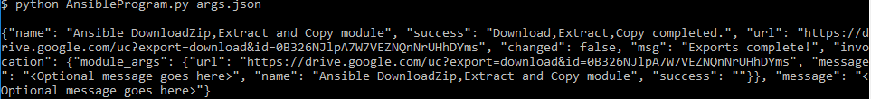

**3.** To successfully run the program in absence of non-required arguments (‘message’ & ‘success’) for the module.  
  
***Input json parameters***:  
{

"ANSIBLE_MODULE_ARGS": {

"name":"Ansible DownloadZip,Extract and Copy module",

"url":"https://raw.githubusercontent.com/GauravPurohit/AnsibleTestRepo/master/ansible.zip"

}

}  
  
***Output***:

{"name": "Ansible DownloadZip,Extract and Copy module", "success": "Download,Extract,Copy completed.", "url": "https://raw.githubusercontent.com/GauravPurohit/AnsibleTestRepo/master/ansible.zip", "changed": false, "msg": "Exports complete!", "invocation": {"module_args": {"url": "https://raw.githubusercontent.com/GauravPurohit/AnsibleTestRepo/master/ansible.zip", "message": null, "name": "Ansible DownloadZip,Extract and Copy module", "success": "Initiating tests!"}}, "message": null}  
  
***Snapshot:***   
  
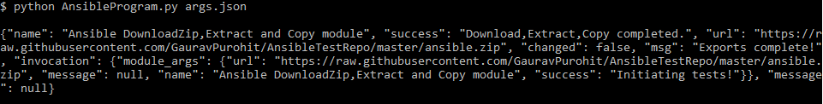

**4.** To intentionally fail the program by passing incorrect download URL location (incorrect file name ‘ansible1.zip highlighted in red) to the ‘url’ parameter.  
  
***Input json parameters***:  
{

"ANSIBLE_MODULE_ARGS": {

"name":"Ansible DownloadZip,Extract and Copy module",

"url":"https://raw.githubusercontent.com/GauravPurohit/AnsibleTestRepo/master/***ansible1***.zip",

"message":"<Optional message goes here>",

"success":""

}

}  
  
***Output***:

{"msg": "Error message:404: Not Found\n", "failed": true, "invocation": {"module_args": {"url": "https://raw.githubusercontent.com/GauravPurohit/AnsibleTestRepo/master/ansible1.zip", "message": "<Optional message goes here>", "name": "Ansible DownloadZip,Extract and Copy module", "success": ""}}}

{"name": "Ansible DownloadZip,Extract and Copy module", "success": "File Download failed!", "url": "https://raw.githubusercontent.com/GauravPurohit/AnsibleTestRepo/master/ansible1.zip", "failed": true, "invocation": {"module_args": {"url": "https://raw.githubusercontent.com/GauravPurohit/AnsibleTestRepo/master/ansible1.zip", "message": "<Optional message goes here>", "name": "Ansible DownloadZip,Extract and Copy module", "success": ""}}, "msg": "Error making a webrequest to the specified URL!", "message": "<Optional message goes here>"}  
  
***Snapshot:***  
  
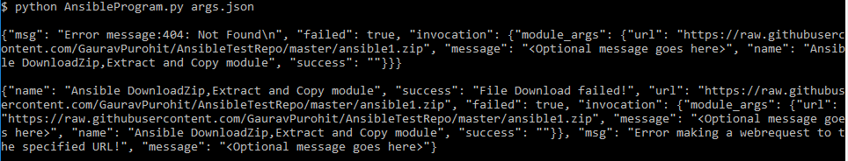

**5.** To intentionally fail the program by not passing required arguments for the Ansible module (viz. name and/or url).

***Input json parameters***:  
{

"ANSIBLE_MODULE_ARGS": {

"message":"<Optional message goes here>",

"success":""

}

}  
  
***Output***:

{"msg": "missing required arguments: url,name", "failed": true, "invocation": {"module_args": {"message": "<Optional message goes here>", "success": ""}}}

***Snapshot:***  
  
