# In a survey people are asked if they smoke or not

# Data: Yes, No, No, Yes, Yes

x = c("Yes", "No", "No", "Yes", "Yes")  
x

## [1] "Yes" "No" "No" "Yes" "Yes"

# summarizing the data using the command table()

table(x)

## x  
## No Yes   
## 2 3

factor(x)

## [1] Yes No No Yes Yes  
## Levels: No Yes

##### Bar_Charts

# a group of 25 people are surveyed as to their coffee-drinking preference. The categories were (1) Latte,

# (2) Cappuccino , (3) Espresso and (4) cold brew

coffee = c(3, 4, 1, 1, 3, 4, 3, 3, 1, 3, 2, 1, 2, 1, 2, 3, 2, 3, 1, 1, 1, 1, 4, 3, 1)

barplot(coffee)

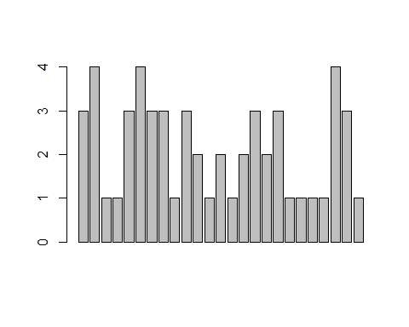

# barplot with summarized data for individual variables  
barplot(table(coffee))

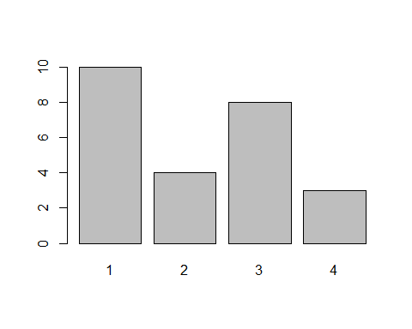

barplot(table(coffee)/length(coffee)) # divided by n for proportion

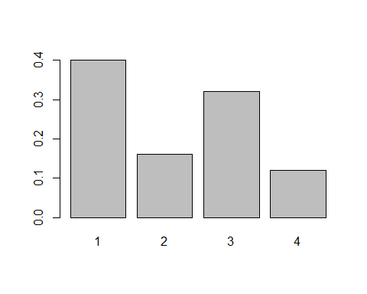

# Arthritis is the dataset that contains only numerical and categorical data

#install.packages("vcd")  
library(vcd)

## Warning: package 'vcd' was built under R version 4.4.1

## Loading required package: grid

Arthritis

## ID Treatment Sex Age Improved  
## 1 57 Treated Male 27 Some  
## 2 46 Treated Male 29 None  
## 3 77 Treated Male 30 None  
## 4 17 Treated Male 32 Marked  
## 5 36 Treated Male 46 Marked  
## 6 23 Treated Male 58 Marked  
## 7 75 Treated Male 59 None  
## 8 39 Treated Male 59 Marked  
## 9 33 Treated Male 63 None  
## 10 55 Treated Male 63 None  
## 11 30 Treated Male 64 None  
## 12 5 Treated Male 64 Some  
## 13 63 Treated Male 69 None  
## 14 83 Treated Male 70 Marked  
## 15 66 Treated Female 23 None  
## 16 40 Treated Female 32 None  
## 17 6 Treated Female 37 Some  
## 18 7 Treated Female 41 None  
## 19 72 Treated Female 41 Marked  
## 20 37 Treated Female 48 None  
## 21 82 Treated Female 48 Marked  
## 22 53 Treated Female 55 Marked  
## 23 79 Treated Female 55 Marked  
## 24 26 Treated Female 56 Marked  
## 25 28 Treated Female 57 Marked  
## 26 60 Treated Female 57 Marked  
## 27 22 Treated Female 57 Marked  
## 28 27 Treated Female 58 None  
## 29 2 Treated Female 59 Marked  
## 30 59 Treated Female 59 Marked  
## 31 62 Treated Female 60 Marked  
## 32 84 Treated Female 61 Marked  
## 33 64 Treated Female 62 Some  
## 34 34 Treated Female 62 Marked  
## 35 58 Treated Female 66 Marked  
## 36 13 Treated Female 67 Marked  
## 37 61 Treated Female 68 Some  
## 38 65 Treated Female 68 Marked  
## 39 11 Treated Female 69 None  
## 40 56 Treated Female 69 Some  
## 41 43 Treated Female 70 Some  
## 42 9 Placebo Male 37 None  
## 43 14 Placebo Male 44 None  
## 44 73 Placebo Male 50 None  
## 45 74 Placebo Male 51 None  
## 46 25 Placebo Male 52 None  
## 47 18 Placebo Male 53 None  
## 48 21 Placebo Male 59 None  
## 49 52 Placebo Male 59 None  
## 50 45 Placebo Male 62 None  
## 51 41 Placebo Male 62 None  
## 52 8 Placebo Male 63 Marked  
## 53 80 Placebo Female 23 None  
## 54 12 Placebo Female 30 None  
## 55 29 Placebo Female 30 None  
## 56 50 Placebo Female 31 Some  
## 57 38 Placebo Female 32 None  
## 58 35 Placebo Female 33 Marked  
## 59 51 Placebo Female 37 None  
## 60 54 Placebo Female 44 None  
## 61 76 Placebo Female 45 None  
## 62 16 Placebo Female 46 None  
## 63 69 Placebo Female 48 None  
## 64 31 Placebo Female 49 None  
## 65 20 Placebo Female 51 None  
## 66 68 Placebo Female 53 None  
## 67 81 Placebo Female 54 None  
## 68 4 Placebo Female 54 None  
## 69 78 Placebo Female 54 Marked  
## 70 70 Placebo Female 55 Marked  
## 71 49 Placebo Female 57 None  
## 72 10 Placebo Female 57 Some  
## 73 47 Placebo Female 58 Some  
## 74 44 Placebo Female 59 Some  
## 75 24 Placebo Female 59 Marked  
## 76 48 Placebo Female 61 None  
## 77 19 Placebo Female 63 Some  
## 78 3 Placebo Female 64 None  
## 79 67 Placebo Female 65 Marked  
## 80 32 Placebo Female 66 None  
## 81 42 Placebo Female 66 None  
## 82 15 Placebo Female 66 Some  
## 83 71 Placebo Female 68 Some  
## 84 1 Placebo Female 74 Marked

head(Arthritis)

## ID Treatment Sex Age Improved  
## 1 57 Treated Male 27 Some  
## 2 46 Treated Male 29 None  
## 3 77 Treated Male 30 None  
## 4 17 Treated Male 32 Marked  
## 5 36 Treated Male 46 Marked  
## 6 23 Treated Male 58 Marked

counts = table(Arthritis$Improved)  
counts

##   
## None Some Marked   
## 42 14 28

#### Bar Plots

barplot(counts,   
 main = "Simple Bar Plot",  
 xlab = "Improvement", ylab = "Improvement" )

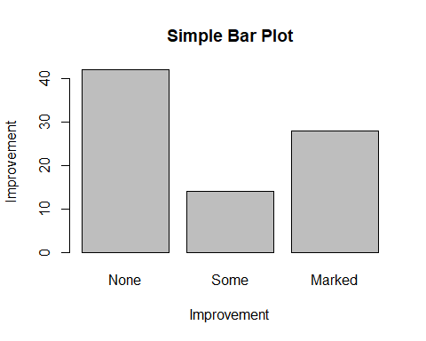

barplot(counts,   
 main = "Simple Bar Plot",  
 xlab = "Improvement", ylab = "Improvement",  
 horiz = TRUE)

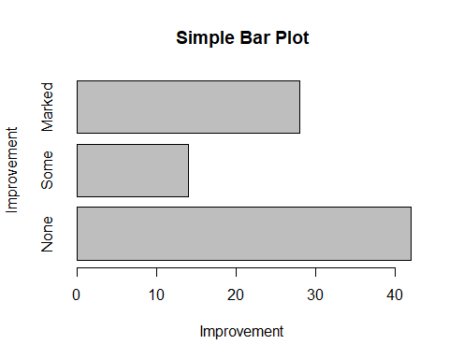

### Pie Charts

# storing the table result  
coffee.counts = table(coffee)  
pie(coffee.counts)

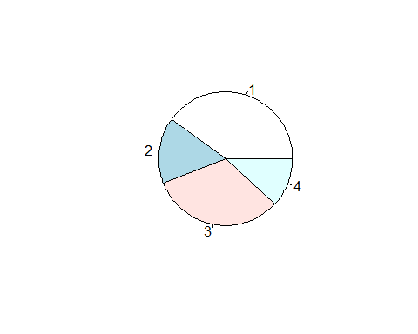

names(coffee.counts) = c("Latte","Cappuccino","Espresso","cold\n brew")  
pie(coffee.counts, col = c("purple", "green", "cyan", "white"))

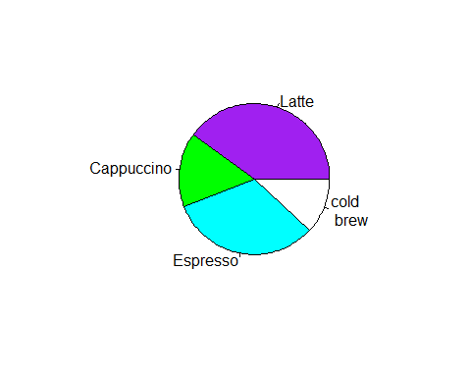

# mtcars

mtcars

## mpg cyl disp hp drat wt qsec vs am gear carb  
## Mazda RX4 21.0 6 160.0 110 3.90 2.620 16.46 0 1 4 4  
## Mazda RX4 Wag 21.0 6 160.0 110 3.90 2.875 17.02 0 1 4 4  
## Datsun 710 22.8 4 108.0 93 3.85 2.320 18.61 1 1 4 1  
## Hornet 4 Drive 21.4 6 258.0 110 3.08 3.215 19.44 1 0 3 1  
## Hornet Sportabout 18.7 8 360.0 175 3.15 3.440 17.02 0 0 3 2  
## Valiant 18.1 6 225.0 105 2.76 3.460 20.22 1 0 3 1  
## Duster 360 14.3 8 360.0 245 3.21 3.570 15.84 0 0 3 4  
## Merc 240D 24.4 4 146.7 62 3.69 3.190 20.00 1 0 4 2  
## Merc 230 22.8 4 140.8 95 3.92 3.150 22.90 1 0 4 2  
## Merc 280 19.2 6 167.6 123 3.92 3.440 18.30 1 0 4 4  
## Merc 280C 17.8 6 167.6 123 3.92 3.440 18.90 1 0 4 4  
## Merc 450SE 16.4 8 275.8 180 3.07 4.070 17.40 0 0 3 3  
## Merc 450SL 17.3 8 275.8 180 3.07 3.730 17.60 0 0 3 3  
## Merc 450SLC 15.2 8 275.8 180 3.07 3.780 18.00 0 0 3 3  
## Cadillac Fleetwood 10.4 8 472.0 205 2.93 5.250 17.98 0 0 3 4  
## Lincoln Continental 10.4 8 460.0 215 3.00 5.424 17.82 0 0 3 4  
## Chrysler Imperial 14.7 8 440.0 230 3.23 5.345 17.42 0 0 3 4  
## Fiat 128 32.4 4 78.7 66 4.08 2.200 19.47 1 1 4 1  
## Honda Civic 30.4 4 75.7 52 4.93 1.615 18.52 1 1 4 2  
## Toyota Corolla 33.9 4 71.1 65 4.22 1.835 19.90 1 1 4 1  
## Toyota Corona 21.5 4 120.1 97 3.70 2.465 20.01 1 0 3 1  
## Dodge Challenger 15.5 8 318.0 150 2.76 3.520 16.87 0 0 3 2  
## AMC Javelin 15.2 8 304.0 150 3.15 3.435 17.30 0 0 3 2  
## Camaro Z28 13.3 8 350.0 245 3.73 3.840 15.41 0 0 3 4  
## Pontiac Firebird 19.2 8 400.0 175 3.08 3.845 17.05 0 0 3 2  
## Fiat X1-9 27.3 4 79.0 66 4.08 1.935 18.90 1 1 4 1  
## Porsche 914-2 26.0 4 120.3 91 4.43 2.140 16.70 0 1 5 2  
## Lotus Europa 30.4 4 95.1 113 3.77 1.513 16.90 1 1 5 2  
## Ford Pantera L 15.8 8 351.0 264 4.22 3.170 14.50 0 1 5 4  
## Ferrari Dino 19.7 6 145.0 175 3.62 2.770 15.50 0 1 5 6  
## Maserati Bora 15.0 8 301.0 335 3.54 3.570 14.60 0 1 5 8  
## Volvo 142E 21.4 4 121.0 109 4.11 2.780 18.60 1 1 4 2

head(mtcars)

## mpg cyl disp hp drat wt qsec vs am gear carb  
## Mazda RX4 21.0 6 160 110 3.90 2.620 16.46 0 1 4 4  
## Mazda RX4 Wag 21.0 6 160 110 3.90 2.875 17.02 0 1 4 4  
## Datsun 710 22.8 4 108 93 3.85 2.320 18.61 1 1 4 1  
## Hornet 4 Drive 21.4 6 258 110 3.08 3.215 19.44 1 0 3 1  
## Hornet Sportabout 18.7 8 360 175 3.15 3.440 17.02 0 0 3 2  
## Valiant 18.1 6 225 105 2.76 3.460 20.22 1 0 3 1

?mtcars

## starting httpd help server ... done

### Histogram

par(mfrow=c(2,2))  
hist(mtcars$mpg)   
hist(mtcars$mpg, breaks=12, col="red", xlab="Miles Per Gallon", main="Colored histogram with 12 bins")  
hist(mtcars$mpg, freq=FALSE,breaks=12,col="red",xlab="Miles Per Gallon",main="Histogram, rug plot, density curve")  
rug(jitter(mtcars$mpg))  
lines(density(mtcars$mpg), col="blue", lwd=2)

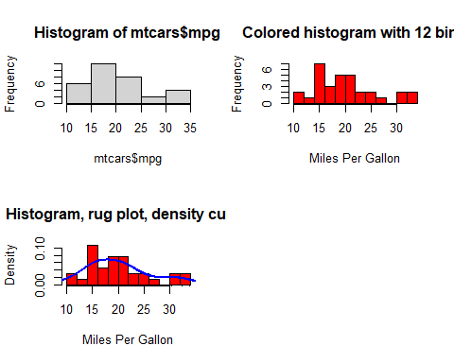

kernel density plot

par(mfrow=c(2,1))  
d <- density(mtcars$mpg)   
plot(d)   
plot(d, main="Kernel Density of Miles Per Gallon")   
polygon(d, col="red", border="blue")

