# Setting up the programming environment

* Install Python
* Get OpenAI API key
* Install Langchain package
* Install ChromaDB
* Install Langchain OpenAI package

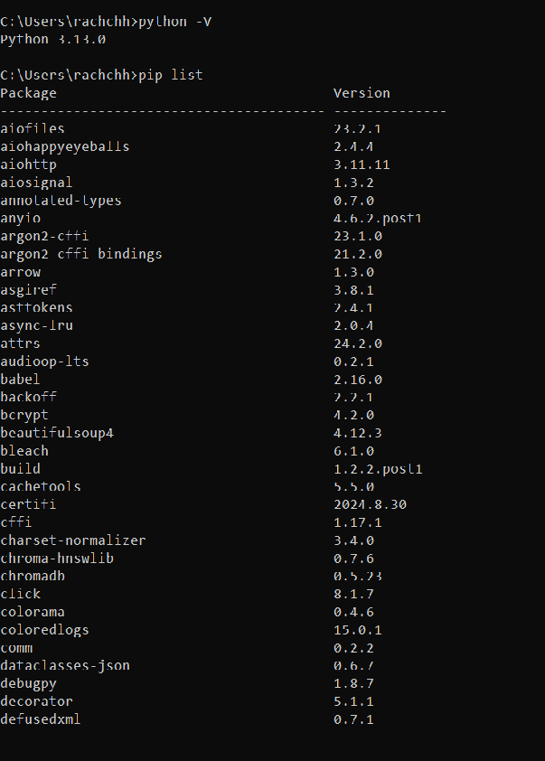

# Processing text documents

* Download and store nestle_hr_policy.pdf PDF file on local storage.
* Process and load PDF file using pyPDFLoader
* Join text from all pages

# Creating text vector representations

* Split the file using recursive text splitter.
* Convert the text into vectors using OpenAI embedding,
* Persist the vector data into Chroma DB

# Building a question-answering system

* Build the QA system using langchain RetrievalQAChain and Open AI chat model
* Develop UI using Gradio

# Prompts

Prompt 1:

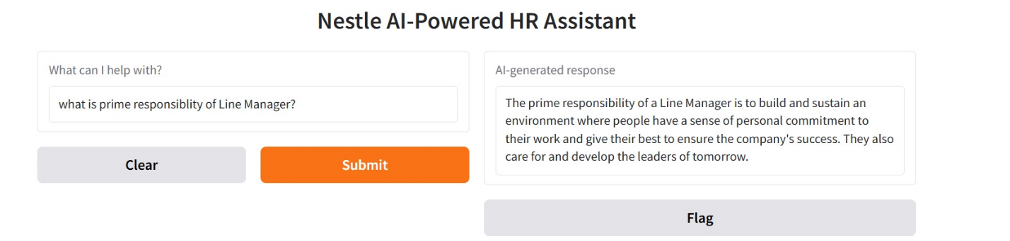

Prompt 2:

