|  |  |
| --- | --- |
| **Run number – 29–HER2/neu test** | **Module - IHC EQAS** |
| **Date of run dispatch – 15thFebruary 2025** | **Date of run closure – 21st April 2025** |
| **Date run reports uploaded – 15th May 2025** | **Center Number: 01**  **Center Name: Tata Medical Centre, Kolkata** |

**Immunohistochemistry module - Her2neu Run 29**

HER2 targeted therapy has been the poster child of success in breast cancer treatment. The standard adjuvant treatment for ERBB2 (HER2 or HER2) positive breast cancer includes chemotherapy and 1 year of trastuzumab, that targets the ERBB2 receptor. Presently in clinically high-risk, early-stage HER2-positive disease with trastuzumab and pertuzumab and chemotherapy combination in the neoadjuvant setting, and if residual disease is found post neoadjuvant therapy, administration of adjuvant TDM1 treatment for 1 year is advocated. Hence impact of an inaccurate HER2 biomarker result is far reaching.

The identification of low HER2 in breast cancer is a new development in the field of HER2 testing. This is defined by immunohistochemistry as incomplete membrane staining that is faint/barely perceptible and in >10% of tumor cells (IHC 1+) or as equivocal (IHC 2+) cases that are non-amplified by FISH. Patients with HER2-low metastatic breast cancer treated with the HER2-targeted drug trastuzumab deruxtecan (Enhertu) lived 6 months longer than standard treatment. The drug is a conjugate of a cytotoxic drug with trastuzumab. It just needs HER2 levels above normal to enter the tumor cell and release the cytotoxic drug within it. Thus, a new era distinguishing between score 0 and score 1+ Her2is important however the protocol advocated for low HER2 is a locked protocol possible only on Ventana ultra / benchmark platforms. Our personal stand has been that when we tested parallel samples with low HER2 and traditional protocol in low HER2 protocol a small percentage of Score 3+ cases was labeled as equivocal (score 2+) and hence we have to wait for more mature pre-analytical data on low HER2 for Indian continent.

The American Society of Clinical Oncology (ASCO)/College of American Pathologists (CAP) has updated that a laboratory should have at least two tests for HER2 assessment in the laboratory, for instance, both immunohistochemistry (IHC) and FISH or two validated antibodies for IHC testing to clarify any ambiguous result. Home brew assays should be stringently validated before use in clinical practice. Increasing reports of tumor heterogeneity are reported and generous testing or re-testing on excision specimens is recommended to translate benefit of a positive report to patients.

**Table 1: Interpretation guidelines for HER2 IHC for breast cancer**

|  |  |
| --- | --- |
| **Score** | **Staining pattern** |
| **IHC 0(negative)** | **No reactivity or membrane staining <10% of invasive tumor cells** |
| **IHC 1+(negative)** | **Faint/barely perceptible INCOMPLETE membrane staining in**  **>10% of tumour cells** |
| **IHC 2+(equivocal)** | **Weak-to-moderate COMPLETE membrane staining in >10% of invasive tumour cells** |
| **IHC 3+(positive)** | **Strong COMPLETE membrane staining in >10% of invasive tumour cells** |

# Details of Her2neu IHC – Run 29

The circulated Tissue Microarray (TMA) comprised of 12 cores containing 10 invasive breast carcinoma samples with one blank and one lymph node core as a negative control. The cores covered a spectrum of results for Her2neu. We are now moving to an era of low Her2Neu expression and the biggest challenge was in selecting score 1+ result (core 5/11). It is essential to understand that Low positive HER2 (score 1+) definition is only applicable to the Ventana ultra or Benchmark XT platform locked protocol as a companion diagnostic for Enhertu. Nevertheless, we used this opportunity to understand practices for low HER2 across the EQAS centers and hence a Google form to understand the same was sent to centers.

An ideal score was generated for each of the cores within the TMA through a sum of several methods. Besides using FISH as a gold standard, these TMA sections were stained using FDA approved antibodies (PATHWAY by Ventana, Clone 4B5 run on Ventana Benchmark Ultra Autostainer and manual Hercep test by DAKO). Fluorescence In-Situ Hybridization (FISH) for Her2neu was done on this TMA using the ZytoLight SPEC ERBB2/CEN 17 Dual color probe. Final immunohistochemistry results were matched with the FISH results.

Sections from the above TMA were couriered to the participants for staining using their protocols. The participants entered their interpretation of the core staining in the Run report as **“Participant score**”. The stained TMA was couriered back by participants to the NCGEQAS after uploading the results.

Two expert breast pathologists from NCGEQAS then saw the TMA and prepared an “**EQAS result**” for every core in the slide after discussing discordant results. Most concordant result was the ideal score. The HER2 TMA had 12 tissue cores and 10 cores to be counted. For each core three results were available as given below viz: - Ideal score, Participant score and NCEQAS score.

Results were interpreted as:-

* **“Concordant”** when all the three results viz: - Ideal score, Participant score and EQA score were same.
* “**Discordant**” when the Participant score did not match with either the Ideal/ EQA score, and these values are highlighted in yellow.
* “**Concordant-I”** indicates an interpretative error by the center but EQA score interpretation was concordant with Ideal score.

The percentage accuracy for test or **Test Pass Rate** was the concordance of the EQA score for a given core with the Ideal score.

The percentage concordance between the EQA score and the Participant score was the **Interpretation Pass rate**. Test pass rate is more important and Interpretation pass rates can be used to improve reporting practices within the center. The definition of Her2 low include the immunohistochemistry score 1+ cases and the equivocal (Score 2+) cases that are not amplified using ISH techniques. We have also evaluated the concordance for score 1+ HER2 in this run to understand overall pattern though many laboratories have not used the Ventana platform (and hence low positive label cannot be used). The score 1+ concordance is only for making participants aware of this definition and lowered score 1+ rates are not a benchmark for lower performance. So participants who have reported score 1+ ad score 0 were given concordant result.

Table 2 gives Her2 Run 29 results for center.

**Table 2: -Results for HER2neu RUN 29 for Center 01**

|  |  |  |  |  |  |
| --- | --- | --- | --- | --- | --- |
| **Core** | **FISH** | **Ideal score** | **Participant score** | **EQAS Score** | **Final** |
|  | **-** | **Lymph Node** | **Lymph Node** | **Lymph Node** | - |
|  | **A\*\*** | **Positive**  **(Score 3+)** | **Positive**  **(Score 3+)** | **Positive**  **(Score 3+)** | Concordant |
|  | **NA\*** | **Equivocal (Score 2+)** | **Equivocal (Score 2+)** | **Equivocal (Score 2+)** | Concordant |
|  | **NA\*** | **Negative (Score 0)** | **Negative (Score 0)** | **Negative (Score 0)** | Concordant |
|  | **NA\*** | **Negative (Score 1+)** | **Negative (Score 0)** | **Negative (Score 0)** | Concordant |
|  | **-** | **Blank** | **Blank** | **Blank** | - |
|  | **NA\*** | **Equivocal (Score 2+)** | **Equivocal (Score 2+)** | **Equivocal (Score 2+)** | Concordant |
|  | **A\*\*** | **Positive**  **(Score 3+)** | **Positive**  **(Score 3+)** | **Positive**  **(Score 3+)** | Concordant |
|  | **NA\*** | **Negative (Score 0)** | **Negative (Score 0)** | **Negative (Score 0)** | Concordant |
|  | **NA\*** | **Equivocal (Score 2+)** | **Equivocal (Score 2+)** | **Equivocal (Score 2+)** | Concordant |
|  | **NA\*** | **Negative (Score 1+)** | **Negative (Score 0)** | **Negative (Score 0)** | Concordant |
|  | **A\*\*** | **Positive**  **(Score 3+)** | **Positive**  **(Score 3+)** | **Positive**  **(Score 3+)** | Concordant |

**\*NA- Non Amplified A**- Amplified**

**Technical comments:**

1. On slide positive control provided.

2. Staining is satisfactory.

|  |  |
| --- | --- |
| **Test pass rate** | **Interpretation pass rate** |
| **10/10 Results concordant** | **10/10 Results concordant** |
| **Pass rate- 100%** | **Pass rate- 100%** |

**HER2neu Run 29 Report**

We thank all the participants for completing NCG EQAS Run 29- Her2neu test. The unstained TMA sections for this run were sent to 215 centers of which 199centers completed the testing procedure. For each center, the run report carried three values, a) ***Final Pass rates*** for staining and result based on the stained slide submitted scored by pathologists on EQAS panel, b) ***Pass rate for interpretation*** whereby concordance between interpretation by expert panel and pathologist & c) ***Concordance for score 1+ staining.***

The median pass rate of centers for this run was 100% and mean was 92.6% hence grading of test result for this run is as follows

|  |  |
| --- | --- |
| Grade | Pass rate percentage |
| Excellent | 100% |
| Good | 70 to 90% |
| Average | < 60% |

A graph depicting both the test pass rate and Interpretation pass rate for each center is shown in Fig 1. Of the 199 laboratories that participated, 74 (37.4%) laboratories had a 100% pass rate, 107 (53.8%) centers had 70 to 90% and 18 (9.1%) centers had ≤60% pass rate. For the interpretation, 105 centers (52.8%) had a 100% concordance with ideal score, 92 centers (46.5%) had concordance rates between 80 to 90% concordance rate while only 2 (1.0%) centers had <80% interpretation concordance rate. Interpretation of immunohistochemistry largely depends upon understanding the inherent staining for a given antibody in a given laboratory, as staining pattern varies across institutes. At the EQAS we use controls submitted as benchmarks to report final scores (See fig 4). Centers are encouraged to provide a composite control which includes Score 3+, Score 2+, Score 1+ and a negative control as this helps the EQA experts understand the inherent staining pattern in a given laboratory. Of the 199 centers 34 (17.1%) provided composite controls, 133 (66.8%) centers sent separate positive and negative controls, 20 (10.1%) centers used only positive controls, while 12 (6%) centers did not provide controls. Special care by NCGEQAS team was taken for distinguishing score 1+ from score 0. Score 1+ is defined as >10% incomplete staining and <10% complete staining. The ultra-low staining <10% incomplete staining was clubbed with score 0.

**Performances of each core in TMA:**

The reporting was more complex this time because we separated score 0 and score 1+ in keeping with the trend but a center that marked score 1+ as negative was still given a concordant result.

Fig 2 gives a summary of the pass rates across the cores within the TMA. As seen from this figure concordance of >90% was seen for core 2, core 8, core 12, core 4 and core 9 which were frank negative and positive cores. For the Positive cores, 80.9% (161 centers) reported core 2 accurately while 99.0% (197 centers) reported the core 8 accurately and 97.5% (194 centers) reported the core 12 accurately. For the equivocal cores, 82% (163 centers) reported core 3 accurately while 75.4% (150 centers) reported core 7 and 51.3% (102 centers) reported core 10 as equivocal. Concordance for score 1+ staining was poor. Core 5 was reported as score 1+ by only 12.1% (24 centers) and core 11 was even worse with only 6% (12 centers) reporting this as score 1+. Core 4 which was a negative core 10 centers gave an equivocal result and one called it positive (score 3+) (Fig 3 & Fig 4). Of these 7 had performed manual staining with less common antibodies which showed cytoplasmic blush and four had used automated platform with different antibodies. Similar pattern was seen with the frankly negative core 9 where 9 centers gave equivocal (score 2+) result. One center showed dense cytoplasmic staining and uninterpretable outcome.

**Staining Protocols used in Run 29 Her2neu**

In the present HER2 Run 29, 87 centers (43.7%) used manual protocol and 112 (56.3%) used an automated staining platform. All automated based HER2 immunohistochemistry gave better results when compared to manual staining. A 100% pass rate was seen in 63.5% centers using automated platforms Vs 36.5% centers using manual platforms. Of the 199 centers, 72 centers (36.2%) used Ventana 4B5 HER2 antibody on Ventana machine, 43 (21.6%) centers used Manual method using Path in situ HER2 EP3 antibody, 17centers used manual/ automated staining with DAKO antibody, 8 centers used DBS antibody manually, 9 centers used the Biogenex antibody on automated or manual platform, 4 centers used master diagnostica antibody manually or on automated method, 9 used Path in situ EP3 on automated platform, 19 centers used manual platform with others antibodies and 18 centers used automated platforms with range of antibodies.

**Fig 2: Concordance rates in different cores**

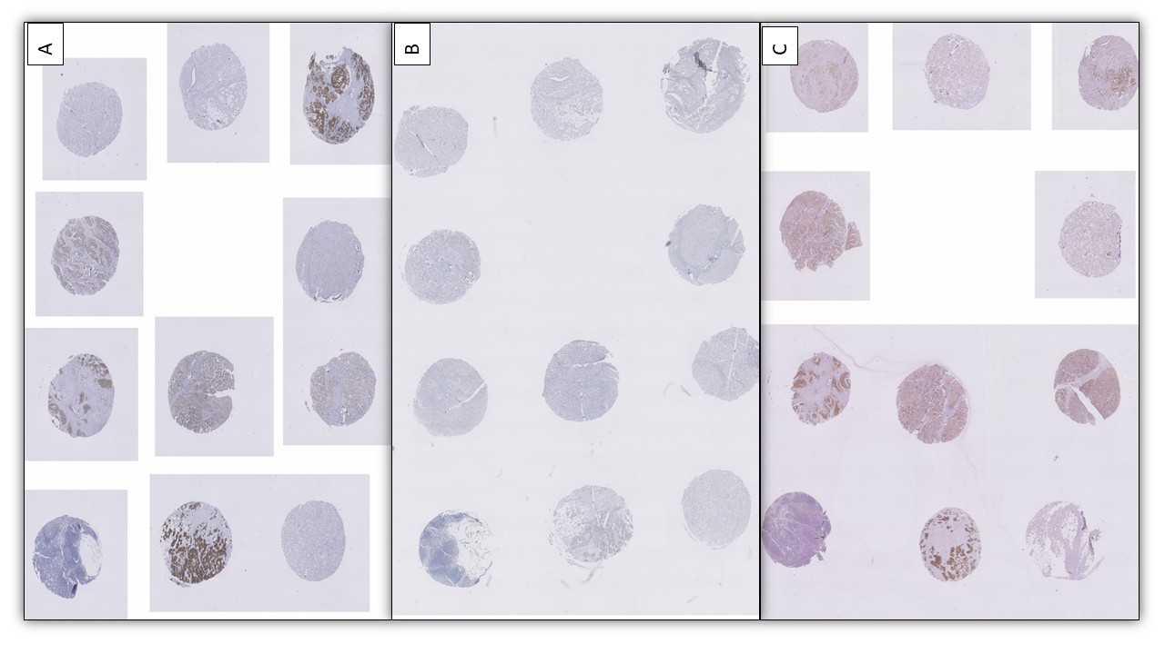

**Fig 3**

1. Ideal stained TMA from one participant
2. Participant with failed run where no cores stained
3. Participant with overstained cores giving false positive (Polyclonal DAKO antibody on manual platform)

Fig 5 gives antibodies and their test performance rates. As seen due to licensing issues, numerous non IVD antibodies have been used by participants and this is not recommended for a predictive marker like HER2. Use of IVD is recommended for testing a predictive marker like HER2 as they give results that are more consistent. It is observed that most new launches supply research use antibodies and are not able to maintain consistency. So while they may be pocket friendly in the long run they reduce test performances. Failure of FDA approved antibody to meet a benchmark of excellence reveals that even the best methods may fail for several reasons. One chief cause of this variation is conductivity of water, which may cause failed runs. Conductivity of water for Ventana machine should be <1muS/cm and type II water is preferred for immuno-strainers. Use of charged slides is essential in Ventana platforms to ensure test accuracy. There are a whole lot of vendors that supply charged slides and in our experience all do not give optimal results.

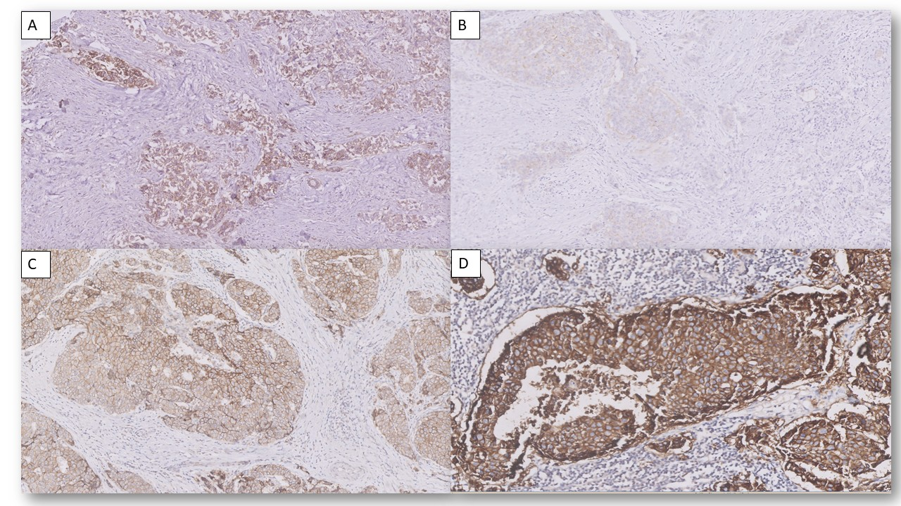

Fig 4: A) Core 4 which was negative, was labeled as equivocal by one participant B) Core 2 which was positive reported as score 1+ by a center C) core 3 was called as score 3+ but on comparison with D) which was the positive control EQAS team labeled as equivocal, thus in house controls helps us to evaluate TMA slide better

Some issues observed in staining reaction in the run were

1. Core 2, core 8 and core 12 were expected to be positive score 3+ but seven centers got the negative staining using manual method. The antibodies used were EP3 clone of master Diagnostica (n=1), Diagnostic biosystem (n=1), Biogenex (n=1) and path in situ (n=4) antibody. Less retrieval time and manual platforms result in underreporting of positive staining and interpretation issues.
2. The cores expected to give negative result (core 4 and core 9) showed stronger staining and an equivocal pattern in ten participant TMA. Again these were manual staining with following antibodies: -SP3 clone of Diagnostic Biosystem (n=2), master Diagnostica (n=3), Dianova (n=1) antibody, Dako antibody with polyclonal clone (n=1), IHC042-1 clone of Genome (n=2) and Bio-SB (n=1) antibody. Because of the long incubation time these antibodies resulted in overstraining and cytoplasmic blush pattern. Drying out of sections on racks or air bubbles can also contribute to over staining. Water and reagent contamination are also additional causes, so participants should check for them.

***Centers please note that differentiating score 0 and score 1+ is just an exercise done by NCGEQAS in keeping with the demand but does not connote poor performance if the score 1+ cores are marked as negative.***

**Performances across seven Cycles of Her2neu EQAS:-** As the NCGEQAS has been operating for five years now we have given the median pass rates across the seven cycles of NCGEQAS. As seen from Fig 6 the pass rate has remained same at 90% over past runs inspite of having new participants, which is encouraging.

**Fig 6: Pass rates across NCEGEQAS Her2neu cycles.**

**Recommended Protocols:**

|  |  |  |  |  |
| --- | --- | --- | --- | --- |
|  | Ventana 4B5 | Hercep Test | Manual Path in situ EP3 | Manual Dako Cerb-B2 |
| **Antigen Retrieval** | For 30 minutes on board | Epitope retrieval solution 40mins in water bath at 98°C | Tris EDTA pH – 9 in pressure cooker (two whistles) | Tris EDTA  pH –9 in pressure cooker (two whistles) |
| **Primary Antibody Incubation** | 16 minutes at 37°C | For 70mins at Room temperature | For 1 hour at 37°C | For 1 hour at 37°C |
| **Dilution** | Ready to use | Ready to Use | Ready to use | 1:1000 |

**Selected References: -**

1. Pernas S, Tolaney SM. Clinical trial data and emerging strategies: HER2-positive breast cancer. Breast Cancer Res Treat. 2022 Jun;193(2):281-291.
2. Pusztai L, Foldi J, Dhawan A, DiGiovanna MP, Mamounas EP. Changing frameworks in treatment sequencing of triple-negative and HER2-positive, early-stage breast cancers. Lancet Oncol. 2019 Jul;20(7):e390-e396.
3. Wolff AC, Hammond ME, Hicks DG*et al.* American Society of Clinical Oncology; College of American Pathologists. Recommendations for human epidermal growth factor receptor 2 testing in breast cancer: American Society of Clinical Oncology/College of American Pathologists clinical practice guideline update. J ClinOncol. 2013; 31:3997-4013.
4. Wolff AC, Hammond ME, Allison KH;; et al Human Epidermal Growth Factor Receptor 2 Testing in Breast Cancer: American Society of Clinical Oncology/College of American Pathologists Clinical Practice Guideline Focused Update. Journal of Clinical Oncology 2018, 36, 2105-2122.
5. Yaziji H, Gown AM. Accuracy and precision in HER2/neu testing in breast cancer: are we there yet? [Hum Pathol.](http://www.ncbi.nlm.nih.gov/pubmed?term=Human+Pathology%5BJour%5D+AND+143%5Bpage%5D+AND+2004%5Bpdat%5D&cmd=detailssearch)2004;35:143-6.
6. Tarantino P, Hamilton E, Tolaney S et al , HER2-Low Breast Cancer: Pathological and Clinical Landscape. Journal of Clinical Oncology 2020 38:17, 1951-1962
7. Ellis C. HER2 amplification status in breast cancer: a comparison between immunohistochemical staining and fluorescence in situ hybridization using manual and automated quantitative image analysis scoring techniques. Journal of Clinical Pathology. 2005;58(7):710-714.

**Thank You all for your participation!**

**+++++++++++++++++++++++++++++++++++++++++++++++++++++++++++++++++**