**ADABOOST MODEL STATS**

1. Resource Stats:

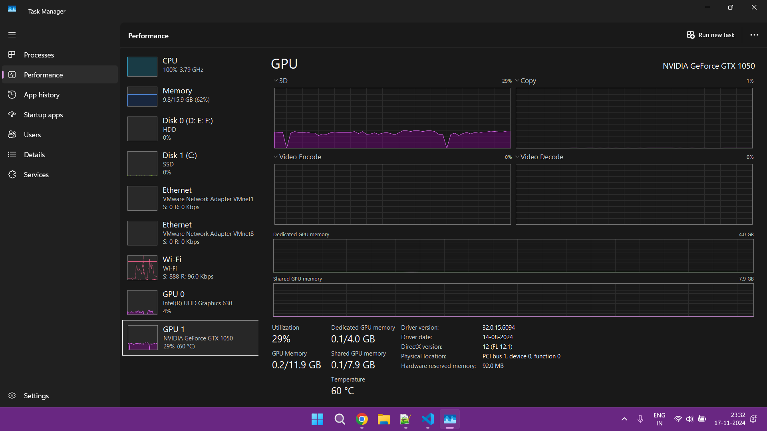

1. Output Resource Stats:

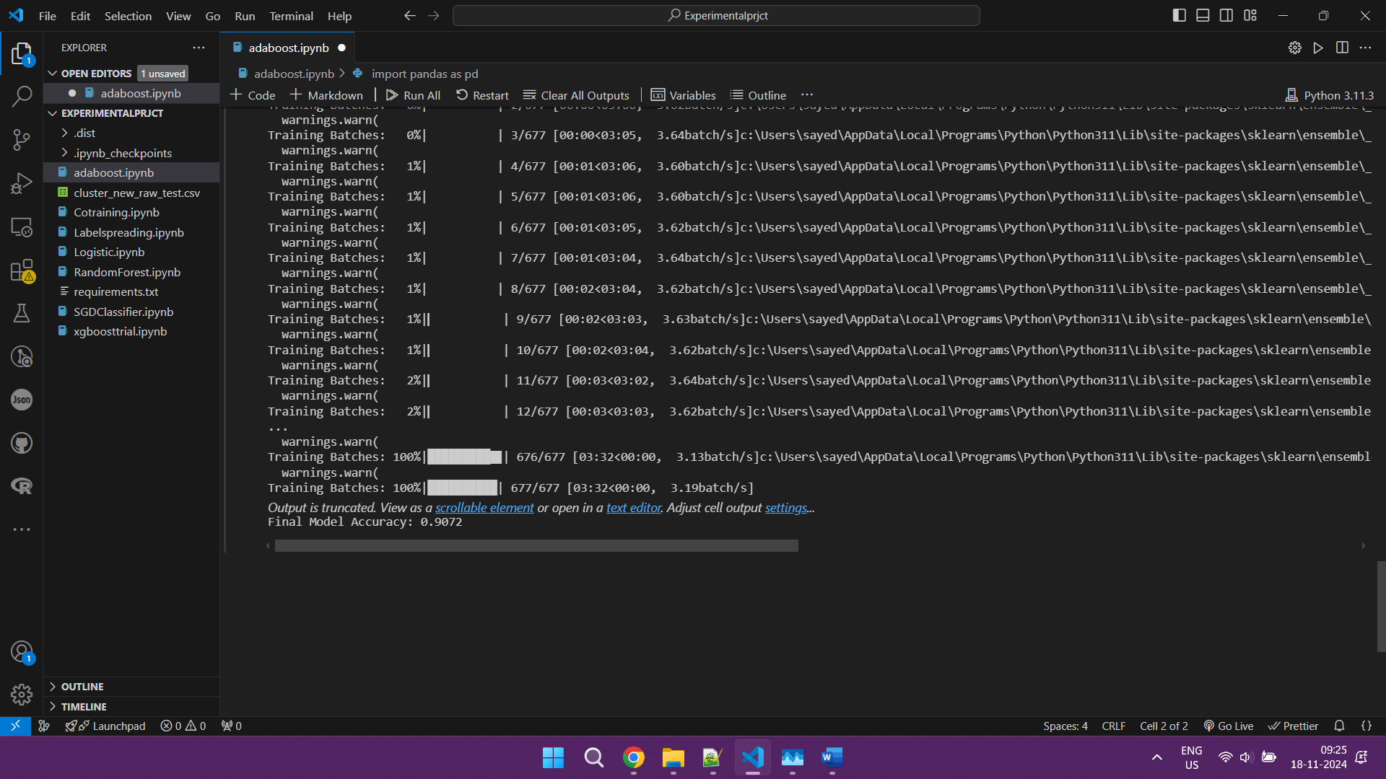

Training Batches: 100%|██████████| 677/677 [03:32<00:00, 3.19batch/s]

Final Model Accuracy: 0.9072