1. Resource Utilization

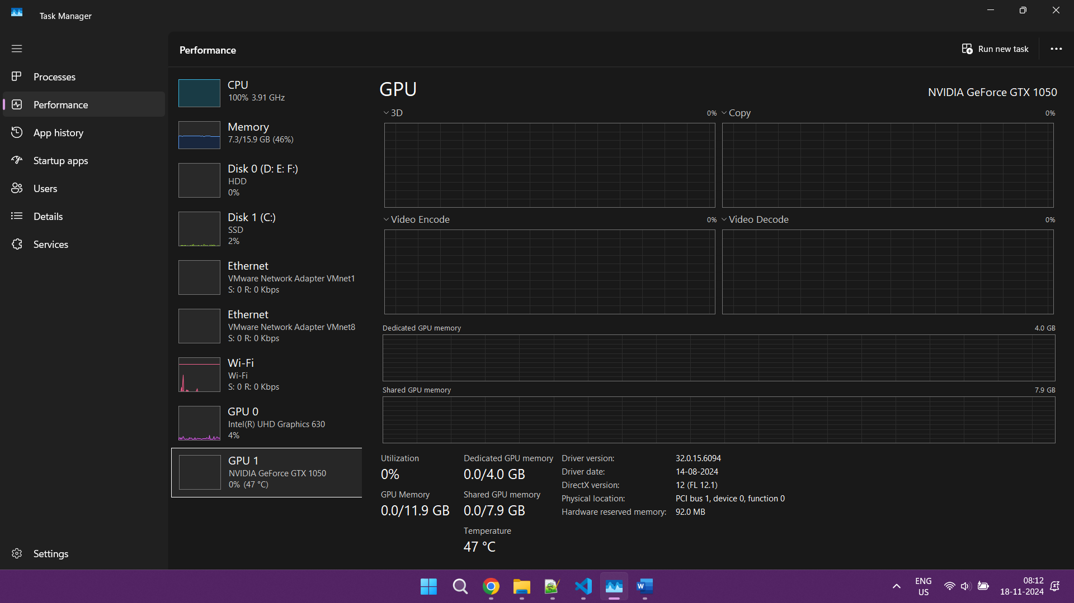

1. Performance Stats:

Training Batches: 100%|██████████| 113/113 [00:02<00:00, 45.63batch/s]

Final Model Accuracy: 0.9173