**LOGISTIC REGRESSION MODEL STATS**

1. **Resource Utilization Stats:**

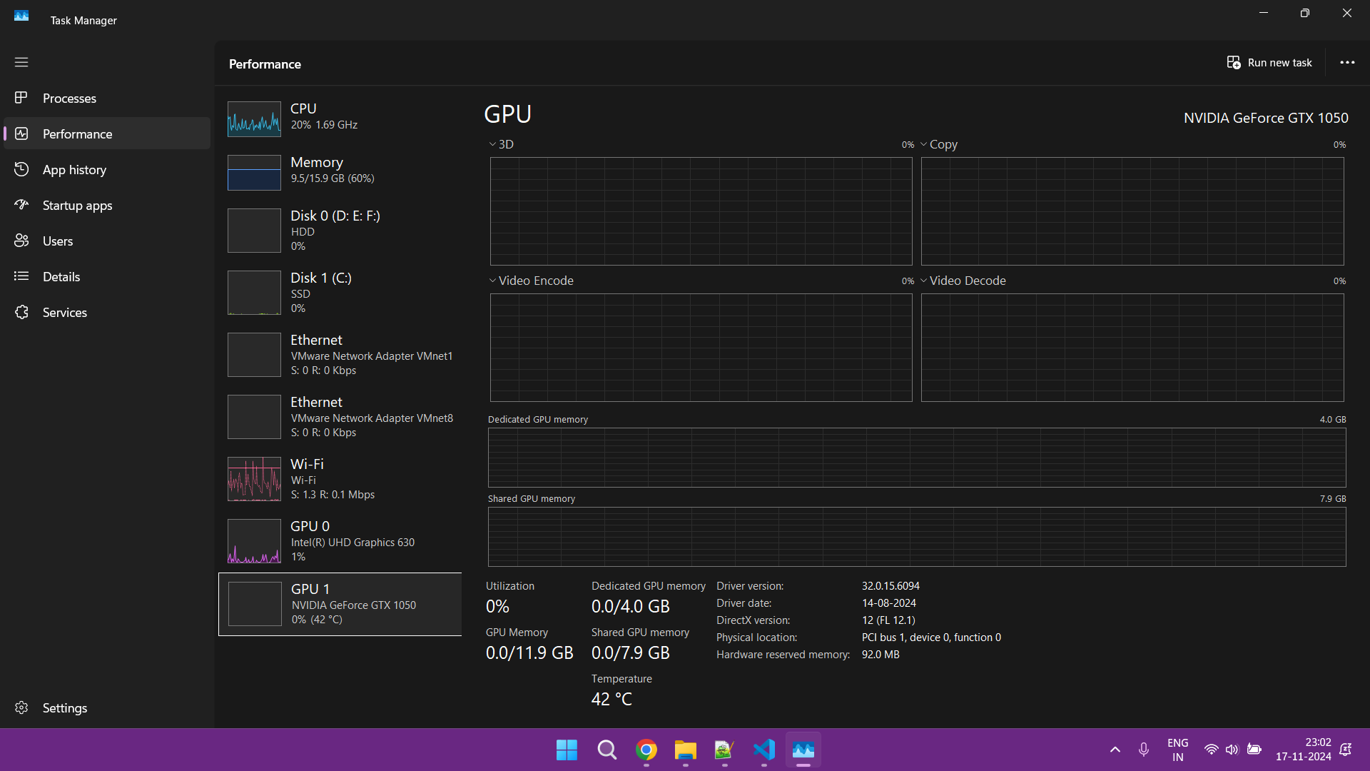

1. Output Result Stats:

Training Batches: 100%|██████████| 113/113 [00:00<00:00, 266.58batch/s]

Final Model Accuracy: 0.9022