MLPCLASSIFER STAS

1. Resource Utilization:

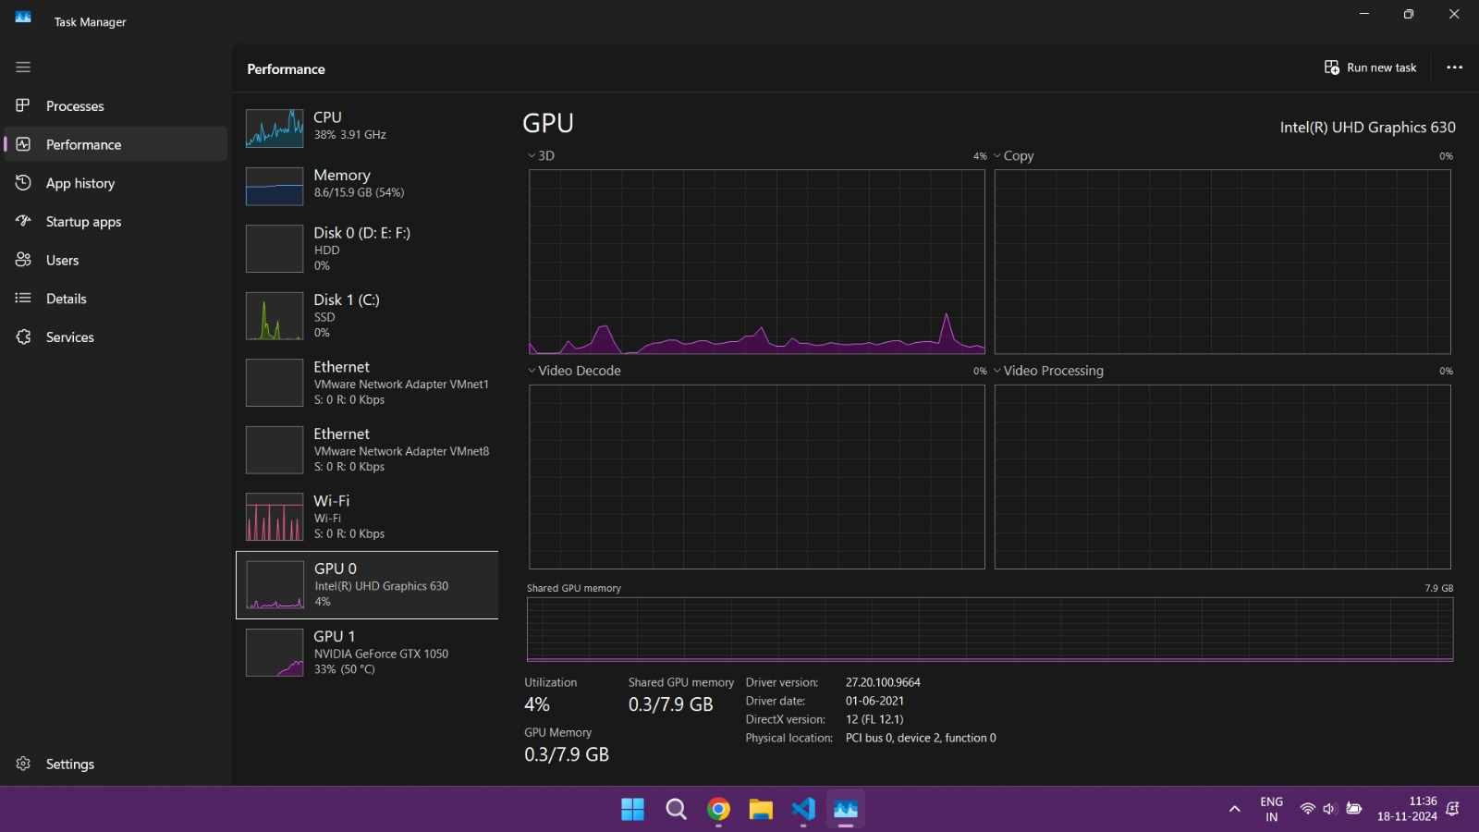

1. Performance Stats:

Hyperparameter Tuning: 100%|██████████| 72/72 [25:28<00:00, 21.23s/it]

Best Accuracy: 0.9550

Best Hyperparameters:

{'batch_size': 512, 'epochs': 20, 'hidden_size': 200, 'learning_rate': 0.01, 'optimizer': 'adam'}