1. Resource Utilization Stats :

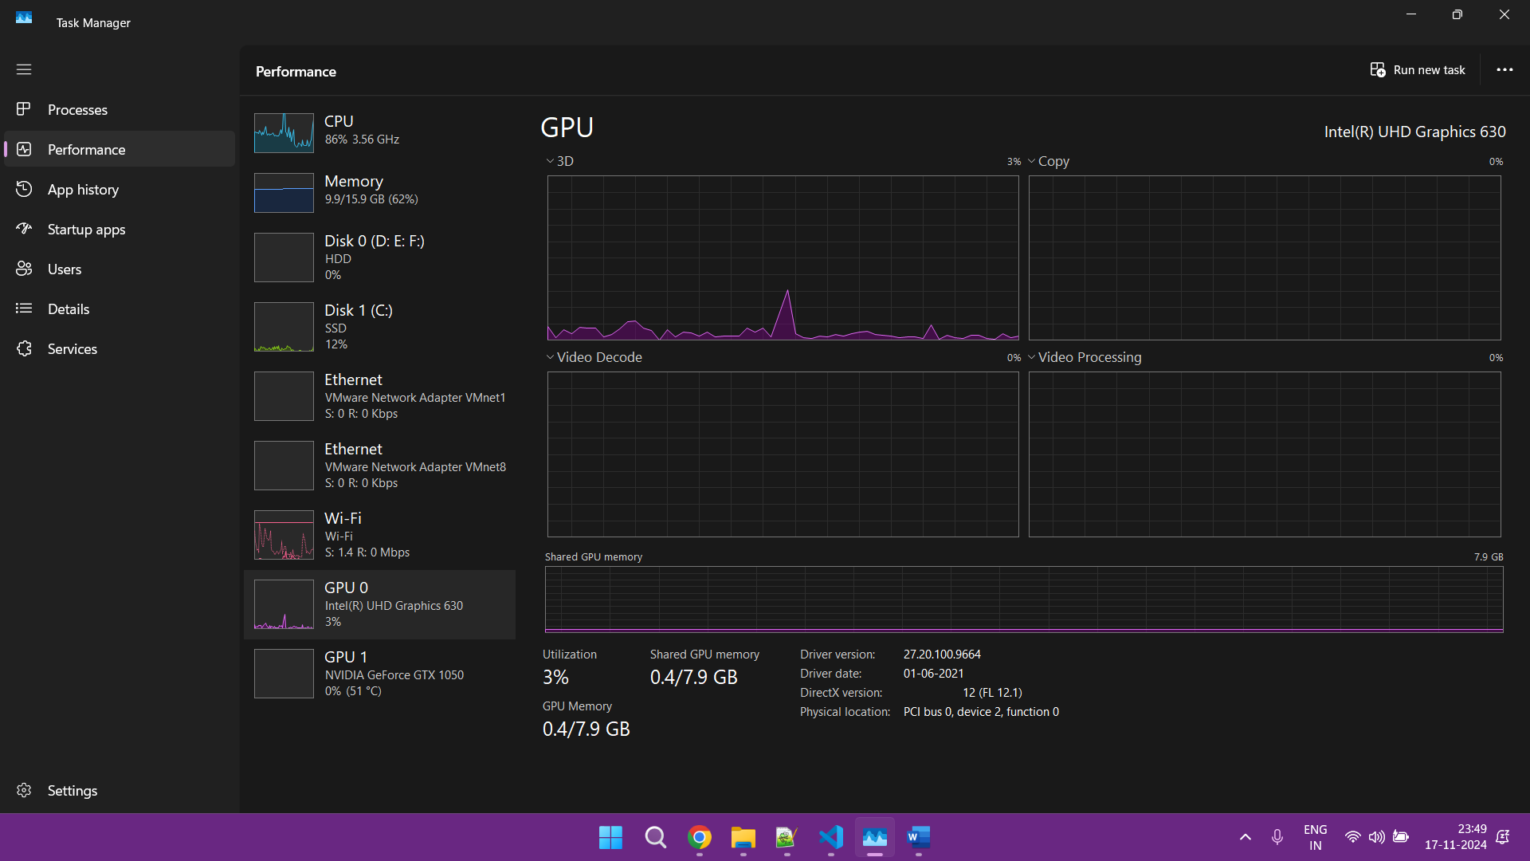

2) Output Results :

Training Batches: 100%|██████████| 677/677 [01:41<00:00, 6.65batch/s]

Final Model Accuracy: 0.9187