1. Resource Utilization:

1. Performance Stats:

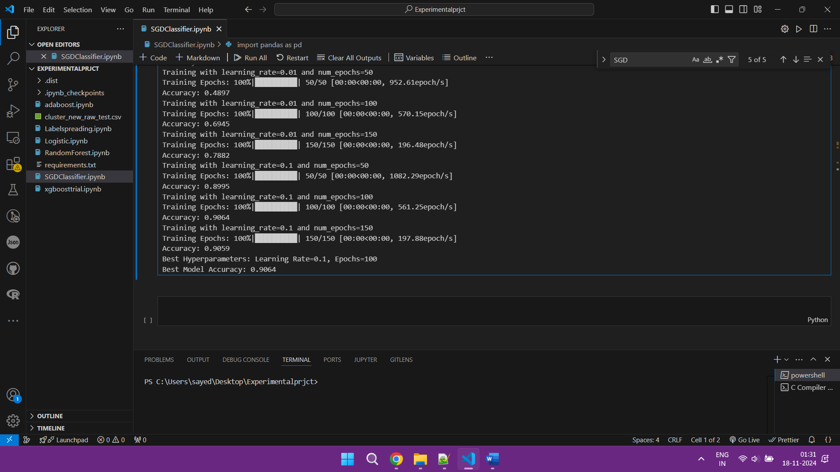

Best Hyperparameters: Learning Rate=0.1, Epochs=50

Best Model Accuracy: 0.9076