**Gaurav Sajnani   
B23 119**

**Devops Lab Assignment 1**

**Aim:** Understand and install git locally. Creation of account on Github

**Objectives:**

1. Understand Git Repository
2. Understand Version Control

**Theory:**

**What Is Version Control?**

Version control helps developers track and manage changes to a software project’s code. As a software project grows, version control becomes essential. Take WordPress…

At this point, WordPress is a pretty big project. If a core developer wanted to work on one specific part of the WordPress codebase, it wouldn’t be safe or efficient to have them directly edit the “official” source code.

**What Is Git?**

Git is a specific open-source version control system created by Linus Torvalds in 2005. Specifically, Git is a distributed version control system, which means that the entire codebase and history is available on every developer’s computer, which allows for easy branching and merging.

Instead, version control lets developers safely work through branchin**g** and merging**.** With branching, a developer duplicates part of the source code (called the repository). The developer can then safely make changes to that part of the code without affecting the rest of the project.

Then, once the developer gets his or her part of the code working properly, he or she can merge that code back into the main source code to make it official.

To understand GitHub, you must first have an understanding of Git. Git is an open-source version control system that was started by Linus Torvalds—the same person who created Linux. Git is similar to other version control systems—Subversion, CVS, and Mercurial to name a few.

So, Git is a version control system, but what does that mean? When developers create something (an app, for example), they make constant changes to the code, releasing new versions up to and after the first official (non-beta) release.

Version control systems keep these revisions straight, storing the modifications in a central repository. This allows developers to easily collaborate, as they can download a new version of the software, make changes, and upload the newest revision. Every developer can see these new changes, download them, and contribute.

Similarly, people who have nothing to do with the development of a project can still download the files and use them. Most Linux users should be familiar with this process, as using Git, Subversion, or some other similar method is pretty common for downloading needed files—especially in preparation for compiling a program from source code (a rather common practice for Linux geeks).

Git is the preferred version control system of most developers, since it has multiple advantages over the other systems available. It stores file changes more efficiently and ensures file integrity better.

Step 1: Downloading Git

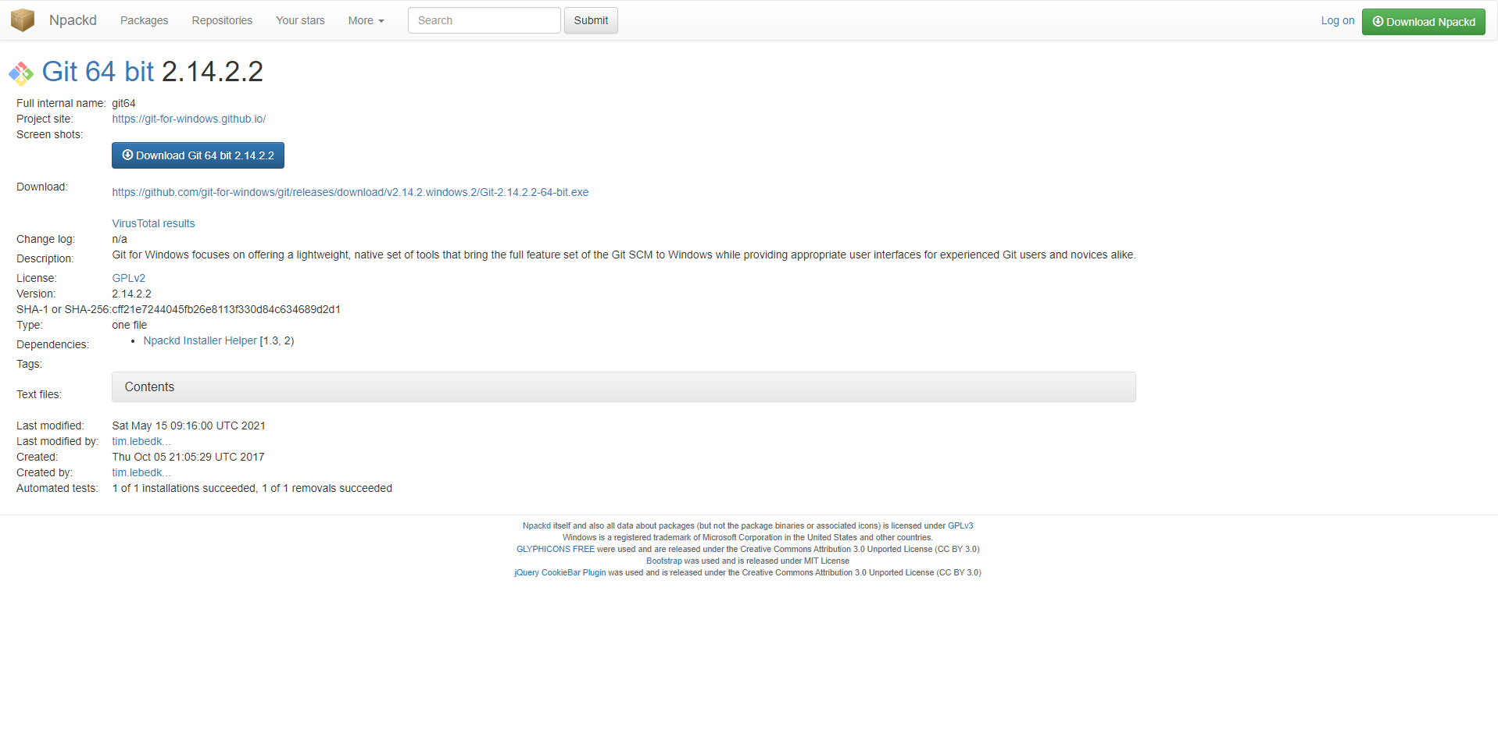

Step 2: Installing Git

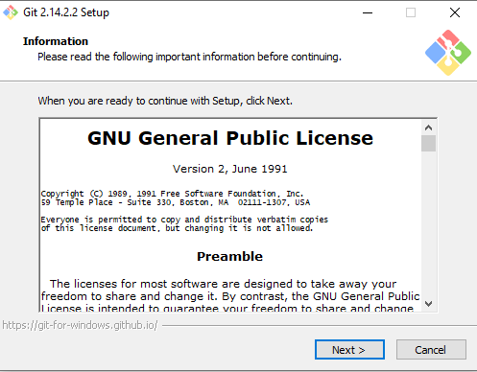

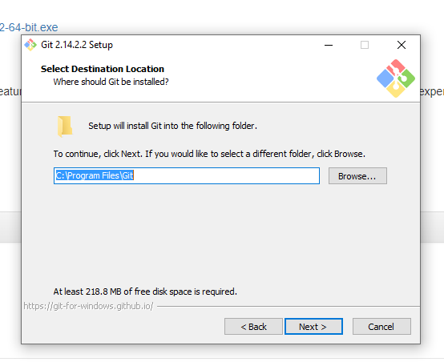

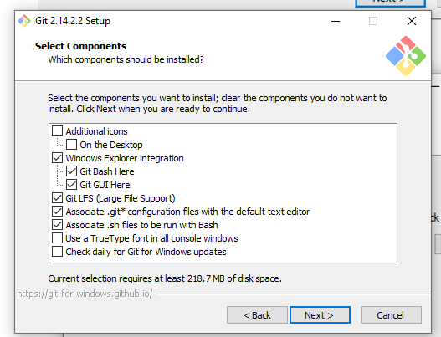

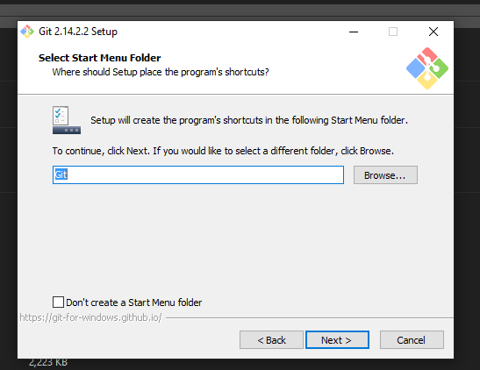

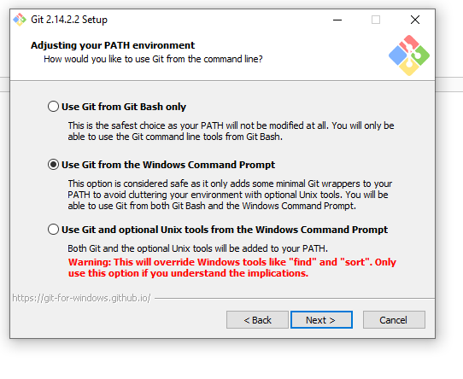

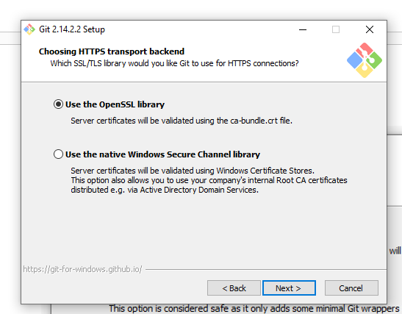

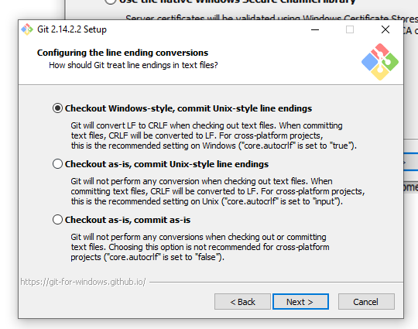

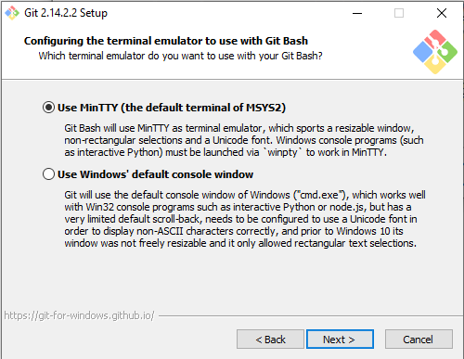

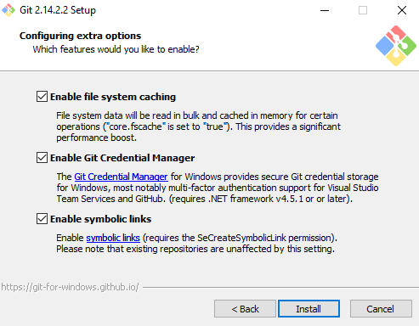

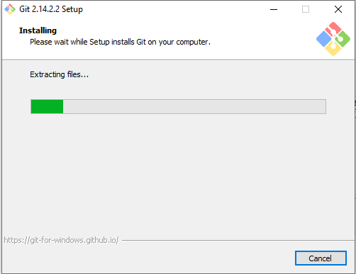

Step 3: Finishing setup and launching Git

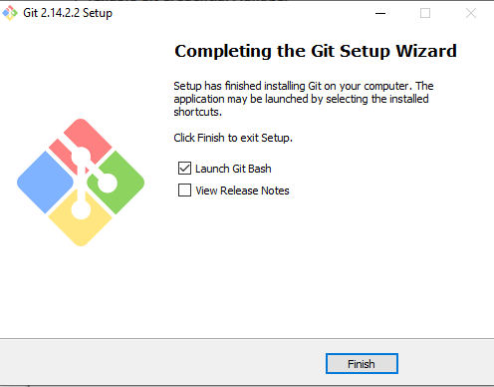

**Conclusion:** In this experiment we have understood Git, created an account and installed it on a local machine.