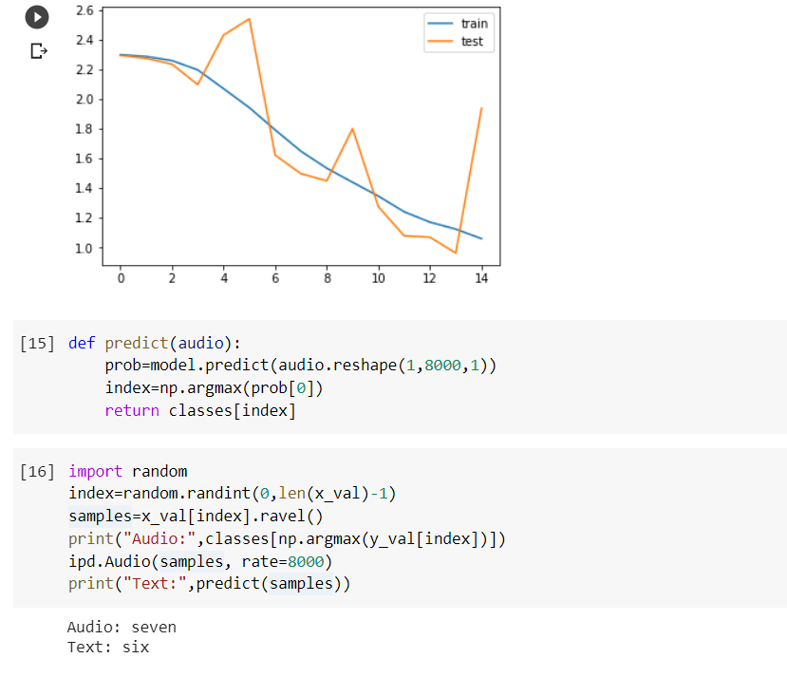

Here, I have used 4 convolutional layers and 2 dense layers. This was a purely experimental setup. I started with this and further made modifications in the layers to get various results. based on the accuracy curves, I further made changes to get better efficiencies. I have shown the various graphs below:

In the next figure ,I have used six convolutional layers and 3 dense layers.

I have added the structure of convolutional and dense layers below,

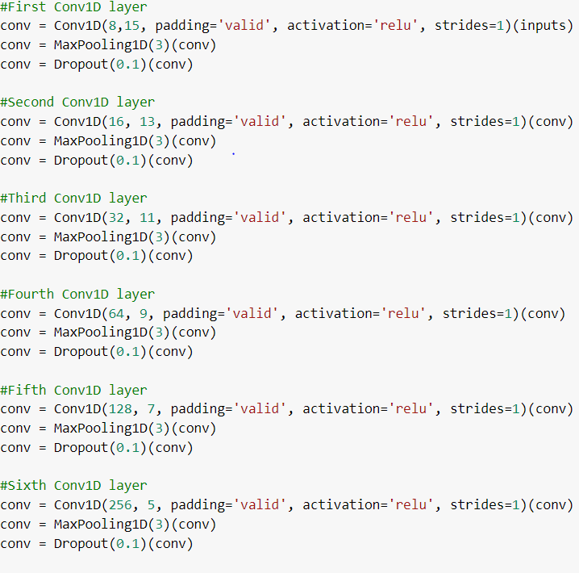

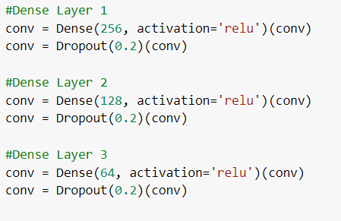

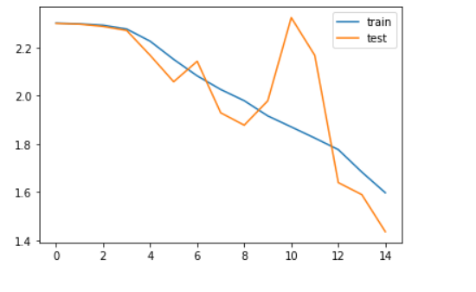

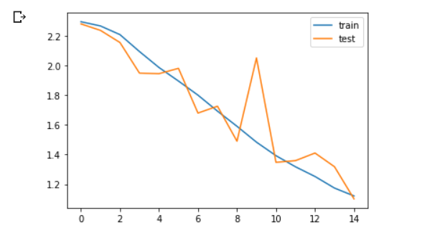

Here I used 2 convolutional layers with 3 dense layers.

So far I have been changing the number of convolutional and dense layers and had kept the number of iterations fixed to 15.(This result seems good)

Now using this combination I will run on 100 iterations.

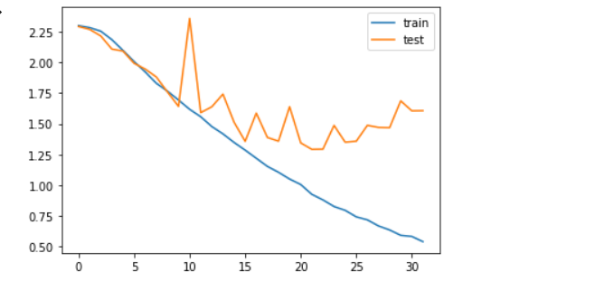

Iterations stopped at iteration number 30 giving the best accuracies.From the plot it is visible that validation error has also reduced a lot.

Now I have saved the model and will use it to predict on the test data.