***Abstract:*** A popular topic of study is the automatic production of multiple-choice questions (MCQ) from text. MCQs are commonly used for large-scale evaluation in a variety of areas and applications. Manually creating MCQs, on the other hand, is costly and time intensive. Many systems for generating MCQs have since been created. These systems are subjected to a thorough examination. The review findings are presented in this report. We present a generic approach for an MCQ creation system that is automated. Six stages make up the workflow. We locate and discuss the list of approaches used in the literature for each of these phases. We also investigate evaluation strategies for determining the quality of MCQs created by the system. Finally, we identify areas in which current research efforts should be devoted to enriching the literature.

***Index Terms***- machine-learning, question-generation, natural-language-processing.

# INTRODUCTION

A question is a crucial instrument for evaluating a learner's knowledge or understanding. Assessment is critical in learning, and questions are vital for assessment. Multiple choice questions (MCQ) are the most common type of question for various levels of assessment. MCQs have several advantages, including quick evaluation, shorter testing time, consistent scoring, and the option of an electronic evaluation. Many examinations employ MCQ-based question papers administered in a computerised setting. Manually preparing MCQs, on the other hand, is time-consuming and costly. As a result, the research community expended considerable effort in developing approaches for the automatic creation of MCQs. Since then, lots of MCQ generation system have been developed in a variety of languages and domains, and for different applications.

# MULTIPLE CHOICE QUESTIONS

A multiple-choice question (MCQ) has two parts: a stem that defines the question or problem, and a collection of alternatives or possible replies that include a key, which is the best solution to the question, and several distractors, which are reasonable but erroneous answers to the question. Students respond to MCQs by selecting the option that best answers or completes the stem. Using MCQs for evaluation has numerous advantages. One of the major advantages of MCQs is that the questions are easy to mark and can be scored even by a machine, making them one of the best assessment methods for courses. Well-designed MCQs enable assessment for a wide range of topics and objectives while also providing an objective evaluation of student aptitude.

The following MCQ design ideas are divided into three sections. These are, i. stem ii. key iii. distractor

The stem is also referred to as an item or a question sentence. Fundamentally, this is the sentence that gives rise to the inquiry. As a result, a question without options could be regarded as a stem. It might be either assertive or interrogative. The right response to the question is the key (also known as target word). Distractors are a group of incorrect answers or choices offered alongside the right answer to confuse the examinee.

# RESEARCH MOTIVATION AND OBJECTIVES

The year in which Covid-19 happened was quite challenging for us all. Everything was shifting to online platforms and our education system was transformed in no time. Somewhere along the line, we felt there was a need for a portal that can help us reduce human efforts so that one can focus more on the teaching aspect rather than going through the tiring process of creating a test. During our foundational research we found out the following pain points that we’ll focus on solving:

* 150 million users depend on Google Forms/Docs for test assessment/generation.
* 93% of institutions have shifted to online assessment.
* On average, 40 min are spent for making a class test.
* 87% of questions are available directly on Google. (Leading students to use unfair means)

Multiple choice questions are popular for large-scale assessments. However, preparation of a set of good MCQs takes time and requires an in-depth knowledge of the subject and construction skill. Therefore, educational technology and natural language processing research community were attracted to the possibilities for automatic MCQ generation.

# IDENTIFY, RESEARCH AND IDEATION

Formulating the research problem is the first stage in conducting a systematic review. The rest of the steps and the review's outcome are detailed below.

A. Literature Search

Searching the literature is the second step in a systematic review. This is a topic of research that spans multiple disciplines. We began our investigation by looking for articles in journals, but we discovered that certain conferences and seminars are very popular and address MCQ-related topics. As a result, this survey includes articles from both journals and conferences. To ensure extensive data collection, we searched multiple databases.

Automatic MCQ generation, question generation, MCQ generation, multiple choice questions, close questions, and fill-in-the-blank questions were used as a starting point. The findings are then compared to the inclusion criteria listed below.

* The automatic process for production of multiple choice or fill-in-the-blank questions is the paper's main focus.
* Unstructured text is used to feed the system.
* The MCQ generation and the individual modules employs automation.
* The focus of the study should not be on static or manual MCQ bank creation and access difficulties.

(Also excluded are efforts involving the correction of MCQ answers).

* The paper should not be solely concerned with the formulation of questions.

The following information was collected from each featured article: Title, Journal or Conference Name,

Year, Volume and Page no., Authors, Country, Question Type, Language, Domain, Application, Learning Outcome, Overall workflow, Pre-processing, Sentence selection strategy, Key selection strategy, Distractor generation strategy, Post-processing, Metrics used for Evaluation, who evaluated, and System accuracy.

B. Analysis and Ideation

To meet the survey's objectives, we examined the articles. Our initial goal is to create a task-specific workflow. As a result, we went over the articles to see if we could come up with a system. Twenty-six of the research articles use a procedure to create the questions. Rest does not adhere to any one technique. Then we concentrated on the various stages of the procedure. We discovered that 23 articles used one or more preprocessing procedures. Certain articles, on the other hand, did not specifically mention pre-processing. Similarly, 19 publications talked about sentence selection, 29 articles talked about key selection procedures, 9 articles talked about question construction, 20 articles talked about distractor generation, and 14 articles talked about post-processing. These results show that four steps are required for automatic MCQ development: pre-processing, phrase selection, key selection, and distractor generation. Then we looked over these papers to see what tactics were employed to carry out the various phases.

# METHODOLOGY

It is a smart quiz generation portal that can generate dynamic quiz from any uploaded text/PDF document using natural language processing. This can be used for self-analysis, question paper generation, and evaluation, thus reducing human effort. A platform that is encrypted and secured so that anyone taking selfassessment cannot use any unfair means. Some of the features of this are:

* implements automatic question generation (AQG) techniques
* Automatic question generation (AQG) is concerned with the construction of algorithms for producing questions from knowledge sources, which can be either structured.
* helps in saving resources (time, money, and human effort)
* Improves and enhances the teaching process, adaptive learning for student based on their specific needs using drill and practice exercises.
* provides an automated mechanism to assemble exams or simply speaking, to adaptively select questions from a question bank

The following flow is illustrated in Fig. 1 and explained below.

1) Input:

1. PDF file that consists of English data.
2. The English text must preferably be over a single broad topic with multiple smaller sub-topics. c. This helps in generating a good quiz.

2) Text Pre-processing:

1. Text is pre-processed so it can be in a format as expected by the natural language models.
2. All non-alphanumeric characters are dropped (except for full stops)
3. This indeed helps in improving the output of the natural language model

3) Named Entity Recognition & Entity Ranking:

1. We’ve used Spacy’s NER model to find out all named entities from the text. These consists of people’s names, dates, places, quantities etc.
2. These entities are good candidate questions and are ranked based on their TF-IDF score (a metric used to weigh a word across multiple documents)

4) Incorrect Option Generator:

1. A Word2Vec model implemented in genism us used to find the top 10 similar entities for a given entity. We then pick the least 4 entities as alternate options.
2. We can also pick words from the given text itself is the entity is not present in the model vocabulary.

5) Implementing Homomorphic Equation:

Homomorphic encryption is a cryptographic technique that permits numerical procedure on information to be performed out on cipher text, rather than on the actual data itself. The cipher text is an encoded version of the input information (additionally called plain text). It is worked on and afterward decoded to get the ideal result. The typical property of homomorphic encryption is that a similar result ought to be acquired from decrypting the worked cipher text as from basically working on the underlying plain text.

For a detailed workflow for the above methodology, refer to Fig. 2.

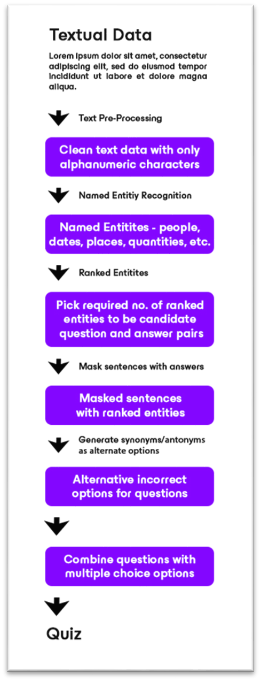

**Fig. 1:** Flowchart for Quiz Generation from Raw Data

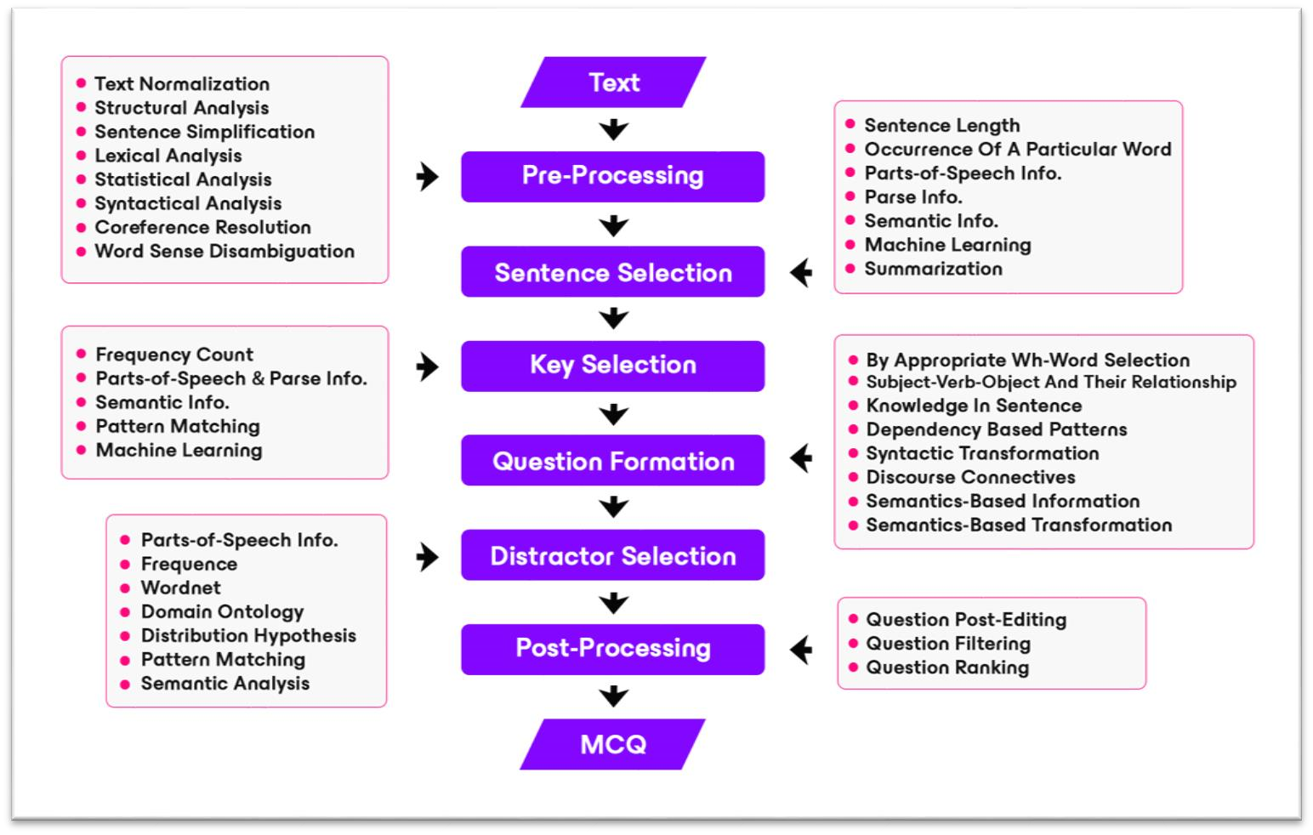

**Fig. 2:** The Flowchart of The Question Generating System

# TOOLS AND TECHNOLOGY USED

* TensorFlow is used as a backend framework with Keras as the interface.
* We’ve measured the loss using Mean Squared Error (MSE) that is the average of the squared differences between the actual and the predicted values.
* Optimizer used is RMSprop which is a gradient-based optimization technique used in training Neural Networks. It uses an adaptive learning rate instead of treating the learning rate as a hyperparameter.
* Metrics used for evaluation are Mean Absolute Error (MAE) which is a measure of errors between paired observations expressing the same phenomena.
* nltk is used for modelling of text. It provides good tools for loading and cleaning text.
* scikit-learn is a library in Python that provides many unsupervised and supervised learning algorithms. • Flask is being used as a WSGI web server
* Jinja is used for templating
* WERKQEUG is being used for WSGI utilities with Flask • Bulma is used as a CSS framework.
* Figma, Framer, Invision Studio are used as design & prototyping tools.
* UsabilityTools (heatmap) is used for conducting usability testing.

# CONCLUSION

Evaluation is critical in the teaching-learning process, and multiple-choice questions (MCQs) are commonly used in educational assessment. We reviewed the efforts on automatic MCQ generation from text provided in the literature in this paper. We talked about the various methods for creating MCQs that are currently in use. We created a generic workflow that included six broadly grouped dependent phases: preprocessing, sentence selection, key selection, question construction, distractor generation, and postprocessing. For the implementation of the individual phases, various strategies have been used. We gave a comparison of various methods. We also talked about how to evaluate MCQs created by the system. In this System, we reviewed the works on automatic MCQ generation from text that have been presented in the literature.

We talked about the various methods for creating MCQs that are currently in use. Pre-processing, sentence selection, key selection, question construction, distract or generation, and post-processing are the six broadly classed dependent phases that we established