Pydantic
Pydantic is a Python library used for:
- ✅ Data validation
- ✅ Type conversion
- ✅ Parsing JSON into Python objects
- ✅ Generating schemas automatically
FastAPI uses Pydantic to validate request bodies and generate API documentation.

BaseModel
Almost every Pydantic model starts like this:
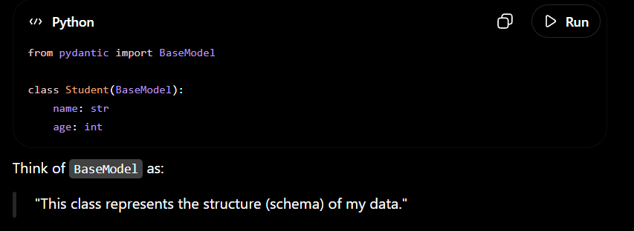
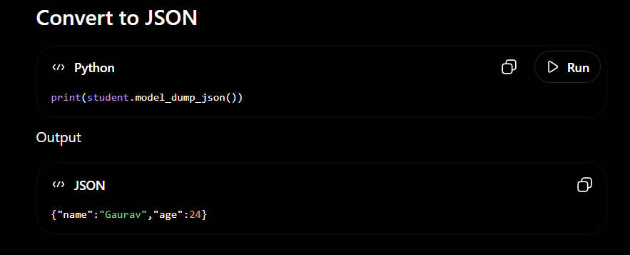
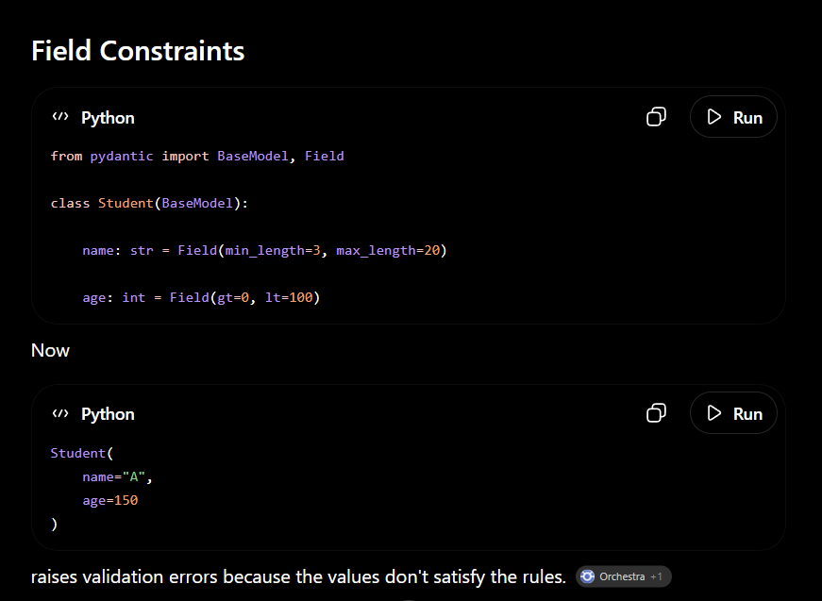

Why does FastAPI use Pydantic?
Because Pydantic provides:
- Automatic request validation
- Type conversion (when appropriate)
- Clear validation errors
- Serialization/deserialization
- Automatic OpenAPI/Swagger schema generation
All of these integrate naturally with Python type hints.

