Databricks Data Platform
Business requirements and system design

Purpose
Give data teams a repeatable way to manage Databricks resources and promote data workloads safely from development to production. This proposal focuses on the platform shape and the decisions that matter first; cloud-specific details can be filled in once the target environment is known.

1. Business requirements
Need | What the platform should do
Consistent environments | Use separate dev, staging, and prod workspaces with the same reviewed release and environment-specific settings.
Governed data | Organize data into bronze, silver, and gold with clear access, ownership, and quality checks.
Less manual setup | Manage jobs, compute, warehouses, schemas, and grants through versioned configuration where supported.
Safe operations | Use non-human identities for automation, keep secrets out of code, and make failures visible to owners.
Controlled production | Test in dev and staging, require approval for production, and retain a straightforward rollback path.

2.Proposed design
Use Databricks Asset Bundles for workspace resources and CI/CD for validation and deployment. Keep cloud and account foundations—workspaces, storage, networking, identities, policies, and secret-manager integration—in infrastructure as code. Each environment has its own workspace, catalog, secret scope, and service identities.
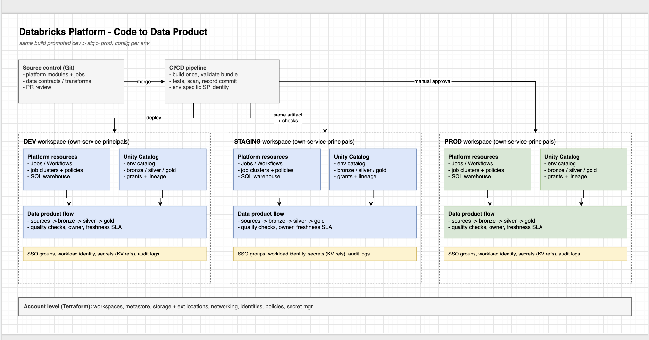

3. Main design choices
Area | Proposal
Workspaces | Separate dev, staging, and prod. Add workspaces for domains or user groups only when isolation or ownership requires it.
Resources | Bundles define jobs, job compute, SQL warehouses, schemas, and grants. Workspace policies cap compute choices and cost.
Data layers | Bronze keeps source-aligned data; silver applies validation and standardization; gold publishes business-ready tables.
Identity and secrets | CI deploys with a service principal; jobs run as a separate workload identity. Store secret values in the approved cloud secret manager and resolve them at runtime.
Promotion | Validate and build once, deploy the same version to dev, test in staging, then promote to prod after approval.

4. Delivery flow
Step | Action
1. Pull request | Review code; run formatting, unit checks, bundle validation, and package build.
2. Development | Deploy the candidate and run smoke, integration, and basic data-quality checks.
3. Staging | Promote the same build; run regression checks and confirm expected access and outputs.
4. Production | Require release approval, deploy with the production identity, and run a smoke check.

5. Risks and open decisions
- Confirm cloud, region, identity standard, and secret manager.
- Choose shared or environment/domain-separated catalogs.
- Agree freshness and recovery targets; validate bundle support in the target workspace.

