**Web Application Documentation**

Name: Gaurav Ramakant Tayade

Project name: Fifa.com

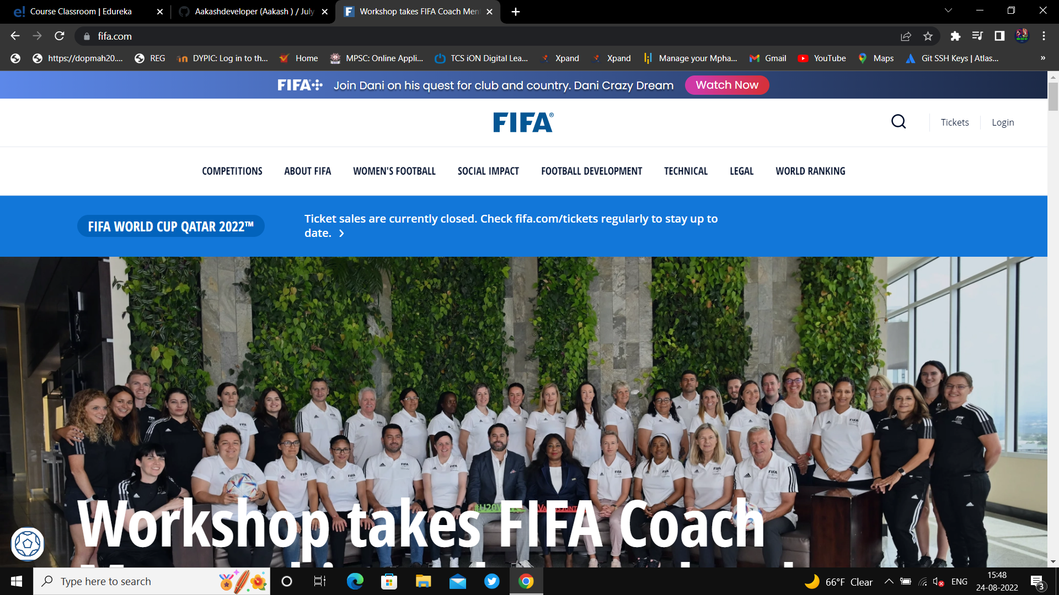

1. **Abstract**:

The project named “**FIFA.com”** is Web application of FIFA . FIFA is an international governing body of [association football](https://en.wikipedia.org/wiki/Association_football), beachfootball and [futsal](https://en.wikipedia.org/wiki/Futsal). It was founded in 1904 to oversee international competition among the national associations of [Belgium](https://en.wikipedia.org/wiki/Royal_Belgian_Football_Association), [Denmark](https://en.wikipedia.org/wiki/Danish_Football_Union), [France](https://en.wikipedia.org/wiki/Union_des_Sociétés_Françaises_de_Sports_Athlétiques), [Germany](https://en.wikipedia.org/wiki/German_Football_Association), the [Netherlands](https://en.wikipedia.org/wiki/Royal_Dutch_Football_Association), [Spain](https://en.wikipedia.org/wiki/Royal_Spanish_Football_Federation), Sweden and [Switzerland](https://en.wikipedia.org/wiki/Swiss_Football_Association). Headquartered in [Zürich](https://en.wikipedia.org/wiki/Zürich), Switzerland, its membership now comprises [211 national associations](https://en.wikipedia.org/wiki/List_of_FIFA_Member_Associations); Russia was suspended in 2022. These national associations must each also be members of one of the six regional confederations into which the world is divided: [Africa](https://en.wikipedia.org/wiki/Confederation_of_African_Football), [Asia](https://en.wikipedia.org/wiki/Asian_Football_Confederation), [Europe](https://en.wikipedia.org/wiki/UEFA), [North & Central America and the Caribbean](https://en.wikipedia.org/wiki/CONCACAF), oceania and [South America](https://en.wikipedia.org/wiki/CONMEBOL).

One of the most important part of it is FIFA+ Streaming service

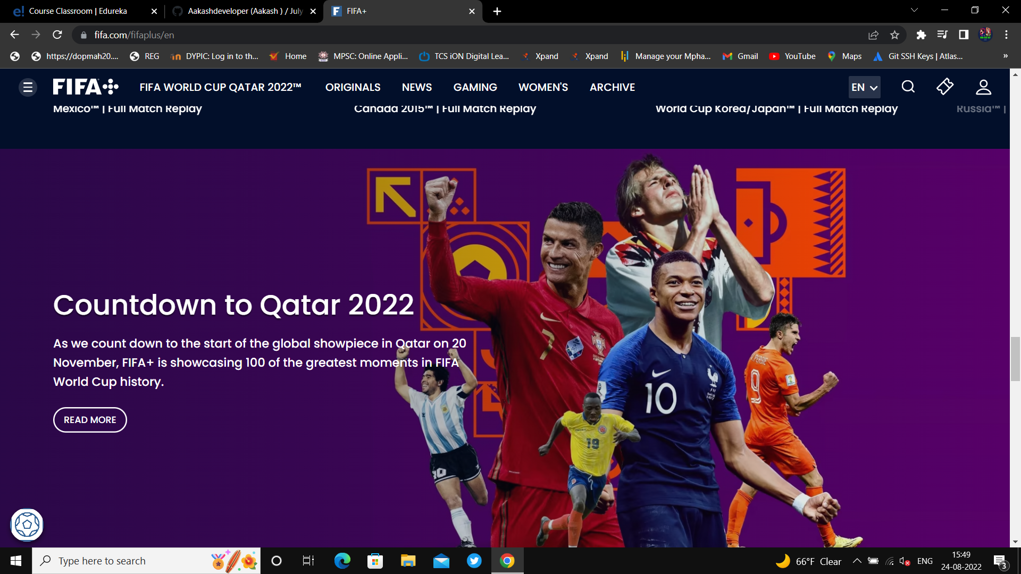

In April 2022 FIFA launched FIFA+ an OTT service providing up to 40,000 live matches per year, including 11,000 women's matches.It was also confirmed that FIFA would make available archival content, including every FIFA World Cup and FIFA Women's World Cup match recorded on camera, together with original documentary content. Eleven sports was later reported to be responsible for populating the FIFA+ platform with live matches.

1. **Introduction**

* **Motivation:**

The idea behind this Project was to make all kind of feature driven web app it have streaming, online matches ticket purchasing, all information about its governing bodies.

* **Problem Statement:**

Design an application using :

* HTML, CSS
* BOOTSTRAP
* JAVASCRIPT
* REACT JS
* MANGO DB
* **Goal And Objectives:**
* HOME PAGE
  + - * Header fifa+
      * Ticket and log in
      * Navigation bar
      * Fifa events
      * Partners
* LOG IN /LOG OUT
* PAYMENT GATEWAY FOR TICKET SALES
* FIFA+ STREAMING SERVICE