PRACTICAL 1 : INTRODUCTION AND CONTRIBUTING TO WIKIPEDIA

1. WHAT IS WIKIPEDIA?

**Wikipedia** is a free, [multilingual](https://en.wikipedia.org/wiki/Multilingualism) [open-collaborative](https://en.wikipedia.org/wiki/Open_collaboration) [online encyclopedia](https://en.wikipedia.org/wiki/Online_encyclopedia) created and maintained by a [community of volunteer editors](https://en.wikipedia.org/wiki/Wikipedians) using a [wiki](https://en.wikipedia.org/wiki/Wiki)-based editing system. It is one of the 15 most popular websites as ranked by [Alexa](https://en.wikipedia.org/wiki/Alexa_Internet), as of January 2021 and [The Economist](https://en.wikipedia.org/wiki/The_Economist) newspaper placed it as the "13th-most-visited place on the web". Featuring no [advertisements](https://en.wikipedia.org/wiki/Online_advertising), it is hosted by the [Wikimedia Foundation](https://en.wikipedia.org/wiki/Wikimedia_Foundation), an [American non-profit organization](https://en.wikipedia.org/wiki/501(c)(3)_organization) funded primarily through donations.

1. STEPS TO CREATE ACCOUNT ON WIKIPEDIA

1 ) GO ON [WIKIPEDIA.ORG](https://en.wikipedia.org/wiki/Main_Page) IN YOUR BROWSER

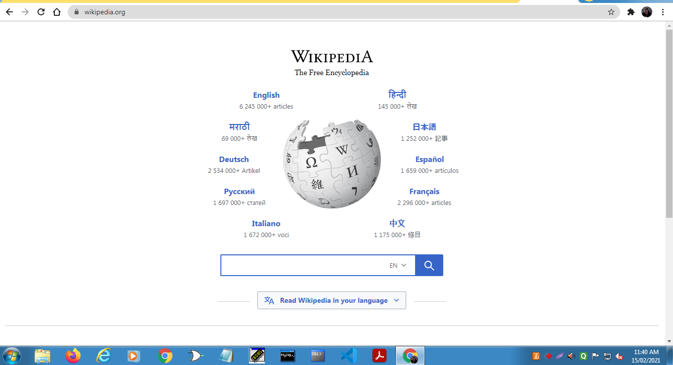

2) CLICK ON CREATE ACCOUNT

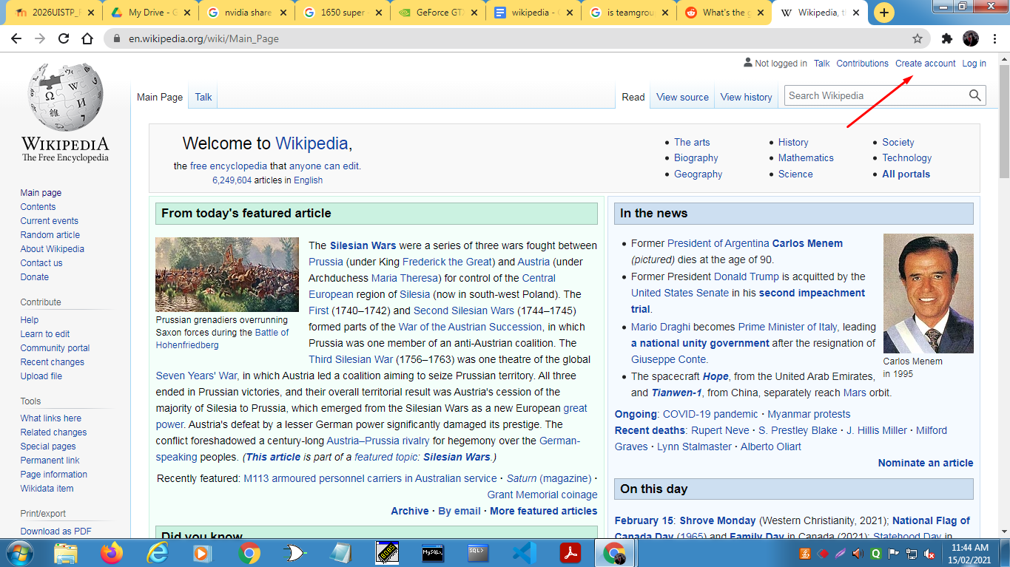

3) CLICK ON CREATE YOUR ACCOUNT (AFTER FILLING THE REQUIRED DETAILS)

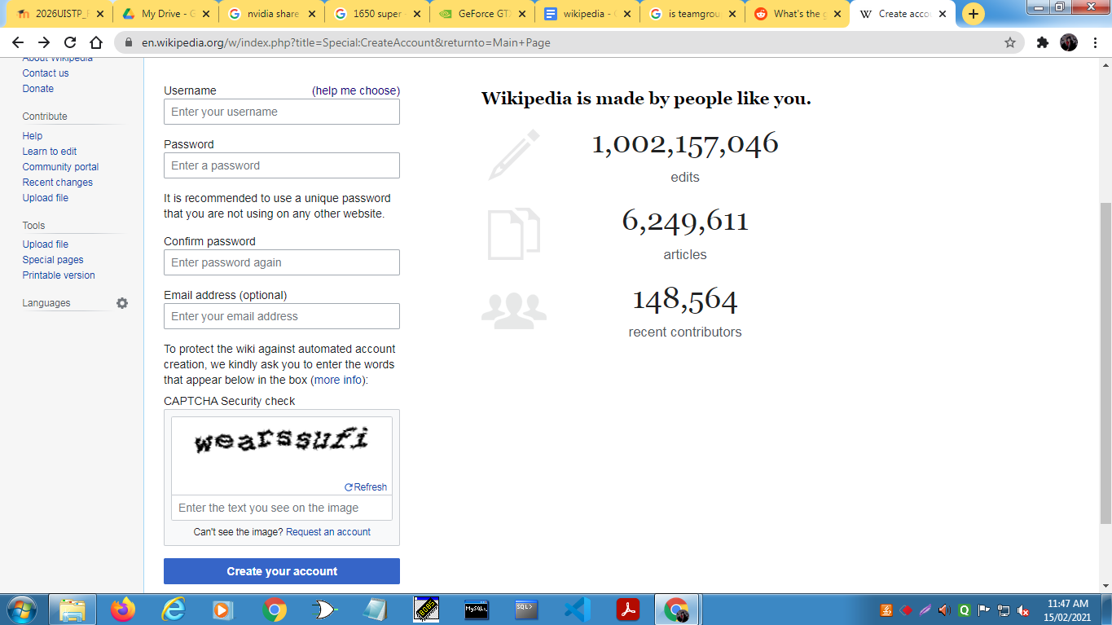

ACCOUNT CREATED

C ) CREATING PAGE ON WIKIPEDIA

1 ) Search an article that is not on Wikipedia click on ask it to be created

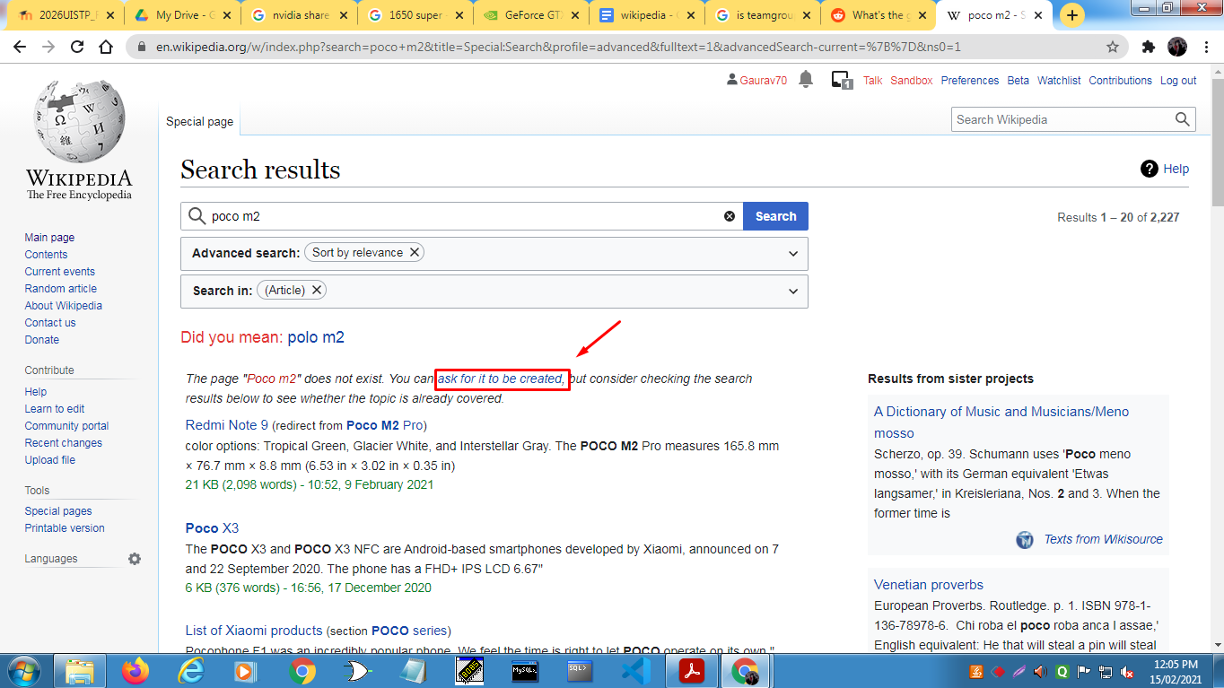

2 ) CLICK ON “CLICK HERE TO START A NEW ARTICLE”

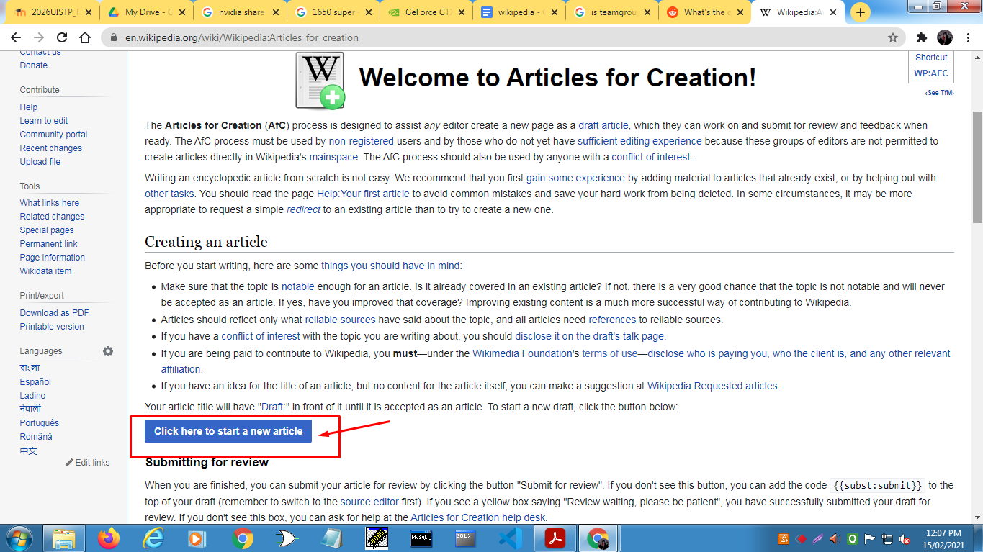

3) CLICK NEXT

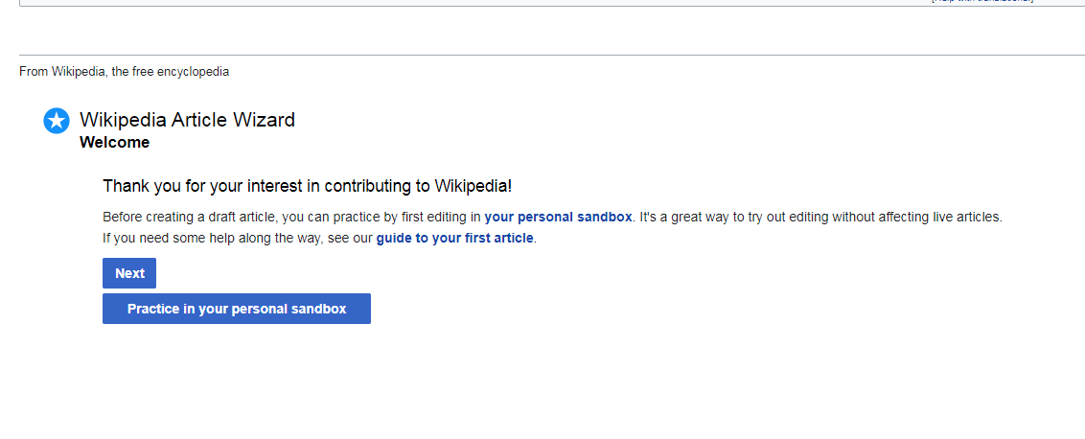

4) CLICK NEXT AFTER SCROLLING DOWN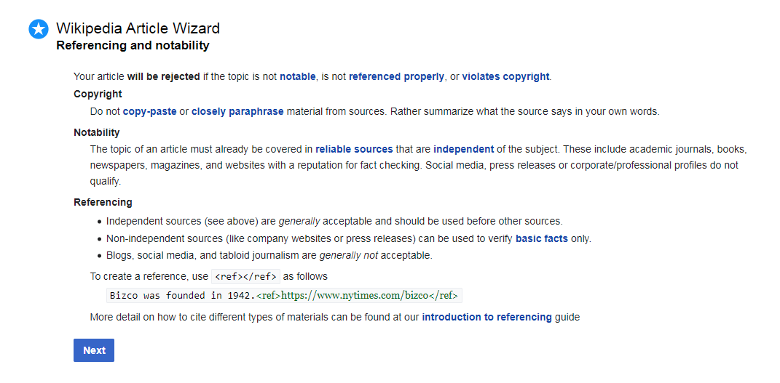

5 ) CLICK THE BUTTON ACCORDING YOUR CIRCUMSTANCE ( Here we choose second option )

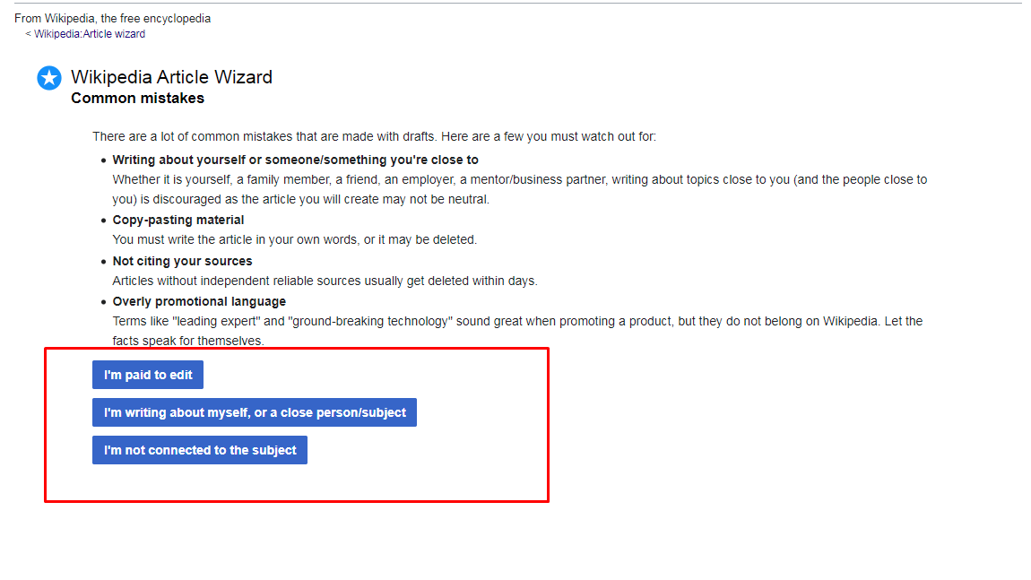

6 ) CLICK “I HAVE DISCLOSED”

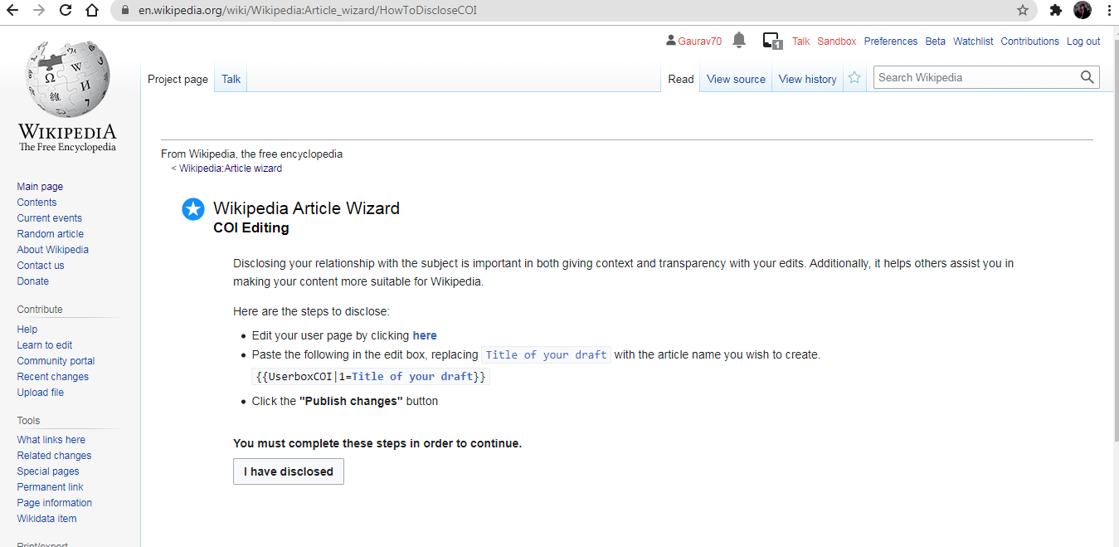

7 ) click next & GIVE THE TITLE AN CLICK ON “CREATE A NEW ARTICLE DRAFT”

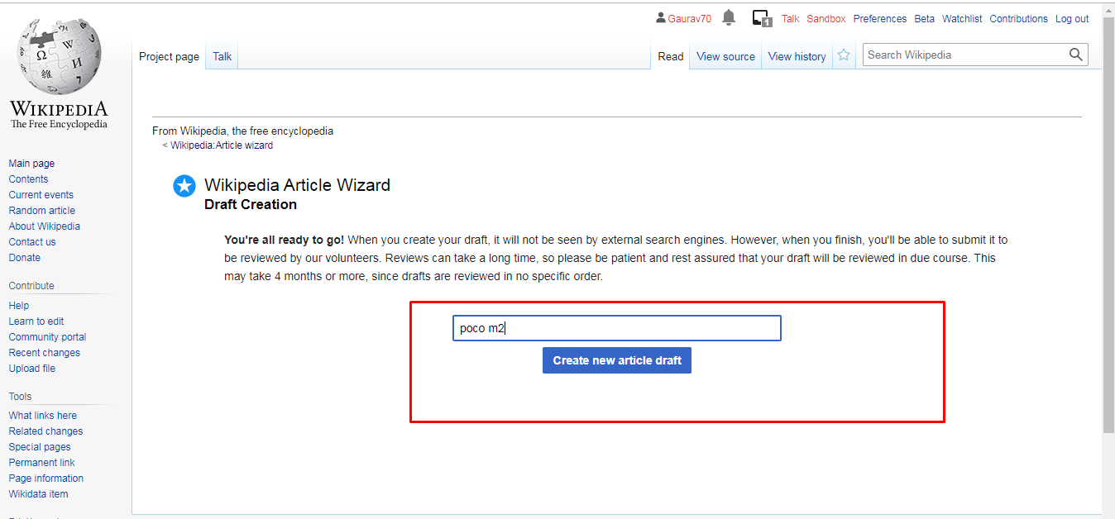

8 ) SCROLL DOWN AND INSERT THE INFORMATION & publish

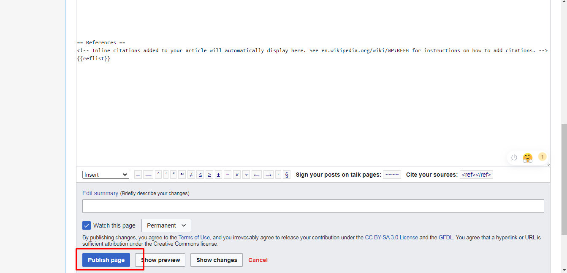

9 ) NOW YOUR PAGE IS CREATED YOU CAN CLICK ON SUBMIT THE DRAFT FOR REVIEW AND THE REVIEWERS WILL CHECK YOUR PAGE.

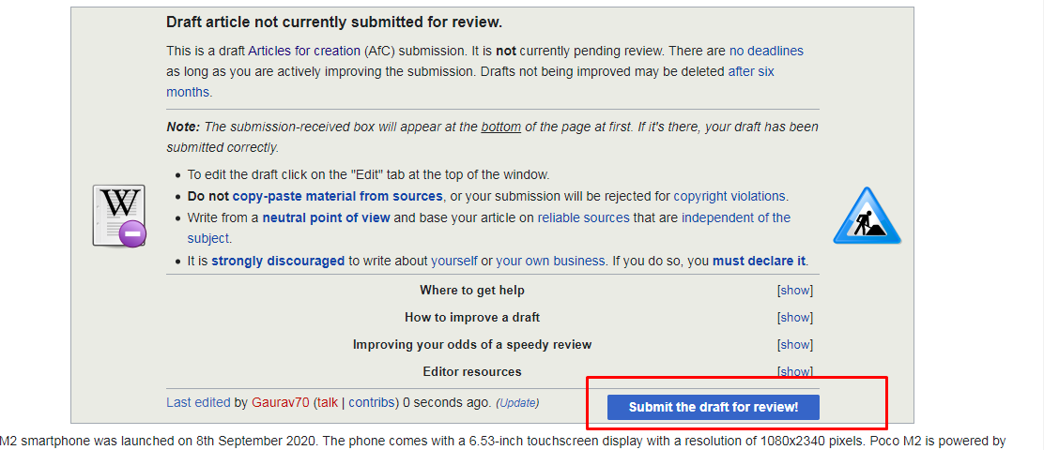

D )EDITING YOUR PAGE ON WIKIPEDIA

1) CLICK ON EDIT SOURCE

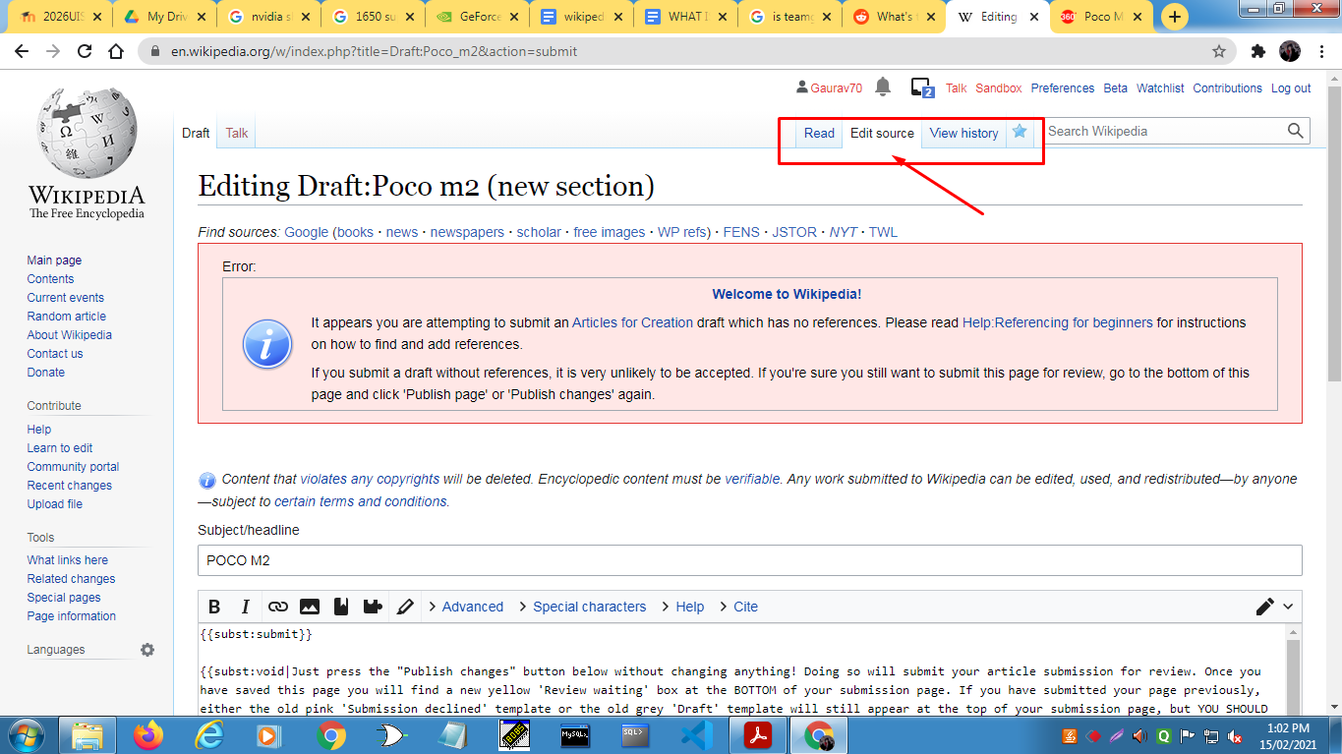

2) EDIT THE INFO YOU WANT and publish changes

