# **GAURAV_BODKHE_2124UCEM1041**

# **ASSIGNMENT NO.1**

## **1. Introduction**

We have to Install the Android SDK and developer tools and build a test project to confirm that those tools are properly installed and configured.

## **2. Tools & Technologies Used**

* Android Studio
* Kotlin (DSL)
* Emulator

## **3. Procedure & Steps**

### **Step 1: Create a New Project**

* Open Android Studio and create a new project.
* Choose an Empty Activity template.
* Set the project name and package name.
* Select the programming language (Kotlin).

**Screenshot:**

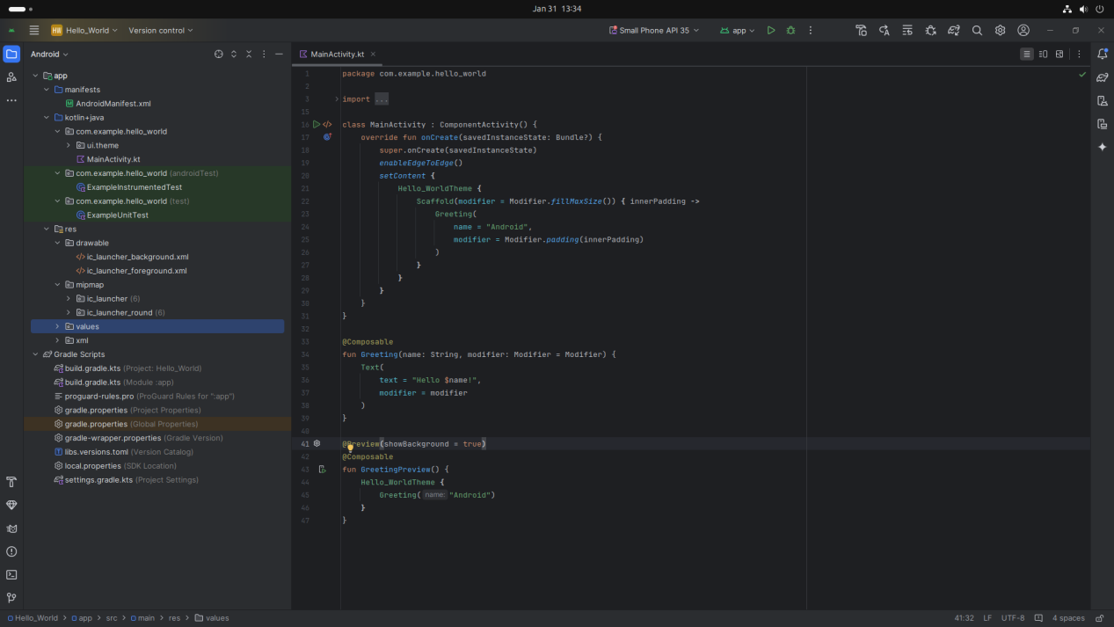

**Step 2: Designing the UI**

* Open activity_main.xml and design the layout using XML.
* Add UI comwponents such as TextView, EditText, Button, etc.

## **Screenshot:**

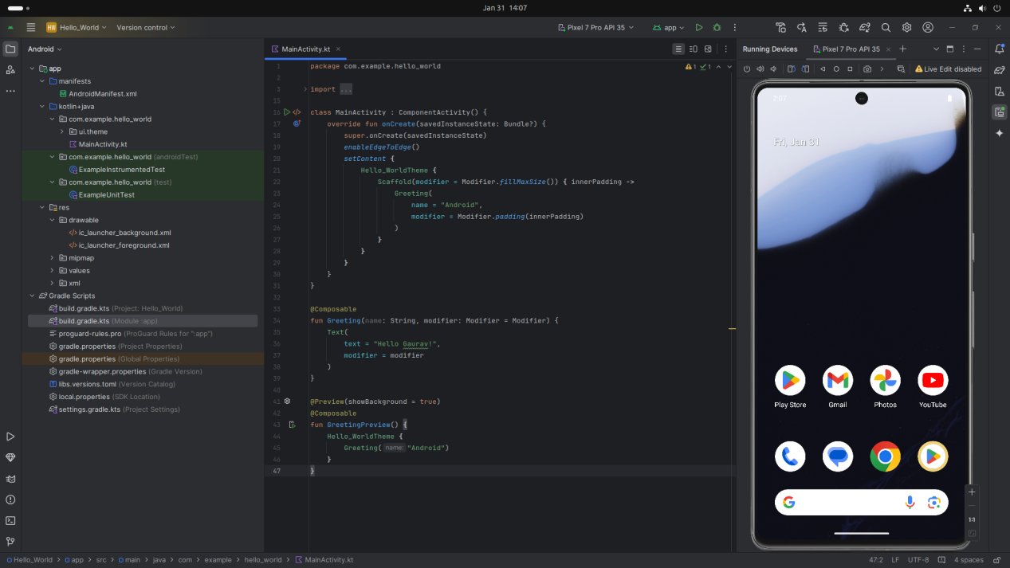

## **Step 3: Writing the Code**

* Open MainActivity.kt.
* Implement functionality such Hello Gaurav etc.
* Use necessary Android components like Intents, RecyclerView, Fragments, etc.

**Kotlin**

*package com.example.hello_world*

*import android.os.Bundle*

*import androidx.activity.ComponentActivity*

*import androidx.activity.compose.setContent*

*import androidx.activity.enableEdgeToEdge*

*import androidx.compose.foundation.layout.fillMaxSize*

*import androidx.compose.foundation.layout.padding*

*import androidx.compose.material3.Scaffold*

*import androidx.compose.material3.Text*

*import androidx.compose.runtime.Composable*

*import androidx.compose.ui.Modifier*

*import androidx.compose.ui.tooling.preview.Preview*

*import com.example.hello_world.ui.theme.Hello_WorldTheme*

*class MainActivity : ComponentActivity() {*

*override fun onCreate(savedInstanceState: Bundle?) {*

*super.onCreate(savedInstanceState)*

*enableEdgeToEdge()*

*setContent {*

*Hello_WorldTheme {*

*Scaffold(modifier = Modifier.fillMaxSize()) { innerPadding ->*

*Greeting(*

*name = "Android",*

*modifier = Modifier.padding(innerPadding)*

*)*

*}*

*}*

*}*

*}*

*}*

*@Composable*

*fun Greeting(name: String, modifier: Modifier = Modifier) {*

*Text(*

*text = "Hello Gaurav$name!",*

*modifier = modifier*

*)*

*}*

*@Preview(showBackground = true)*

*@Composable*

*fun GreetingPreview() {*

*Hello_WorldTheme {*

*Greeting("Android")*

*}*

*}*

**Screenshot:**

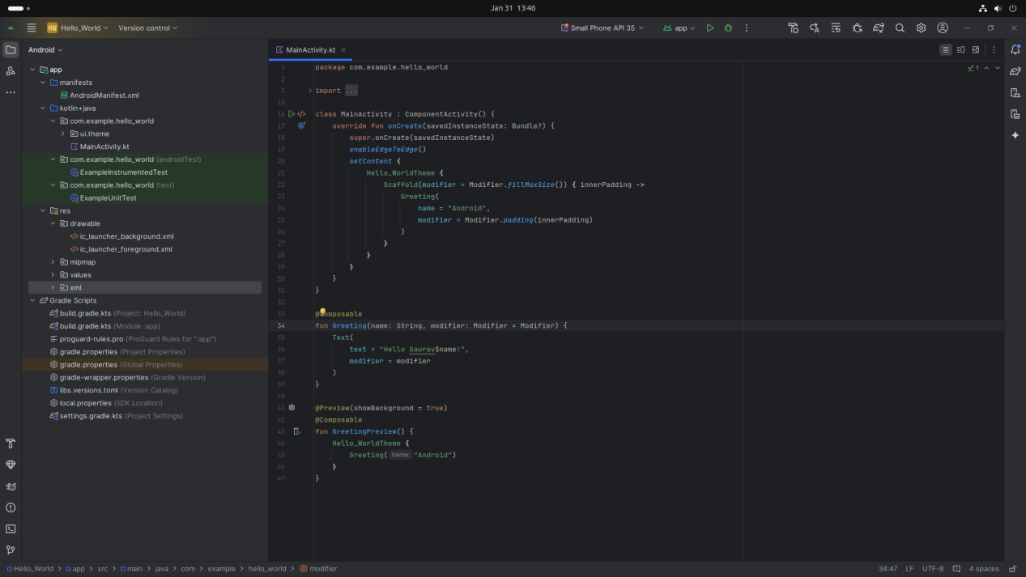

### **Step 4: Running the Application on Emulator**

* Click on the Run button in Android Studio.
* Select the emulator and launch the app.

**Screenshot:**

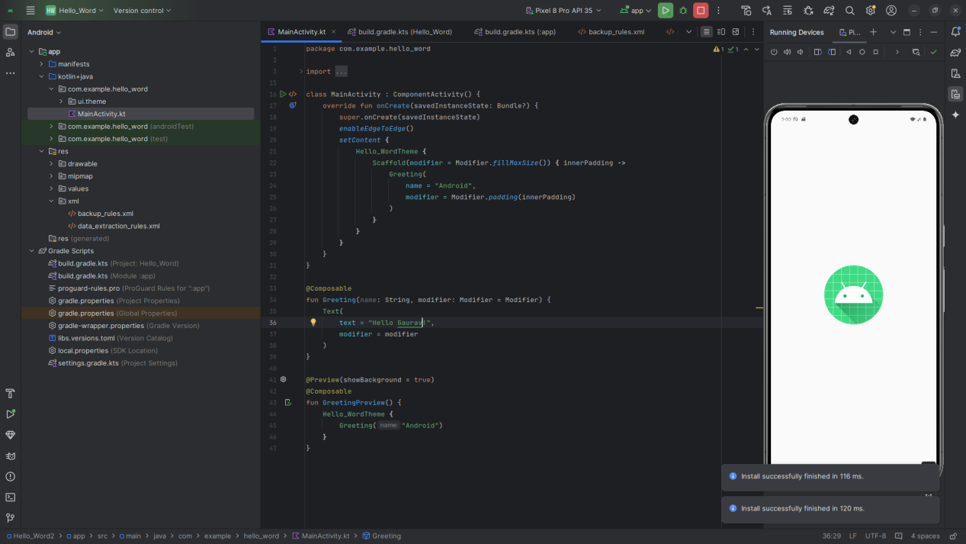

### **Step 5: Testing & Output**

* Rest different functionalities of the app.
* Capture the output results.

**Screenshot:**

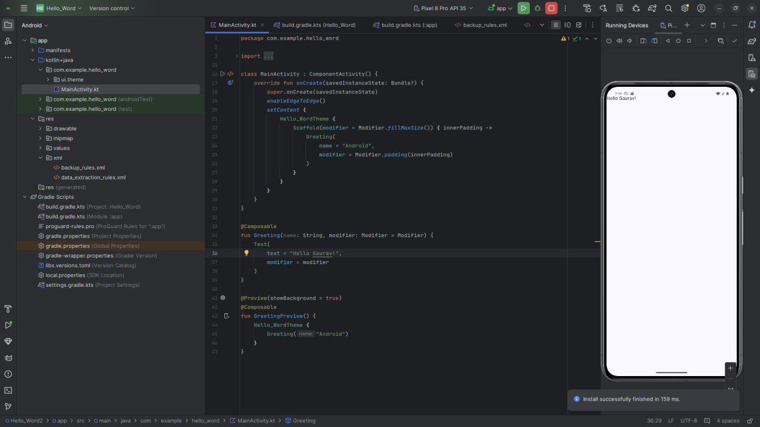

## **4. Conclusion**

I learned a lot about to Install the Android SDK and developer tools and build a test project and gained new skills like how to build simple Hello World App on Android Studio . Some challenges I faced included how to resolve error of androuid 34 and how to make changes in code but I was not able to solve them but I Explain this issue to our subject teacher and he helped me to ressolve this error

In the end, I feel more confident and better prepared to use what I’ve learned in the future. The experience also taught me how to problem-solve and manage my time better.