# **ASSIGNMENT NO.2**

# **GAURAV_BODKHE_2124UCEM1041**

## **1. Introduction**

We have to develop a program that implement restaurant data entry form with a table layout. It allows restaurant owners first to enter details of Login credentials like Username,Password And on next page enter details uses a table layout to create a restaurant data entry form. Include fields like "Restaurant Name," "Location," and "Cuisine Type." Add a set of radio buttons to let the user select the type of restaurant (e.g., "Fast Food," "Fine Dining," or "Cafe"). Use this to design a user-friendly interface for restaurant owners to input their data.

## **2. Tools & Technologies Used**

* Android Studio
* Java/Kotlin
* Emulator

## **3. Procedure & Steps**

### **Step 1: Create a New Project**

* Open Android Studio and create a new project.
* Choose an Bottom navigation Views Activity template.
* Set the project name and package name of your Application
* Select the programming language (Java/Kotlin).
* **Screenshot:**

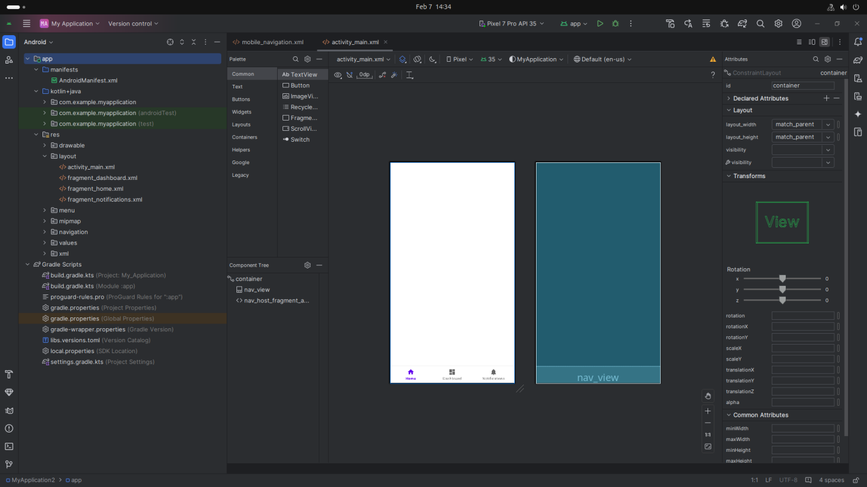

### 

### **Step 2: Designing the UI**

* Open activity_main.xml and design the layout using XML.
* Add UI comwponents such as TextView, EditText, Button, etc.

**Screenshot:**

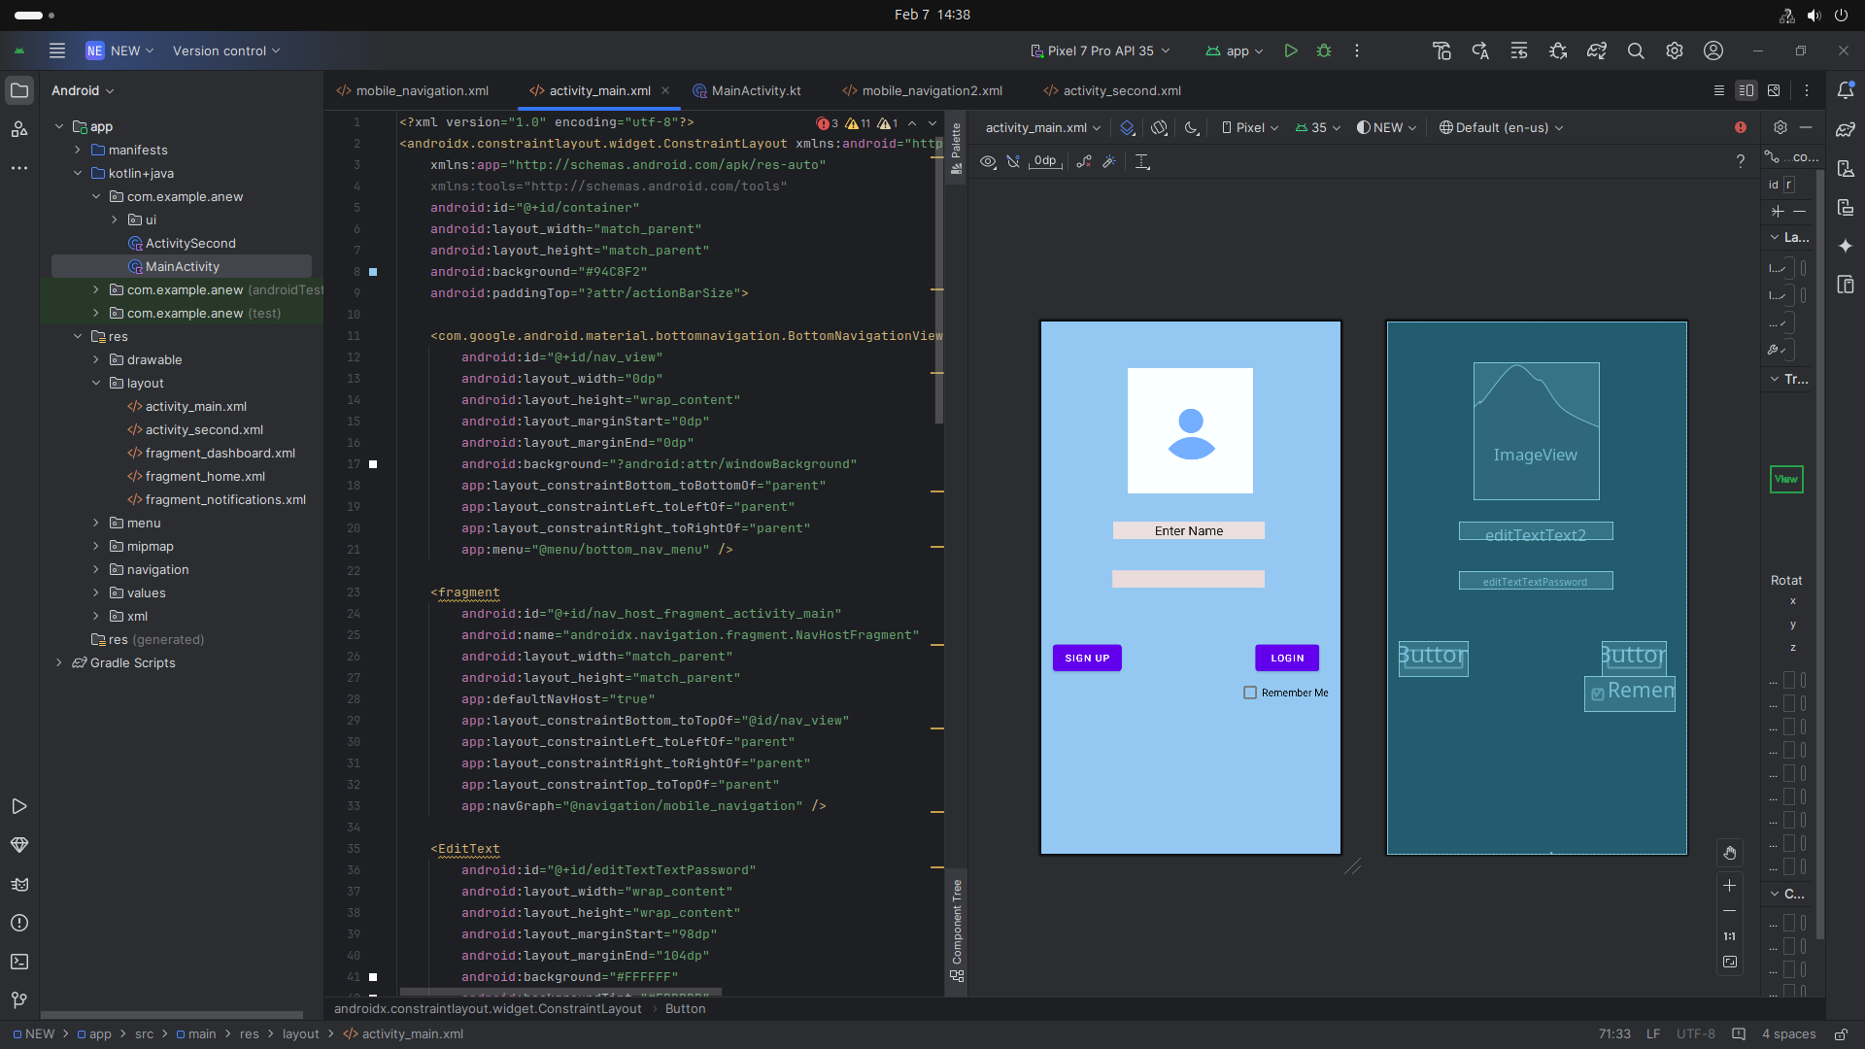

### 

### **Screenshot from 2025-02-07 14-38-54**

### **Step 3: Writing the Code**

* Open MainActivity.java or MainActivity.kt.
* Implement functionality such as Username,Password,Login(button),Restaurant name
* Use necessary Android components like Intents, RecyclerView, Fragments, etc

**Xml=**

## *<?xml version="1.0" encoding="utf-8"?>*

## *<androidx.constraintlayout.widget.ConstraintLayout xmlns:android="http://schemas.android.com/apk/res/android"*

## *xmlns:app="http://schemas.android.com/apk/res-auto"*

## *xmlns:tools="http://schemas.android.com/tools"*

## *android:id="@+id/container"*

## *android:layout_width="match_parent"*

## *android:layout_height="match_parent"*

## *android:background="#94C8F2"*

## *android:paddingTop="?attr/actionBarSize">*

## *<com.google.android.material.bottomnavigation.BottomNavigationView*

## *android:id="@+id/nav_view"*

## *android:layout_width="0dp"*

## *android:layout_height="wrap_content"*

## *android:layout_marginStart="0dp"*

## *android:layout_marginEnd="0dp"*

## *android:background="?android:attr/windowBackground"*

## *app:layout_constraintBottom_toBottomOf="parent"*

## *app:layout_constraintLeft_toLeftOf="parent"*

## *app:layout_constraintRight_toRightOf="parent"*

## *app:menu="@menu/bottom_nav_menu" />*

## *<fragment*

## *android:id="@+id/nav_host_fragment_activity_main"*

## *android:name="androidx.navigation.fragment.NavHostFragment"*

## *android:layout_width="match_parent"*

## *android:layout_height="match_parent"*

## *app:defaultNavHost="true"*

## *app:layout_constraintBottom_toTopOf="@id/nav_view"*

## *app:layout_constraintLeft_toLeftOf="parent"*

## *app:layout_constraintRight_toRightOf="parent"*

## *app:layout_constraintTop_toTopOf="parent"*

## *app:navGraph="@navigation/mobile_navigation" />*

## *<EditText*

## *android:id="@+id/editTextTextPassword"*

## *android:layout_width="wrap_content"*

## *android:layout_height="wrap_content"*

## *android:layout_marginStart="98dp"*

## *android:layout_marginEnd="104dp"*

## *android:background="#FFFFFF"*

## *android:backgroundTint="#EBDBDB"*

## *android:ems="10"*

## *android:inputType="textPassword"*

## *app:layout_constraintBottom_toBottomOf="parent"*

## *app:layout_constraintEnd_toEndOf="parent"*

## *app:layout_constraintHorizontal_bias="1.0"*

## *app:layout_constraintStart_toStartOf="parent"*

## *app:layout_constraintTop_toTopOf="parent"*

## *app:layout_constraintVertical_bias="0.439" />*

## *<EditText*

## *android:id="@+id/editTextText2"*

## *android:layout_width="wrap_content"*

## *android:layout_height="wrap_content"*

## *android:background="#FBFBFB"*

## *android:backgroundTint="#EBDFDF"*

## *android:ems="10"*

## *android:inputType="text"*

## *android:text="Enter Name"*

## *android:textAlignment="center"*

## *app:layout_constraintBottom_toBottomOf="parent"*

## *app:layout_constraintEnd_toEndOf="parent"*

## *app:layout_constraintHorizontal_bias="0.487"*

## *app:layout_constraintStart_toStartOf="parent"*

## *app:layout_constraintTop_toTopOf="parent"*

## *app:layout_constraintVertical_bias="0.336" />*

## *<Button*

## *android:id="@+id/button"*

## *android:layout_width="wrap_content"*

## *android:layout_height="wrap_content"*

## *android:text="Login"*

## *app:layout_constraintBottom_toBottomOf="parent"*

## *app:layout_constraintEnd_toEndOf="parent"*

## *app:layout_constraintHorizontal_bias="0.91"*

## *app:layout_constraintStart_toStartOf="parent"*

## *app:layout_constraintTop_toTopOf="parent"*

## *app:layout_constraintVertical_bias="0.609" />*

## *<Button*

## *android:id="@+id/button2"*

## *android:layout_width="wrap_content"*

## *android:layout_height="wrap_content"*

## *android:text="Sign Up"*

## *app:layout_constraintBottom_toBottomOf="parent"*

## *app:layout_constraintEnd_toEndOf="parent"*

## *app:layout_constraintHorizontal_bias="0.05"*

## *app:layout_constraintStart_toStartOf="parent"*

## *app:layout_constraintTop_toTopOf="parent"*

## *app:layout_constraintVertical_bias="0.609" />*

## *<CheckBox*

## *android:id="@+id/checkBox"*

## *android:layout_width="wrap_content"*

## *android:layout_height="wrap_content"*

## *android:text="Remember Me"*

## *app:layout_constraintBottom_toBottomOf="parent"*

## *app:layout_constraintEnd_toEndOf="parent"*

## *app:layout_constraintHorizontal_bias="0.944"*

## *app:layout_constraintStart_toStartOf="parent"*

## *app:layout_constraintTop_toTopOf="parent"*

## *app:layout_constraintVertical_bias="0.685" />*

## *<ImageView*

## *android:id="@+id/imageView"*

## *android:layout_width="172dp"*

## *android:layout_height="188dp"*

## *app:layout_constraintBottom_toBottomOf="parent"*

## *app:layout_constraintEnd_toEndOf="parent"*

## *app:layout_constraintHorizontal_bias="0.497"*

## *app:layout_constraintStart_toStartOf="parent"*

## *app:layout_constraintTop_toTopOf="parent"*

## *app:layout_constraintVertical_bias="0.0"*

## *app:srcCompat="@drawable/h" />*

## *</androidx.constraintlayout.widget.ConstraintLayout>*

## **4. Procedure & Steps(second page of restaurant App)**

### **Step 1: Create a New Activity**

* Go to App section (Right click) Click on New
* Choose An Activity
* Select an Empty Views Activity
* Set the project name and package name of your Application
* Select the programming language (Java/Kotlin).
* **Screenshot:**

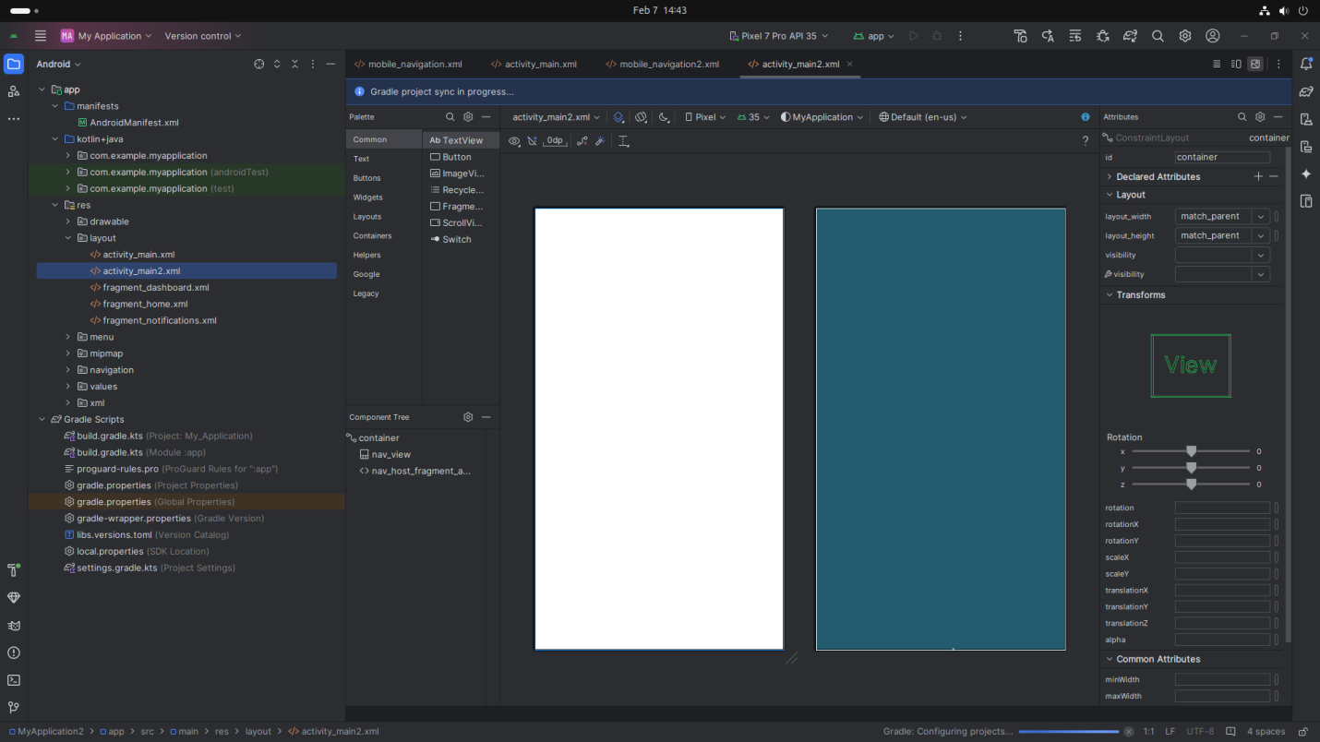

### **Step 2: Designing the UI**

* Open activity_main2.xml and design the layout using XML.
* Add UI comwponents such as TextView, EditText,Radio Button,image etc.

**Screenshot:**

## **Screenshot from 2025-02-07 14-44-33**

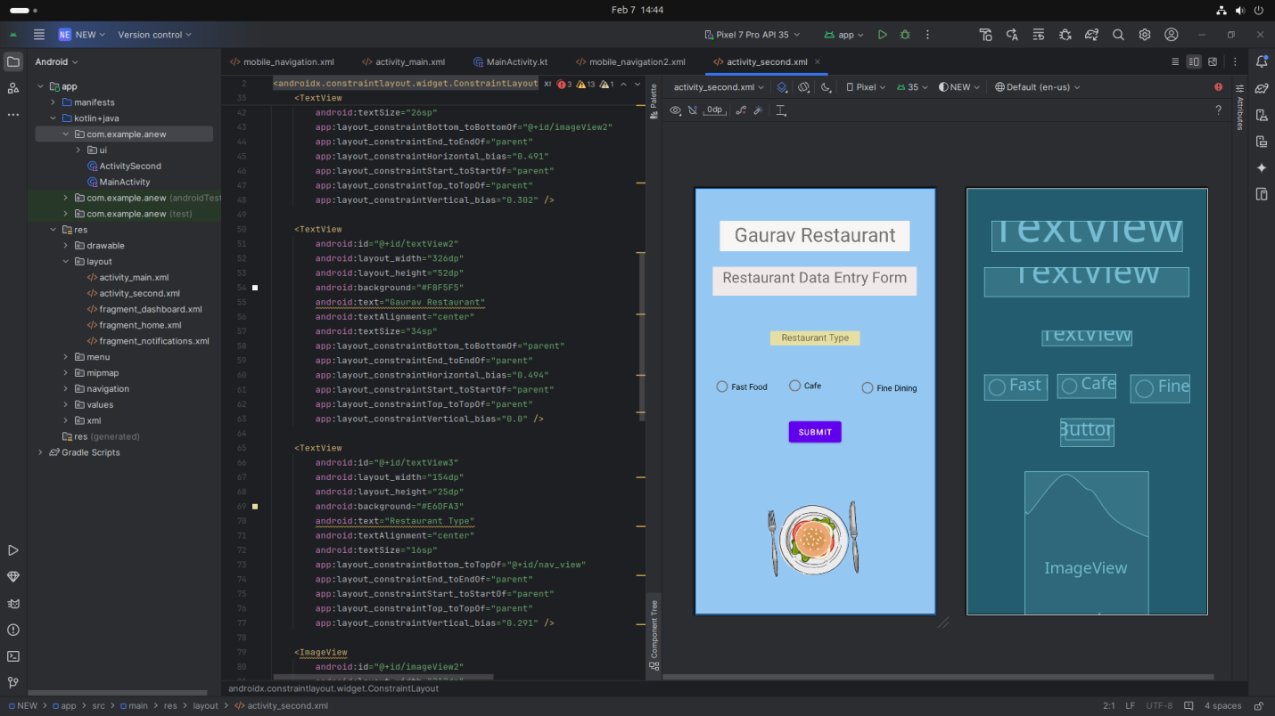

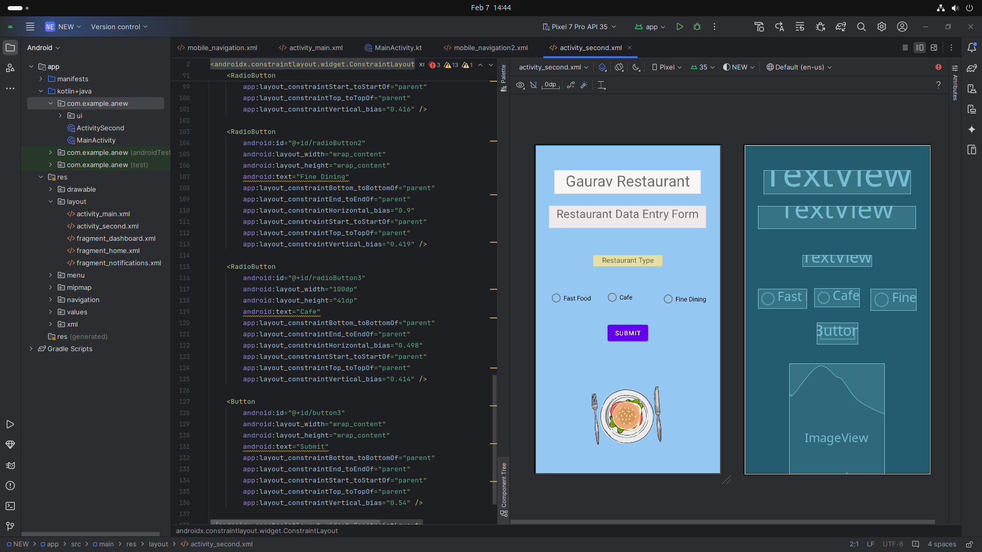

### **Step 3: Writing the Code**

* Open MainActivity.java or MainActivity2.kt.
* Implement functionality such as Username,Password,Login(button),Restaurant name
* Use necessary Android components like Intents, RecyclerView, Fragments, etc

**Xml=**

### <?xml version="1.0" encoding="utf-8"?>

### <androidx.constraintlayout.widget.ConstraintLayout xmlns:android="http://schemas.android.com/apk/res/android"

### xmlns:app="http://schemas.android.com/apk/res-auto"

### xmlns:tools="http://schemas.android.com/tools"

### android:id="@+id/container"

### android:layout_width="match_parent"

### android:layout_height="match_parent"

### android:background="#94C8F2"

### android:paddingTop="?attr/actionBarSize">

### <com.google.android.material.bottomnavigation.BottomNavigationView

### android:id="@+id/nav_view"

### android:layout_width="0dp"

### android:layout_height="wrap_content"

### android:layout_marginStart="0dp"

### android:layout_marginEnd="0dp"

### android:background="?android:attr/windowBackground"

### app:layout_constraintBottom_toBottomOf="parent"

### app:layout_constraintLeft_toLeftOf="parent"

### app:layout_constraintRight_toRightOf="parent"

### app:menu="@menu/bottom_nav_menu" />

### <fragment

### android:id="@+id/nav_host_fragment_activity_second"

### android:name="androidx.navigation.fragment.NavHostFragment"

### android:layout_width="match_parent"

### android:layout_height="match_parent"

### app:defaultNavHost="true"

### app:layout_constraintBottom_toTopOf="@id/nav_view"

### app:layout_constraintLeft_toLeftOf="parent"

### app:layout_constraintRight_toRightOf="parent"

### app:layout_constraintTop_toTopOf="parent"

### app:navGraph="@navigation/mobile_navigation2" />

### <TextView

### android:id="@+id/textView"

### android:layout_width="350dp"

### android:layout_height="50dp"

### android:background="#EFE9E9"

### android:text="Restaurant Data Entry Form"

### android:textAlignment="center"

### android:textSize="26sp"

### app:layout_constraintBottom_toBottomOf="@+id/imageView2"

### app:layout_constraintEnd_toEndOf="parent"

### app:layout_constraintHorizontal_bias="0.491"

### app:layout_constraintStart_toStartOf="parent"

### app:layout_constraintTop_toTopOf="parent"

### app:layout_constraintVertical_bias="0.302" />

### <TextView

### android:id="@+id/textView2"

### android:layout_width="326dp"

### android:layout_height="52dp"

### android:background="#F8F5F5"

### android:text="Gaurav Restaurant"

### android:textAlignment="center"

### android:textSize="34sp"

### app:layout_constraintBottom_toBottomOf="parent"

### app:layout_constraintEnd_toEndOf="parent"

### app:layout_constraintHorizontal_bias="0.494"

### app:layout_constraintStart_toStartOf="parent"

### app:layout_constraintTop_toTopOf="parent"

### app:layout_constraintVertical_bias="0.0" />

### <TextView

### android:id="@+id/textView3"

### android:layout_width="154dp"

### android:layout_height="25dp"

### android:background="#E6DFA3"

### android:text="Restaurant Type"

### android:textAlignment="center"

### android:textSize="16sp"

### app:layout_constraintBottom_toTopOf="@+id/nav_view"

### app:layout_constraintEnd_toEndOf="parent"

### app:layout_constraintStart_toStartOf="parent"

### app:layout_constraintTop_toTopOf="parent"

### app:layout_constraintVertical_bias="0.291" />

### <ImageView

### android:id="@+id/imageView2"

### android:layout_width="212dp"

### android:layout_height="246dp"

### app:layout_constraintBottom_toBottomOf="parent"

### app:layout_constraintEnd_toEndOf="parent"

### app:layout_constraintHorizontal_bias="0.497"

### app:layout_constraintStart_toStartOf="parent"

### app:layout_constraintTop_toTopOf="parent"

### app:layout_constraintVertical_bias="1.0"

### app:srcCompat="@drawable/f" />

### <RadioButton

### android:id="@+id/radioButton"

### android:layout_width="108dp"

### android:layout_height="43dp"

### android:text="Fast Food"

### app:layout_constraintBottom_toBottomOf="parent"

### app:layout_constraintEnd_toEndOf="parent"

### app:layout_constraintHorizontal_bias="0.099"

### app:layout_constraintStart_toStartOf="parent"

### app:layout_constraintTop_toTopOf="parent"

### app:layout_constraintVertical_bias="0.416" />

### <RadioButton

### android:id="@+id/radioButton2"

### android:layout_width="wrap_content"

### android:layout_height="wrap_content"

### android:text="Fine Dining"

### app:layout_constraintBottom_toBottomOf="parent"

### app:layout_constraintEnd_toEndOf="parent"

### app:layout_constraintHorizontal_bias="0.9"

### app:layout_constraintStart_toStartOf="parent"

### app:layout_constraintTop_toTopOf="parent"

### app:layout_constraintVertical_bias="0.419" />

### <RadioButton

### android:id="@+id/radioButton3"

### android:layout_width="100dp"

### android:layout_height="41dp"

### android:text="Cafe"

### app:layout_constraintBottom_toBottomOf="parent"

### app:layout_constraintEnd_toEndOf="parent"

### app:layout_constraintHorizontal_bias="0.498"

### app:layout_constraintStart_toStartOf="parent"

### app:layout_constraintTop_toTopOf="parent"

### app:layout_constraintVertical_bias="0.414" />

### <Button

### android:id="@+id/button3"

### android:layout_width="wrap_content"

### android:layout_height="wrap_content"

### android:text="Submit"

### app:layout_constraintBottom_toBottomOf="parent"

### app:layout_constraintEnd_toEndOf="parent"

### app:layout_constraintStart_toStartOf="parent"

### app:layout_constraintTop_toTopOf="parent"

### app:layout_constraintVertical_bias="0.54" />

### </androidx.constraintlayout.widget.ConstraintLayout>

### **Step 5: Writing the Backend Code**

### **For first Page=**

* Open MainActivity.java or MainActivity.kt.
* Implement functionality such as By Click on Button Go to Next Activity

**Screenshot:**

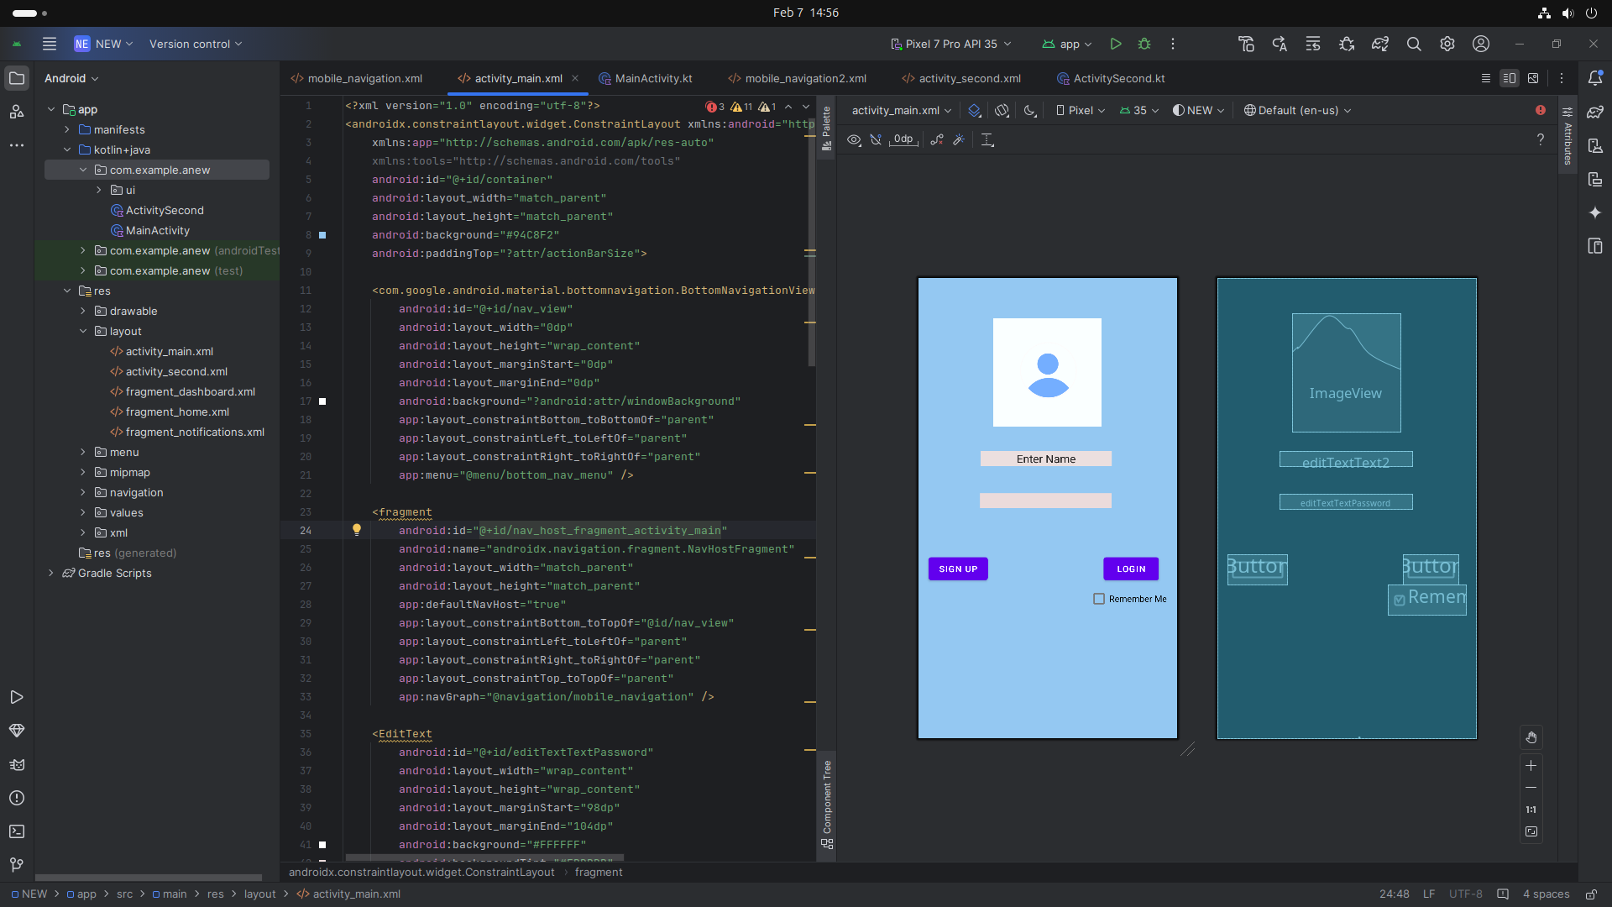

**Kotlin:**

## **Code:**

package com.example.anew

import android.content.Intent

import android.os.Bundle

import android.widget.Button

import com.google.android.material.bottomnavigation.BottomNavigationView

import androidx.appcompat.app.AppCompatActivity

import androidx.navigation.findNavController

import androidx.navigation.ui.AppBarConfiguration

import androidx.navigation.ui.setupActionBarWithNavController

import androidx.navigation.ui.setupWithNavController

import com.example.anew.databinding.ActivityMainBinding

class MainActivity : AppCompatActivity() {

private lateinit var binding: ActivityMainBinding

override fun onCreate(savedInstanceState: Bundle?) {

super.onCreate(savedInstanceState)

binding = ActivityMainBinding.inflate(layoutInflater)

setContentView(binding.root)

val navView: BottomNavigationView = binding.navView

val navController = findNavController(R.id.nav_host_fragment_activity_main)

// Passing each menu ID as a set of Ids because each

// menu should be considered as top level destinations.

val appBarConfiguration = AppBarConfiguration(

setOf(

R.id.navigation_home, R.id.navigation_dashboard, R.id.navigation_notifications

)

)

setupActionBarWithNavController(navController, appBarConfiguration)

navView.setupWithNavController(navController)

val activity2ctbutton = findViewById<Button>(R.id.button)

activity2ctbutton.setOnClickListener() {

val Intent = Intent( this, activity2ctbutton::class.java)

startActivity(Intent)

}

}

}

**For Second Page=**

**Screenshot:**

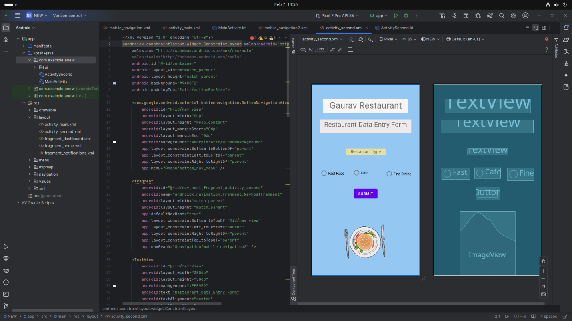

**Kotlin:**

package com.example.anew

import android.os.Bundle

import com.google.android.material.bottomnavigation.BottomNavigationView

import androidx.appcompat.app.AppCompatActivity

import androidx.navigation.findNavController

import androidx.navigation.ui.AppBarConfiguration

import androidx.navigation.ui.setupActionBarWithNavController

import androidx.navigation.ui.setupWithNavController

import com.example.anew.databinding.ActivitySecondBinding

class ActivitySecond : AppCompatActivity() {

private lateinit var binding: ActivitySecondBinding

override fun onCreate(savedInstanceState: Bundle?) {

super.onCreate(savedInstanceState)

binding = ActivitySecondBinding.inflate(layoutInflater)

setContentView(binding.root)

val navView: BottomNavigationView = binding.navView

val navController = findNavController(R.id.nav_host_fragment_activity_second)

// Passing each menu ID as a set of Ids because each

// menu should be considered as top level destinations.

val appBarConfiguration = AppBarConfiguration(

setOf(

R.id.navigation_home, R.id.navigation_dashboard, R.id.navigation_notifications

)

)

setupActionBarWithNavController(navController, appBarConfiguration)

navView.setupWithNavController(navController)

}

}

### **Step 6: Running the Application on Emulator**

* Click on the **Run** button in Android Studio.
* Select the emulator and launch the app.

**Screenshot:**

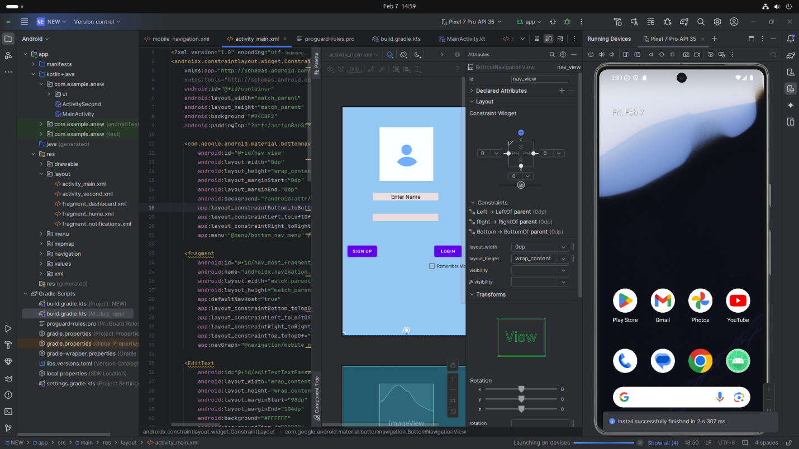

### **Step 7: Testing & Output**

* Test different functionalities of the app.
* Capture the output results.
* **Screenshot:**

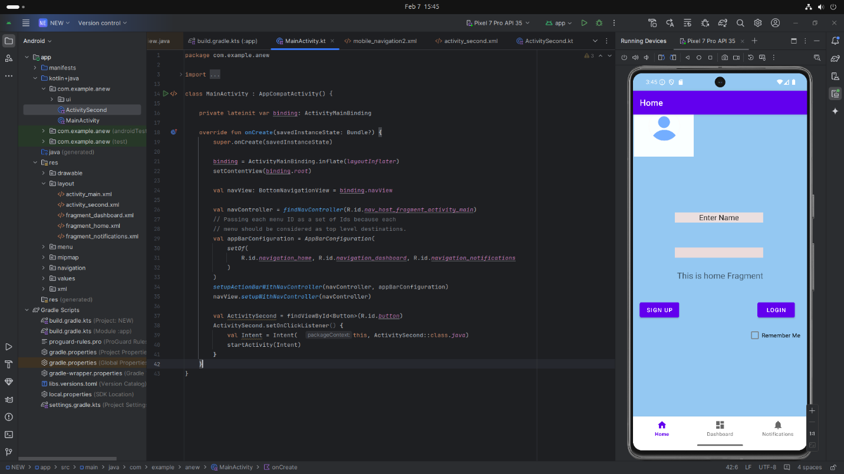

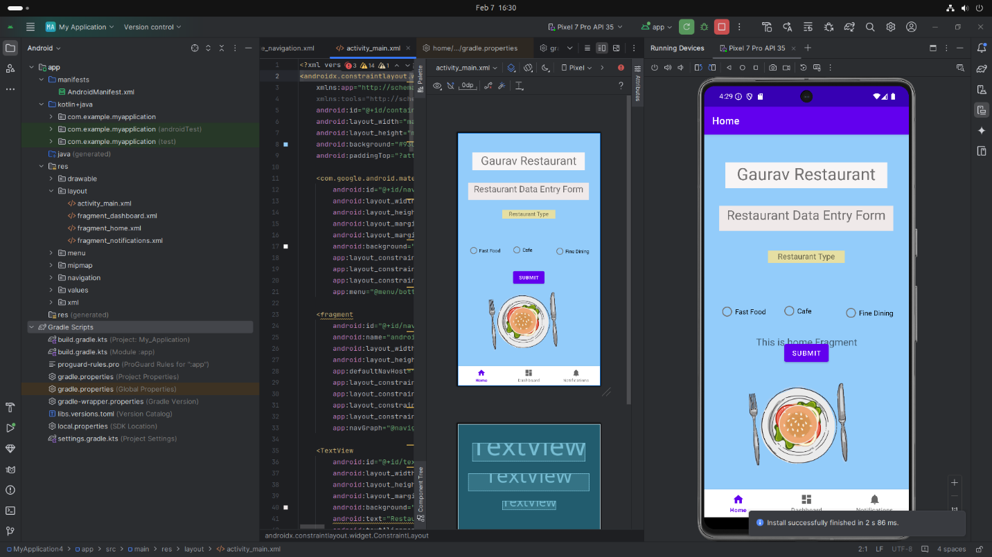

## **4. Conclusion**

I learned a lot about creating a restaurant data entry form using a table layout in Kotlin and Java for Android development. I gained new skills, like how to design a user-friendly interface with fields for restaurant name, location, cuisine type, and radio buttons for restaurant type selection. Some challenges I faced included figuring out how to properly organize the layout and ensure all fields were correctly linked, but I was able to overcome these by researching and experimenting with the code. In the end, I feel more confident in my ability to create forms and solve layout-related problems. This experience also helped me improve my problem-solving skills and manage my time better.

窗体顶端

窗体底端

.