# **ASSIGNMENT NO.3**

# **Gaurav_bodkhe_2124UCEM1041**

## **1. Introduction**

## In this program, we will create a simple app that allows users to make phone calls by typing a mobile number. The user can enter the phone number they wish to call into a text field. After entering the number, they can press a "Call" button to initiate the call. This app provides a straightforward way for users to dial a number and make a call directly, without the need for selecting contacts from a list.

## **2. Tools & Technologies Used**

* Android Studio
* Java
* Emulator

## **3. Procedure & Steps**

### **Step 1: Create a New Project**

* Open Android Studio and create a new project.
* Choose an Empty Views Activity template.
* Set the project name and package name of your Application
* Select the programming language (Java).
* **Screenshot:**

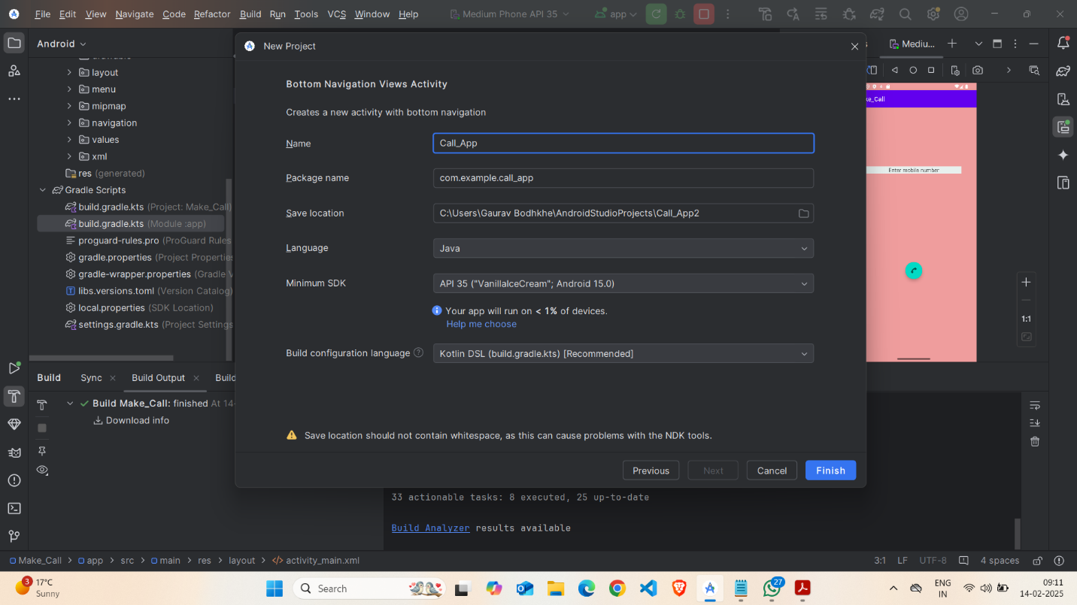

### 

### **Step 2: Designing the UI**

* Open activity_main.xml and design the layout using XML.
* Add UI comwponents such as Ab Phone Text, EditText,TextView CallButton, etc.

**Screenshot:**

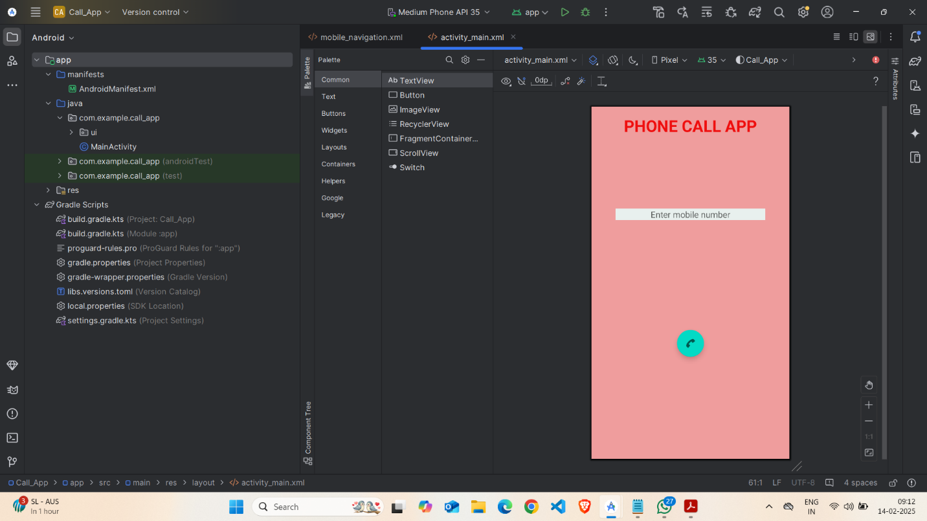

### **Step 3: Writing the Code**

* Open Activity_main.xml
* Implement functionality such as Enter Mobile No, floating action button,
* Use necessary Android components like Intents, RecyclerView, Fragments, etc
* **Screenshot:**

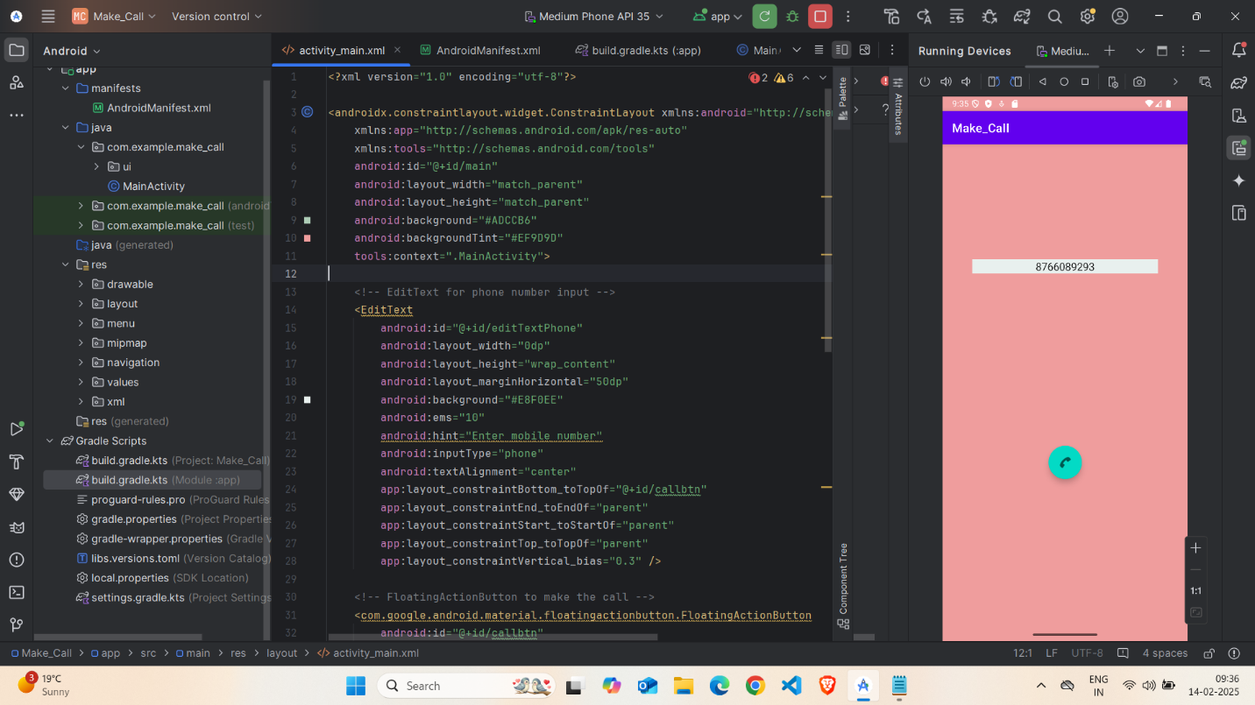

* **XML**

*<?xml version="1.0" encoding="utf-8"?>*

### *<androidx.constraintlayout.widget.ConstraintLayout xmlns:android="http://schemas.android.com/apk/res/android"*

### *xmlns:app="http://schemas.android.com/apk/res-auto"*

### *xmlns:tools="http://schemas.android.com/tools"*

### *android:id="@+id/main"*

### *android:layout_width="match_parent"*

### *android:layout_height="match_parent"*

### *android:background="#ADCCB6"*

### *android:backgroundTint="#EF9D9D"*

### *tools:context=".MainActivity">*

### *<!-- EditText for phone number input -->*

### *<EditText*

### *android:id="@+id/editTextPhone"*

### *android:layout_width="0dp"*

### *android:layout_height="wrap_content"*

### *android:layout_marginHorizontal="50dp"*

### *android:background="#E8F0EE"*

### *android:ems="10"*

### *android:hint="Enter mobile number"*

### *android:inputType="phone"*

### *android:textAlignment="center"*

### *app:layout_constraintBottom_toTopOf="@+id/callbtn"*

### *app:layout_constraintEnd_toEndOf="parent"*

### *app:layout_constraintStart_toStartOf="parent"*

### *app:layout_constraintTop_toTopOf="parent"*

### *app:layout_constraintVertical_bias="0.3" />*

### *<!-- FloatingActionButton to make the call -->*

### *<com.google.android.material.floatingactionbutton.FloatingActionButton*

### *android:id="@+id/callbtn"*

### *android:layout_width="wrap_content"*

### *android:layout_height="wrap_content"*

### *android:layout_marginTop="16dp"*

### *android:src="@android:drawable/ic_menu_call"*

### *app:layout_constraintBottom_toBottomOf="parent"*

### *app:layout_constraintEnd_toEndOf="parent"*

### *app:layout_constraintHorizontal_bias="0.5"*

### *app:layout_constraintStart_toStartOf="parent"*

### *app:layout_constraintTop_toBottomOf="@+id/editTextPhone"*

### *app:layout_constraintVertical_bias="0.5" />*

### *<!-- TextView for displaying app name -->*

### *<TextView*

### *android:id="@+id/textView"*

### *android:layout_width="wrap_content"*

### *android:layout_height="wrap_content"*

### *android:text="PHONE CALL APP"*

### *android:textAlignment="center"*

### *android:textColor="#EF0E0E"*

### *android:textSize="34sp"*

### *android:textStyle="bold"*

### *app:layout_constraintBottom_toTopOf="@+id/editTextPhone"*

### *app:layout_constraintEnd_toEndOf="parent"*

### *app:layout_constraintStart_toStartOf="parent"*

### *app:layout_constraintTop_toTopOf="parent"*

### *app:layout_constraintVertical_bias="0.1" />*

### *</androidx.constraintlayout.widget.ConstraintLayout>*

### **Step 4: Writing the Code (For Uses Permission)**

* Open AndroidManifest.xml
* Implement functionality get Uses Permission Android-Permission for Call_App

**Screenshot:**

## 

* **Code(** AndroidManifest.xml**)**

*<?xml version="1.0" encoding="utf-8"?>*

*<manifest xmlns:android=*[*http://schemas.android.com/apk/res/android*](http://schemas.android.com/apk/res/android)

*xmlns:tools="http://schemas.android.com/tools">*

*<!-- Permission to make phone calls -->*

*<uses-permission android:name="android.permission.CALL_PHONE" />*

### *<application*

### *android:allowBackup="true"*

### *android:dataExtractionRules="@xml/data_extraction_rules"*

### *android:fullBackupContent="@xml/backup_rules"*

### *android:icon="@mipmap/ic_launcher"*

### *android:label="@string/app_name"*

### *android:roundIcon="@mipmap/ic_launcher_round"*

### *android:supportsRtl="true"*

### *android:theme="@style/Theme.Make_Call"*

### *tools:targetApi="31">*

### *<!-- Main Activity -->*

### *<activity*

### *android:name=".MainActivity"*

### *android:exported="true"*

### *android:label="@string/app_name">*

### *<intent-filter>*

### *<action android:name="android.intent.action.MAIN" />*

### *<category android:name="android.intent.category.LAUNCHER" />*

### *</intent-filter>*

### *</activity>*

### *</application>*

### *</manifest>*

### **Step 5: Writing the Backend Code (java)**

* Open MainActivity.java
* Implement functionality such as By Click on Call Button The Call get started.

**Screenshot:**

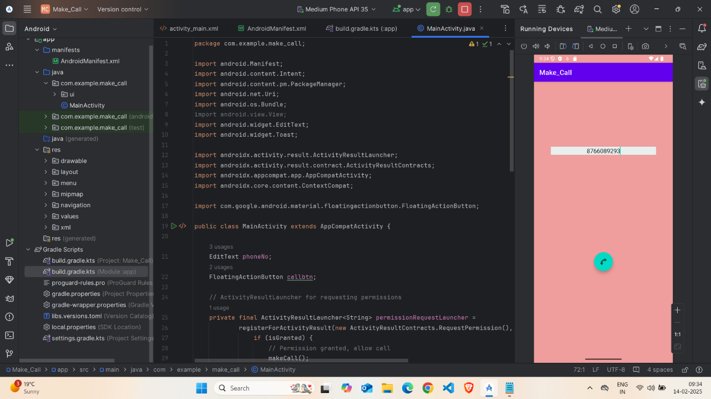

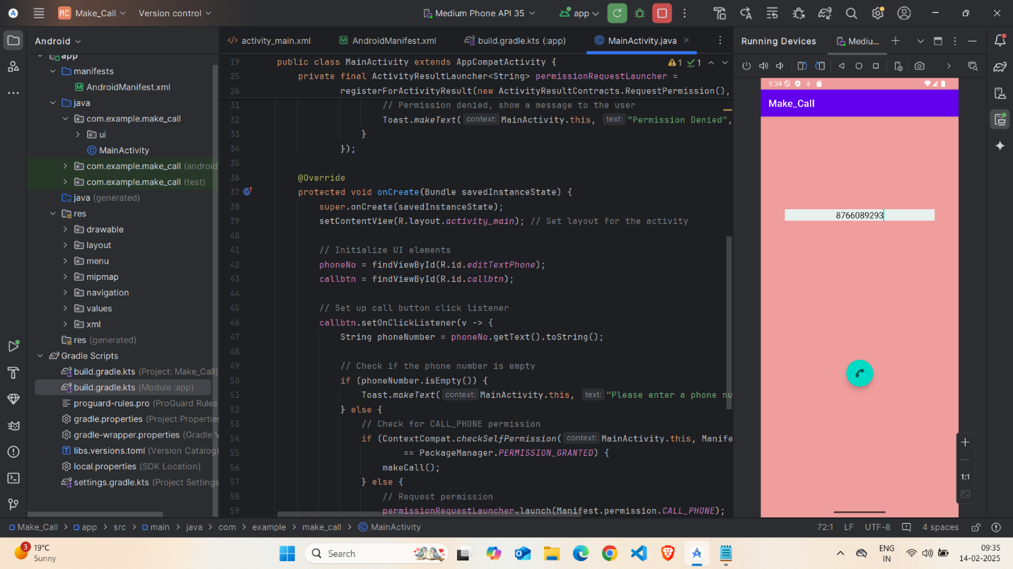

## **Code(java):**

*package com.example.make_call;*

*import android.Manifest;*

*import android.content.Intent;*

*import android.content.pm.PackageManager;*

*import android.net.Uri;*

*import android.os.Bundle;*

*import android.view.View;*

*import android.widget.EditText;*

*import android.widget.Toast;*

*import androidx.activity.result.ActivityResultLauncher;*

*import androidx.activity.result.contract.ActivityResultContracts;*

*import androidx.appcompat.app.AppCompatActivity;*

*import androidx.core.content.ContextCompat;*

*import com.google.android.material.floatingactionbutton.FloatingActionButton;*

*public class MainActivity extends AppCompatActivity {*

*EditText phoneNo;*

*FloatingActionButton callbtn;*

*// ActivityResultLauncher for requesting permissions*

*private final ActivityResultLauncher<String> permissionRequestLauncher =*

*registerForActivityResult(new ActivityResultContracts.RequestPermission(), isGranted -> {*

*if (isGranted) {*

*// Permission granted, allow call*

*makeCall();*

*} else {*

*// Permission denied, show a message to the user*

*Toast.makeText(MainActivity.this, "Permission Denied", Toast.LENGTH_SHORT).show();*

*}*

*});*

*@Override*

*protected void onCreate(Bundle savedInstanceState) {*

*super.onCreate(savedInstanceState);*

*setContentView(R.layout.activity_main); // Set layout for the activity*

*// Initialize UI elements*

*phoneNo = findViewById(R.id.editTextPhone);*

*callbtn = findViewById(R.id.callbtn);*

*// Set up call button click listener*

*callbtn.setOnClickListener(v -> {*

*String phoneNumber = phoneNo.getText().toString();*

*// Check if the phone number is empty*

*if (phoneNumber.isEmpty()) {*

*Toast.makeText(MainActivity.this, "Please enter a phone number", Toast.LENGTH_SHORT).show();*

*} else {*

*// Check for CALL_PHONE permission*

*if (ContextCompat.checkSelfPermission(MainActivity.this, Manifest.permission.CALL_PHONE)*

*== PackageManager.PERMISSION_GRANTED) {*

*makeCall();*

*} else {*

*// Request permission*

*permissionRequestLauncher.launch(Manifest.permission.CALL_PHONE);*

*}*

*}*

*});*

*}*

*private void makeCall() {*

*String phoneNumber = phoneNo.getText().toString();*

*Intent intent = new Intent(Intent.ACTION_CALL);*

*intent.setData(Uri.parse("tel:" + phoneNumber));*

*startActivity(intent); // Start the activity to make the call*

*}*

*}*

### **Step 6: Running the Application on Emulator**

* Click on the **Run** button in Android Studio.
* Select the emulator and launch the app.

**Screenshot:**

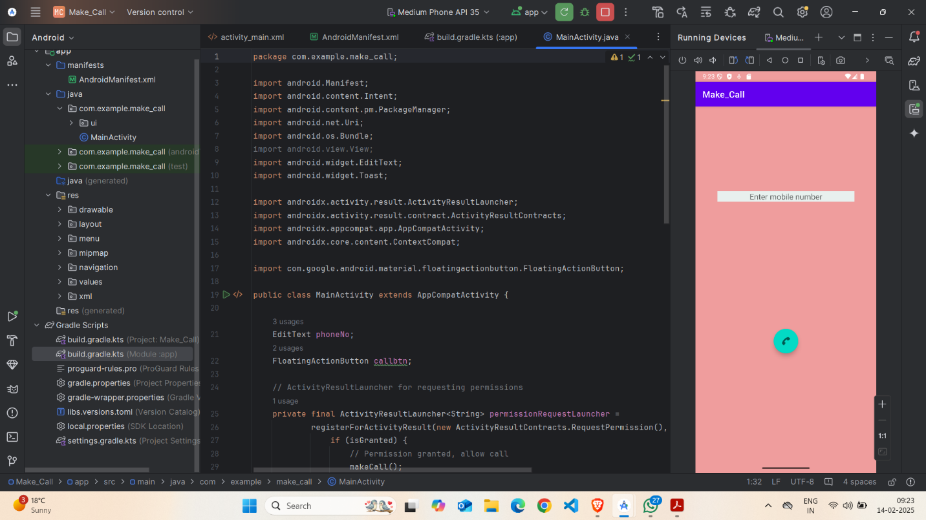

### **Step 5: Testing & Output**

* Test different functionalities of the app.
* Capture the output results.
* **Screenshot:**



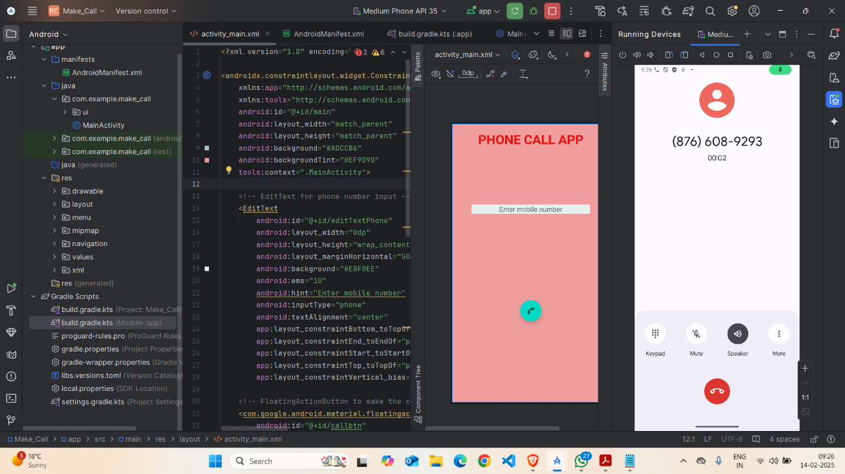

## **4. Conclusion**

I learned a lot about creating a simple phone dialing app using Java for Android development. I gained valuable skills in designing a user-friendly interface where users can input a phone number and press a "Call" button to make a call. One challenge I faced was organizing the layout and ensuring the button worked properly, but I solved these issues by researching and experimenting with the code. By the end, I felt more confident in building apps with basic functionality and fixing layout problems. This experience also helped me improve my problem-solving skills and manage my time better.

窗体顶端

窗体底端

.