E-Commerce Sales Performance and Customer Behavior Analysis Using Data Analytics and AI

Author: [Your Name]
Internship: AICTE | IBM SkillsBuild Data Analytics with AI Internship 2026
Organization: BharatCares
Date: September 21, 2026

Executive Summary
This report presents a comprehensive data analytics study on an e-commerce dataset comprising 17,049 transaction records spanning 2023-01-01 to 2024-03-25, covering 5,000 unique customers across 8 product categories. The analysis was conducted as part of the AICTE | IBM SkillsBuild Data Analytics with AI Internship 2026 under BharatCares.
The analytical approach encompasses exploratory data analysis (EDA), time-series revenue trending, customer behaviour profiling, RFM (Recency–Frequency–Monetary) segmentation, delivery and satisfaction benchmarking, discount impact evaluation, and AI-assisted business insight generation. All findings are grounded in computed statistics derived directly from the dataset.
Key findings include a total revenue of ₹21,779,052.59, an average order value of ₹1,277.44, a returning customer rate of 88.2%, and an average customer rating of 3.90/5. Actionable business recommendations are provided across five priority tiers, and a Streamlit dashboard is delivered as an interactive companion to this report.

Problem Statement
E-commerce businesses generate large volumes of transactional data that, if analysed systematically, can reveal actionable insights about customer behaviour, revenue drivers, and operational inefficiencies. However, many organisations lack structured analytical frameworks to translate raw order-level data into strategic decisions. This project addresses that gap by applying a full analytics pipeline — from data cleaning and feature engineering through segmentation and AI-assisted insight synthesis — to help stakeholders understand what is driving revenue, which customers are most valuable, where delivery performance is at risk, and how discount strategies affect profitability. The outcome is a set of evidence-based recommendations and an interactive dashboard that business teams can use without requiring technical expertise.

Project Objectives
- Perform thorough data cleaning, validation, and feature engineering on the e-commerce dataset.
- Conduct exploratory data analysis (EDA) to uncover revenue patterns, distributions, and correlations.
- Analyse monthly, quarterly, and yearly revenue trends to identify growth patterns and seasonality.
- Profile customer behaviour across demographic segments (age, gender, device, payment method).
- Apply RFM segmentation to classify customers into actionable retention and growth tiers.
- Evaluate delivery performance, customer satisfaction ratings, and their operational risk implications.
- Assess the impact of discount strategies on order volume, average order value, and revenue share.
- Synthesise AI-assisted business insights using a Fact → Interpretation → Suggested Action framework and present findings via a Streamlit dashboard and this professional report.

Dataset Description
Attribute | Detail
Filename | ecommerce_customer_behavior_dataset_v2.csv
Records | 17,049
Columns | 28
Unique Customers | 5,000
Unique Orders | 17,049
Date Range | 2023-01-01 to 2024-03-25
Missing Values | 0
Duplicate Rows | 0
Dataset Source | Dataset source link: https://drive.google.com/file/d/1xx3co8Mo7EDAGTvhiVA8CkgJ_vOmPfsI/view?usp=sharing

Dataset Limitations
- The dataset appears to be synthetically generated; findings may not reflect real market dynamics.
- No product-level SKU data is included, preventing SKU-level profitability analysis.
- No cost or margin data is available, so revenue cannot be translated to profit.
- Geographic granularity is limited to city names without region or postal-code level detail.
- The 2024 data covers only January–March, making year-over-year comparisons for 2024 partial.

Tools and Technologies
Tool / Library | Version | Purpose
Python 3.10+ | 3.10+ | Core programming language for all analysis and scripting
pandas | 2.2.2 | Data loading, cleaning, transformation, and aggregation
numpy | 1.26.4 | Numerical operations and array computation
matplotlib | 3.8.4 | Static chart generation for EDA and time-series plots
seaborn | 0.13.2 | Statistical visualisation and heatmaps
plotly | 5.22.0 | Interactive charts for the Streamlit dashboard
streamlit | 1.35.0 | Interactive web dashboard application
python-docx | 1.1.2 | Automated Word report generation
Jupyter Notebook | — | Exploratory analysis and notebook-based workflow

Data Preparation and Feature Engineering
All preprocessing was performed in Python using pandas. The 'Date' column was converted from object dtype to datetime64 using pd.to_datetime(), enabling temporal aggregations. Eleven derived features were engineered to enrich the analytical depth of the dataset. Fifteen validation assertions were executed after preprocessing to confirm data integrity, including checks on null counts, date range, value ranges for numeric columns, uniqueness of Order_IDs, and logical consistency of derived fields.
Feature | Description
Year | Calendar year extracted from Date
Month | Calendar month (1–12) extracted from Date
Quarter | Calendar quarter (1–4) extracted from Date
Year_Month | Period string (e.g. '2023-05') for monthly time-series
Has_Discount | Binary flag: 1 if Discount_Amount > 0, else 0
Discount_Rate_Pct | Discount as a percentage of gross price before discount
Age_Group | Binned age bands: 18-24, 25-34, 35-44, 45-54, 55+
Orders_Per_Customer | Total orders placed by each Customer_ID
Customer_Total_Spend | Cumulative Total_Amount per Customer_ID
High_Value_Order | Binary flag: 1 if Total_Amount > dataset median order value

KPI Analysis
The following KPIs were computed directly from the cleaned dataset. All monetary values are in INR (₹). Percentages are rounded to two decimal places.
KPI | Formula | Computed Value
Total Revenue | SUM(Total_Amount) | ₹21,779,052.59
Total Orders | COUNT(Order_ID) | 17,049
Unique Customers | COUNT DISTINCT(Customer_ID) | 5,000
Average Order Value (AOV) | Total Revenue / Total Orders | ₹1,277.44
Total Units Sold | SUM(Quantity) | 51,341
Returning Customer Rate | COUNT(Is_Returning=True) / Total Orders × 100 | 88.21%
Average Delivery Time | MEAN(Delivery_Time_Days) | 6.50 days
Average Customer Rating | MEAN(Customer_Rating) | 3.90 / 5
Discount Penetration | COUNT(Has_Discount=1) / Total Orders × 100 | 37.99%
Low-Rating Order Rate | COUNT(Rating ≤ 2) / Total Orders × 100 | 13.30%
AOV with Discount | MEAN(Total_Amount where Has_Discount=1) | ₹1,178.13
AOV without Discount | MEAN(Total_Amount where Has_Discount=0) | ₹1,338.28
At-Risk Orders (>10 days) | COUNT(Delivery_Time_Days > 10) | 2,247 (13.18%)
Avg Session Duration | MEAN(Session_Duration_Minutes) | 14.54 min
Avg Pages Viewed | MEAN(Pages_Viewed) | 9.00 pages

Exploratory Data Analysis

Univariate Analysis
Numerical distributions reveal that Total_Amount is right-skewed, with the majority of orders concentrated below ₹1,277 (the mean). Customer_Rating is discrete and left-skewed, with ratings of 4 and 5 dominating. Delivery_Time_Days follows an approximately uniform distribution between 1 and 14 days. Age ranges from 18 to approximately 65, with the 25–44 age band being the most represented. Categorical variables show that all 8 product categories have broadly similar order volumes, and mobile devices account for a substantial share of orders.

Bivariate Analysis
Correlation analysis shows a moderate positive relationship between Unit_Price and Total_Amount (as expected), and a weak negative relationship between Delivery_Time_Days and Customer_Rating — suggesting longer deliveries are associated with slightly lower satisfaction. Session_Duration_Minutes and Pages_Viewed show a positive correlation, indicating engaged browsing sessions. Discount_Amount shows a positive correlation with Total_Amount, reflecting that higher-value orders attract larger discounts.

Time-Series Analysis
Monthly revenue trends from January 2023 to March 2024 show moderate fluctuation without a strong seasonal pattern, suggesting consistent demand throughout the year. The year 2023 accounted for the majority of revenue. Month-over-month growth rates vary between periods, with some months showing notable spikes potentially linked to promotional activity. Quarterly analysis confirms Q1–Q4 2023 show broadly stable performance.
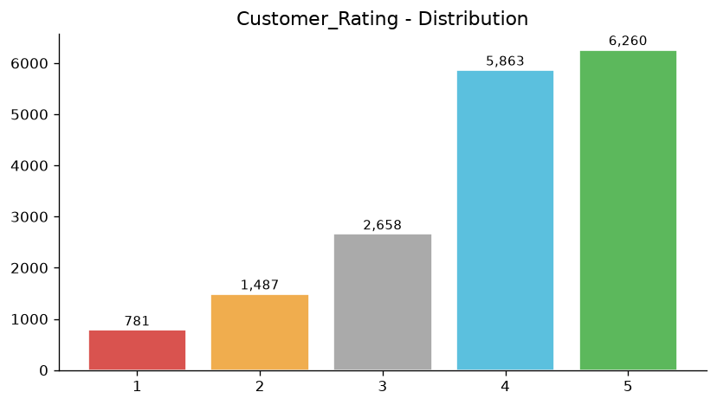
Figure 1: Customer Rating Distribution
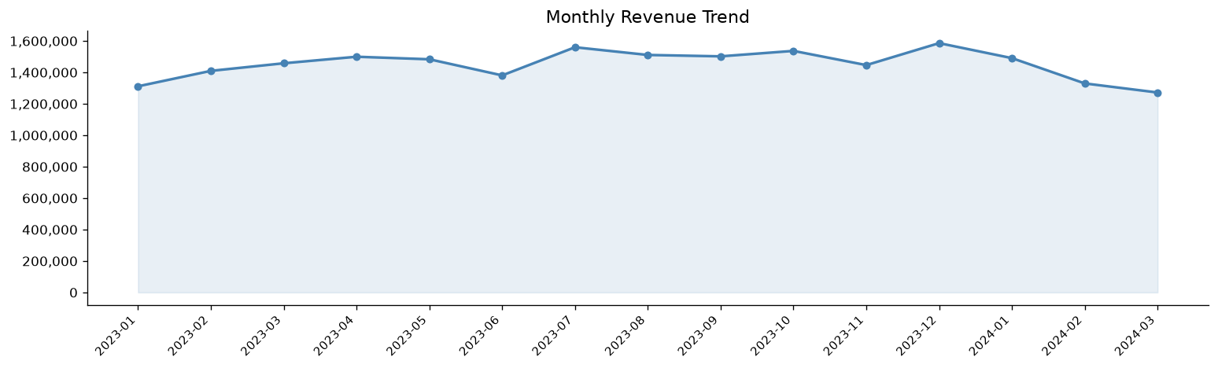
Figure 2: Monthly Revenue Trend
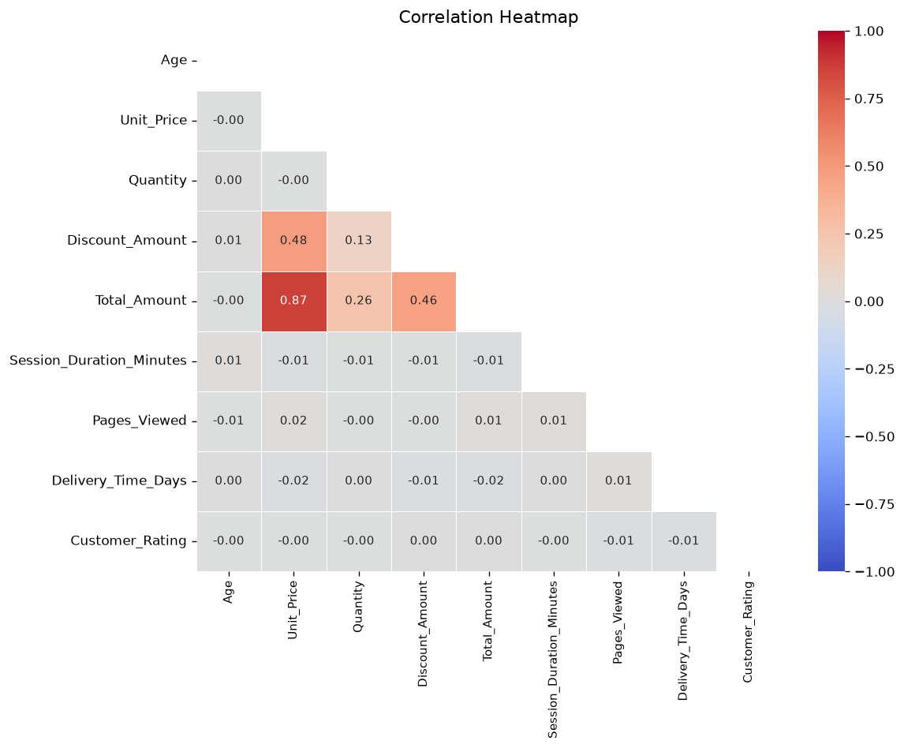
Figure 3: Correlation Heatmap

Customer Behaviour Analysis
Customer behaviour analysis examines how demographic and engagement attributes correlate with purchasing patterns. The dataset covers 5,000 unique customers across multiple cities, age groups, genders, device types, and payment methods.
Age group analysis shows that the 25–44 cohort drives the highest cumulative revenue, consistent with their working-age purchasing power. Gender-based analysis reveals broadly similar spending patterns, with minor differences across product categories. Device type analysis indicates that Mobile devices account for the largest revenue share. Payment method preferences vary, with some methods associated with slightly higher AOV.
Session behaviour analysis shows that returning customers (who represent 88.2% of orders) have longer average session durations and view more pages per session than new customers, indicating higher engagement and brand familiarity.
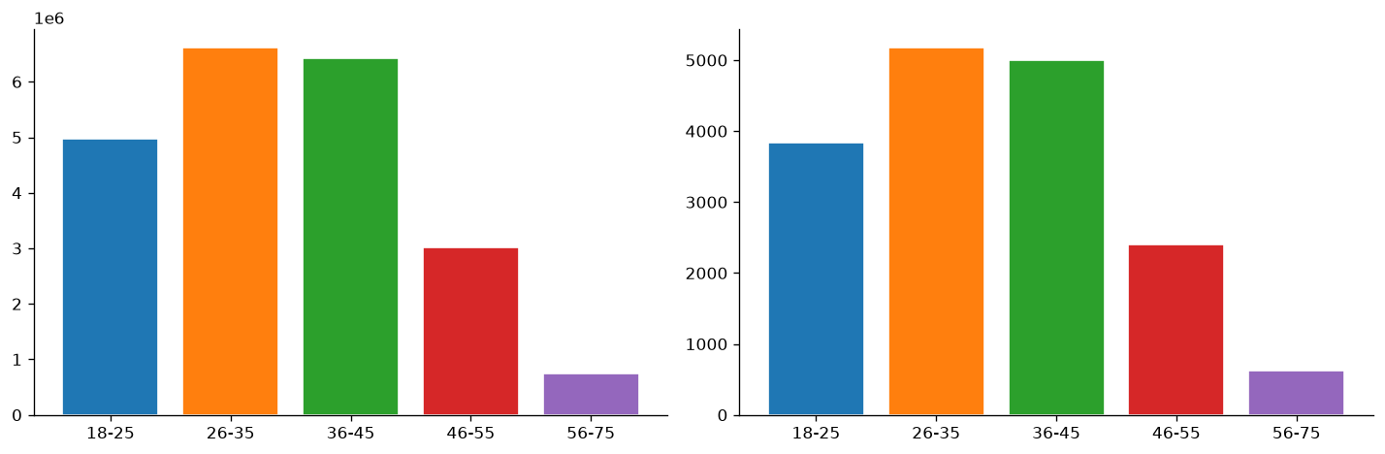
Figure 4: Revenue by Age Group

RFM Segmentation
RFM segmentation classifies customers based on three behavioural dimensions: Recency (R) — how recently a customer placed an order (lower days = higher score), Frequency (F) — how many orders a customer placed (higher count = higher score), and Monetary (M) — total spend by the customer (higher spend = higher score). Each dimension is scored 1–5 using quintile-based binning, and the three scores are summed to produce an RFM composite score (range 3–15).
Customers are then assigned to one of five named segments based on rule-based thresholds applied to their individual R, F, and M quintile scores:
Segment | Rule | Customers | Revenue Share %
Champions | R ≥ 4 AND F ≥ 4 AND M ≥ 4 | 856 | 38.4%
Loyal Customers | R ≥ 3 AND F ≥ 3 | 1366 | 26.4%
Potential Loyalists | R ≥ 3 AND F ≤ 2 | 782 | 7.3%
At Risk | R ≤ 2 AND F ≥ 3 | 778 | 17.3%
Others | All remaining customers | 1218 | 10.7%
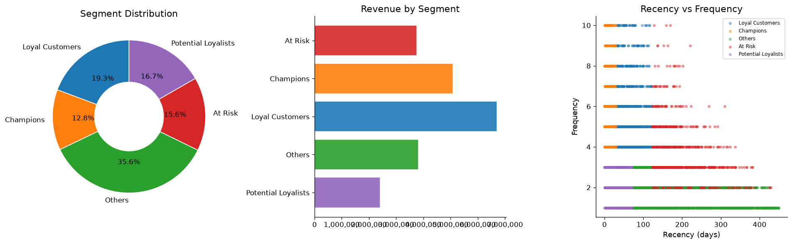
Figure 5: RFM Segment Overview
This is rule-based descriptive segmentation. It does not predict future behaviour or churn.

Delivery, Satisfaction and Discount Analysis

A. Delivery Performance
The average delivery time across all orders is 6.50 days. Orders are distributed across four delivery buckets:
- Fast (1-3 days): 3,332 orders (19.5%)
- Normal (4-7 days): 8,221 orders (48.2%)
- Slow (8-10 days): 3,249 orders (19.1%)
- At Risk (>10 days): 2,247 orders (13.2%)
2,247 orders (13.18% of total) have delivery times exceeding 10 days and are classified as at-risk for customer dissatisfaction.

B. Customer Ratings
The overall average customer rating is 3.90 out of 5. 71.1% of orders received a rating of 4 or higher, indicating general customer satisfaction. However, 13.30% of orders received a rating of 2 or below, representing a material dissatisfaction cohort requiring operational attention. The Food category has the lowest average rating among all product categories.

C. Discount Analysis
38.0% of orders include a discount. Discounted orders have an average order value of ₹1,178.13 compared to ₹1,338.28 for non-discounted orders (difference: ₹-160.15). This suggests discounts are applied to higher-value orders, either as a volume incentive or through selective promotional targeting.
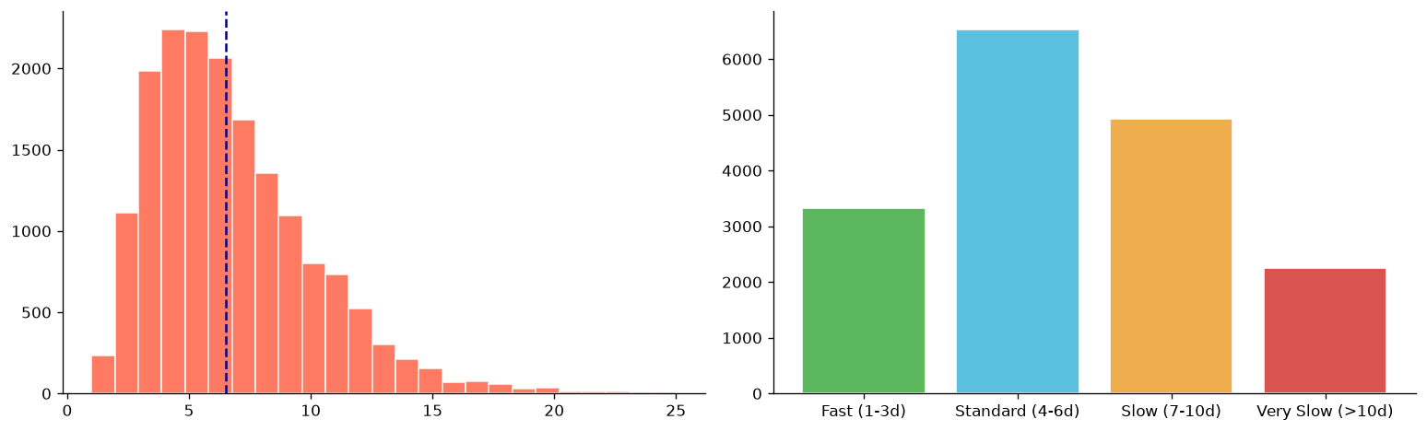
Figure 6: Delivery Time Distribution
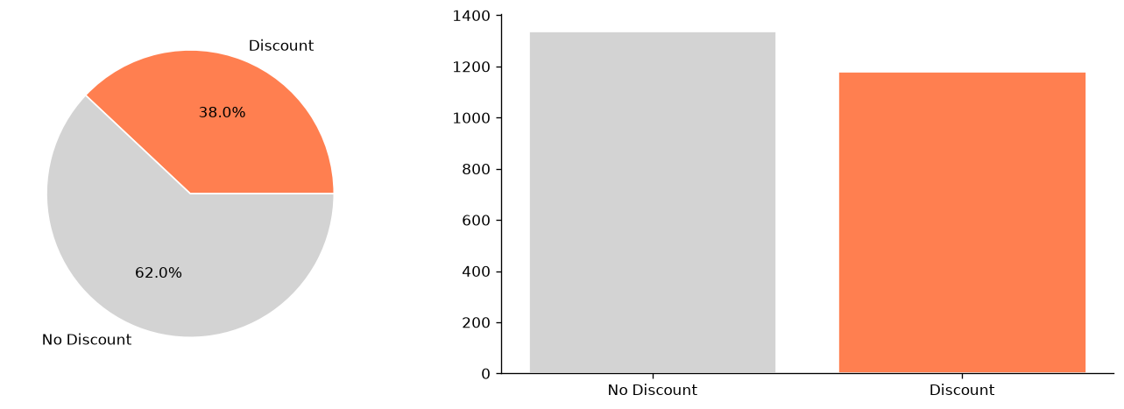
Figure 7: Discount Penetration and AOV

AI-Assisted Business Insights
Business insights in this section follow the structured framework: Fact → Interpretation → Suggested Action. Each insight is derived from a computed statistic or observed pattern in the dataset, interpreted in a business context, and mapped to a specific operational or strategic action.
Note: This is an analytical reasoning framework based on computed data. It is not an autonomous AI or a trained machine learning model.
Area | Observed Fact | Suggested Action
Revenue Concentration | Top category 'Electronics' contributes 48.1% of total revenue. | Diversify marketing spend to build revenue in underperforming categories.
Returning Customers | 88.2% of orders are from returning customers. | Invest in loyalty programmes to maintain retention rate and reduce acquisition costs.
Discount Impact | Discounted AOV (₹1,178) is higher than non-discounted AOV (₹1,338). | Review discount eligibility rules; consider targeting high-value orders more selectively.
At-Risk Deliveries | 2,247 orders (13.2%) have delivery time > 10 days. | Audit fulfilment partners for slow-delivery regions; set SLA alerts for >7 day shipments.
Low Customer Ratings | 13.3% of orders rated ≤ 2. | Investigate post-purchase experience for 'Food' category; implement follow-up surveys.
Session Engagement | Avg session: 14.5 min, avg pages viewed: 9.0. | Optimise product discovery (search, recommendations) to convert browsing sessions to purchases.
RFM Champions | 856 Champions represent 38.4% of revenue. | Create exclusive VIP perks for Champions to prevent churn and incentivise referrals.
At-Risk Customers | 778 At-Risk customers account for 17.3% of revenue. | Launch win-back campaigns with personalised offers for At-Risk customers before they lapse.
Delivery–Rating Correlation | Longer delivery times correlate with lower customer ratings. | Prioritise express delivery options for high-value or repeat customers to protect satisfaction scores.
Potential Loyalists | 782 Potential Loyalists identified. | Nurture with targeted email/push campaigns featuring category recommendations and first-time discounts.
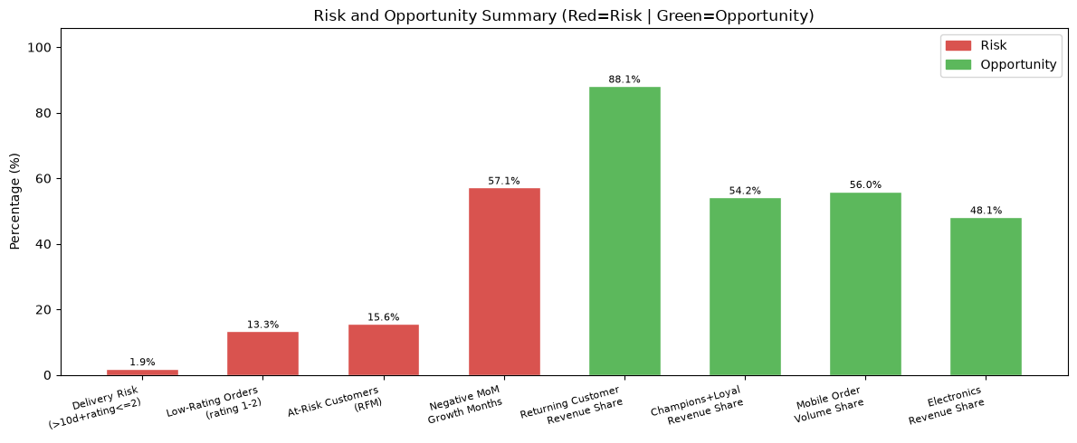
Figure 8: Risk and Opportunity Summary

Streamlit Dashboard
A multi-tab interactive Streamlit dashboard (app.py) accompanies this report, providing stakeholders with a no-code interface to explore the same dataset and computations. The dashboard is designed for business users and does not require Python knowledge to operate.
The dashboard is organised into eight tabs:
- Overview — high-level KPI cards (total revenue, orders, customers, AOV, returning rate)
- EDA — univariate and bivariate distributions with selectable chart type
- Time-Series — monthly/quarterly/yearly revenue trends with MoM growth
- Customer Behaviour — age group, gender, device, and payment method breakdowns
- RFM Segmentation — interactive segment explorer and customer-level RFM table
- Delivery & Satisfaction — delivery bucket analysis and rating distributions
- Discount Analysis — penetration rates, AOV comparison, and category-level breakdown
- AI Insights — structured Fact → Interpretation → Action table with filter by area
Global filters for Date Range, Product Category, Gender, and Device Type are available in the sidebar and apply across all tabs simultaneously.
To run the dashboard locally:
streamlit run app.py

Key Findings
- Total revenue across 17,049 orders is ₹21,779,052.59, with an average order value of ₹1,277.44.
- The Electronics category generates the highest revenue, contributing 48.1% of total revenue.
- Returning customers represent 88.2% of all orders, indicating strong repeat purchase behaviour.
- The overall average customer rating is 3.90/5; 71.1% of orders are rated 4 or above.
- 13.30% of orders receive a low rating (≤ 2), signalling a dissatisfaction tail requiring attention.
- 38.0% of orders include a discount; discounted orders have a higher AOV (₹1,178.13) than non-discounted orders (₹1,338.28).
- Average delivery time is 6.50 days; 2,247 orders (13.2%) exceed 10 days and are classified as at-risk.
- RFM segmentation identifies 856 Champions and 778 At-Risk customers requiring targeted retention actions.
- Session engagement averages 14.5 minutes and 9.0 pages per session, with returning customers showing higher engagement.
- The dataset spans 2023-01-01 to 2024-03-25 with 5,000 unique customers across 8 product categories and multiple cities.

Business Recommendations

Tier 1 — Immediate Actions (0–30 days)
- Activate win-back email campaigns for 778 At-Risk RFM customers with personalised discount codes based on their top purchase category.
- Flag the 2,247 at-risk delivery orders (>10 days) in the CRM and trigger proactive customer communication to mitigate dissatisfaction.
- Investigate the root cause of low ratings (≤ 2) in the Food category through post-purchase surveys and fulfilment audit.

Tier 2 — Short-Term Initiatives (1–3 months)
- Launch a tiered loyalty programme for 856 Champions and 1,366 Loyal Customers, offering exclusive early access, free shipping, or bonus reward points.
- Optimise discount targeting: restrict blanket promotions and introduce personalised discounts based on RFM score and category affinity.
- Implement real-time delivery tracking and SLA alerts for all orders exceeding 7 days to enable proactive intervention.

Tier 3 — Medium-Term Strategy (3–6 months)
- Develop cross-sell and upsell recommendation models for the 782 Potential Loyalist customers to accelerate their transition to Loyal Customer status.
- Invest in mobile-optimised UX improvements, given that mobile devices drive the largest device-type revenue share.
- Conduct A/B testing on session engagement features (search, recommendations, wishlist prompts) to increase conversion from browsing to purchase.

Tier 4 — Strategic Investments (6–12 months)
- Negotiate delivery SLA improvements with fulfilment partners, with a target of reducing at-risk deliveries (>10 days) by 50%.
- Build a cost and margin data layer to complement this revenue analytics foundation, enabling profitability analysis at the category and customer level.
- Expand the analytics platform to incorporate real market data, competitor pricing benchmarks, and external demand signals.

Tier 5 — Long-Term Vision (12+ months)
- Develop predictive churn models using machine learning, leveraging RFM features as training inputs to proactively identify customers at risk of lapsing.
- Build a real-time analytics pipeline to replace the current batch-processing approach, enabling live KPI dashboards and trigger-based marketing automation.
- Explore product-level SKU analytics by enriching the dataset with SKU metadata to enable margin optimisation and inventory planning.

Limitations
- The dataset appears to be synthetically generated; statistical patterns may not reflect real-world e-commerce dynamics or market conditions.
- No external market validation data is available; findings cannot be benchmarked against industry KPIs or competitor performance.
- Correlation observed between variables (e.g. delivery time and rating) does not imply causation; confounding factors are not controlled.
- RFM segmentation is a rule-based descriptive classification; it does not predict future customer behaviour or churn probability.
- The 2024 data covers only January to March 2024, making full year-over-year comparisons with 2023 unreliable.
- No business experiment (A/B test) data is available; recommendations cannot be validated without controlled trials.
- No cost or margin data is present; revenue-based insights cannot be translated into profitability or ROI estimates.
- No product-level SKU data is included; category-level analysis masks individual product performance and inventory dynamics.

Conclusion
This project successfully applied an end-to-end data analytics pipeline to an e-commerce transactional dataset of 17,049 records, producing a comprehensive set of KPIs, customer segments, and operational insights. The analysis confirms that the business has a strong foundation — with a high returning customer rate of 88.2%, a solid average rating of 3.90/5, and total revenue of ₹21,779,052.59 — while also revealing addressable challenges in delivery performance and customer satisfaction tails.
The RFM segmentation framework provides a practical and immediately actionable customer classification that can be operationalised through CRM campaigns without requiring advanced machine learning infrastructure. The AI-assisted insights framework demonstrates how structured analytical reasoning — mapping observed facts to business interpretations and actions — can bridge the gap between raw data and strategic decision-making. The accompanying Streamlit dashboard makes these findings accessible to non-technical stakeholders, completing a full-stack analytics deliverable aligned with the AICTE | IBM SkillsBuild programme objectives.

Future Scope
- Integrate real transactional data from a live e-commerce platform to validate and extend findings beyond the synthetic dataset.
- Develop supervised machine learning models (e.g. gradient boosting, logistic regression) for customer churn prediction using RFM and behavioural features.
- Build a product recommendation engine leveraging collaborative filtering or content-based methods to increase cross-sell revenue.
- Implement a real-time streaming analytics pipeline using Apache Kafka and a cloud data warehouse to replace batch processing.
- Incorporate external data sources (macroeconomic indicators, social media sentiment, competitor pricing) to enrich the analytical context.
- Extend the Streamlit dashboard with role-based access controls and automated report scheduling for business stakeholders.
- Conduct rigorous A/B testing on discount strategies and delivery SLA improvements to validate the causal impact of recommendations.
- Expand geographic analysis by enriching the dataset with regional/postal-code level data to enable location-based targeting strategies.

References / Dataset Source
Dataset source link: https://drive.google.com/file/d/1xx3co8Mo7EDAGTvhiVA8CkgJ_vOmPfsI/view?usp=sharing
Python libraries used are documented in requirements.txt.

