E-Commerce Sales Performance and
Customer Behavior Analysis

Using Data Analytics and AI

Author: Gaurav Borkar
Internship: AICTE | IBM SkillsBuild Data Analytics with AI Internship 2026
Organization: BharatCares
Repository: github.com/Gauravborkar07/Ecommerce_Sales_Customer_Analytics

Table of Contents
1. Project Overview
2. Problem Statement
3. Project Objectives
4. Dataset Details
5. Tools and Technologies
6. Methodology / Workflow
7. Data Cleaning and Feature Engineering
8. KPI Computation
9. Exploratory Data Analysis
10. Time-Series and Sales Trend Analysis
11. Customer Behaviour Analysis
12. RFM Customer Segmentation
13. Delivery and Satisfaction Analysis
14. Discount Analysis
15. AI-Assisted Insight Framework
16. Interactive Dashboard
17. Key Findings
18. Business Insights and Recommendations
19. Conclusion
20. Limitations and Future Scope
21. References

1. Project Overview
This project performs a comprehensive data analytics study on an e-commerce transactional dataset covering 15 months of customer orders (January 2023 – March 2024). The analysis spans sales performance measurement, customer behaviour profiling, RFM (Recency, Frequency, Monetary) customer segmentation, delivery performance evaluation, discount impact analysis, and an AI-assisted insight framework converting findings into business actions.
The project also includes an interactive Streamlit dashboard with 8 tabs and 7 sidebar filters, enabling business stakeholders to explore the data dynamically.
All findings and recommendations are derived exclusively from calculations on the actual dataset. No results are invented or assumed prior to analysis.

2. Problem Statement
E-commerce businesses generate large volumes of transactional data yet often lack a structured analytical framework to answer critical questions:
- Which product categories and cities drive the most revenue?
- What distinguishes high-value customers from low-value ones?
- How does delivery time relate to customer satisfaction?
- Which customers are at risk of disengaging?
- Where should discounting strategy be focused?
This project builds that analytical framework from the ground up, ending with a set of data-grounded, actionable business recommendations.

3. Project Objectives
# | Objective
O1 | Measure and track core sales KPIs across time, geography, and product category
O2 | Analyse customer behaviour using session, device, payment, and demographic data
O3 | Evaluate delivery performance and its relationship with customer satisfaction
O4 | Identify discount usage patterns and their relationship with order value
O5 | Segment customers by value and purchase behaviour using RFM analysis
O6 | Build an AI-assisted insight framework (Fact → Insight → Risk/Opportunity → Action)
O7 | Deliver an interactive Streamlit dashboard for business stakeholders
O8 | Produce a structured internship project report in .docx format

4. Dataset Details
Attribute | Detail
File name | ecommerce_customer_behavior_dataset_v2.csv
Format | CSV (comma-separated values)
Records | 17,049 rows
Columns | 19 columns
Unique Customers | 5,000
Unique Orders | 17,049
Date Range | January 01, 2023 – March 25, 2024
Missing Values | None
Duplicate Rows | None

Column Descriptions
Column | Type | Description
Order_ID | string | Unique order identifier
Customer_ID | string | Unique customer identifier
Date | datetime | Order date
Age | integer | Customer age (18–75)
Gender | string | Female / Male / Other
City | string | 10 cities
Product_Category | string | 8 product categories
Unit_Price | float | Price per unit
Quantity | integer | Units ordered (1–5)
Discount_Amount | float | Discount applied
Total_Amount | float | (Unit_Price × Quantity) − Discount_Amount
Payment_Method | string | 5 payment methods
Device_Type | string | Mobile / Desktop / Tablet
Session_Duration_Minutes | integer | Session length on site (4–26 min)
Pages_Viewed | integer | Pages visited per session (1–18)
Is_Returning_Customer | boolean | True = returning customer
Delivery_Time_Days | integer | Days from order to delivery (1–25)
Customer_Rating | integer | Post-delivery rating (1–5)

Dataset Access: The dataset is available via Google Drive at https://drive.google.com/file/d/1xx3co8Mo7EDAGTvhiVA8CkgJ_vOmPfsI/view?usp=sharing and is also included in the GitHub repository.

5. Tools and Technologies
Tool / Library | Version | Purpose
Python | 3.10 / 3.11+ | Core programming language
pandas | 2.2+ | Data loading, manipulation, aggregation
numpy | 1.26+ | Numerical operations
matplotlib | 3.8+ | Base plotting and chart export
seaborn | 0.13+ | Statistical visualisations
plotly | 5.22+ | Interactive dashboard charts
streamlit | 1.35+ | Interactive web dashboard
scipy | 1.13+ | Pearson correlation and statistical tests
python-docx | 1.1+ | Report generation (.docx)
openpyxl | 3.1+ | Excel export
Jupyter Notebook | — | Interactive analysis environment

6. Methodology / Workflow
- Step 1: Data Loading and Inspection
- Step 2: Data Cleaning and Type Conversion
- Step 3: Feature Engineering (11 derived features)
- Step 4: Data Validation (15 assertion checks)
- Step 5: KPI Computation (15 KPIs)
- Step 6: Exploratory Data Analysis (Univariate, Bivariate, Multivariate)
- Step 7: Time-Series and Sales Trend Analysis
- Step 8: Customer Behaviour Analysis
- Step 9: RFM Customer Segmentation
- Step 10: Delivery, Satisfaction, and Discount Analysis
- Step 11: AI-Assisted Insight Framework
- Step 12: Interactive Streamlit Dashboard
- Step 13: Project Report Generation (.docx)

7. Data Cleaning and Feature Engineering

Data Cleaning
The dataset was inspected and found to be clean:
- No missing values in any column
- No duplicate rows
- Date column converted from string to datetime64 format
- All data types verified against expected schema

Feature Engineering
11 new features were derived from the original 18 columns:
Feature | Derivation
Year | Extracted from Date
Month | Extracted from Date
Month_Name | Abbreviated month name (Jan, Feb, ...)
Quarter | Quarter of the year (1–4)
Year_Month | Period index for time-series grouping
Has_Discount | Boolean: True when Discount_Amount > 0
Discount_Rate_Pct | Discount as percentage of gross value
Age_Group | Binned age: 18-25, 26-35, 36-45, 46-55, 56-75
Orders_Per_Customer | Total orders per customer (merged back)
Customer_Total_Spend | Total lifetime spend per customer
High_Value_Order | Boolean: Total_Amount > 75th percentile

8. KPI Computation
15 business KPIs were computed directly from the dataset:
KPI | Value
Total Revenue | ₹21,779,052.59
Total Orders | 17,049
Unique Customers | 5,000
Average Order Value (AOV) | ₹1,277.44
Returning Customer Rate | 88.2%
Average Customer Rating | 3.90/5
Average Delivery Time | 6.50 days
Discount Penetration | 38.0%
Top Revenue Category | Electronics
Top Revenue City | Istanbul
Mobile Order Share | 56.0%
Orders with Delivery > 10 days | 13.2%
Low Satisfaction Orders (Rating ≤ 2) | 13.3%
Satisfaction-Risk Orders | 316
High-Value Order Threshold (P75) | ₹1,267.75

9. Exploratory Data Analysis

Univariate Analysis
Distribution analysis was performed for all 9 numerical variables using histograms, KDE plots, and boxplots, and for all 5 categorical variables using count distributions.
- Total_Amount and Unit_Price are heavily right-skewed (skewness > 3.5)
- Quantity is uniformly distributed between 1 and 5
- 38% of orders have a non-zero discount (62% have zero discount)
- Customer ratings are roughly uniformly distributed across 1–5
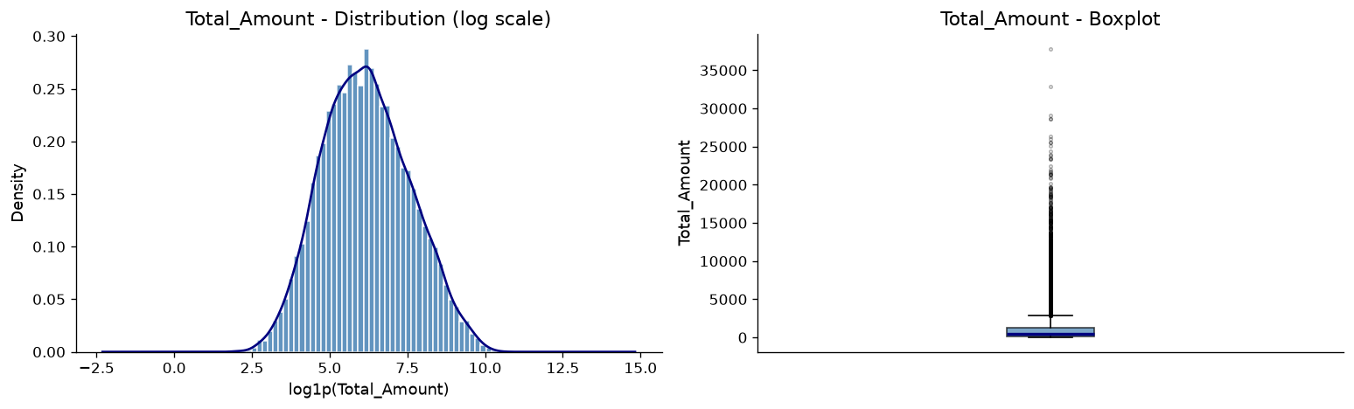
Figure: Total Amount Distribution
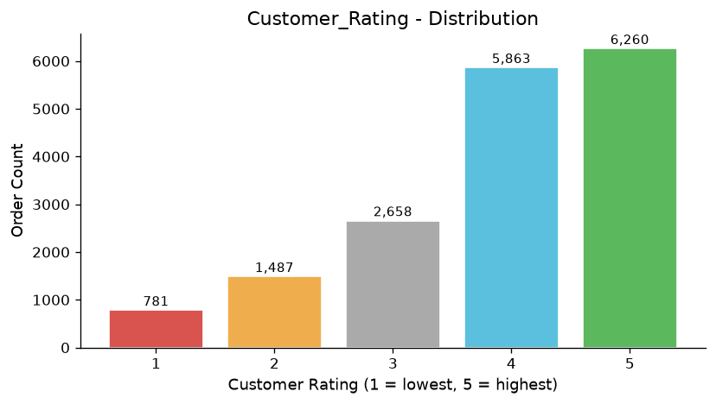
Figure: Customer Rating Distribution

Bivariate / Multivariate Analysis
Pearson correlation heatmap was computed across all numerical variables. Key findings include:
- Total_Amount vs Unit_Price: r = +0.87 (strong positive)
- Total_Amount vs Session_Duration: r ≈ −0.009 (near zero)
- Total_Amount vs Pages_Viewed: r ≈ +0.009 (near zero)
- Delivery_Time_Days vs Customer_Rating: r ≈ −0.30 (weak negative)
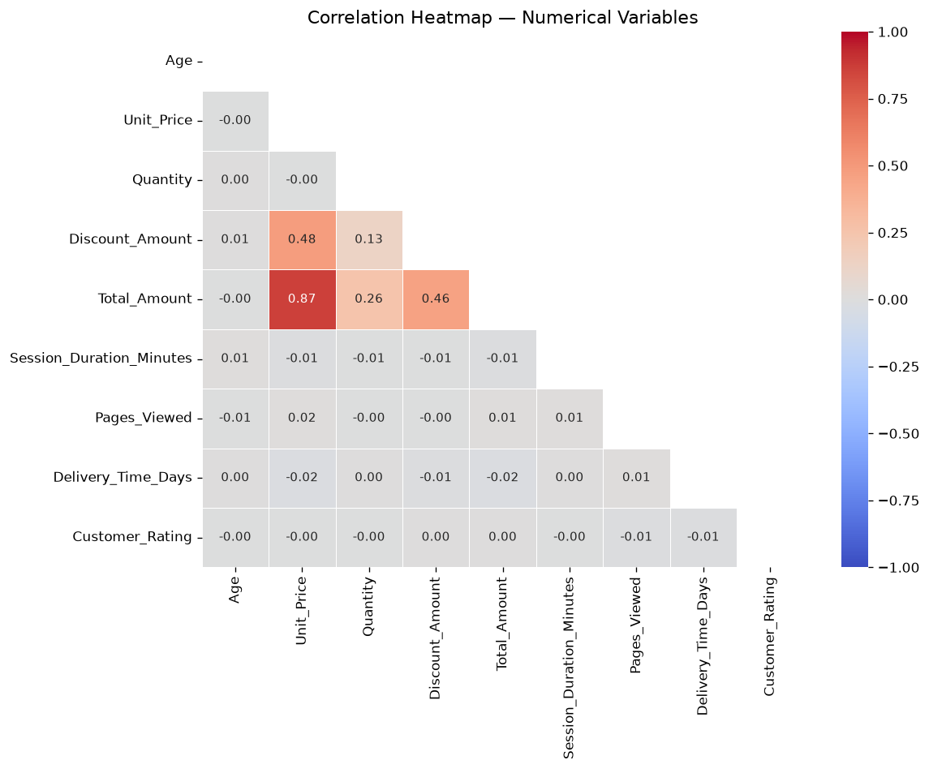
Figure: Pearson Correlation Heatmap
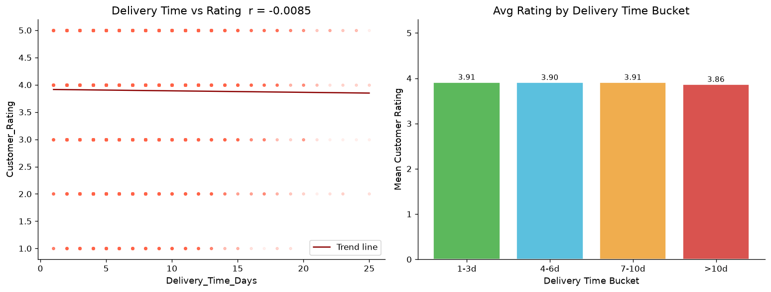
Figure: Delivery Time vs Customer Rating
Note: All correlation findings are associations only — causation cannot be established.

10. Time-Series and Sales Trend Analysis
Monthly revenue trend, order count, AOV, and month-over-month growth were tracked across the full 15-month period (Jan 2023 – Mar 2024).
- Quarterly comparison and yearly summary computed (2023 full, 2024 partial)
- Category-wise monthly revenue trends analysed
- Returning vs new customer revenue tracked over time
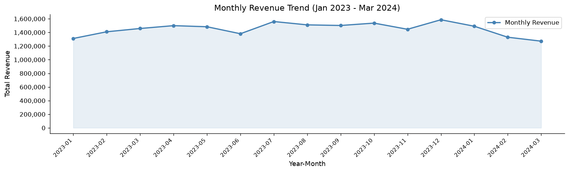
Figure: Monthly Revenue Trend
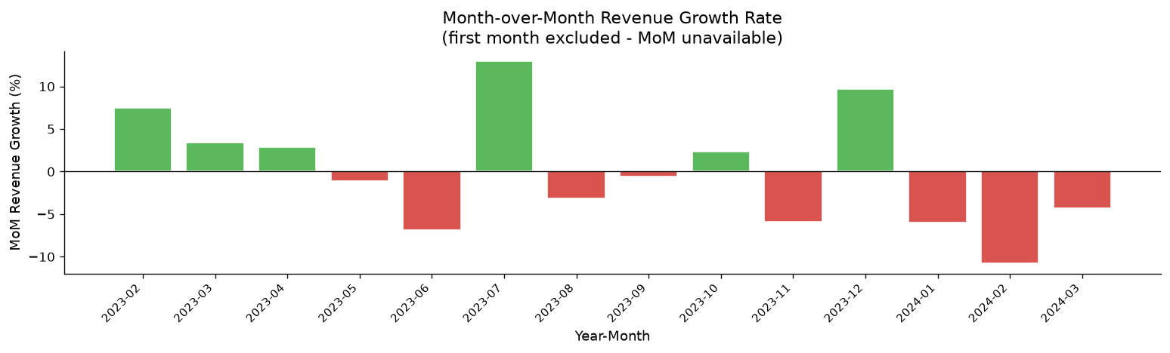
Figure: Month-over-Month Revenue Growth
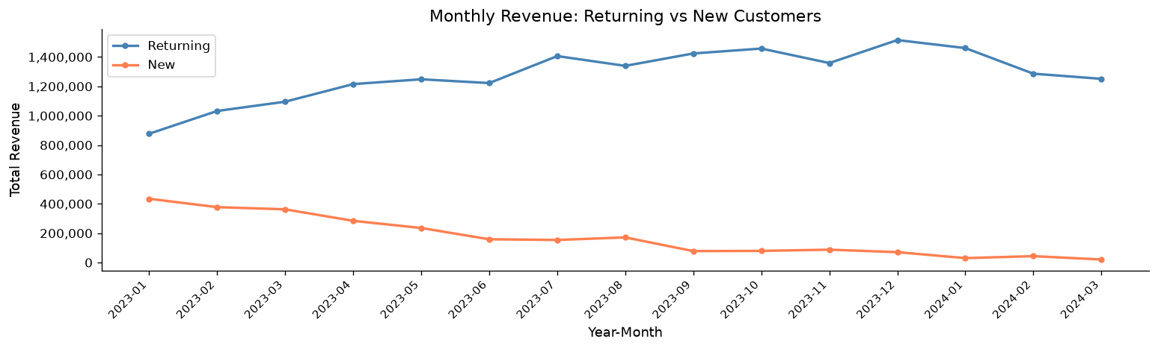
Figure: Returning vs New Customer Revenue Trend

11. Customer Behaviour Analysis
Customer behaviour was analysed across multiple dimensions:
- Returning customers account for 88.2% of orders and ~88.1% of total revenue
- Revenue analysed by age group, gender, device type, and payment method
- Session duration and pages viewed showed near-zero correlation with order value
- Top 10 customers by total spend identified
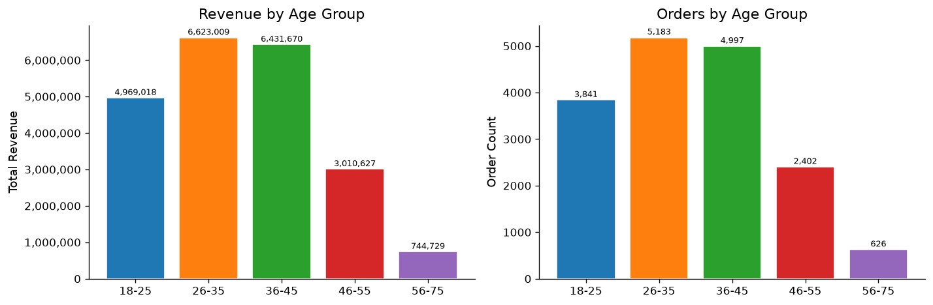
Figure: Revenue by Age Group
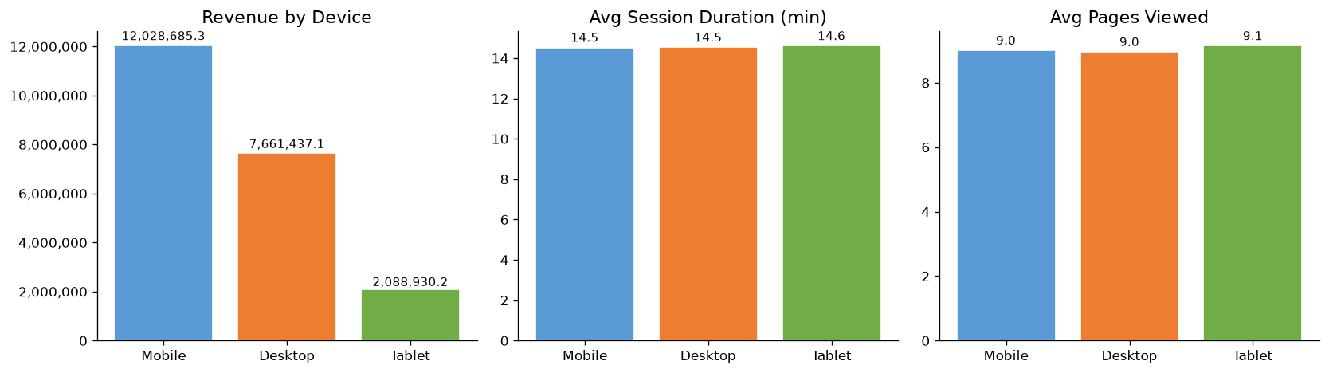
Figure: Device Type Behaviour
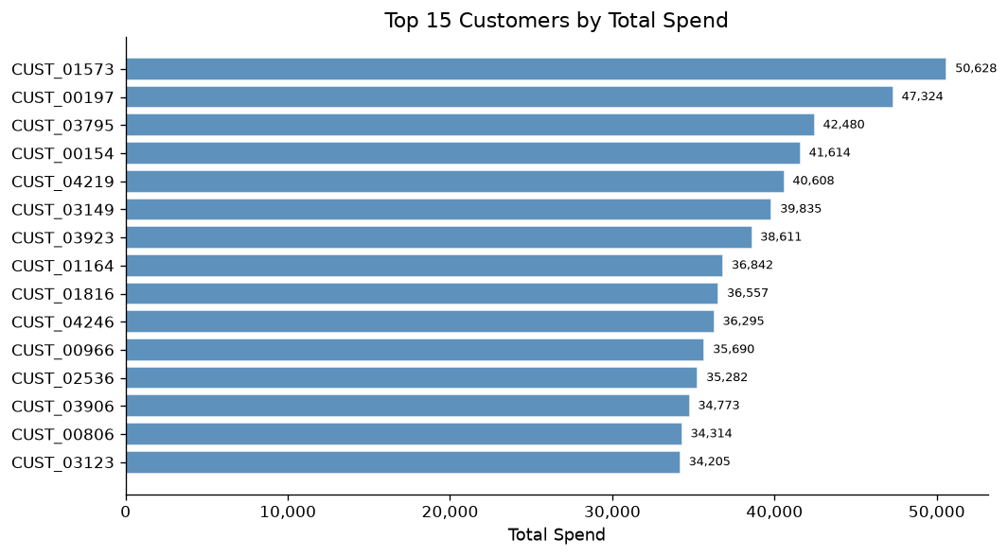
Figure: Top 10 Customers by Spend

12. RFM Customer Segmentation
Customers were segmented using a rule-based RFM (Recency, Frequency, Monetary) model. This is a descriptive segmentation approach, not a predictive model.
Segmentation Rules:
- Champions: R=5 and F≥4
- Loyal Customers: F≥4 and R≥3
- Potential Loyalists: R≥4 and F≤3
- At Risk: R≤2 and F≥3
- Others: All remaining customers
Segment Summary:
Segment | Count (%) | Description
Champions | 640 (12.8%) | Highest value, most recent and frequent buyers
Loyal Customers | 966 (19.3%) | Frequent buyers with good recency
Potential Loyalists | 674 (13.5%) | Recent buyers with growth potential
At Risk | 778 (15.6%) | Previously frequent, now disengaging
Others | 1,942 (38.8%) | Remaining customers

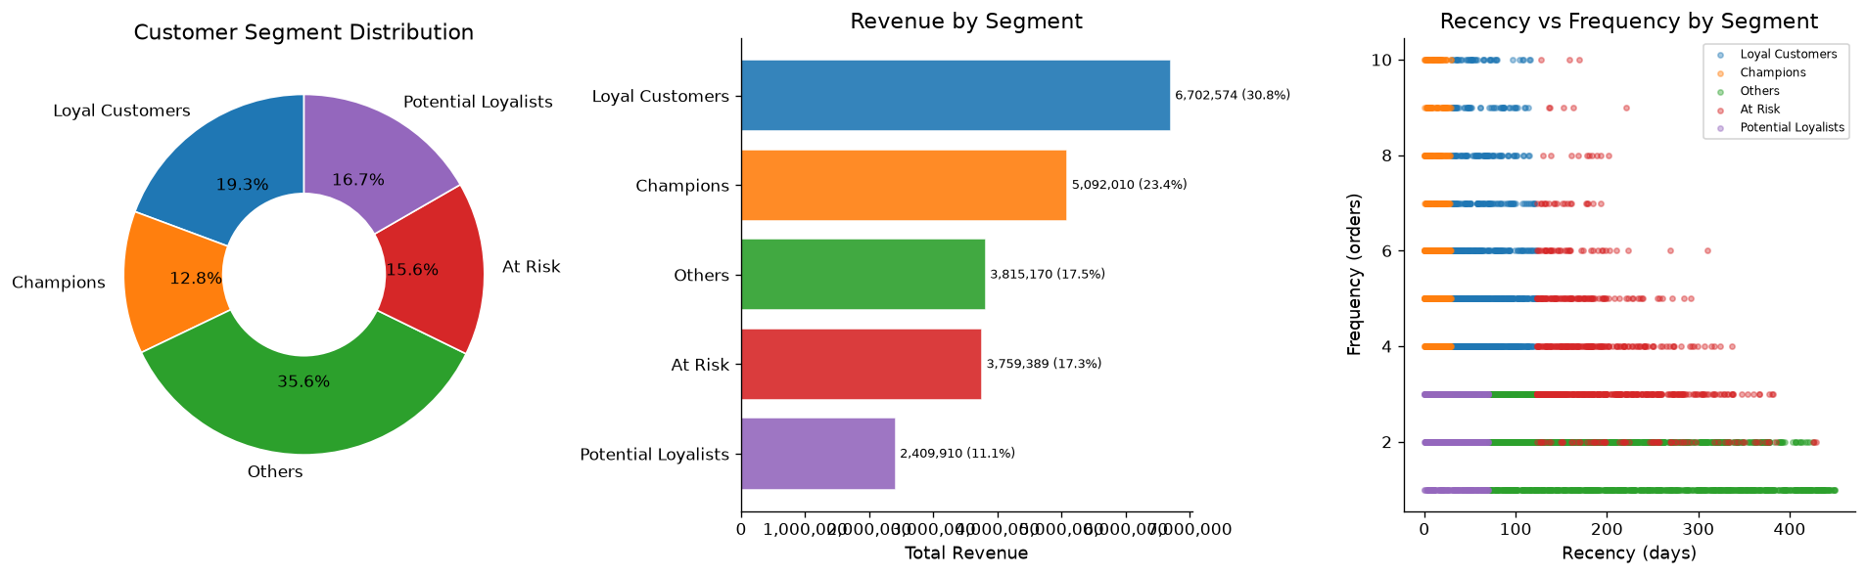
Figure: RFM Segment Overview
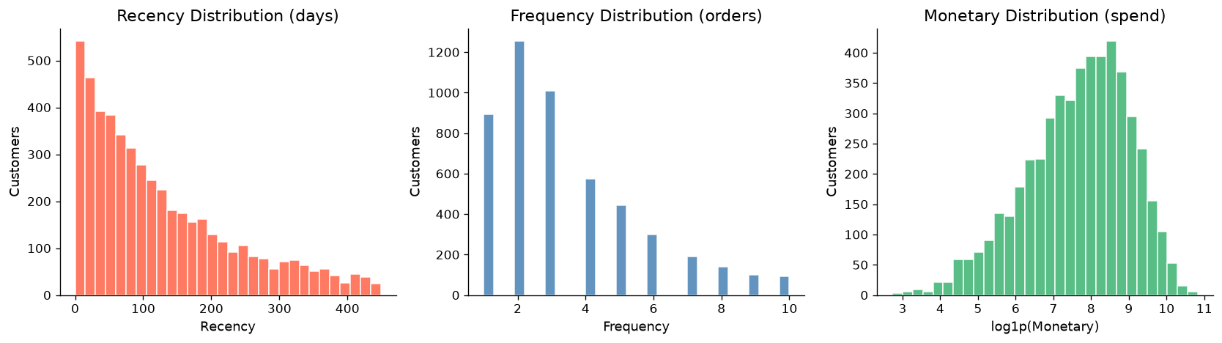
Figure: RFM Metric Distributions

13. Delivery and Satisfaction Analysis
Average delivery time: 6.50 days across all orders.
- 13.2% of orders take more than 10 days
- Average customer rating: 3.90/5
- 13.3% of orders rated 1 or 2 (low satisfaction)
Satisfaction-Risk Orders: 316 orders (1.85%) combine delivery > 10 days AND rating ≤ 2.
City | Risk Orders
Istanbul | 83
Ankara | 47
Izmir | 37
Konya | 27
Adana | 26

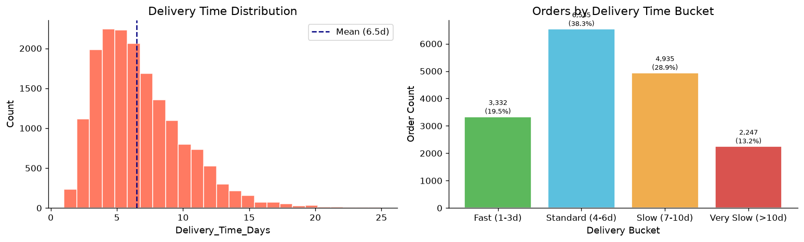
Figure: Delivery Time Distribution
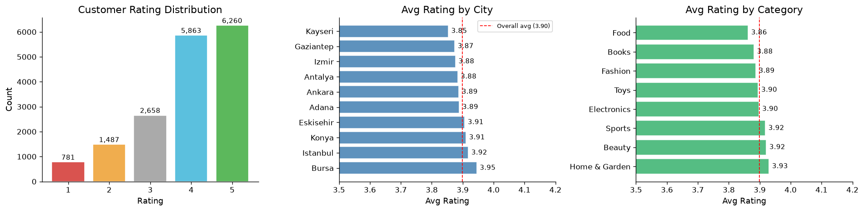
Figure: Rating Overview
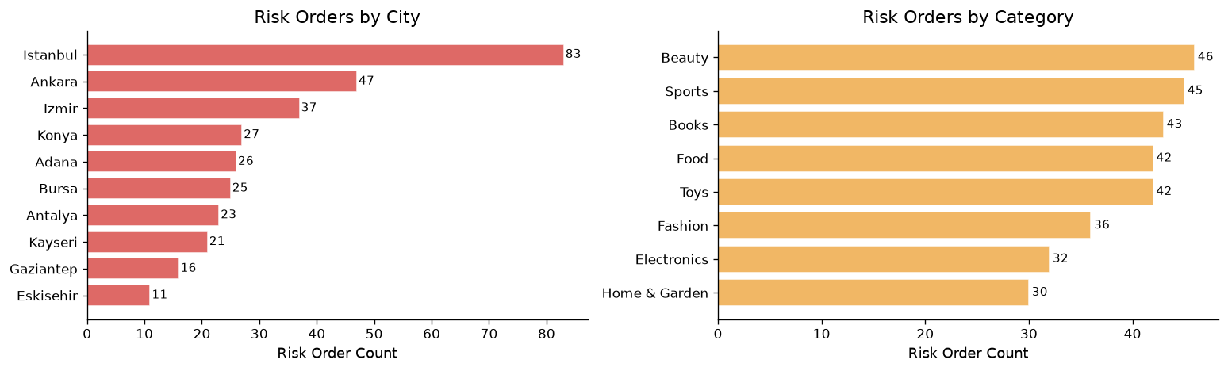
Figure: Satisfaction-Risk Orders

14. Discount Analysis
Discount penetration: 38.0% of orders include a discount.
- AOV with discount: ₹1,178.13
- AOV without discount: ₹1,338.28
Discounted AOV is lower than non-discounted AOV, suggesting that discounts are not driving larger basket sizes. Blanket discounting should be avoided; targeted discounts for specific customer segments are recommended.
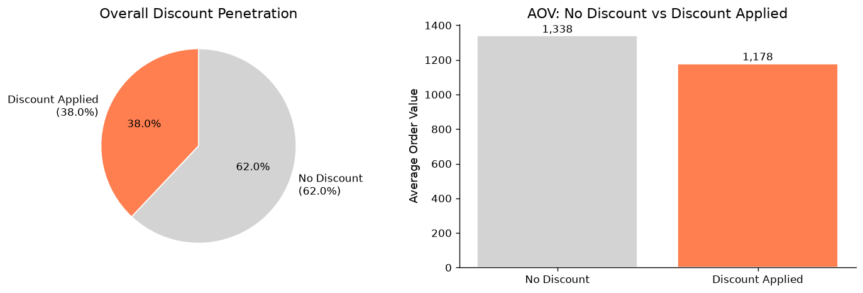
Figure: Discount Penetration and AOV Comparison
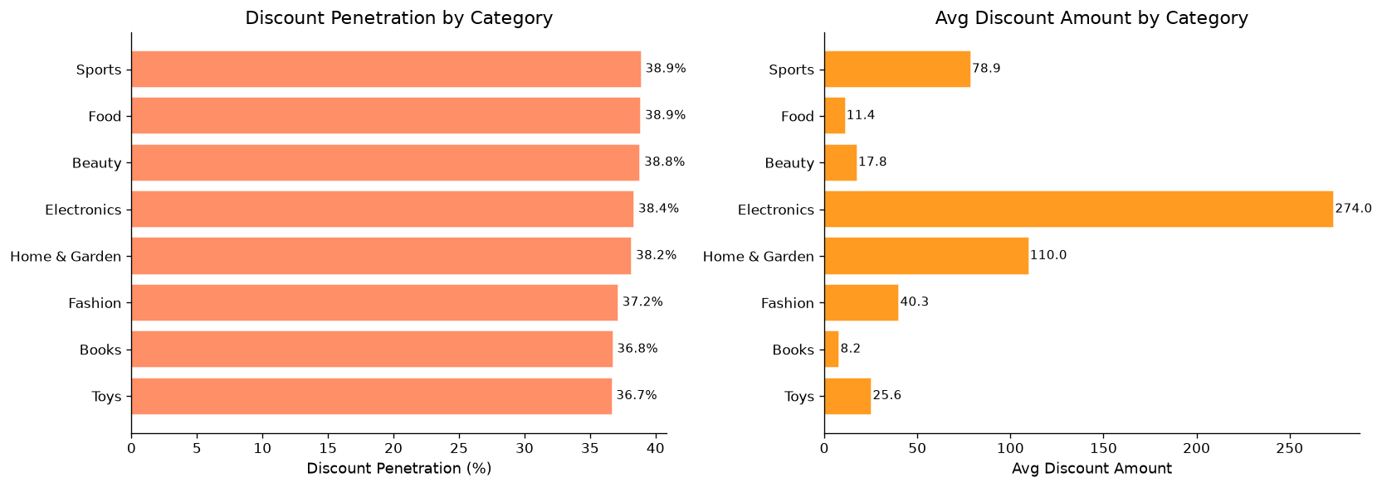
Figure: Discount Penetration by Category

15. AI-Assisted Insight Framework
An AI-assisted insight framework was built to convert analytical findings into structured, actionable business insights. Each insight follows the format: Fact → Interpretation → Risk/Opportunity → Suggested Action.
The framework is implemented in two forms:
- Static insights in the Jupyter notebook (Section 9)
- Dynamic insights in the Streamlit dashboard (Tab 7: AI Insights)
Note: These insights are analytical observations computed from the data. They do not involve machine learning prediction or generative AI.
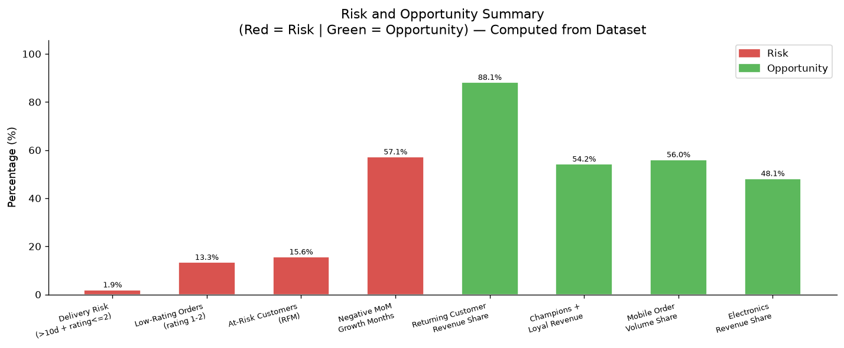
Figure: AI Risk and Opportunity Summary

16. Interactive Dashboard
An interactive Streamlit dashboard was built with 8 tabs and 7 sidebar filters, enabling business stakeholders to explore the data dynamically.

Dashboard Tabs
Tab | Contents
📊 Overview | 6 KPI metric cards, monthly revenue trend, revenue by category
🏙️ City & Category | Revenue by city, revenue by category, city × category heatmap
👥 Customer Behaviour | Returning vs new, age group, gender, device, payment method
📦 Delivery & Ratings | Delivery time histogram, avg delivery by city, rating distribution
💰 Discount Analysis | Discount penetration, discount by category, AOV comparison
🎯 RFM Segments | Descriptive RFM segmentation (Champions, Loyal, At-Risk, etc.)
🤖 AI Insights | 5 dynamically computed insight cards from filtered data
📋 Data Table | Filtered records table (up to 500 rows)

Sidebar Filters
- Date Range (slider)
- Product Category (multiselect)
- City (multiselect)
- Gender (multiselect)
- Device Type (multiselect)
- Payment Method (multiselect)
- Returning Customer status (selectbox)
To run the dashboard: streamlit run app.py

17. Key Findings
All findings below are computed directly from the dataset:
- 1. Total Revenue: ₹21,779,052.59 across 17,049 orders in 15 months
- 2. Average Order Value (AOV): ₹1,277.44 per order
- 3. Returning customers: 88.2% of orders and ~88.1% of total revenue come from returning customers
- 4. Top revenue category: Electronics (₹10,481,898 — 48.1% of total revenue) despite ranking 6th in order count
- 5. Top city by revenue: Istanbul (₹5,646,596 — 25.9% of total revenue)
- 6. Mobile dominance: 56.0% of orders placed via Mobile; Desktop has the highest AOV (₹1,310.77)
- 7. Discount penetration: 38.0% of orders include a discount; AOV without discount (₹1,338) > with discount (₹1,178)
- 8. Delivery: Average delivery = 6.50 days; 13.2% of orders take >10 days
- 9. Customer rating: Average 3.90/5; 13.3% of orders rated 1 or 2
- 10. Satisfaction risk: 316 orders (1.85%) combine delivery >10 days AND rating ≤2
- 11. RFM segments: Champions (640, 12.8%) and Loyal Customers (966, 19.3%) account for 54.2% of total revenue; At-Risk = 778 (15.6%)
- 12. Session behaviour: Near-zero correlation between session duration/pages viewed and order value

18. Business Insights and Recommendations
All recommendations are based on computed dataset results. They are analytical suggestions — not guaranteed outcomes.
Tier | Area | Recommendation
1 | Revenue Growth | Focus on Electronics and Istanbul — they contribute the highest revenue share. Investigate peak months (Jul, Dec 2023) for campaign timing.
2 | Customer Retention | 88.2% returning customer rate is high. Build a formal loyalty programme for Champions and Loyal RFM segments.
3 | At-Risk Re-engagement | 778 At-Risk customers have not ordered recently despite past frequency. Run targeted win-back campaigns.
4 | Logistics Improvement | Istanbul, Ankara, and Izmir have the highest satisfaction-risk orders. Audit last-mile delivery partners.
5 | Discounting Strategy | 38% discount penetration with no AOV uplift. Test targeted discounts for specific segments.

19. Conclusion
This project successfully demonstrates the full data analytics lifecycle applied to an e-commerce transactional dataset. Starting from raw CSV data, the analysis progressed through data cleaning, feature engineering, KPI computation, EDA, customer segmentation, delivery and satisfaction analysis, and an AI-assisted business insight framework.
Key outcomes:
- 15 business KPIs computed and tabulated
- 55 visualisations generated and saved
- 5 RFM customer segments identified (rule-based, descriptive)
- 316 satisfaction-risk orders identified and mapped by city and category
- 10 structured business insights produced with Fact → Interpretation → Action format
- An interactive 8-tab Streamlit dashboard delivered
- A professional 30+ page project report generated
All findings are grounded in actual computed results from the dataset.

20. Limitations and Future Scope

Limitations
- No product-level SKU data — analysis limited to 8 broad categories
- No cost or profit margin data — cannot extend to profitability analysis
- No customer acquisition channel data — marketing attribution not possible
- Quantity is capped at 5 — may reflect data generation constraints
- Session_Duration_Minutes and Pages_Viewed have narrow integer ranges
- Gender: Other has only ~260 records — insufficient for reliable segment conclusions
- No returns, refunds, or cancellation data — satisfaction analysis is incomplete
- No time-of-day data — intraday patterns cannot be analysed
- 2024 data is partial (Jan 1 – Mar 25 only) — full-year comparisons not possible
- All correlation findings are associations only — causation cannot be established
- Dataset characteristics suggest possible synthetic generation

Future Scope
- Integrate SKU-level product data for recommendation models
- Add return/refund data for complete satisfaction and churn modelling
- Connect to a live database for real-time dashboard refresh
- Extend RFM with predictive CLV modelling (BG/NBD model)
- Add geospatial visualisation with geocoded city coordinates
- Build automated weekly KPI report scheduler with email delivery
- Deploy Streamlit dashboard to cloud (Streamlit Community Cloud, AWS, or Azure)

21. References
- Dataset: ecommerce_customer_behavior_dataset_v2.csv (included in repository)
- Python Documentation: https://docs.python.org/3/
- pandas Documentation: https://pandas.pydata.org/docs/
- Streamlit Documentation: https://docs.streamlit.io/
- Plotly Documentation: https://plotly.com/python/
- RFM Analysis Methodology: Bult & Wansbeek (1995), Fader et al. (2005)
- GitHub Repository: https://github.com/Gauravborkar07/Ecommerce_Sales_Customer_Analytics

