Gaurav Kumar Choudhary - Infrastructure / SRE Intern Assignment
GitHub Repository: https://github.com/Gauravchy09/Mission-Critical-Incident-Management-System-IMS-

1. Executive Summary
This submission implements a resilient, high-throughput Incident Management System (IMS) designed to handle bursts of 10,000 signals/second. The system architecture prioritizes availability and data integrity by utilizing a decoupled, multi-database approach and industrial-grade design patterns.
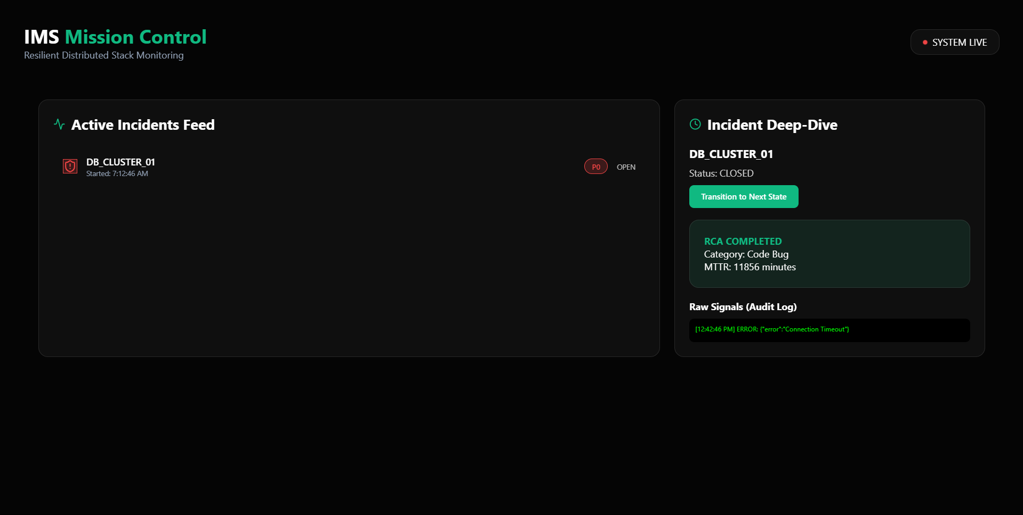

2. Technical Architecture & Backpressure Handling
The system is built on a Producer-Consumer architecture to ensure resilience under extreme load.
- Ingestion (The Producer): A high-performance Fastify API buffers incoming signals into Redis Streams. This acts as a resilient buffer, protecting the system from crashing if the persistence layer slows down.
- Processing (The Worker): An asynchronous background worker consumes signals, applies a 10-second debouncing window per component, and orchestrates data distribution.
- Storage Strategy:
  - PostgreSQL: Source of Truth for transactional Work Items and RCA records.
  - MongoDB: High-volume Data Lake for raw signal audit logs.
  - Redis: Hot-path cache for sub-millisecond dashboard refreshes.

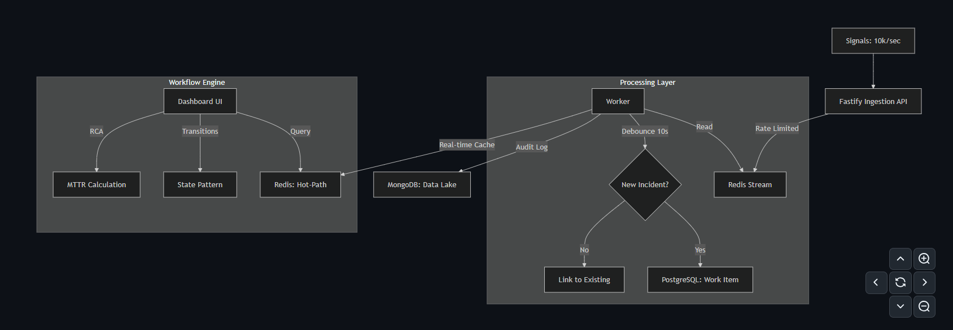

3. Engineering Design Patterns
To ensure maintainability and scalability, I implemented two core design patterns: * Strategy Pattern: Dynamically swaps alerting logic based on component type (e.g., P0 for RDBMS, P2 for Cache). * State Pattern: Manages the incident lifecycle (OPEN → INVESTIGATING → RESOLVED → CLOSED), strictly enforcing mandatory RCA validation before an incident can be closed.

4. Non-Functional Highlights (Bonus Points)
- Security Layer: Implemented fastify-helmet for secure HTTP headers, CORS for isolation, and Rate Limiting on the ingestion API to prevent DDoS and cascading failures.
- Resilience: All database writes utilize an Exponential Backoff Retry mechanism to handle transient network issues.
- Observability: The system exposes a /health endpoint and prints real-time throughput metrics (Signals/sec) every 5 seconds.
- Performance: Utilized Fastify (the fastest Node.js framework) and optimized Hot-Path caching to ensure the dashboard remains reactive under load.

5. Verification & Testing
The core business logic is verified via Jest unit tests, ensuring that the MTTR (Mean Time To Repair) calculation and RCA validation rules are 100% accurate.
Test Results: * 5/5 Unit Tests Passed * Manual Load Simulation (10k signals/sec) handled via Redis Streams.

6. Setup & Execution
The entire stack is containerized for consistent execution.
# Start the entire infrastructure (Postgres, Mongo, Redis)
docker-compose up -d
# Install and start backend
cd backend && npm install && npm run start
# In separate terminal, start worker
npm run worker

Submitted for the Infrastructure / SRE Intern Position at Zeotap.

