**Aim:Study HTTP module and working of Node.js as a web server**

**Objective: To easily understand the communication done in node.js**

**Scope:** **Message display along with different ways are done**

**Theory:-**

By using node.js command-line interface, we can create console applications. To open a node.js command-line interface, search for node.js in windows and click on Node.js desktop app like as shown below.

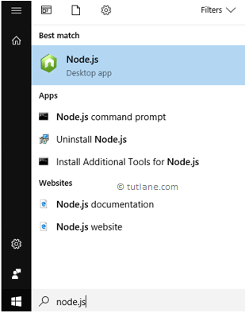

Generally, when we [install a node.js](https://www.tutlane.com/tutorial/nodejs/nodejs-setup-development-environment) in our machine, we will get a **Node.js** command-line interface and other required components.

After opening Node.js command-line interface, type console.log(“Hello World”) command in the console and click on the **enter** button that will show the output like as shown below.

>” **Hello World**”

>’ **Hello World**

If you observe the above result, we tried to print a message in node.js shell by typing the message “**Hello World**”. After we type a message and click on **Enter**, it returned the string whatever we mentioned in a terminal.

## 2.1Node.js Hello World Web Application

The following are the three main components required in node.js to create a web application.

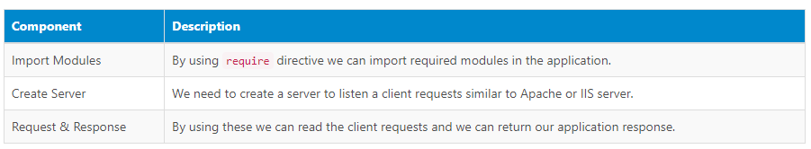

Now create a new folder wherever you want in your system, and in that create a file called **Helloworld.js** and write the code like as shown below.

## Helloworld.js

// Importing http core package/module provided by nodejs

var http = require('http');

// Creating a server

http.createServer(function (req, res) {

// Write response as Html(text)

res.writeHead(200, {'Content-Type': 'text/html'});

// Writing static text

res.end('Hello World');

// Server listening on port number 8080

}).listen(8080);

If you observe above code, we are importing http module by using require directive and created the server to listen a request and response on port number **8080**.

Here, the above code will tell the computer to write “**Hello World**” if anyone tries to access your computer on port **8080.**

## 2.2Run or Execute JavaScript File in Node.js

The node.js files can be executed by using a command-line interface program of our computer so open a command prompt (cmd) and navigate to the folder that contains a **Helloworld.js** file like as shown below.

Generally, the node.js files can be initiated by entering a command like node <Your_File_Name> so enter a command node Helloworld.js and hit **enter** button like as shown below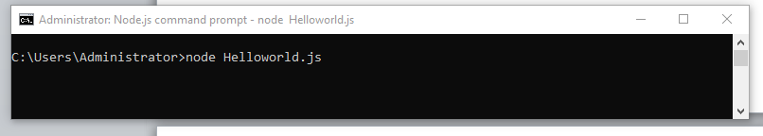

Now your computer will work as a server so if anyone tries to access your computer with port **8080**, then in return, they will get a “**Hello world**” message. To test this, open a browser in your machine and type a URL called http://localhost:8080 and click enter, which will show the result as shown below.

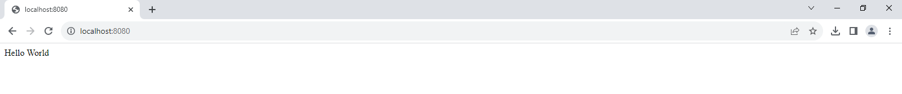

This is how we can create a console or web application in node.js based on our requirements. In the next chapters, we will learn more about other topics in node.js with examples.

Conclusion: Node.js display simple messages successfully.