**Aim**- Write a program that open the requested file and return the content of the file to the client if anything goes wrong, throw a 404 error.

**Objective:** To access the content of files if content not found it shows error.

**Scope:** The Node.js file system module allows you to work with the file system on your computer.

**Theory-** The ‘url’ module provides utilities for URL resolution and parsing. The getters and setters implement the properties of URL objects on the class prototype, and the URL class is available on the global object.

The **new URL()**(Added in v7.0.0, v6.13.0)method is an inbuilt application programming interface of the URL module which creates a new URL object by parsing the input relative to the base. If the base is passed as a string, it will be parsed equivalent to new URL(base).

Syntax:

new URL(input[, base])

const url = require('url');

**Parameters:**This method accepts two parameters as mentioned above and described below:

**input**<*string*>**:** It is the input which is *string* type that is used to parse the absolute or relative input URL. The base is required if the input is relative and ignored if the input is absolute.

**base** <*string*> **|** <*URL*>**:** It is the base URL which is either of *string* type or *URL*, used to resolve against if the input is absolute or not.

**Return Value:**It returns the new URL generated along with an array of data like hostname, protocol, pathname, etc.

**Steps:**

* Create two html files and save them in the same folder as your node.js files.
* Create a Node.js file that opens the requested file and returns the content to the client. If anything goes wrong, throw a 404 error
* Initiate demo_fileserver.js:

C:\Users*Your Name*>node demo_fileserver.js

**Program:**

Summer.html

<!DOCTYPE html>  
<html>  
<body>  
<h1>Summer</h1>  
<p>I love the sun!</p>  
</body>  
</html>

Winter.html

<!DOCTYPE html>  
<html>  
<body>  
<h1>Winter</h1>  
<p>I love the snow!</p>  
</body>  
</html>

demo_fileserver.js

var http = require('http');  
var url = require('url');  
var fs = require('fs');  
  
http.createServer(function (req, res) {  
  var q = url.parse(req.url, true);  
  var filename = "." + q.pathname;  
  fs.readFile(filename, function(err, data) {  
    if (err) {  
      res.writeHead(404, {'Content-Type': 'text/html'});  
      return res.end("404 Not Found");  
    }   
    res.writeHead(200, {'Content-Type': 'text/html'});  
    res.write(data);  
    return res.end();  
  });  
}).listen(8080);

**Output:**

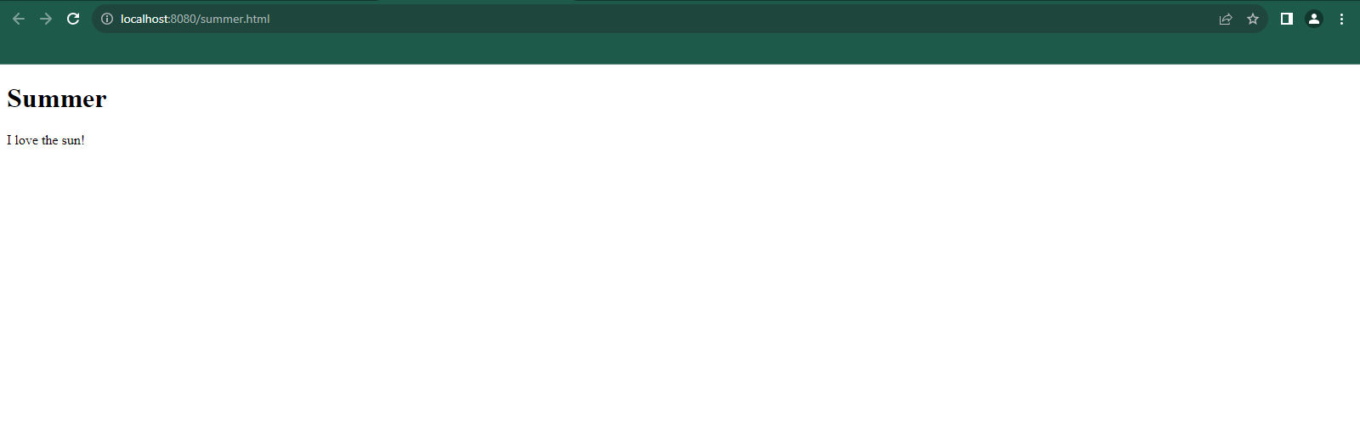

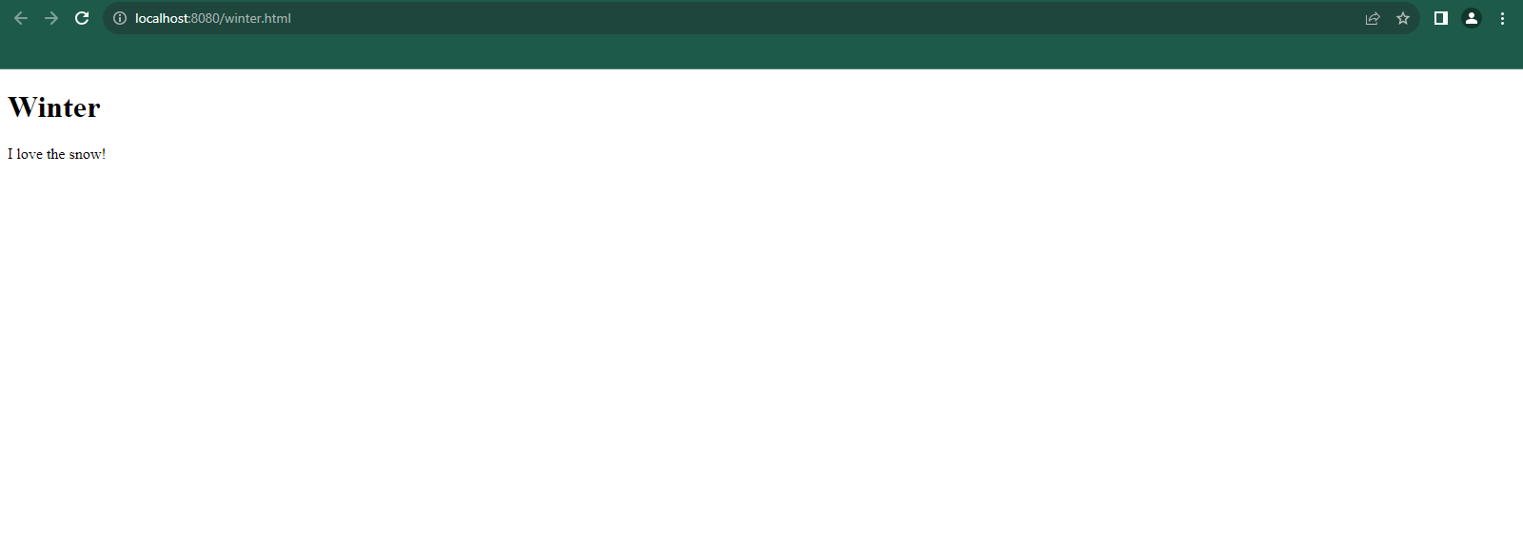

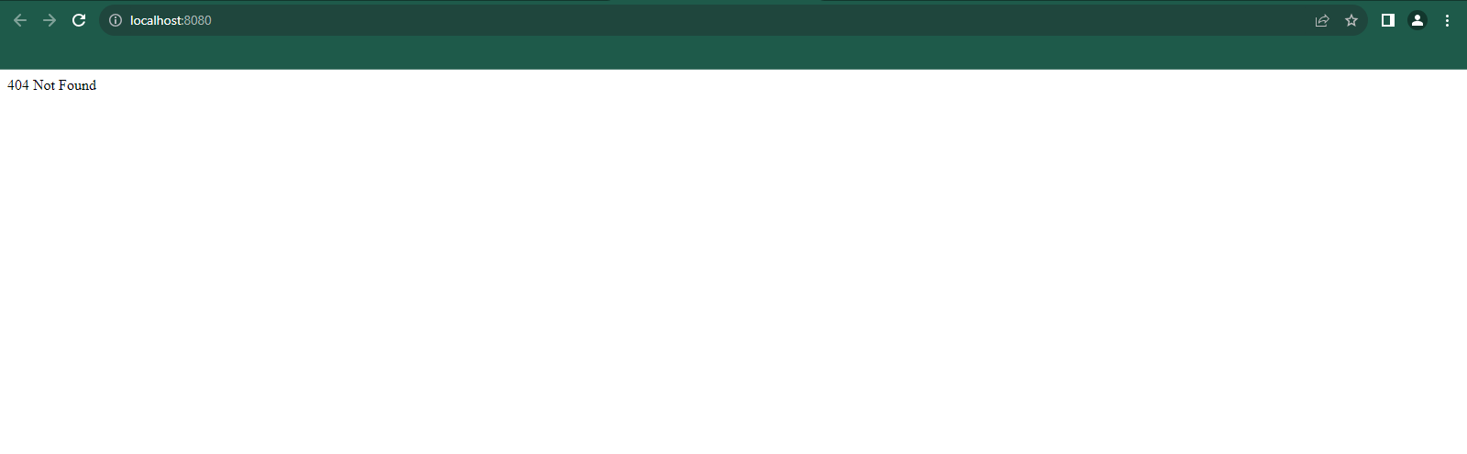

**Conclusion**: In this way we have successfully completed the practical that open the requested file and return the content of the file to the client if anything goes wrong, throw a 404 error.