**Aim**: Write a program to convert the output into upper- case letters by installing the “Upper-case” package of NPM.

**Objective:** To understand the conversion of file content into upper-case using NPM’s “Upper-case “ package.

**Scope:** NPM is a package manager for Node.js packages it contain thousands of free packages to download and use.

**Theory**:

NPM is a package manager for Node.js packages, or modules if you like.[www.npmjs.com](https://www.npmjs.com/) hosts thousands of free packages to download and use. The NPM program is installed on your computer when you install Node.js

What is a Package?

A package in Node.js contains all the files you need for a module. Modules are JavaScript libraries you can include in your project.

Download a Package

Downloading a package is very easy.

Open the command line interface and tell NPM to download the package you want.

Download "upper-case":

C:\Users*Your Name*>npm install upper-case

Now you have downloaded and installed your first package!

NPM creates a folder named "node_modules", where the package will be placed. All packages you install in the future will be placed in this folder.

Using a Package

Once the package is installed, it is ready to use.

Include the "upper-case" package the same way you include any other module:

var uc = require('upper-case');

**Program:**

var http = require('http');  
var uc = require('upper-case');  
http.createServer(function (req, res) {  
  res.writeHead(200, {'Content-Type': 'text/html'});  
  res.write(**uc.upperCase("Hello World!")**);  
  res.end();  
}).listen(8080);

Save the code above in a file called "demo_uppercase.js", and initiate the file:

Initiate demo_uppercase:

C:\Users*Your Name*>node demo_uppercase.js

**Output:**

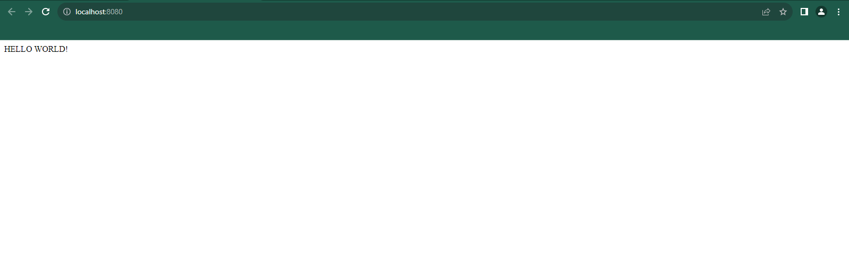

**Conclusion:** In this practical we have successfully convert the output into upper- case letters by installing the “Upper-case” package of NPM.