**Title Of Project**

This is the test project of the JsonPowerDB Training.

**Description**

In this project i have created a basic html page which will communicate with the JsonPowerDataBase .

In this pages I am saving the user data to a server and fetch back to the user and will also update the data in it.

**Benefits of using JsonPowerDB**

* Minimum Development Cost
* Minimum Time to Market
* Minimize the complexity of interperability of different applications.
* Maximum data processing performance.
* Technology Futuristic.

Fill gap from database to big-data.

Pluggable with new algorithms.

Pluggable and user defined API.

* Minimize total Cost of Ownership.

**Release History**

1st : Date: 01-04-2022

**Starting Page of the project**

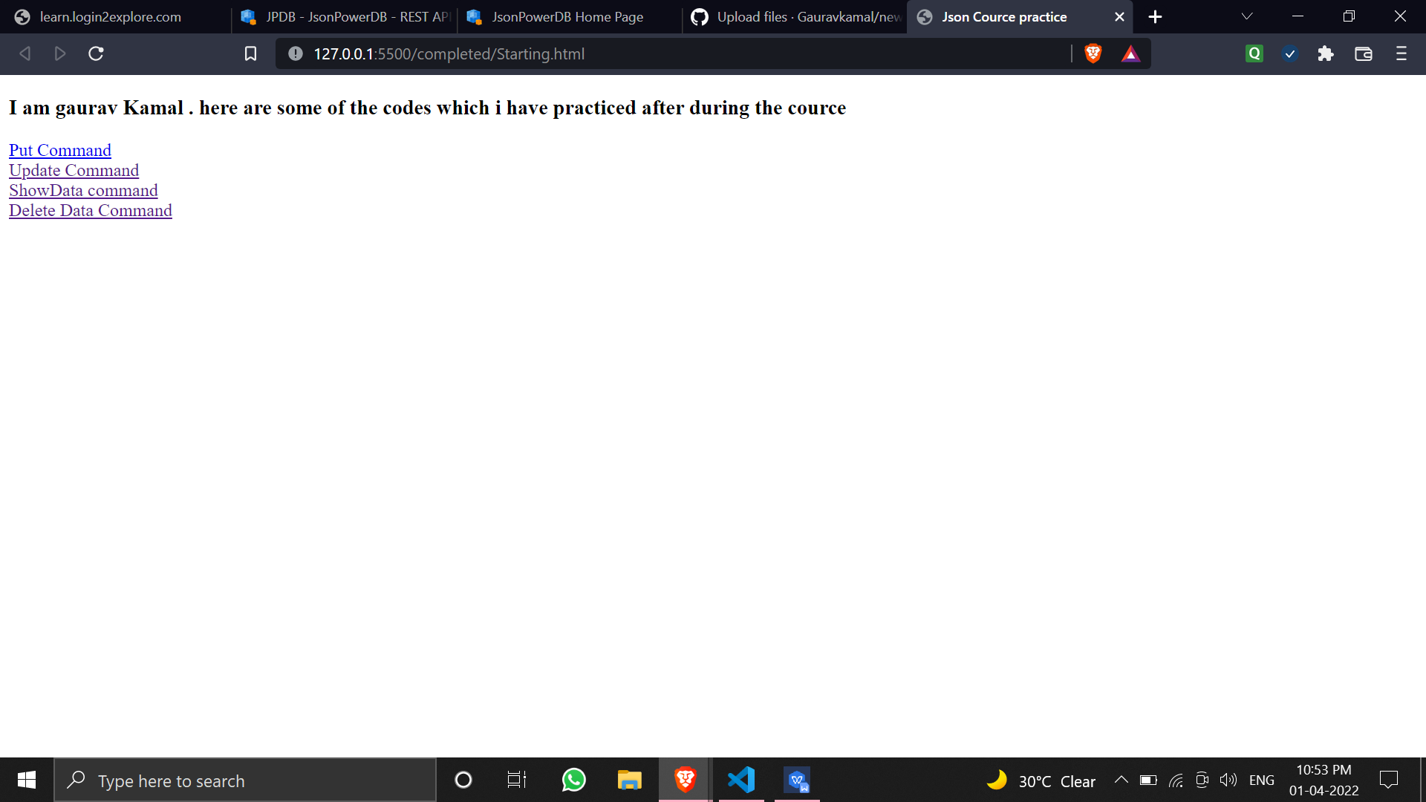

**PUT command Page of the project.**

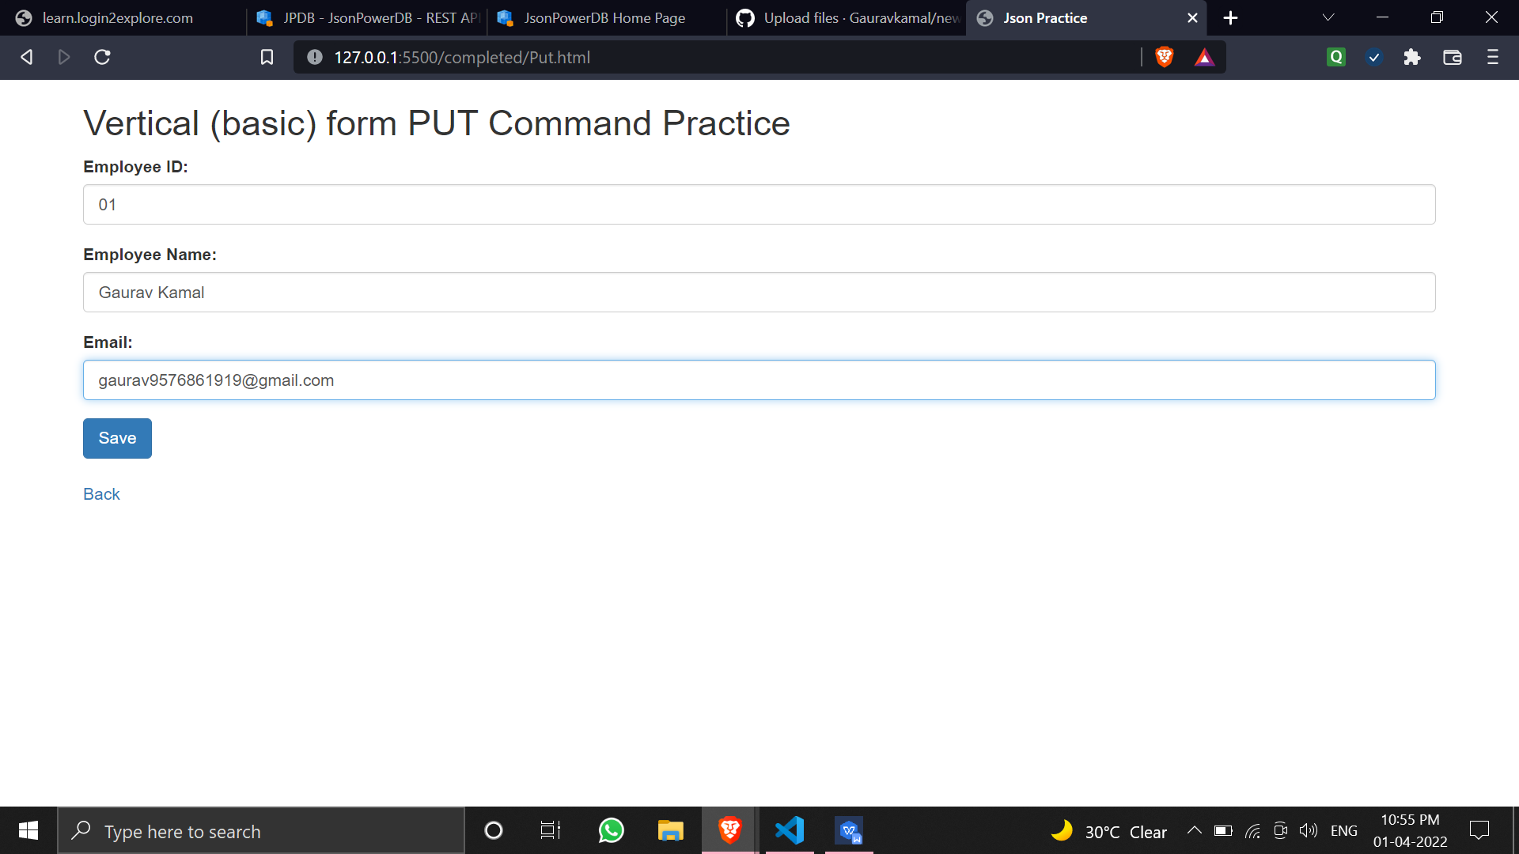

**Saving the data in the Database.**

