**1.How effective is NREGA in providing employment opportunities to rural households?**

**Effectiveness in Employment Generation**:

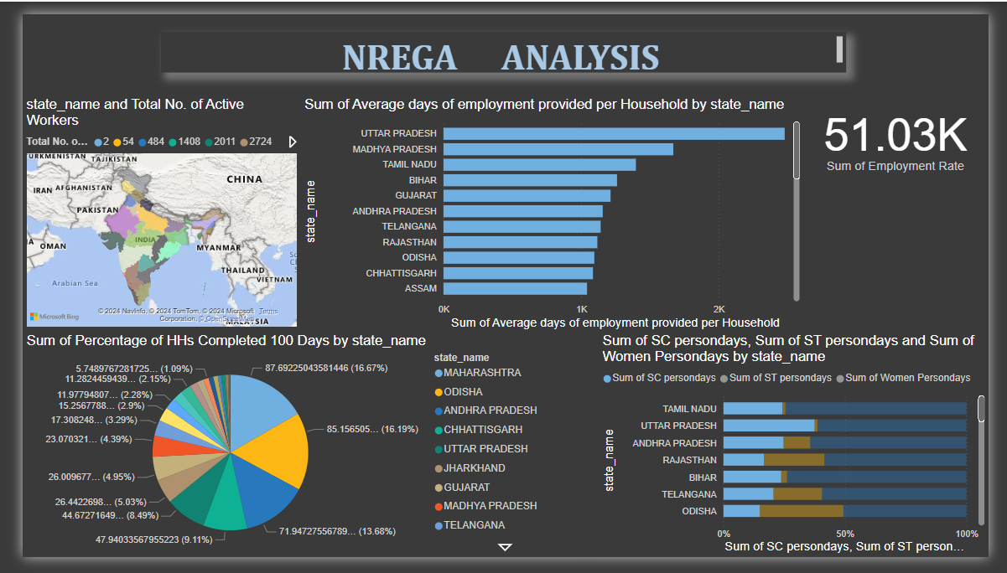

**2. Are there regional disparities in the implementation and outcomes of the scheme?**

**Regional Disparities**:



**3. What is the utilization of the allocated budget, and how does it correlate with employment generation?**

**Budget Utilization**:

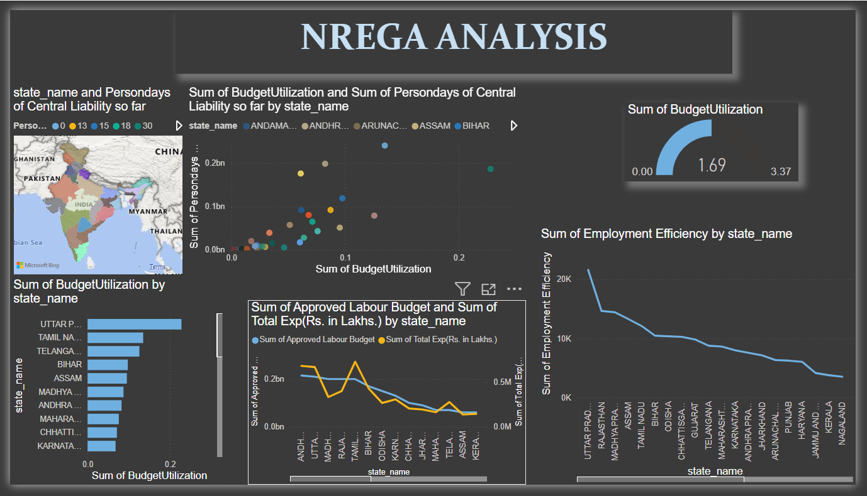

**4. What are the key factors contributing to the completion of NREGA works, and are there any roadblocks to its success?**

**Key Factors and Roadblocks**:

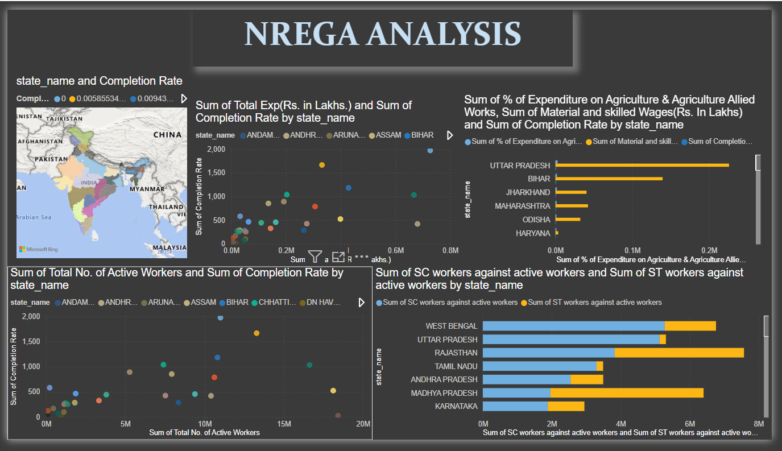

**5. Can data-driven insights guide policymakers and administrators in optimizing the scheme's impact?**

**Policy Optimization**

