**DR. K. N. MODI INSTITUTE OF**

**ENGINEERING & TECHNOLOGY**



**A** **SYNOPSIS**

**ON**

**TRAVEL THE BEST AGENCY**

**Submitted as a part of course curriculum for**

**Bachelor of Technology**

**in**

**Computer Science and Engineering**

|  |  |
| --- | --- |
| **Under the Guidance of:**  **Mr.Praveen Kr. Gangwar**  **Edge Department(Trainer)**  **Dr.K.N.M.I.E.T** | **Submitted by:**  **Akanksha Shakya(1307710008)**  **Gaurav Kr. Gupta(1307710033)** |



Travel the best agency

Synopsis



## ITRODUCTION

The Project **Travel the Best Agency** is the Online Tourism Information System which is travel for recreational, leisure, family or business purposes, usually of a limited duration. Tourism is commonly associated with trans-national travel, but may also refer to travel to another location within the same country or internationally. **Tourism has numerous tangible and intangible elements.** Major tangible elements include transportation, accommodation and other components of a hospitality industry. Major intangible elements relate to the purpose or motivation for becoming a tourist, such as rest, relaxation, the opportunity to meet new people and experience other cultures, or simply to do something different and have an adventure. It attracts tourists for its **historical forts, palaces, art and culture**.

**Tourism** is vital for all countries, due to the income generated by the consumption of goods and services by tourists, the taxes levied on businesses in the tourism industry, and the opportunity for employment and economic advancement by working in the industry. Due to India's rich history, its cultural and geographical diversity, makes it international tourism. We present heritage and cultural tourism along with transportation, packages, and various events of India via our websites. **Travel the Best Agency**, is a leading name in tours & industry, offering the best tours in **India and other parts of Asia**. Being in this field of travel and hospitality for more than 5 years we understand the needs and requirements of every traveler in a better way. Our priority is to **complete satisfaction to our clients**, valuing time and money. We take utmost care of your safety and privacy***.***

**India** **is really incredible** with its diversities that cannot be explored in a single trip. The majestic land of India will compel you to visit it again and again. Its **vibrant culture, rich heritage, numerous festivals, multiple mouth-watering cuisines, colorful attires and different religions & languages contribute to its uniqueness**. The perfect blend of rural and urban culture adds to the glory of India, which is admired throughout the world and so attracts tourists in large to visit India every year. We, at **Travel the Best Agency** help you plan your India tour itineraries according to your interest for a perfect trip in majestic India. We carefully craft your tour itineraries providing you scope to make last minute changes.

We offer you exclusively customized packages for **Heritage, Wildlife, Beaches, Backwaters and adventurous tour** in India. A safari in the desert or jungle can add charm to your trip in India. We help you enjoy to the fullest during your first time visit to India, making it worth remembering. Our contagious friendliness, remarkable professionalism with impeccable services will not let you repent on your decision of hiring us to plan your India Tour..!!

Our mission is to make every tourist to India explore the Indian vicinities to the core. Our highly customizable tour packages help our travelers reach every nook and corner genuinely. We have always kept our motto “Our customer’s satisfaction is our top most priority”. Travel the Best Agency believes in “better travel, better living” strategy, resulting in safe and hassle free travel to India.

## OBJECTIVES OF THE PROJECT

## The objective of the Travel and Tourism Management System project is to develop a system that automates the processes and activities of a travel and the purpose is to design a system using which one can perform all operations related to traveling.

To develop a web based application which includes:

* To provide best travelling services to the customers and travel agents.
* To provide a search platform where a tourist can find their tour places according to their choices.
* To promote responsible and interesting tourism so that people can enjoy their holidays at their favorable places.
* To develop tourism with different cultures so that they enrich the tourism experience and build pride.
* To create and promote forms of tourism that provide healthy interaction opportunities for tourists and locals and increase better understanding of different cultures, customs, lifestyles, traditional knowledge and believes.
* To make strong relationship with customers so that they can enjoy the holiday of their dreams.
* To globalism, organize, standardize and goal of journey towards perfectionism.
* To provide a better way to connect with various events.

**Advantages**

* Information on tourist attractions, cities, and provinces.
* Map and navigation system.
* Temperature and weather information.
* Searching tours based on location.
* Offering/Booking tours.
* Hotel Booking System.
* Ability to create a personal profile and keep a history of visited places.
* Ability to create content, share experiences and comment on tours and places.

# Project Category

The software which is being developed comes under both OOPS and RDBMS category.The project based on  **HTML5, CSS3,**  **JAVA SCRIPT** as a **front end and PHP(MYSQL)** as **back end**. While taking **HTML5, CSS & JS** it gives the strong support of Object Oriented Programming System technology. On the other hand **PHP (MYSQL)** gives the database consistency, reliability and strong RDBMS supports.

**Web development** is the broad term for the work involved in developing the web site for the Internet (World Wide Web) or an intranet (a private network).The web development can range from developing the simplest static single page of the plain text to most complex web-based internet applications, electronic businesses, and social network services etc. The more comprehensive list of tasks to which web development commonly refers, it may include web- engineering, web design, web content development, client liaison, client-side and a scripting

a web server and network security configuration, and e-commerce development. Among web professionals & "web development" usually refers to the main non-design aspects of building web sites a writing markup and coding. Most recently Web development has come to mean a creation of a content management systems or CMS. These CMS can be made from scratch or proprietary or open source. In broad terms the CMS acts as middleware between the database and the user through the browser. A principle benefit of a CMS is that it allows non-technical people to make changes to their web site without having technical knowledge

* **HTML5- HTML5** is a markup language used for structuring and presenting content on the World Wide Web. It is the fifth and current version of the HTML standard. HTML5 includes detailed processing models to encourage more interoperable implementations; it extends, improves and rationalizes the markup available for documents, and introduces markup and application programming interfaces (APIs) for complex web applications. For the same reasons, HTML5 is also a candidate for cross-platform mobile applications, because it includes features designed with low-powered devices in mind.
* **CSS3- C**ascading **S**tyle **S**heets, fondly referred to as CSS, is a simple design language intended to simplify the process of making web pages presentable. CSS is easy to learn and understand but it provides powerful control over the presentation of an HTML document. Most commonly, CSS is combined with the markup languages HTML or XHTML.
* **JAVASCRIPT-** Javascript is a dynamic computer programming language. It is lightweight and most commonly used as a part of web pages, whose implementations allow client-side script to interact with the user and make dynamic pages. It is an interpreted programming language with object-oriented capabilities.JavaScript was first known as **LiveScript,** but Netscape changed its name to JavaScript, possibly because of the excitement being generated by Java. JavaScript made its first appearance in Netscape 2.0 in 1995 with the name **LiveScript**. The general-purpose core of the language has been embedded in Netscape, Internet Explorer, and other web browsers.
* **JQUERY-** Query is a fast and concise JavaScript Library created by John Resig in 2006 with a nice motto − **Write less, do more**. JQuery simplifies HTML document traversing, event handling, animating, and Ajax interactions for rapid web development. JQuery is a JavaScript toolkit designed to simplify various tasks by writing less code.

**PHP (MySQL):**

**MySQL** is world’s most popular open source database. With its proven performance, reliability and ease-of-use, **MySQL** has become the leading database choice for web-based applications, used by high profile web properties including **Facebook, Twitter, YouTube, Yahoo!** and many more.

**MySQL** is the most popular **Open Source Relational SQL database management system**. MySQL is one of the best **RDBMS** being used for developing web-based software applications. **Oracle** drives **MySQL** innovation delivering new capabilities to power next generation **web, cloud, mobile and embedded applications.**

A **Relational Database Management System (RDBMS)** is a software that:

* Enables you to implement a database with tables, columns and indexes.
* Guarantees the Referential Integrity between rows of various tables.
* Updates the indexes automatically.
* Interprets an SQL query and combines information from various tables.

**MySQL** is a fast, easy-to-use **RDBMS** being used for many small and big businesses. MySQL is developed, marketed, and supported by MySQL AB, which is a Swedish company. MySQL is becoming so popular because of many good reasons:

* MySQL is released under an **open-source license**. So you have nothing to pay.
* MySQL is a very powerful program in its own right. It handles a large subset of the functionality of the most expensive and powerful database packages.
* MySQL uses a standard form of the well-known SQL data language.
* MySQL works on many operating systems and with many languages including PHP, PERL, C, C++, JAVA, etc.
* MySQL works very quickly and works well even with large data sets.
* MySQL is very friendly to PHP, the most appreciated language for web development.
* MySQL supports large databases, up to 50 million rows or more in a table. The default file size limit for a table is 4GB, but you can increase this to a theoretical limit of 8 million terabytes (TB).
* MySQL is customizable. The open-source GPL license allows programmers to modify the MySQL software to fit their own specific environments.

**TOOLS/PLATEFORM**

For the undergoing project, following tools are used:

|  |  |
| --- | --- |
| **Platform** | **Windows** |
| **Operating System** | **Windows XP professional with Service Pack 3** |
| **Front-End Tool** | **HTML5,CSS3, JAVASCRIPT, JQUERY** |
| **Scripting Language** | **JavaScript** |
| **Interface** | **HTML, SUBLIME TEXT** |
| **Server** | **Apache Tomcat** |
| **Back-End Tool** | **PHP (MYSQL)** |
| **Technology** | **HTML5** |

**HARDWARE:**

|  |  |
| --- | --- |
| **Processor** | **Intel Pentium 2.4 GHZ** |
| **Memory** | **256 M.B., D.D.R. RAM** |
| **Network Adapter** | **Ethernet Adapter** |
| **Modem** | **56kpbs Voice Fax Data** |
| **Secondary Storage** | **Samsung/Seagate Hard disk (40 G.B)** |

#### Minimum System Requirements

**Hardware requirement:**

* **Processor: Pentium IV 2.4 GHZ**
* **Memory: 256 MB RAM**
* **Hard Disk: 10GB**
* **Monitor**
* **Keyboard**

**Software requirement:**

* **Front End :**

HTML5

CSS3

JAVASCRIPT

JQUERY

* **Back End :**

PHP (MySQL)

* **Operating System :**

WINDOW XP with SP2

WINDOW 2000

## Project Planning and Scheduling

**Gantt chart**

This chart represents all the activities and the amount of time that will require during the product development period. A tabular form is maintained where rows indicate the task with milestones and columns indicate duration.

TASKS AUG-SEP OCT-NOV DEC JAN FEB

Requirement

Gathering

Design

Design review

Coding

Quality

Assurance

Testing

Build

## Fig1: Gantt chart

COMPLETE STRUCTURE OF THE PROGRAM

**Project Modules**

The proposed website will have its main page and will be mainly divided into partially dependent and partially independent modules as-

* 1. **User Management**

1. Login.
2. User profile.
3. Update information.
4. Role based rights.
   1. **Admin Module**
5. Manage user information.
6. Update information.
7. Manage Trips.
8. Manage Transportation.
9. Manage hotel, Bookings.
   1. **Hotel Module**
10. Registration (as user)
11. Registration (as Hotel)
12. Search
    1. **Transportation Module**
13. Flight
14. Train
15. Bus
    1. **Itinerary Module**
16. Tour Information
17. Travel Agents
    1. **Package Modules**
18. Family
19. Couple
20. Holiday
    1. **Event Module**
21. Current Events
22. Festivals
    1. **Gallery Module**
23. Photos
24. Videos
    1. **Payment Module**
25. PayPal
26. Draft
27. Credit Card
28. Net Banking

**2.1** **Search Module**

1. City wise hotels
2. Flights
3. Packages
4. Bus
5. Rails
6. Events.

**2.2 Advertisement Module**

1. Registration
2. Publishing Add

**ANALYSIS**

**DFD of the Project**

At zero and one level the border scenario of the whole portal is considered and at second level an instance of this project is shown. Each break-up has been numbered as per the rule of DFD. Here we attempted to incorporate all the details of the system.

**0 Level DFD:**

This is the context level DFD of the proposed system. The whole system has been depicted in the way so that the information flow continuity should not be lost in the next level. The purposed system is shown as a whole process and the inputs and outputs are shown with incoming and outgoing arrow from the system.

**1st Level DFD:**

This DFD shows all the processes together with all the data stores (tables). It shows the true data flow i.e. how data is actually flowing in the system. Data is coming from which table and going into which table is clearly shown by this understanding the whole system. The application developer will fall back upon this DFD during the development phase.

**0 Level DFD**

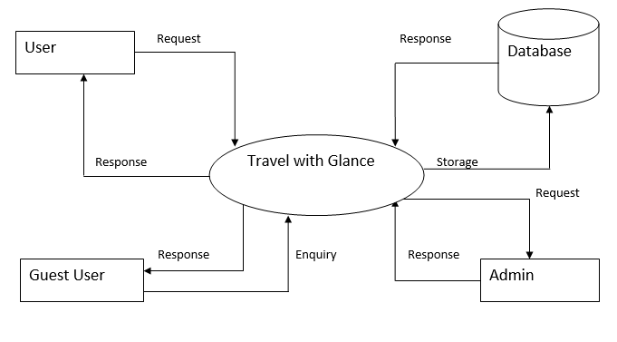

**Level 1 DFD**

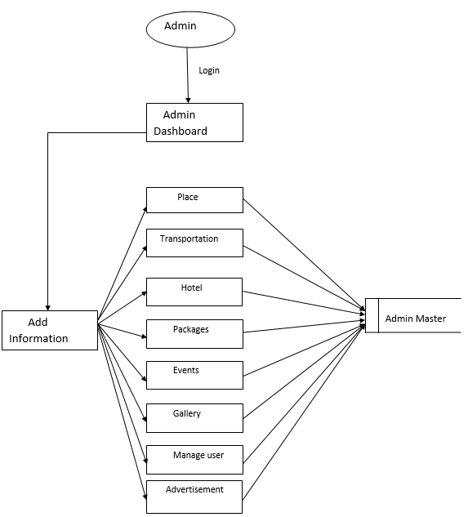

**Level 2 DFD**

**Tourist Place**

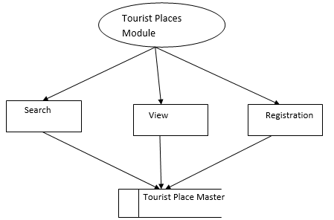

**Transportation**

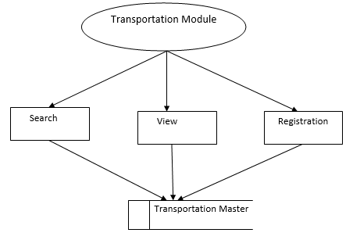

**Hotel**

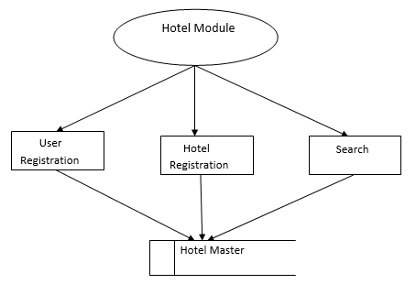

**Packages**

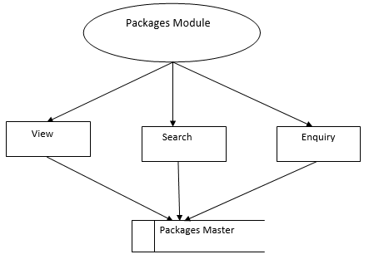

**Event**

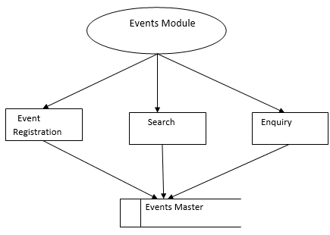

**Advertisement**

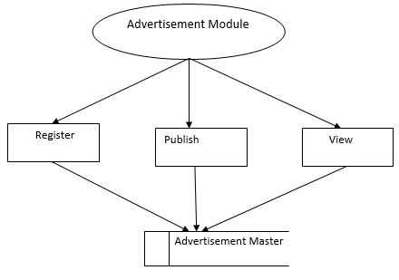

**ER Model:**

id

Name

id

Type

id

Type

Advertisements

Gallery

Events

Address

Name

id

Hotel

Type

Transport Type

id

Name

Fare

City

State

Tourist Places

id

Country

Name

Status

Email

Address

DOB

Password

Name

id

Manage

Password

Name

id

Admin

Contact

User

**USER**

Type

Transport Type

Has A

Name

Fare

Transportation

Address

Name

id

Phone no

id

Address

Name

DOB

Email

Hotel

View

Profile

Has

DOL

Account

History

DOJ

id

Registration

Contact

Email

Address

DOB

Password

Name

id

User

**Hotel Booking**

Advertisement

Gallery

id

Check_in_date

Bill

Bill_no

Amount

Date

Paying Method

Type

Hotel_id

Name

Hotel

Pays

Check_out_date

Books

User

User_id

Name

**User Case Digram**

**1. Admin Module**

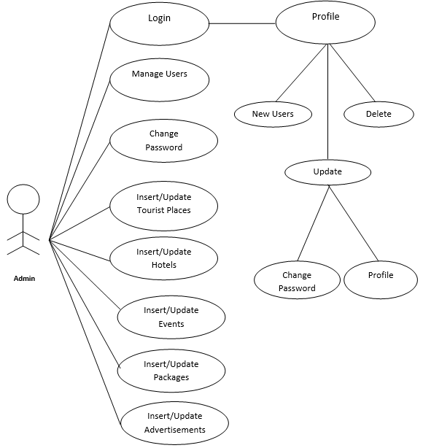

**2.User Module**

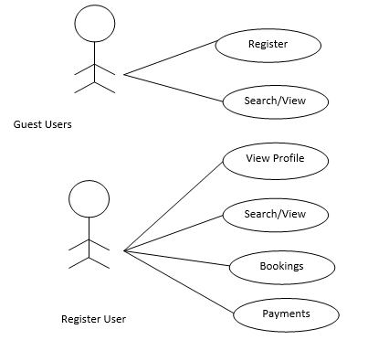

**DATA STRUCTURE**

The normalized form of the table with their structure is describe as under-

**Table 1: SIGN UP**

|  |  |  |  |
| --- | --- | --- | --- |
| **Field Name** | **Data Type** | **Description** | **Key Constraint** |
| User_id | Varchar | Userid | Primary key |
| Email-id | Varchar | emailid | Foreign Key |
| Password | Varchar | password | - |
| Mobile | integer | mobile |  |

**Table 2: Trip Booking**

|  |  |  |  |
| --- | --- | --- | --- |
| **Field Name** | **Data Type** | **Description** | **Key Constraint** |
| Name | Varchar | name | Primary key |
| Email-id | Varchar | emailid | - |
| Code | Integer | code | - |
| Contact | Integer | contact | - |
| Address | Varchar | address | - |
| Country | Varchar | country | - |
| Arrive | Time | Arrive | - |
| Depart | Time | Depart | - |
| Adult | Integer | Adult |  |
| Child | Integer | Child |  |
| Room | Integer | Room |  |
| Comment | Varchar | comment | - |

**Table 3: Hotel booking detail**

|  |  |  |  |
| --- | --- | --- | --- |
| **Field Name** | **Data Type** | **Description** | **Key Constraint** |
| Name | Varchar | Name |  |
| Email | Varchar | Email |  |
| Mobile | Integer | Mobile | - |
| Id | Varchar | Id | - |
| Adult | Integer | Adult | - |
| Child | Integer | Child |  |
| Room | Integer | Room |  |
| Hotel type | Integer | Hotel |  |
| City | Varchar | city |  |

**Table 4: Contact Us**

|  |  |  |  |
| --- | --- | --- | --- |
| **Field Name** | **Data Type** | **Description** | **Key Constraint** |
| Name | Varchar | Name | **-** |
| Email | Varchar | Email | **-** |
| Subject | Varchar | Subject | **-** |
| Query | Varchar | Query | **-** |

**REQUIRMENTS**

**Functional Requirements :**

* Modules for admin to handle the administration task.
* Module for user to manage user information.
* Modules to manage hotel booking
* Module for manage trip booking
* Module to make Online Payment.
* Modules for customer to search place of their choices.

**Non-Functional Requirements :**

* Secure system protected with Login ID and Password.

.

#### SECURITY

**Physical Security**

The Divisional/Central Security Administrator shall be responsible for the physical security of the system

Their responsibilities shall include

* Maintenance of security of Database Servers by keeping it locked and prohibiting entry of any unauthorized person to prevent thefts and other untoward incidents
* Access to the database server shall be protected by password and only the System Administrator shall be aware of the same.
* Maintenance of multiple power supply connections for uninterrupted power supply.

**Database Security**

* **MySQL Authentication**: In this case, MySQL requires that a user specifies a name and password at the time when connection is attempted. The login name and one-way hash of the password need to match one of entries in the sys login table for the login attempt to be successful.
* **Windows Authentication:** With built in Windows authentication and per-application configuration, you can be assured that your applications are secure.

#### FUTURE SCOPE

The main purpose of “**Travel the Best Agency**” is to provide an alternate and convenient way for a customer to book hotels, flight, train and bus for tour purposes. In this project, we aim to choose that particular experience which will shape vision of the country by visiting our website. We will make an easier task of searching places and for booking train, flight or bus.

It is highly likely that the scope will change as the web application moves forward the web process model should be incremental. This allows development team to freeze the scope for one increment so that an operation web application of the preceding increment but once the second increment commence, scope is again frozen temporarily. This approach enables the web application team to work with having to accommodate continual stream of change be still recognized. The continuous evolutions characteristics of most web application. Beside that the following basic quality in the software always safeguards the future scope of the software.

**BIBLIOGRAPHY**

We referred some books which had provided us with much of guidance to develop the code for the website. There are a few good books and websites that we referred to develop **HTML, CSS, JavaScript, Jquery and PHP (MySQL) codes.**

Apart from codes these books and websites had provides us with few good techniques and methodologies to develop the website. There are a list of few books and websites that we referred are:

**BOOKS:**

* **HTML, CSS, JS** By **Head First HTML, CSS, JS**
* **MySQL** By **Learning MySQL**

**SITES FOR REFERENCE**

* <http://www.javatpoint.com>
* http://www.webdesgin.com
* <http://www.w3school.com>
* <http://www.tutorialspoint.com>
* <http://webdevlopment.com>
* http://getbootstrap.com
* <https://in.youtube.com/Javabrains>