College Placement Preparation Platform - Comprehensive Plan

1. Platform Overview & Vision

Core Problem Statement
- Lack of structured interaction between seniors and juniors
- Missing depth in placement/internship preparation guidance
- Students don't know what to study, what depth is required
- No proper understanding of company-specific preparation strategies

Unique Value Propositions
- Gamified Learning Journey - Progress tracking with unlockable content
- AI-Powered Personalized Learning - Adaptive content based on progress
- Senior-Junior Bridge - Direct mentorship opportunities
- Company-Specific Preparation - Tailored content for target companies
- Continuous Engagement - Not just PDF downloads but interactive learning

2. Innovative Features & Engagement Strategies

A. Gamification & Progress System
- Learning Streaks - Daily problem-solving streaks with rewards
- Achievement Badges - Complete DSA topics, win contests, help juniors
- Leaderboards - College-specific rankings, topic-wise rankings
- Credit System - Earn credits through activities, spend on premium features
- Level Progression - Beginner → Intermediate → Advanced → Expert

B. Unlockable Content System
- Previous Year Questions - Locked behind completion milestones
- Company Insights - Access after completing relevant tracks
- Senior Mentorship Sessions - Earn through consistent performance
- Mock Interview Access - Unlock after topic completion

C. Interactive Learning Approach
- AI Learning Companion - Personalized explanations based on learning style
- Integrated Code Editor - Practice without leaving the platform
- Real-time Collaboration - Study groups, pair programming sessions
- Progress Analytics - Detailed insights into learning patterns

3. Platform Structure & User Journey

Year-wise Learning Paths

First Year Students
Foundation Track
- Programming Fundamentals (C++/Java/Python)
- Basic Problem Solving & Logic Building
- Introduction to Data Structures
- Mathematics for CS (Discrete Math, Statistics)
Engagement Strategy:
- Weekly coding challenges
- Peer learning groups
- Senior buddy system
- Foundation certification

Second Year Students
Intermediate Track
- Advanced Data Structures & Algorithms
- System Design Basics
- Development Specialization (MERN/ML/Mobile)
- Competitive Programming
Engagement Strategy:
- Company-specific preparation tracks
- Mock assessment rounds
- Industry project collaborations
- Internship preparation bootcamps

Third/Fourth Year Students
Advanced Track
- Interview Preparation
- System Design Deep Dive
- Leadership & Mentoring
- Career Guidance

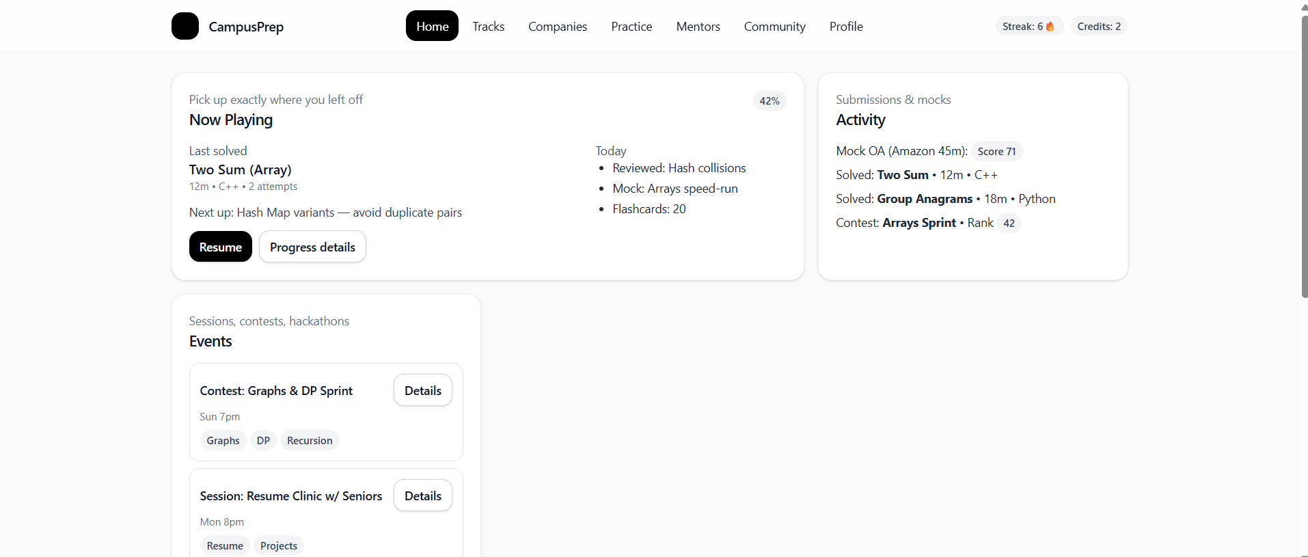

Specialization Tracks

DSA Track
Basic Level:
- Array, Strings, Basic Math
- Time/Space Complexity
- Basic Sorting & Searching
- Simple Problem Solving Patterns
Intermediate Level:
- Linked Lists, Stacks, Queues
- Trees & Binary Search Trees
- Hashing & Hash Maps
- Dynamic Programming Basics
Advanced Level:
- Graphs & Advanced Algorithms
- Advanced DP, Backtracking
- Segment Trees, Fenwick Trees
- Contest-level Problem Solving
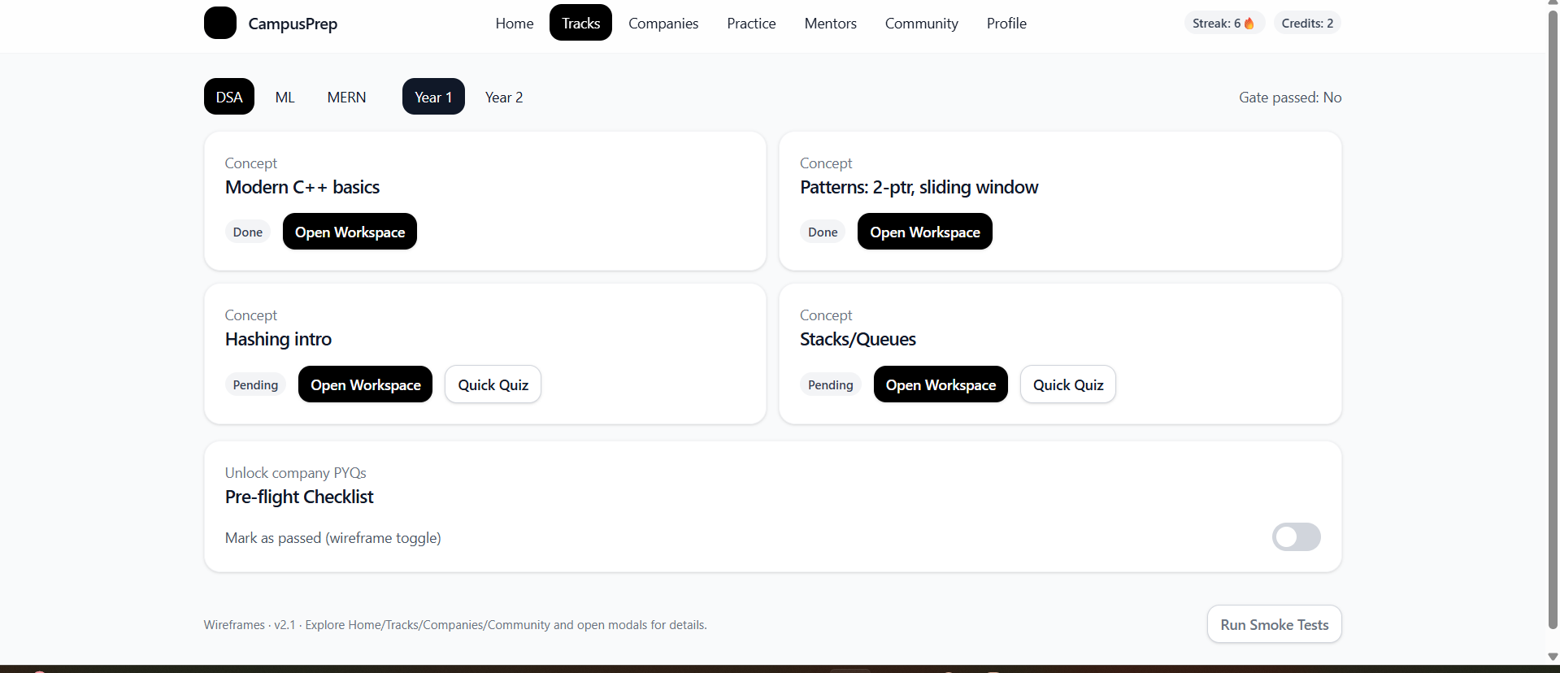

ML Track
Foundation:
- Linear Algebra & Statistics
- Python for Data Science
- Data Preprocessing & EDA
Core Algorithms:
- Linear/Logistic Regression
- KNN, Decision Trees
- SVM, Random Forest
- Neural Networks Basics
Advanced Topics:
- Deep Learning (CNN, RNN)
- Computer Vision
- NLP & Transformers
- LLM Architecture

Development Track (MERN)
Frontend:
- HTML5, CSS3, JavaScript ES6+
- React.js Fundamentals
- State Management, Hooks
- Responsive Design, UI/UX
Backend:
- Node.js & Express.js
- REST APIs, GraphQL
- Database Design (MongoDB)
- Authentication & Authorization
Full Stack:
- Project Architecture
- Deployment & DevOps
- Testing Strategies
- Performance Optimization
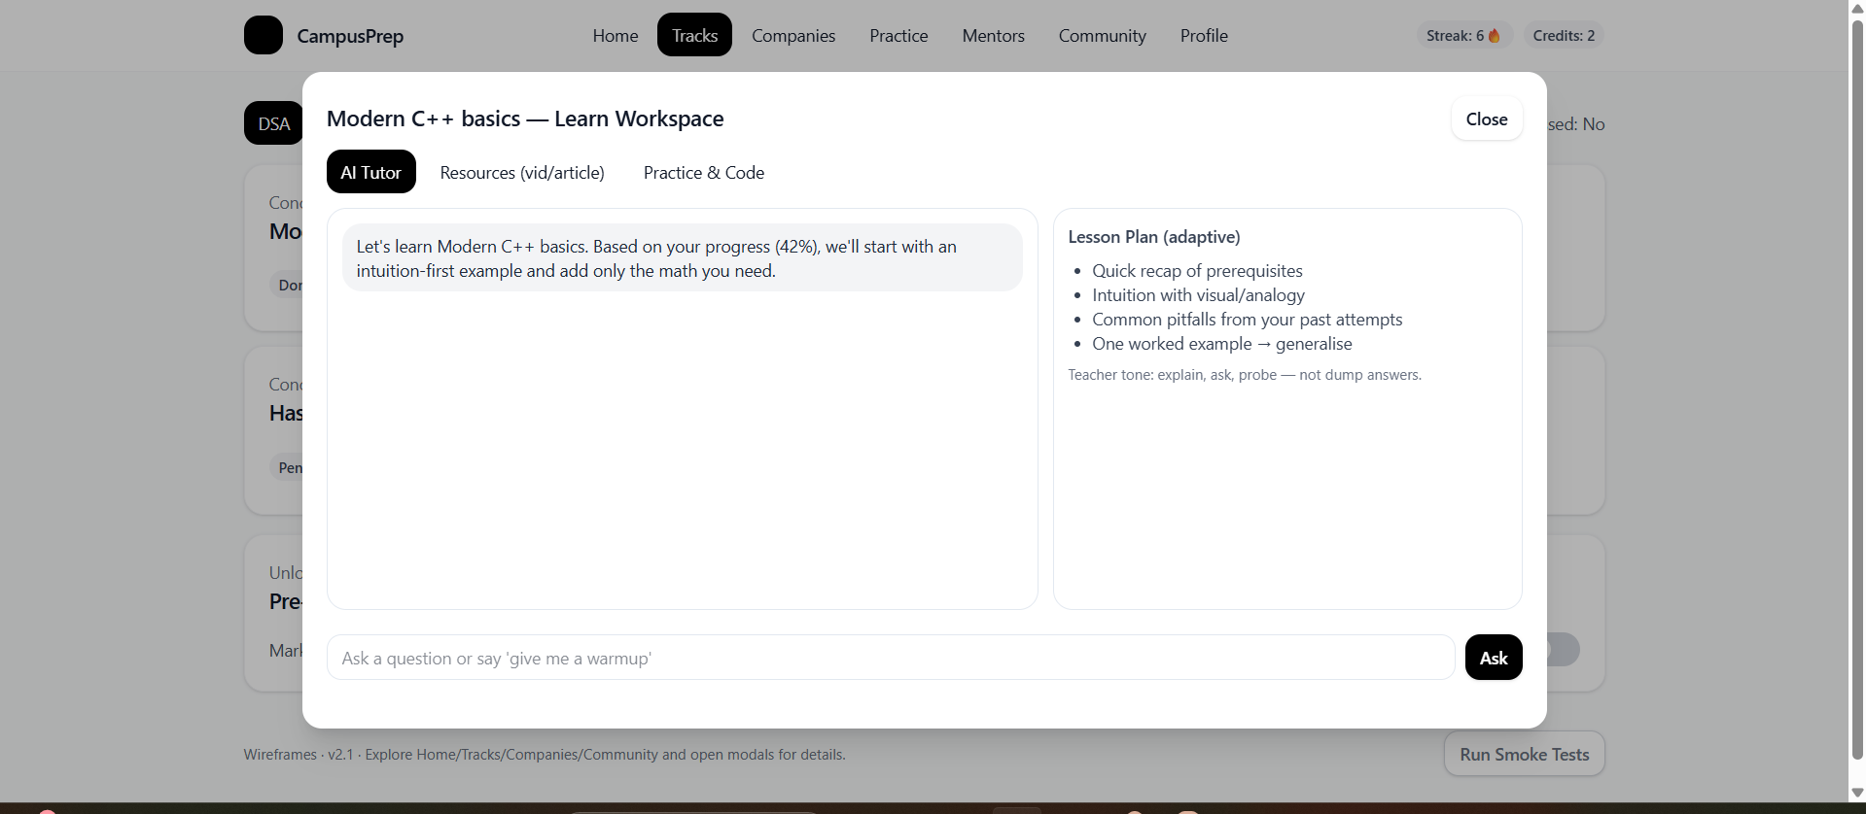

4. Home Page Design & Features

Main Dashboard Components

Progress Overview Card
Current Sprint: "Arrays & Strings Mastery"
├── Recently Completed: "Two Sum Problem"
├── Current Focus: "Sliding Window Technique"
├── Next Target: "Hash Map Patterns"
└── Completion: 65% (13/20 problems)

Daily Streak: 🔥 7 days | Credits: 💰 150

Notifications & Upcoming Events
📅 Upcoming Events
├── Contest: "Weekly DSA Challenge" (2 days)
│ Topics: Graphs, DP, Recursion
├── Session: "Google Interview Experience" (5 days)
│ By: Rohit Sharma (SDE-2 @ Google)
└── Hackathon: "Build for Tomorrow" (1 week)
Theme: AI/ML Applications

Leaderboard Snapshot
🏆 Weekly Leaderboard
1. Priya Singh | 245 pts | 15 problems | Java
2. Arjun Kumar | 230 pts | 12 problems | C++
3. You | 180 pts | 10 problems | Python

Quick Actions
- Continue Learning
- Take Mock Test
- Join Study Group
- Ask Mentor

5. Learning Experience Design

AI-Powered Learning Interface

Three Learning Modes (Single Page)
Mode 1: AI Tutor Chat (Primary Focus - 60% screen)
AI Tutor: "Let's understand Binary Search today!
Based on your progress with arrays, you're ready for this.

Can you tell me what you know about searching in sorted arrays?"

[User Input Box]

Features:
- Adaptive questioning based on user's pace
- Visual examples and diagrams
- Step-by-step problem breakdown
- Concept reinforcement through questions

Mode 2: Video/Article Resources (Collapsible Panel - 20%)
📖 Additional Resources
├── Video: "Binary Search Visualization" (8 min)
├── Article: "Binary Search Implementation Guide"
└── Interactive Demo: "BS Simulator"

Mode 3: Integrated Code Editor (40% when active)
Problem: Find target in sorted array
Difficulty: Easy | Companies: Google, Amazon

[Monaco Code Editor]
- Real-time syntax highlighting
- Auto-completion
- Test case execution
- Submission tracking

Learning Analytics Dashboard
📊 Your Learning Insights
├── Learning Style: Visual + Hands-on
├── Best Time: 2-4 PM (87% accuracy)
├── Strength: Array Problems (92% success)
├── Improvement Area: Tree Algorithms (45% success)
└── Recommended: Practice 2-3 tree problems daily

6. Community & Social Features

Achievement Feed (Instagram-style)
🎉 Recent Achievements

[@priya_codes]
"Just cracked Microsoft's Online Assessment! 🚀
Thanks to the DP track on our platform 💪"
❤️ 23 likes | 💬 5 comments | 🔄 2 shares

[@tech_arjun]
"Won our college's first hackathon! 🏆
Team formed through platform's team-building feature"
❤️ 45 likes | 💬 12 comments | 🔄 8 shares

Team Building & Projects
🤝 Find Your Team
├── Hackathons
│ ├── Smart India Hackathon 2024
│ ├── Skills: React, Node.js, ML
│ └── Looking for: 2 developers, 1 designer
├── Study Groups
│ ├── "Advanced DP Masters"
│ ├── Schedule: Daily 8-9 PM
│ └── Members: 4/6
└── Project Collaboration
├── "E-commerce Platform"
├── Tech Stack: MERN
└── Contributors: 3/5

Mentorship Integration
🎯 Your Mentors
├── Rahul Gupta (SDE-3 @ Amazon)
│ ├── Specialization: System Design, DSA
│ ├── Next Session: "Designing Scalable Systems"
│ └── Booking: Available weekends
└── Sneha Patel (ML Engineer @ Microsoft)
├── Specialization: Machine Learning, Data Science
├── Next Session: "Breaking into ML Roles"
└── Booking: Credits required: 50

7. Company-Specific Preparation

Enhanced Company Sections
🏢 Target Companies

[Google]
├── 📝 Coding Round
│ ├── Difficulty: Medium-Hard
│ ├── Topics: Arrays, Trees, Graphs, DP
│ ├── Time: 90 minutes, 2 problems
│ └── Success Rate: 15% (college average)
├── 🧠 Technical Interviews
│ ├── Round 1: DSA + Problem Solving
│ ├── Round 2: System Design (for experienced)
│ └── Tips from successful candidates
├── 💡 Aptitude & Reasoning
│ ├── Quantitative Aptitude
│ ├── Logical Reasoning
│ └── Verbal Ability
└── 📚 CS Fundamentals
├── Object-Oriented Programming
├── Database Management Systems
├── Computer Networks
└── Operating Systems

8. Profile & Analytics System

Comprehensive Profile Dashboard
👤 Your Profile

🔥 Current Streak: 15 days
🏆 Global Rank: #1,247 (Top 2%)
📈 College Rank: #12 (Top 5%)
⭐ Credits Earned: 1,250

📊 Performance Analytics
├── Problems Solved: 245
│ ├── Easy: 120 (85% accuracy)
│ ├── Medium: 95 (72% accuracy)
│ └── Hard: 30 (45% accuracy)
├── Contest Performance
│ ├── Contests Participated: 12
│ ├── Average Rank: 145
│ └── Best Rank: 23 🏆
└── Learning Velocity
├── Problems/Week: 15 (↗️ +20%)
├── Study Hours/Week: 18
└── Concept Mastery Rate: 78%

🎯 Achievements Unlocked
├── "Array Master" - Solved 50 array problems
├── "Consistent Coder" - 10-day streak
├── "Contest Warrior" - Top 50 in college contest
└── "Mentor Helper" - Helped 5 juniors

📈 Progress Milestones
├── ✅ Foundation Complete (Rank achieved: #50)
├── 🔄 Intermediate Track (65% complete)
└── 🔒 Advanced Track (Unlock at 80%)

🎪 Recent Activity
├── Solved "Longest Palindromic Substring" (Medium)
├── Attended "System Design Basics" session
├── Helped junior with "Binary Trees" concept
└── Participated in "Weekly Algorithm Challenge"

Visual Progress Representation
- Heat map showing daily activity
- Skill radar chart showing strengths/weaknesses
- Learning curve graphs
- Company readiness scores

9. Engagement & Retention Strategies

Continuous Engagement Features

Daily Challenges
- "Problem of the Day" based on learning level
- Streak bonuses and multipliers
- Social sharing of achievements

Weekly Events
- College-specific coding contests
- Topic-focused challenges
- Team competitions

Monthly Goals
- Learning path completions
- Company readiness assessments
- Mentorship milestones

Seasonal Programs
- Internship preparation bootcamps
- Placement season intensive training
- Hackathon seasons

Reward System
🎁 Reward Tiers

Bronze Tier (0-500 credits)
├── Access to basic content
├── 1 mentor session/month
└── Community participation

Silver Tier (500-1500 credits)
├── Previous year questions (last 2 years)
├── 2 mentor sessions/month
├── Mock interview access
└── Advanced analytics

Gold Tier (1500-3000 credits)
├── All historical questions
├── Unlimited mentor sessions
├── Priority support
├── Beta feature access
└── Company-specific prep guides

Platinum Tier (3000+ credits)
├── One-on-one mentoring
├── Career guidance sessions
├── Industry networking events
├── Placement guarantee programs
└── Alumni network access

10. Technical Architecture Considerations

Scalability Features
- Progressive Web App (PWA) for mobile experience
- Offline content access for limited connectivity
- Real-time collaboration using WebRTC
- Microservices architecture for different modules

Data Analytics
- User behavior tracking for personalization
- Learning pattern analysis
- Success rate optimization
- Predictive modeling for placement success

Integration Capabilities
- College LMS integration
- Industry partner APIs
- Video conferencing for mentorship
- Payment gateway for premium features

11. Success Metrics & KPIs

User Engagement
- Daily/Weekly/Monthly Active Users
- Session duration and frequency
- Problem-solving completion rates
- Community participation levels

Learning Outcomes
- Skill progression rates
- Assessment score improvements
- Interview success rates
- Placement/Internship conversion rates

Platform Health
- Content consumption patterns
- Feature adoption rates
- User retention rates
- Mentor-mentee matching success

12. Implementation Roadmap

Phase 1 (Months 1-3): Foundation
- Core learning platform
- User authentication & profiles
- Basic DSA content
- Simple gamification

Phase 2 (Months 4-6): Enhancement
- AI tutoring system
- Company-specific content
- Mentorship features
- Advanced analytics

Phase 3 (Months 7-9): Community
- Social features
- Team building
- Events & contests
- Mobile optimization

Phase 4 (Months 10-12): Scale
- Industry partnerships
- Advanced ML features
- Multi-college expansion
- Revenue optimization

This platform will revolutionize how students prepare for placements by creating an engaging, comprehensive, and personalized learning experience that bridges the gap between academic learning and industry requirements.

