HR ANALYTICS AT SCALEWORKS
Behavioural Modelling to Predict Candidate Renege
A Machine Learning Classification Study
Group Assignment Report
Group 4
Course: Machine Learning — Case Study Application

GitHub Link :- Click Here
Submitted: August 2026

1. Executive Summary
ScaleneWorks, a recruitment analytics company, faces a recurring business problem: a meaningful share of candidates who accept a job offer do not eventually join the organisation, a phenomenon known as “renege.” This project builds a machine learning classification model to predict, at the time an offer is accepted, whether a candidate is likely to join or renege, and to identify the factors that drive this decision.
Using a dataset of 12,333 candidate records with 17 attributes, three classification models were built and compared: Logistic Regression, Decision Tree, and Random Forest. Random Forest was the best-performing model, achieving 83.66% accuracy. The analysis found that the duration a candidate takes to accept the offer, together with salary-related variables (percentage hike offered, percentage hike expected, and percentage difference in CTC), are the strongest predictors of joining behaviour, followed by notice period and age. These findings allow ScaleneWorks to flag high-risk candidates early and take proactive retention steps.

2. Business Problem
The CEO of ScaleneWorks wants to use an analytical, data-driven approach to reduce the rate at which candidates who accept a job offer subsequently fail to join. Reneging on an accepted offer is costly: it disrupts workforce planning, delays project staffing, and wastes recruitment effort and cost already spent on the candidate. The organisation needs a way to anticipate which candidates are at risk of not joining so that HR can intervene early with engagement, communication, or compensation adjustments.
Problem statement: “Which candidates are likely to not join the company after accepting the offer, and what factors drive that decision?”

3. Objectives
- Build a classification model that predicts whether a candidate will join or renege after accepting an offer.
- Compare multiple machine learning algorithms and select the model with the best predictive performance.
- Identify and rank the key drivers (features) that influence a candidate's decision to join.
- Translate the model's findings into actionable HR recommendations to reduce renege rates.

4. Dataset Description
The dataset used for this analysis is the ScaleneWorks candidate dataset, consisting of 12,333 records and 17 columns before cleaning. Each row represents one candidate who received and accepted a job offer, along with attributes describing the offer, the candidate's profile, and the eventual outcome.
Column | Description
Candidate Ref | Unique candidate identifier (dropped before modelling)
DOJ Extended | Whether the candidate's date of joining was extended (Yes/No)
Duration to accept offer | Number of days taken by the candidate to accept the offer
Notice period | Notice period (in days) required at the candidate's current employer
Offered band | Job grade / band offered to the candidate
Percent hike expected in CTC | Salary hike (%) the candidate expected over current CTC
Percent hike offered in CTC | Salary hike (%) actually offered by ScaleneWorks
Percent difference CTC | Difference (%) between expected and offered hike
Joining Bonus | Whether a joining bonus was offered (Yes/No)
Candidate relocate actual | Whether the candidate had to relocate for the role
Gender | Candidate's gender
Candidate Source | Recruitment channel: Direct, Agency, or Employee Referral
Rex in Yrs | Relevant experience of the candidate in years
LOB | Line of business the candidate was hired into
Location | Job location
Age | Candidate's age
Status (Target) | Outcome: Joined or Not Joined
Target variable: Status — a binary outcome indicating whether the candidate ultimately Joined or did Not Join (reneged).

5. Data Cleaning

5.1 Missing Values
An initial check of the dataset revealed missing values concentrated in four numerical columns:
Column | Missing Values
Duration to accept offer | 2,719
Percent hike expected in CTC | 747
Percent hike offered in CTC | 596
Percent difference CTC | 851
Numerical missing values were imputed using the column mean, and categorical missing values (if any) were imputed using the column mode (most frequent value). After imputation, the dataset had zero missing values across all columns.

5.2 Duplicate Records
A check for duplicate rows found 0 duplicate records, so no rows needed to be removed on this basis.

5.3 Column Removal
The Candidate Ref column was dropped, since it is purely a unique identification number with no predictive relationship to whether a candidate joins. This reduced the feature set from 17 columns to 16 (15 predictors plus the target).

6. Exploratory Data Analysis (EDA)
Exploratory analysis was carried out to understand the distribution of candidates across key variables and to surface early patterns before modelling.

6.1 Target Variable — Status Distribution
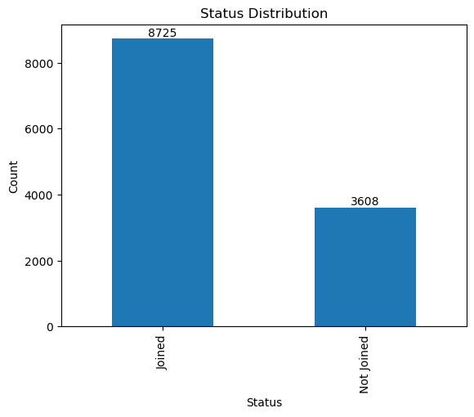
Figure 1: Distribution of candidate joining status
Of the 12,333 candidates, 8,725 (70.75%) joined the company, while 3,608 (29.25%) did not join after accepting the offer. This means nearly 3 in 10 candidates reneged, confirming the business problem is significant and that the target classes are moderately imbalanced (roughly 71:29), which is an important consideration in model evaluation.

6.2 Gender Distribution
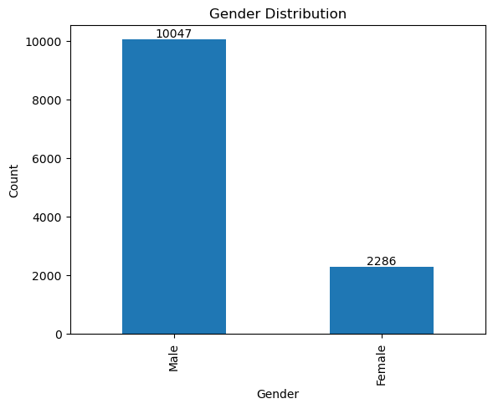
Figure 2: Candidate distribution by gender
The dataset contains 10,047 male candidates and 2,286 female candidates, showing the candidate pool is heavily skewed toward male applicants.

6.3 Candidate Source
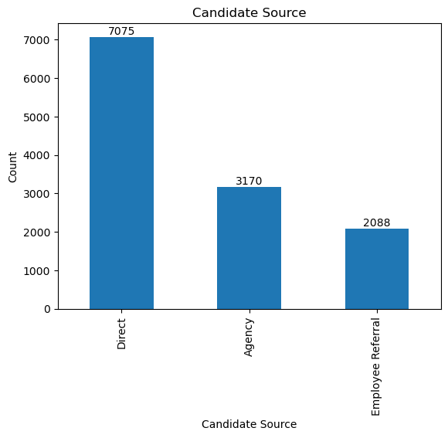
Figure 3: Candidate distribution by recruitment source
Direct recruitment was the largest channel with 7,075 candidates (about 57%), followed by Agency recruitment with 3,170 candidates (about 26%), and Employee Referral with 2,088 candidates (about 17%).

6.4 Date of Joining (DOJ) Extended
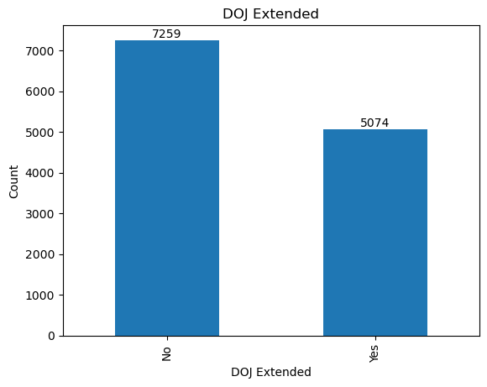
Figure 4: Whether the candidate's date of joining was extended
7,259 candidates (about 59%) did not have their joining date extended, while 5,074 candidates (about 41%) had an extension. A DOJ extension can signal ongoing negotiation or delay between the candidate and the company, which may relate to eventual renege.

6.5 Joining Bonus
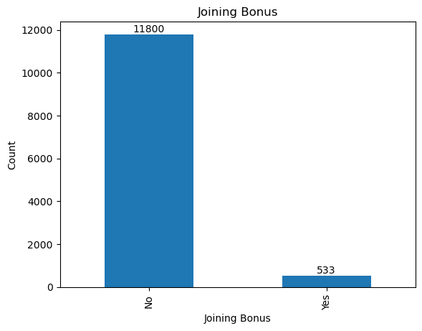
Figure 5: Candidates offered a joining bonus

6.6 Notice Period Distribution
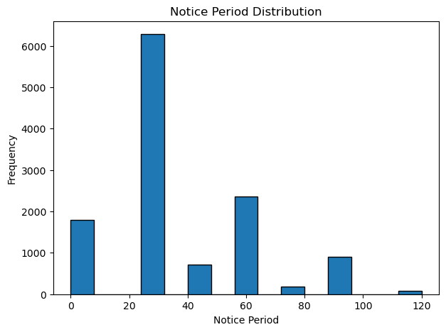
Figure 6: Distribution of candidate notice period (days)
The 30-day notice period is by far the most common category, accounting for the majority of candidates. Longer notice periods give candidates more time to reconsider or receive counter-offers, which can increase the likelihood of reneging.

6.7 Age Distribution
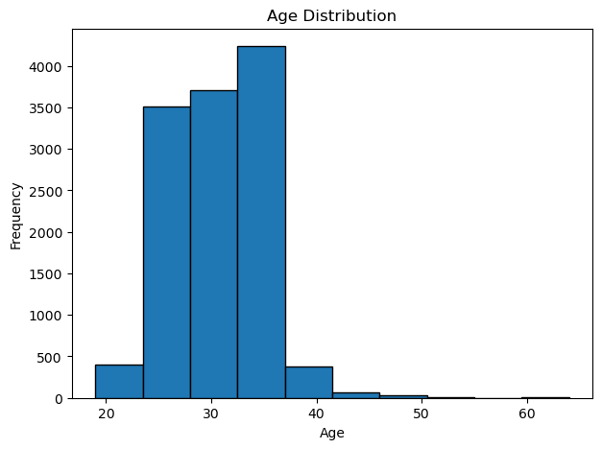
Figure 7: Distribution of candidate age
Most candidates fall between roughly 27 and 35 years of age, with the highest concentration around 28-32 years, consistent with a workforce dominated by early-to-mid career professionals.

6.8 Correlation Heatmap
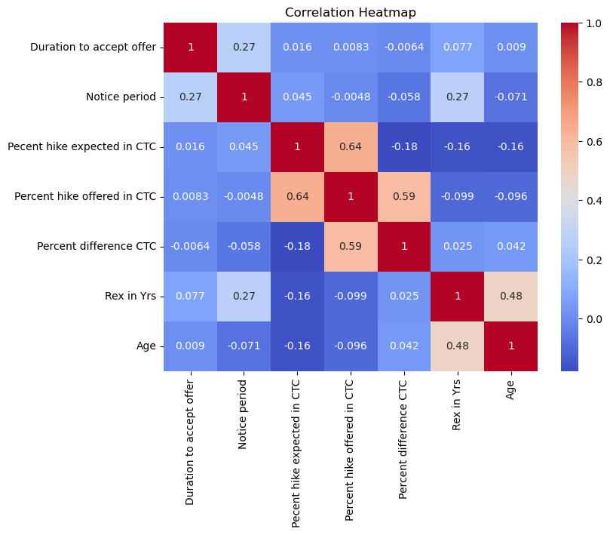
Figure 8: Correlation heatmap of numerical variables
The strongest correlation observed is between Percent hike expected in CTC and Percent hike offered in CTC (≈ 0.64), indicating that when candidates expect a higher hike, the company tends to offer a correspondingly higher hike. Percent hike offered in CTC and Percent difference CTC are also correlated (≈ 0.59), and Rex in Yrs and Age show a moderate correlation (≈ 0.48), which is expected since experience typically increases with age. No single numerical variable shows a strong direct linear correlation with the target, which is why a machine learning model — capable of capturing non-linear, multi-variable patterns — was necessary rather than relying on correlation alone.

7. Data Preprocessing
Before model building, the dataset was prepared as follows:
- Categorical columns (DOJ Extended, Offered band, Joining Bonus, Candidate relocate actual, Gender, Candidate Source, LOB, Location, and Status) were converted into numeric form using Label Encoding, since machine learning algorithms require numerical input.
- The dataset was split into features (X) — all columns except Status — and the target (y) — the Status column.
- The data was divided into 80% training data (9,866 records) and 20% testing data (2,467 records) using train_test_split with random_state = 42, ensuring the model is trained on the majority of the data while retaining an unseen portion for honest evaluation.

8. Model Building
Three classification algorithms were trained on the same training set and evaluated on the same test set, allowing a fair, like-for-like comparison of performance.

8.1 Model 1 — Logistic Regression
Logistic Regression, a simple linear baseline model, achieved an accuracy of 74.83%.
Metric | Class 0 (Joined) | Class 1 (Not Joined)
Precision | 0.77 | 0.64
Recall | 0.92 | 0.34
F1-score | 0.84 | 0.45
Confusion Matrix: [[1597, 143], [478, 249]]. The model is strong at identifying candidates who joined (92% recall) but weak at catching candidates who reneged, correctly identifying only 34% of the Not Joined class — a significant limitation for this business problem, since missing at-risk candidates defeats the purpose of the model.

8.2 Model 2 — Decision Tree
The Decision Tree classifier improved on the baseline, achieving an accuracy of 78.03%.
Metric | Class 0 (Joined) | Class 1 (Not Joined)
Precision | 0.85 | 0.63
Recall | 0.84 | 0.63
F1-score | 0.84 | 0.63
Confusion Matrix: [[1466, 274], [268, 459]]. Recall for the Not Joined class rose sharply from 34% to 63%, meaning the Decision Tree is considerably better at flagging candidates likely to renege, at a small cost to overall precision on the Joined class.

8.3 Model 3 — Random Forest
Random Forest, an ensemble of many decision trees, delivered the best overall performance with an accuracy of 83.66%.
Metric | Class 0 (Joined) | Class 1 (Not Joined)
Precision | 0.84 | 0.83
Recall | 0.95 | 0.56
F1-score | 0.89 | 0.67
Confusion Matrix: [[1656, 84], [319, 408]]. Random Forest achieves the highest accuracy and the best precision for the Not Joined class (0.83), meaning that when it predicts a candidate will renege, it is correct 83% of the time — valuable for HR teams who want confidence before investing effort in retention outreach.

9. Model Comparison
Model | Accuracy
Logistic Regression | 74.83%
Decision Tree | 78.03%
Random Forest | 83.66%
Random Forest is selected as the final model, since it delivers the highest accuracy and the most balanced performance across both classes, particularly a much-improved ability to correctly flag candidates at risk of reneging compared to Logistic Regression.

10. Feature Importance — Key Drivers of Renege

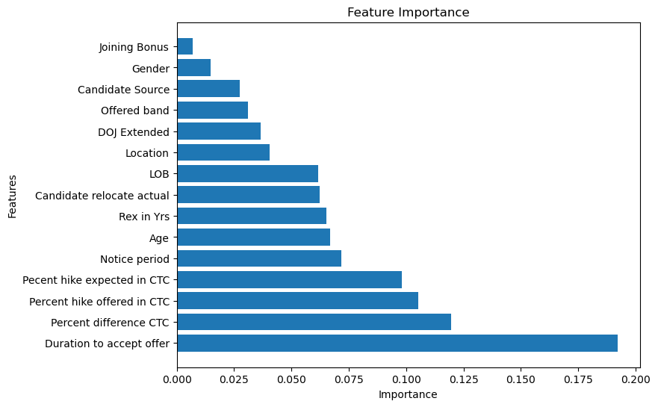

Figure 9: Random Forest feature importance
Rank | Feature | Importance
1 | Duration to accept offer | 19.22%
2 | Percent difference CTC | 11.94%
3 | Percent hike offered in CTC | 10.54%
4 | Percent hike expected in CTC | 9.81%
5 | Notice period | 7.16%
6 | Age | 6.69%
7 | Rex in Yrs (Experience) | 6.51%
8 | Candidate relocate actual | 6.22%
9 | LOB | 6.16%
10 | Location | 4.06%
11 | DOJ Extended | 3.67%
12 | Offered band | 3.10%
13 | Candidate Source | 2.75%
14 | Gender | 1.48%
15 | Joining Bonus | 0.70%
The single biggest driver of a candidate's decision is Duration to accept offer (19.22% importance) — candidates who take longer to accept an offer are more likely to eventually renege, likely because a longer decision time signals hesitation or ongoing negotiation with other employers. Salary-related variables collectively dominate the top of the list: Percent difference CTC, Percent hike offered, and Percent hike expected together account for roughly 32% of total importance, confirming that compensation gaps are a major driver of reneging. Notice period and Age follow as moderately important factors. In contrast, Gender and Joining Bonus have very low importance, suggesting that, in this dataset, offering a bonus alone does little to influence whether a candidate joins.

11. Business Insights
- Nearly 3 in 10 candidates (29.25%) who accept an offer do not eventually join — this is a material and addressable business problem.
- Slow offer acceptance is the strongest warning sign of renege; candidates who deliberate longer before accepting are more likely to be exploring other options.
- Compensation gaps matter more than compensation size alone — the gap between what a candidate expects and what is offered is more predictive than the offered hike in isolation.
- Longer notice periods give candidates more time to be approached with counter-offers, increasing renege risk.
- A joining bonus, on its own, is not a strong lever for improving joining rates in this dataset.

12. Recommendations
- Flag candidates who take unusually long to accept an offer for proactive HR engagement and regular check-ins between acceptance and joining.
- Benchmark salary offers against candidate expectations more closely to reduce the CTC gap, particularly for high-priority hires.
- For candidates with long notice periods, maintain frequent, structured communication to reduce the risk of losing them to counter-offers.
- Use the Random Forest model's predicted risk score to prioritise retention effort on the highest-risk candidates rather than treating all accepted offers equally.
- Revisit the value of joining bonuses as a retention tool, since they show limited standalone impact on joining behaviour in the current data.

13. Limitations and Future Scope
- The target classes are imbalanced (71% Joined vs 29% Not Joined); techniques such as SMOTE or class-weight balancing could further improve recall on the minority (Not Joined) class.
- Missing values were imputed with simple mean/mode substitution, which can understate true variability; more advanced imputation could be explored.
- Hyperparameter tuning (e.g., GridSearchCV) on the Random Forest model was not performed and could yield further accuracy gains.
- Additional features, such as counter-offer history or communication frequency during the notice period, could improve predictive power if available.

14. Conclusion
This project successfully built and compared three classification models to predict candidate renege at ScaleneWorks. The Random Forest model was the best performer, achieving 83.66% accuracy, clearly ahead of Decision Tree (78.03%) and Logistic Regression (74.83%). The feature importance analysis identified duration to accept the offer and salary-related factors (percentage difference in CTC, percentage hike offered, and percentage hike expected) as the leading drivers of whether a candidate joins, followed by notice period and age. These insights give ScaleneWorks a concrete, data-driven basis for identifying high-risk candidates early and taking targeted action — such as faster engagement, closer compensation alignment, and consistent communication during the notice period — to reduce the rate of offer reneges and improve overall recruitment efficiency.

15. Tools and Technologies
Category | Tools Used
Programming Language | Python
Data Handling | pandas, numpy
Visualisation | matplotlib, seaborn
Preprocessing | scikit-learn (LabelEncoder, train_test_split)
Modelling | scikit-learn (LogisticRegression, DecisionTreeClassifier, RandomForestClassifier)
Evaluation | scikit-learn (accuracy_score, classification_report, confusion_matrix)

