

**1. Team Details**

* **Team Name:** SPxT
* **Team Members:**
  1. Yash Koyande
  2. Gaurav Padam
  3. Shreyash Tirpude
  4. Prince Mishra

**2. Theme Details**

* **Theme Name:** Theme 2 - Create a GenAI-Powered Tool to Simplify Cross-Border Regulations and Government Incentives for Sellers in E-commerce
* **Theme Benefits:**
  + This solution will empower Indian SMBs to navigate international compliance requirements, stay updated with changing regulations, and leverage incentives effectively.
  + By providing real-time regulatory notifications, customized news, and an AI assistant, the platform will deliver timely insights and guidance to reduce compliance-related risks and streamline international expansion.

**3. Idea and Approach Details**

* **Solution Overview:**
  + The platform will be a subscription-based GenAI-powered service focused on three main modules:
    1. **Real-Time Regulation & Compliance Insights**: Monitors regulatory changes across target markets and sends alerts for any new policies, incentives, or compliance requirements relevant to the user’s products.
    2. **Customer-centric News Feed**: Curates news from trusted sources, tailored to each user’s industry and specific product focus, providing timely insights on market trends, regulatory updates, and trade news.
    3. **Smart Compliance & Incentive Advisor**: A conversational AI assistant that answers compliance-related queries, offering real-time support on certifications, documentation requirements, and incentives.
    4. **Export-Ready Document Generator:** The AI-Powered document generator helps users navigate export requirements by providing tailored, location-based regulatory guidance. By selecting origin, destination, and product (via HS6 codes), users receive a customized list of applicable regulations, required pre-requisites, and formalities. The assistant also provides links to helpful resources and official portals, simplifying compliance and ensuring exporters are equipped with all essential information to streamline international trade. Not only does it supply links to necessary forms, but it also auto-fills these forms based on the context gathered, reducing manual input and minimizing errors.
  + **Target Audience**: E-commerce SMBs, with a generalized approach for easy adaptability across different industries.
* **Technical Stack:**
  + **Generative AI Models**: For customer-centric regulation compliance assistance and chatbot.
  + **Frontend**: ReactJS for user-friendly and interactive dashboards.
  + **Backend**: Python for API development, data processing, and integration of notification and news modules. Langchain for integrating LLM capabilities.
  + **Analytics**: Langfuse for tracing every LLM Call.
  + **AWS Services**:
    1. **AWS SNS** (Simple Notification Service) for real-time notifications.
    2. **AWS API GATEWAY** for enabling serverless API management, providing secure and scalable integration for backend services and real-time data processing.
    3. **AWS Lambda** for event-driven updates on regulatory changes and serverless backend.
    4. **Amazon Comprehend** for sentiment and keyword extraction from news articles.
  + **Docker**: For containerization and efficient deployment.
  + **Database**: PostgreSQL for storing user information. Chroma for regulatory and incentive information as embeddings.
  + **Web Scraping Tools**: BeautifulSoup and Firecrawl for collecting relevant content.
* **Decision Rationale:**
  + **Real-Time Capability**: AWS services like SNS and Lambda enable real-time, event-driven notifications.
  + **Scalability**: Cloud-based deployment and Docker containers ensure scalability as more users subscribe.
  + **User Relevance**: Customizable news feeds and notifications provide users with high-value, targeted insights.
* **Innovation Highlights:**
  + The real-time notification system ensures users are always informed about relevant regulatory changes.
  + Custom news provides a unique, curated view of market trends, combining real-time updates with sentiment analysis.
  + The chatbot's instant access to compliance and incentive information reduces time spent searching for resources, enhancing user experience.
  + The Export-Ready Document Generator automates the creation of essential export documentation, streamlining the process for SMBs and reducing the manual effort required to meet compliance requirements.
* **Feasibility and User-Friendliness:**
  + The user-friendly dashboard and intuitive chatbot interaction make it easy for users to navigate the platform and find information quickly.
  + Real-time alerts, tailored news feeds, and a responsive chatbot create a highly relevant and dynamic experience for SMBs looking to expand internationally.
* **Success Metrics:**
  + **Notification Engagement Rate**: Measures how often users engage with regulatory notifications and alerts.
  + **Chatbot Accuracy and Response Time**: Evaluates the chatbot’s ability to provide relevant and quick answers.
  + **User Retention**: Monitors subscription renewals and usage frequency to assess ongoing value for users.
  + **Custom News Engagement**: Tracks clicks and interactions with news articles, indicating the relevance of curated content.

**4. Methodology/Architecture Diagram**

* **Architecture Diagram**:

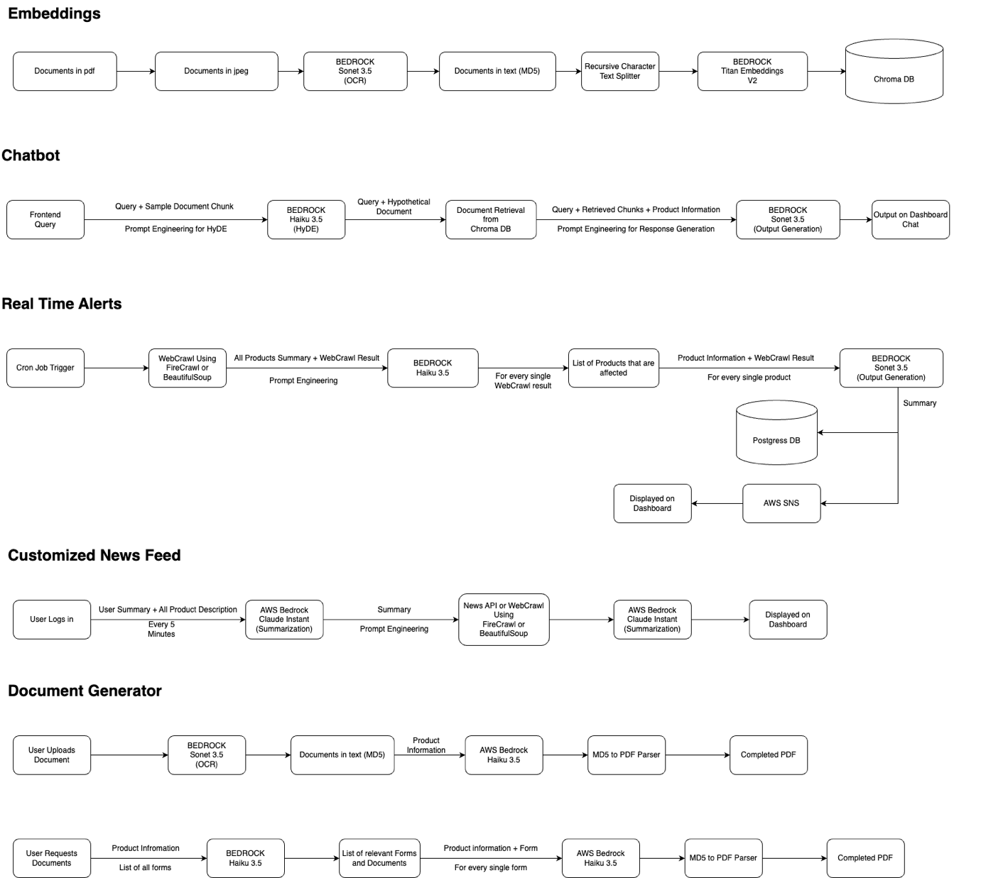

* **Flowchart**:

* **UI Mockups**:

