UIDAI(Unique Identification Authority of India)
Data Hackathon – 2026

Project Report
Problem Statement: Unlocking Societal Trends in Aadhaar Enrolment &Update : Identify meaningful patterns, trends, anomalies, or predictive indicators and translate them into clear insights or solution frameworks that can support informed decision-making and system improvements.

Team ID: UIDAI_12041

Team Details:
Ayush Raj Sinha
Gaurav Rao
Harsh Bind
Rashi Gupta(Team Lead)
Shashank Awasthi

Abstract
Aadhaar plays a critical role in identity verification and access to government services in India. Analysing enrolment trends helps understand coverage gaps and operational challenges.
This project analyses Aadhaar enrolment data provided by UIDAI to identify temporal and regional trends in enrolment patterns. The study highlights key insights, anomalies, and gaps which can support data-driven planning and service improvements.

Problem Statement
Despite availability of large-scale Aadhaar enrolment data, there is limited insight into regional, temporal, and demographic enrolment patterns. This lack of clarity affects effective planning and resource allocation by UIDAI.

So to identify the patterns WE,
- Analysed Aadhaar enrolment trends over time
- Identify high and low enrolment regions
- Detect anomalies or irregular patterns
- Propose data-driven recommendations
- Extract meaningful insights
- Support better planning.

Dataset Description
- Data Source: The dataset is sourced from the UIDAI Open Data Portal, released for the UIDAI Data Hackathon 2026.
- Data Overview: The dataset contains Aadhaar enrolment records captured across different regions of India over multiple time periods. It reflects the number of Aadhaar enrolments performed at various locations, helping analyse coverage, demand, and enrolment patterns.
- Time Period: The data spans multiple years, allowing both short-term and long-term trend analysis.
- Key Attributes:
Column | Description
date | Date on which Aadhaar enrolment was recorded in state
state | Name of the state where enrolment took place
district | District within the state
pincode | PIN code representing the enrolment location
age_0_5 | Number of Aadhaar enrolments for children aged 0–5 years
age_5_17 | Number of Aadhaar enrolments for individuals aged 5–17 years
age_18_greater | Number of Aadhaar enrolments for individuals aged 18 years and above

Methodology
This project follows a structured data analysis approach to extract meaningful insights from the Aadhaar Enrolment dataset provided by UIDAI. The methodology consists of the following steps:
- Data Collection: The Aadhaar Enrolment dataset was obtained from the UIDAI Open Government Data Platform.
- Data Loading:The dataset was loaded into a Python environment using the Pandas library for efficient data handling and analysis.
- Data Pre-processing :To ensure data quality and consistency.
- Feature Engineering : Additional features were created to support deeper analysis.
- Exploratory Data Analysis (EDA): conducted to understand data distribution and patterns.
- Visualization: Visual representations were used to clearly communicate trends and insights.
- Insight Extraction : Patterns, trends, and anomalies observed during analysis were interpreted to derive meaningful insights .

Key Insights and Analysis
- Enrolment activity is unevenly distributed across states and districts, highlighting regional disparities in Aadhaar service reach. These insights can support data-driven planning, helping UIDAI focus resources on under-served regions instead of uniform deployment.
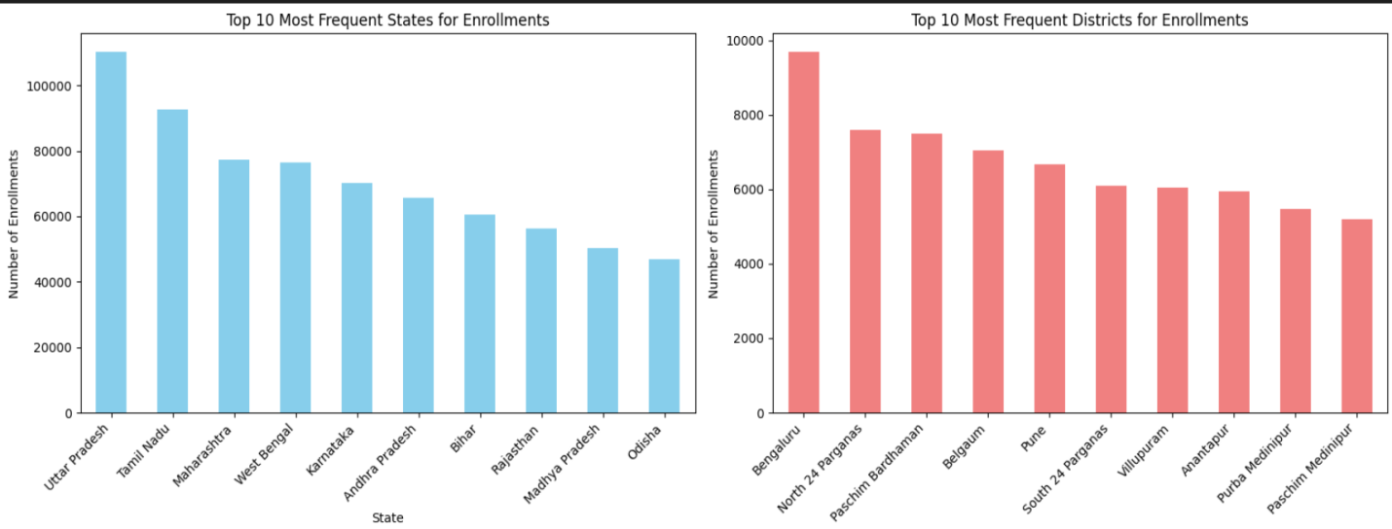

- Aadhaar enrolment shows a clear seasonal trend, with the highest registrations across all age groups around September.Child (0–5) and student (5–17) enrolments increase sharply during this period, indicating the need for extra enrolment centres and staff in peak months.

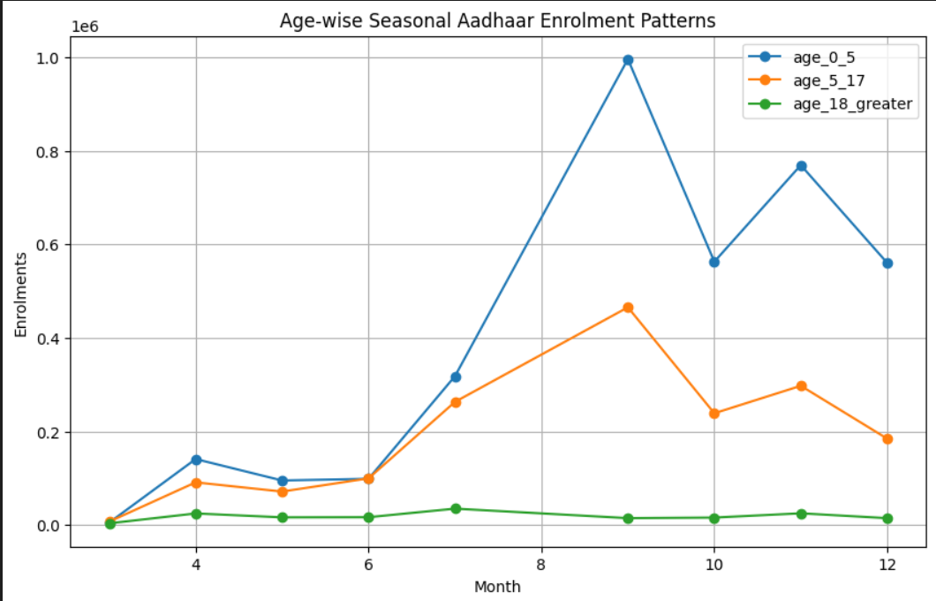

- Meghalaya shows the highest average enrolments among the top states, while Delhi and Bihar follow at a much lower level.The wide variation in averages indicates uneven enrolment intensity across states, suggesting the need for state-specific planning rather than a uniform approach.

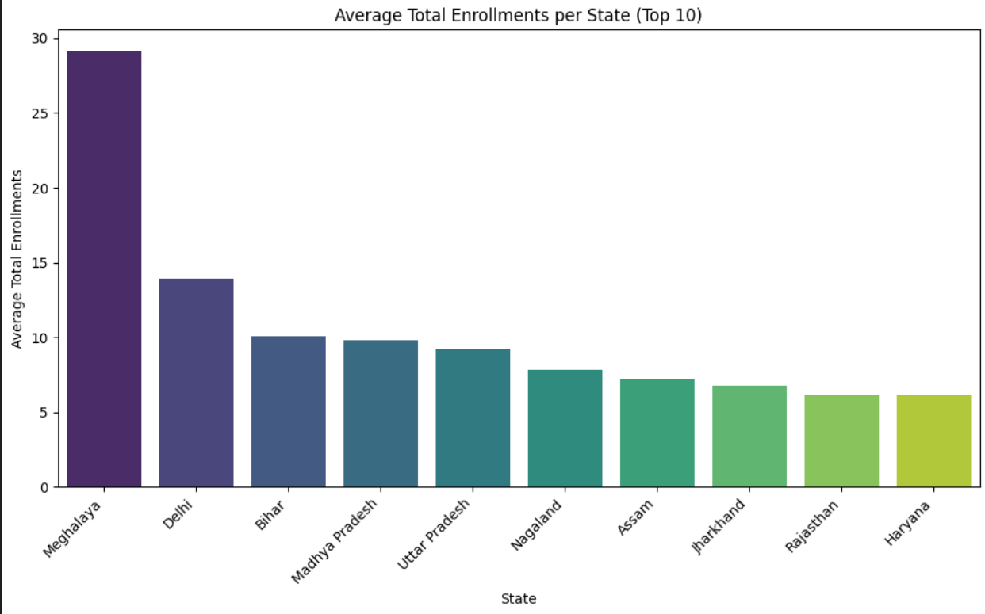
.
- A few districts like Thane, Sitamarhi, and Bahraich handle a very high Aadhaar enrolment load compared to others. This shows enrolment services are concentrated in limited districts, which may lead to overloading

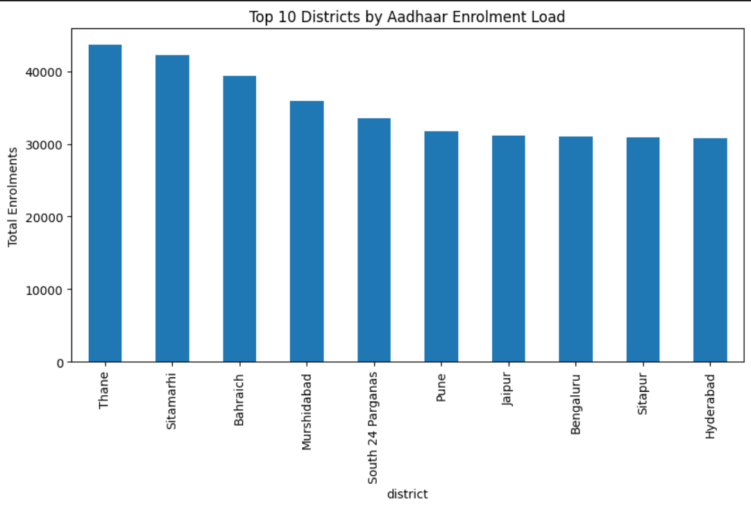

- Aadhaar enrolments show abnormal spikes in later months, especially around September, where values approach or cross the anomaly threshold. Detecting these spikes early helps UIDAI prepare extra staff and infrastructure in advance, preventing system overload and service delays.
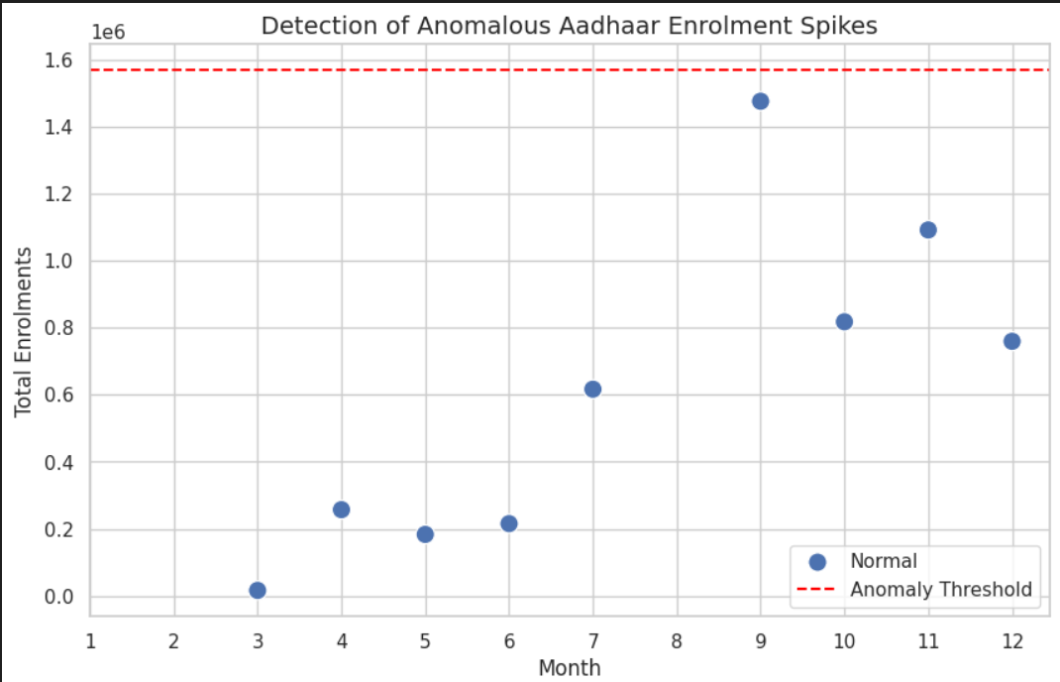
- Several districts show high enrolment pressure during specific months, especially around July–September, indicating seasonal system stress.These districts should receive temporary centres, extra staff, or extended working hours during peak months to reduce system stress and improve service delivery.
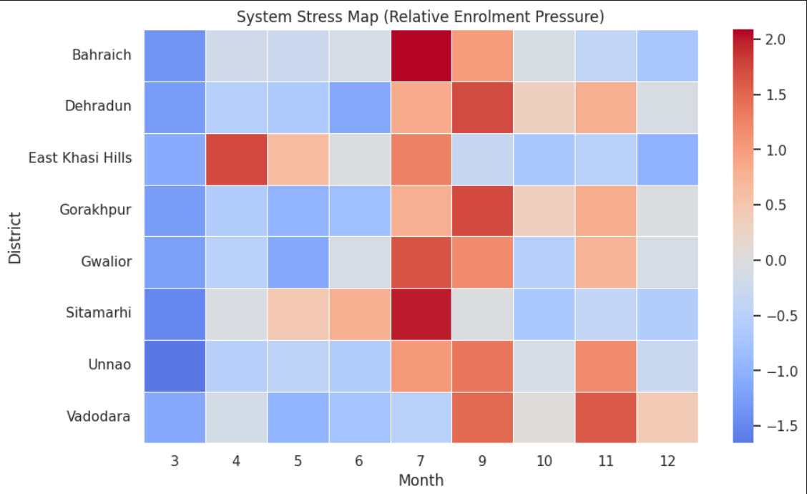

- The Lorenz Curve shows unequal Aadhaar enrolment load, where a small number of districts handle most enrolments.Most districts contribute very little, indicating workload imbalance.

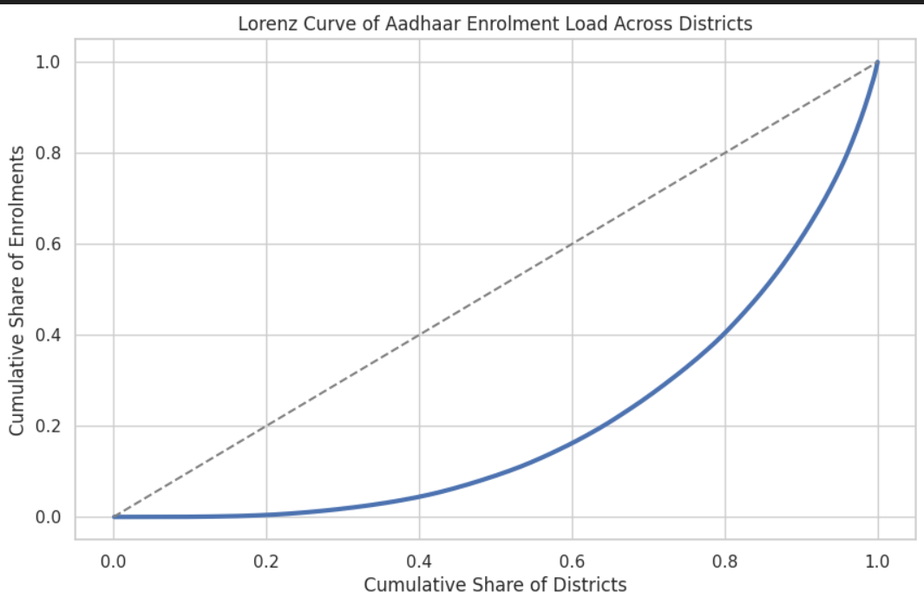

- Aadhaar enrolments increase sharply during specific months, showing seasonal demand patterns. Enrolment load is uneven across districts, indicating the need for better resource planning.
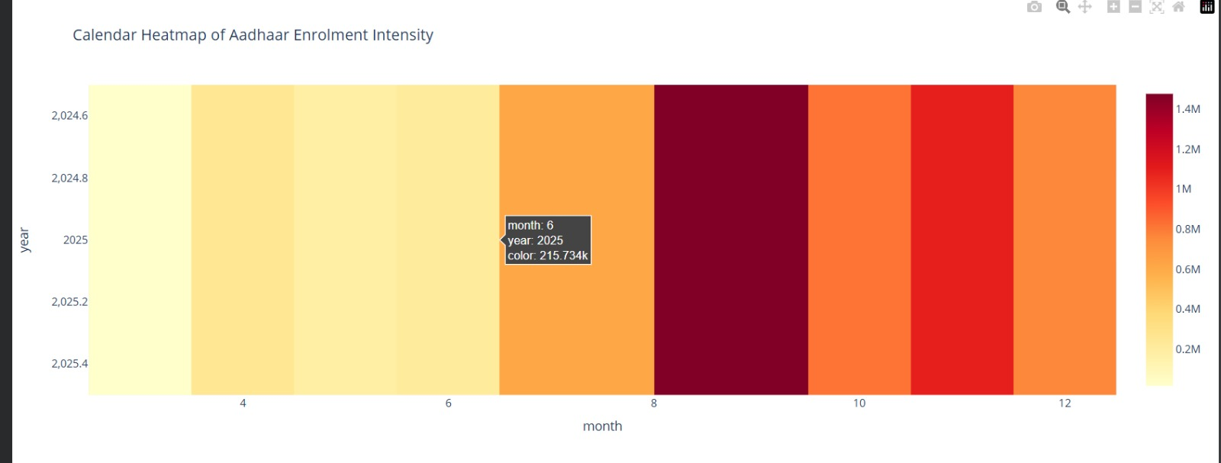

- The chart clearly shows that Aadhaar enrolment demand rises sharply during peak months compared to normal months. This indicates strong seasonal patterns, highlighting the need for advance planning of staff and infrastructure during peak periods.
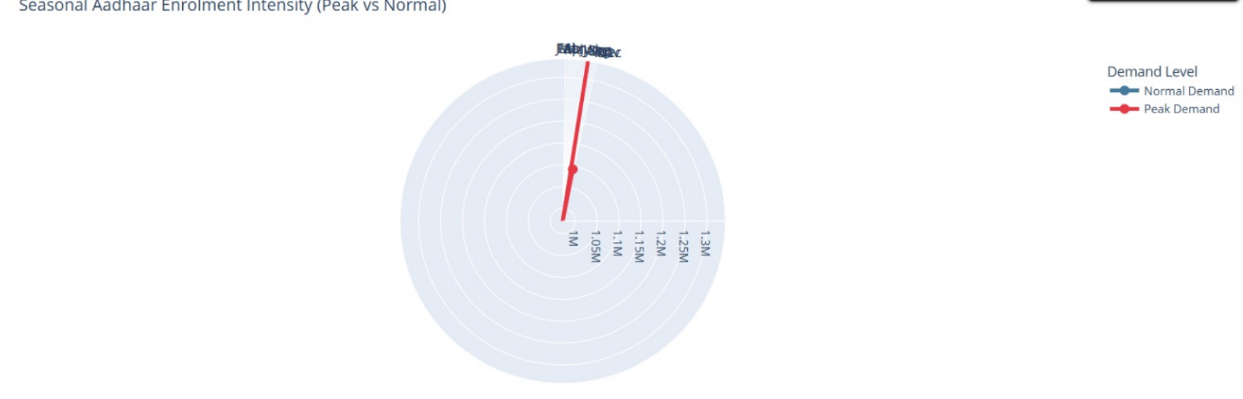

Anomalies, Challenges, and Limitations
- Anomalies (Unusual Patterns Observed)
- Some districts show unusually high enrolment numbers compared to neighbouring regions, indicating possible over-dependency on a few centres.
- Certain months record sudden spikes in enrolment, suggesting seasonal drives or temporary campaigns rather than uniform demand.
- A few states show low average enrolments despite large populations, which may indicate access or awareness gaps.
- Challenges
- Enrolment data is unevenly distributed across states and districts, making uniform planning difficult.
- High enrolment load in selected districts can cause long waiting times and operational stress.
- Seasonal peaks require additional resources, which may not always be available.
- Lack of real-time data limits immediate decision-making.
- Limitations
- The dataset does not include population or infrastructure details, limiting deeper comparison.
- Data is aggregated, so individual-level or centre-level analysis is not possible.
- External factors such as policy changes or special enrolment drives are not explicitly captured.
- Analysis is based only on available UIDAI datasets and may not reflect ground-level constraints fully.
Despite these limitations, the analysis provides valuable insights for improving Aadhaar enrolment planning and service delivery.

Solution Framework & Recommendations
- Solution Framework
The proposed solution uses Aadhaar enrolment data to identify trends, gaps, and high-load regions and convert them into actionable insights for better planning and service delivery.
- Data Analysis:
Enrolment data is analysed across states, districts, age groups, and time to understand patterns and variations.
- Trend Identification:
Seasonal peaks, high-load districts, and age-wise enrolment differences are identified using visual analysis.
- Gap Detection:
Regions with low or inconsistent enrolment are flagged as priority areas.
- Alert & Monitoring Layer:
High-load districts and sudden enrolment spikes are highlighted to support timely intervention.
- Decision Support:
Insights are presented through dashboards to help policymakers plan resources efficiently.
- Recommendations
- Targeted Resource Allocation:
Deploy additional enrolment centres and staff in high-load districts such as urban and densely populated areas.
- Seasonal Planning:
Increase manpower and infrastructure during peak enrolment months to manage demand smoothly.
- Balanced Regional Coverage:
Strengthen enrolment facilities in low-performing districts to reduce pressure on high-load regions.
- Age-Specific Campaigns:
Conduct focused awareness programs for child and student enrolment during peak seasons.
- Continuous Monitoring:
Use dashboards and alerts for regular tracking of enrolment trends and early issue detection.

Tools & Technologies

- Python – data cleaning, analysis, and logic implementation
- Pandas & NumPy – data handling and preprocessing
- Matplotlib / Seaborn – data visualization (trends, anomalies, Lorenz curve)
- Jupyter Notebook – analysis, experimentation, and documentation
- Statistical Methods – anomaly detection and distribution analysis

