

**Digital X-Ray**

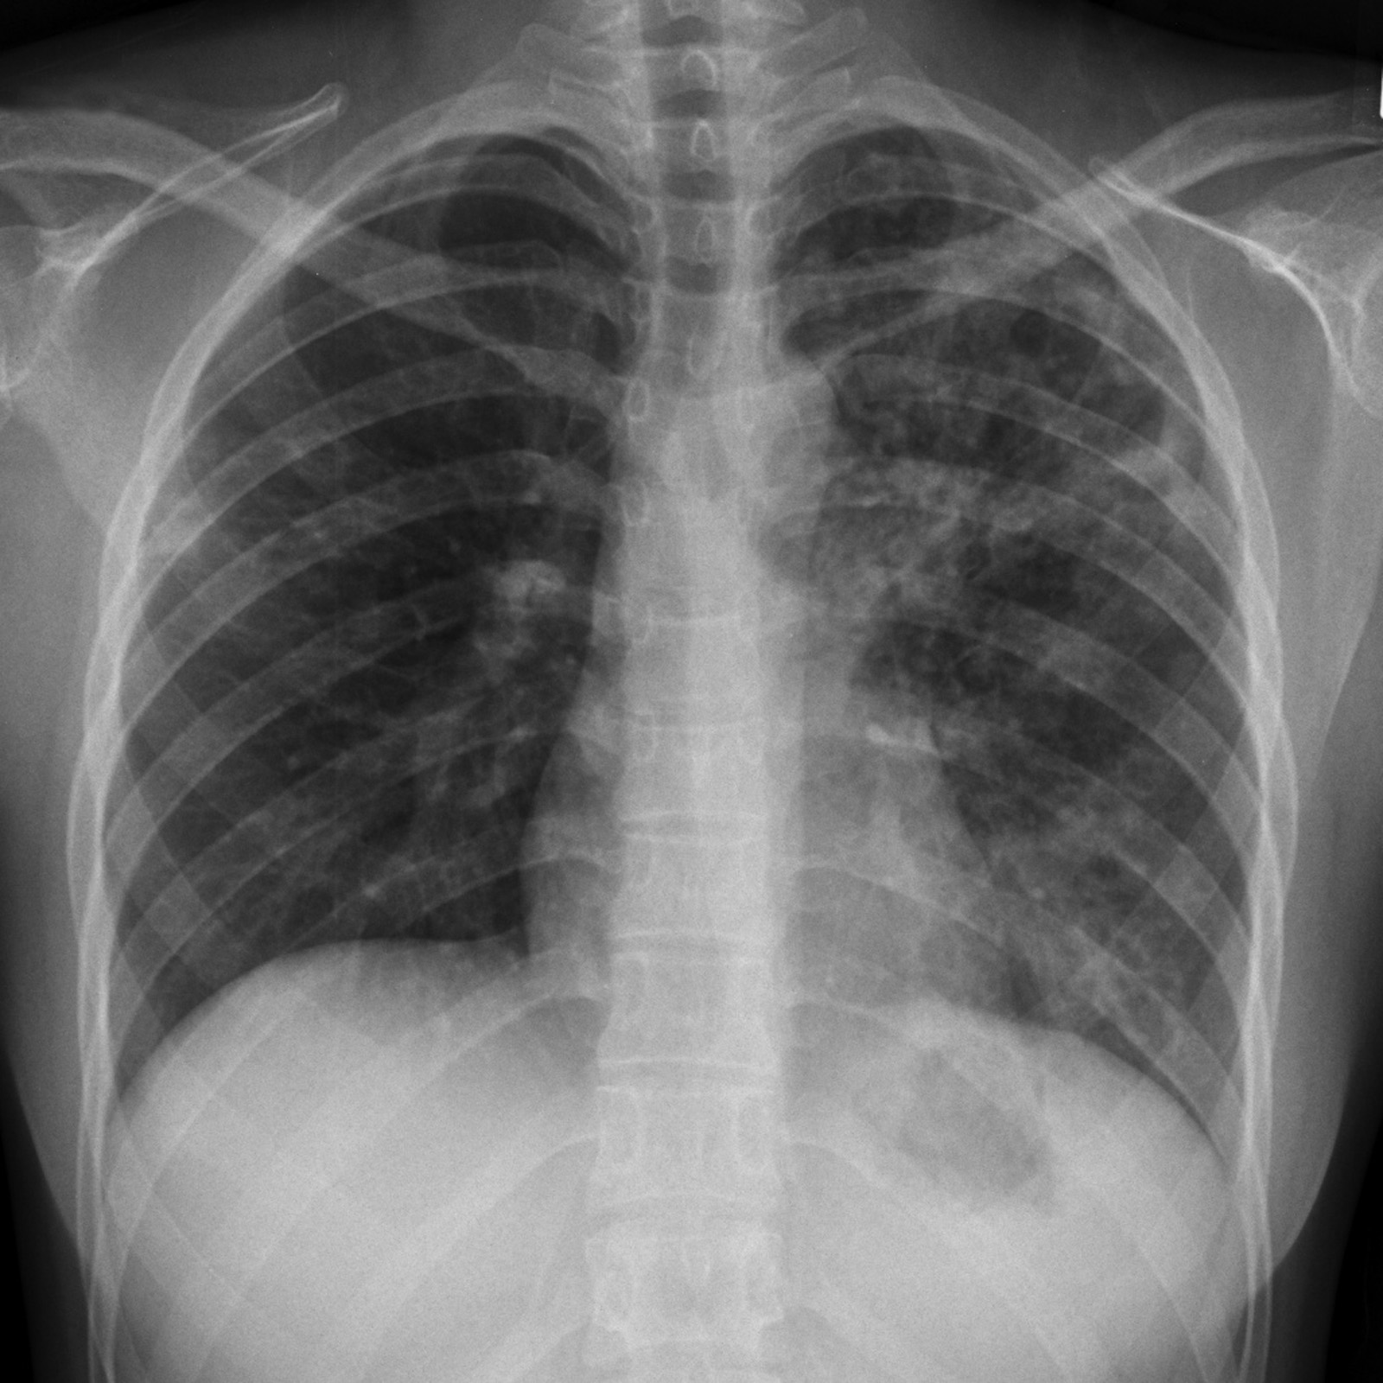

**Analysis Report**

|  |  |
| --- | --- |
| Patient ID | HU123 |
| Patient Name | XYZ |
| Imaging Center | XYZ Center |
| Scan Date | 02/04/2020 |
| Analysis Date | 18/03/2020 00:07:23 |
| Application Version | 1.0 |
| Result | Tuberculosis: 100.00% |
| Patient age | 39 |
| Hospital or center | XCVBN Hospital |
| Sex | M |