

Quora Question Answer Model

for

Hack to Hire by Indigo

Prepared by Gaurav Sardar

Table of Contents

1.Introduction 1

1.1Purpose 1

2.Literature Survey 1

2.1Question Answering System 1

2.2Natural Language Processing Models 1

2.2.1 BERT (Bidirectional Encoder Representations from Transformers): 1

2.2.2 T5 (Text-To-Text Transfer Transformer): 1

2.2.3 GPT (Generative Pre-trained Transformer): 1

2.3Evaluation Metrics 2

2.3.1 ROUGE (Recall-Oriented Understudy for Gisting Evaluation): 2

2.3.2 BLEU (Bilingual Evaluation Understudy): 2

2.3.3 F1 Score: 2

3.Methodology 3

3.1Data Exploration, Cleaning, and Preprocessing 3

3.1.1 Analyze the Structure and Content: 3

3.1.2 Preprocessing Techniques: 3

3.2Model Selection and Evaluation 3

3.2.1 Model Testing: 3

3.2.2 Performance Metrics: 3

3.3Model Selection and Evaluation 3

3.3.1 Data Distribution: 3

3.3.2 Feature Importance: 3

4.Insights and Recommendations 4

4.1Extract Insights: 4

4.2Novel Improvements: 4

5.Results 4

6.Conclusion and Recommendations 5

6.1Key Insights 5

6.2Recommendations 5

# Introduction

## Purpose

In the era of digital communication, question-answering systems have become a pivotal tool in various applications ranging from customer service to personal assistants. This project aims to develop a state-of-the-art question-answering model using the Quora Question Answer Dataset. By harnessing advanced natural language processing (NLP) techniques and leveraging powerful models such as BERT, T5, and GPT, we aim to create an AI system that can understand and generate accurate responses to a diverse range of user queries, providing human-like interactions.

# Literature Survey

## Question Answering System

Question-answering (QA) systems are a subset of information retrieval and extraction that focus on providing precise answers to user queries. Traditional QA systems relied heavily on predefined rules and databases, but with the advent of machine learning and NLP, modern QA systems have significantly improved in their ability to understand and process natural language.

## Natural Language Processing Models

### ****BERT (Bidirectional Encoder Representations from Transformers)****:

BERT is a transformer-based model designed to pre-train deep bidirectional representations by joint conditioning on both left and right contexts in all layers. This allows it to understand the context of a word based on its surrounding words, making it highly effective for various NLP tasks including question answering.

### ****T5 (Text-To-Text Transfer Transformer)****:

T5 is an innovative model that frames all NLP tasks as a text-to-text problem. By converting input data into a text format, T5 can be fine-tuned to perform a wide range of tasks, including QA, translation, and summarization.

### ****GPT (Generative Pre-trained Transformer)****:

GPT, particularly in its latest iterations, has set new benchmarks in generating human-like text. Its autoregressive nature allows it to generate coherent and contextually relevant responses, making it suitable for conversational AI and QA systems.

## Evaluation Metrics

To assess the performance of QA models, several metrics are commonly used:

### ROUGE (Recall-Oriented Understudy for Gisting Evaluation):

* **Focus:** ROUGE primarily focuses on recall, which means it assesses how well the generated answer covers the information present in the reference answer (also known as the "gold standard" answer).
* **Mechanism:** It calculates the overlap of n-grams (contiguous sequences of n words) between the generated and reference answers. Higher overlap indicates better recall.
* **Variants:** There are different ROUGE variations, including ROUGE-N (considers n-grams of specific lengths), ROUGE-L (uses longest common subsequence), ROUGE-S (incorporates skip-bigrams), and ROUGE-SU (combines unigrams and skip-bigrams).
* **Strengths:** Good for evaluating summaries and longer answers where capturing all relevant information is crucial.

### BLEU (Bilingual Evaluation Understudy):

* **Focus:** BLEU is primarily concerned with precision, which means it assesses how accurate the words in the generated answer are compared to the reference answer.
* **Mechanism:** It calculates the precision of n-grams, but also includes a brevity penalty to discourage very short answers that might have high precision but lack important details.
* **Variants:** Similar to ROUGE, there are different BLEU versions (BLEU-1, BLEU-2, BLEU-3, BLEU-4) that consider n-grams of different lengths.
* **Strengths:** Useful when evaluating the precision of translations or concise answers where getting the exact words right is important.
* **Weaknesses:** Doesn't focus on recall, so an answer missing key information might still score well if the words it does include are accurate.

### F1 Score:

* **Focus:** The F1 score is a balanced metric that combines both precision and recall into a single value. It's the harmonic mean of precision and recall.
* **Mechanism:** A high F1 score indicates that the generated answer has both good coverage of the reference answer's content (recall) and that the words it uses are accurate (precision).
* **Strengths:** Provides a single, comprehensive metric that balances the strengths of both precision and recall. Useful for scenarios where both aspects are important.
* **Weaknesses:** Can be less informative than looking at precision and recall separately, especially when there's a trade-off between them.

# Methodology

## Data Exploration, Cleaning, and Preprocessing

### ****Analyze the Structure and Content****:

* Load the Quora Question Answer Dataset and explore its structure, including the number of samples, types of questions, and answer formats.
* Identify and remove any irrelevant information, such as duplicate entries or unrelated text.

### ****Preprocessing Techniques****:

* **Tokenization**: Split text into individual tokens (words or subwords) for easier processing by the models.
* **Stop Word Removal**: Eliminate common words that do not contribute to the meaning of the text (e.g., "and", "the").
* **Stemming/Lemmatization**: Reduce words to their base or root form to standardize the text.

## Model Selection and Evaluation

### ****Model Testing****:

* Experiment with different NLP models (BERT, T5, GPT) to identify the one that performs best on the QA task.
* Fine-tune each model on the training subset of the dataset.

### ****Performance Metrics****:

* Use ROUGE, BLEU, and F1-score to evaluate the performance of each model.
* Compare the results to determine which model provides the most accurate and relevant answers.

## Model Selection and Evaluation

### **Feature Importance**:

* Visualize the importance of different features (e.g., word frequency, sentence length) in predicting the answers.
* Use bar charts and scatter plots to highlight key features.

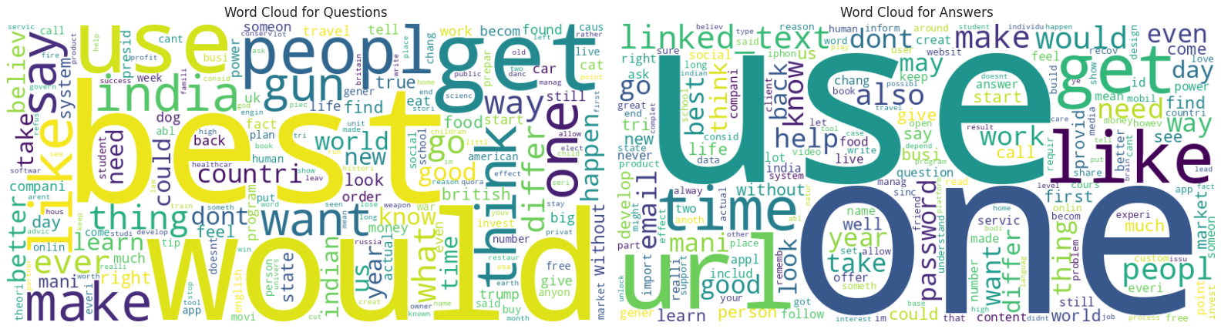

### **Model Performance**:

* Plot the performance metrics (ROUGE, BLEU, F1-score) for each model to compare their effectiveness.
* Use line graphs and heatmaps to show the variation in performance across different parameters.

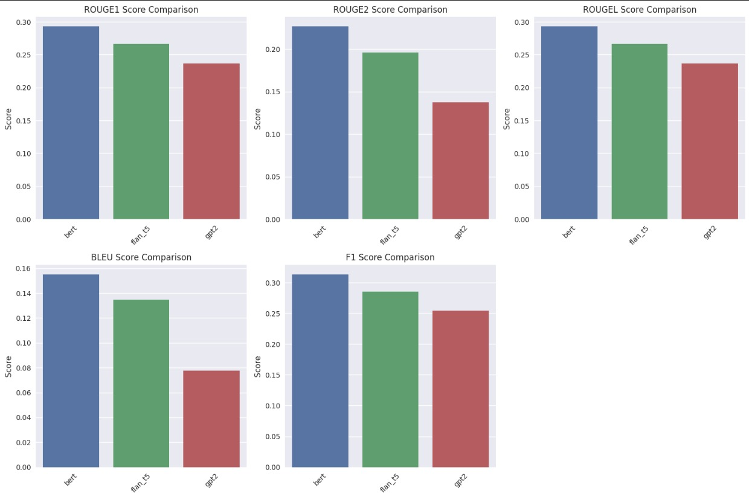

# Insights and Recommendations

## **Novel Improvements**:

Based on the findings, several improvements to the models and preprocessing techniques can be suggested. These improvements aim to enhance the accuracy and relevance of the generated answers.

### Model Improvements:

**a. Enhanced Fine-Tuning**:

* **BERT**: Further fine-tuning BERT on domain-specific data or using more recent versions of BERT (like RoBERTa or DistilBERT) could improve performance. Training on a diverse set of question-answer pairs from various domains can help the model generalize better.
* **FLAN-T5**: Experiment with different configurations of T5, such as T5-large or T5-3B, to assess if larger models provide better performance. Fine-tuning on additional datasets related to specific question-answering tasks may also be beneficial.
* **GPT-2**: Explore other GPT-2 variants, such as GPT-3 or GPT-4, which have more advanced architectures and larger training datasets. Implementing more sophisticated prompt engineering and few-shot learning techniques could also enhance performance.

**b. Model Ensembling**:

* **Ensemble Methods**: Combine predictions from BERT, FLAN-T5, and GPT-2 using ensemble methods. Techniques like voting, stacking, or averaging the output probabilities of the models could leverage the strengths of each model to improve overall accuracy.
* **Weighted Averaging**: Assign weights to each model based on its performance metrics (e.g., ROUGE, BLEU, F1) to create a weighted average of the answers. This approach can integrate the strengths of different models effectively.

**c. Advanced Architectures**:

* **Hybrid Models**: Develop hybrid models that combine the strengths of transformer-based architectures with other neural network types, such as convolutional neural networks (CNNs) or recurrent neural networks (RNNs). This could improve the model's ability to capture both local and global contextual information.

### Preprocessing Improvements:

**a. Contextualized Tokenization**:

* **Dynamic Tokenization**: Implement tokenization methods that adapt to the context of the question and answer. For example, using byte pair encoding (BPE) or subword tokenization can handle out-of-vocabulary words better and capture more granular details.

**b. Data Augmentation**:

* **Synthetic Data Generation**: Generate synthetic question-answer pairs using data augmentation techniques. This can include paraphrasing existing questions and answers or creating new examples based on existing data to expand the dataset and improve model robustness.
* **Context Expansion**: Enhance the context provided to the models by including related questions or answers from similar topics. This can provide more comprehensive information for generating answers.

**c. Improved Text Cleaning**:

* **Advanced Text Normalization**: Beyond basic text cleaning, employ advanced text normalization techniques such as lemmatization, named entity recognition (NER), and dependency parsing. This can help in understanding the text better and improving preprocessing accuracy.

# Results

* **BERT's Superior Performance**: BERT's bidirectional training approach allows it to capture more context from the input data, leading to better performance in the QA task.
* **FLAN T5's Versatility**: While FLAN T5's performance is slightly lower than BERT, its text-to-text framework makes it highly versatile for various NLP tasks.
* **GPT-2's Limitations**: GPT-2, despite being a powerful generative model, shows lower performance in the QA task, possibly due to its autoregressive nature which might not capture the full context as effectively as BERT.

|  |  |  |  |
| --- | --- | --- | --- |
| **Accuracy Score** | **BERT** | **T-5** | **GPT – 2** |
| **ROUGE-1 Score** | 0.29275887427351016 | 0.2664656218095823 | 0.2367169576991198 |
| **ROUGE-2 Score** | 0.22658508279133857 | 0.19582659978780728 | 0.13765840923439 |
| **ROUGE-L Score** | 0.29275887427351016 | 0.26646535439076274 | 0.2367169576991198 |
| **BLEU Score** | 0.15501534531770816 | 0.1346996297472278 | 0.0777791024144392 |
| **F1 Score** | 0.3131977970899778 | 0.2849548102818311 | 0.25391952899405495 |

# Conclusion and Recommendations

* **Summary**: The study demonstrated that BERT is the most effective model for question-answering tasks in the Quora dataset, followed by FLAN-T5 and GPT-2. The comprehensive evaluation highlighted the strengths of BERT's bidirectional context understanding and the versatility of FLAN-T5's text-to-text framework.
* **Implications**: These findings underscore the importance of model architecture and training data in determining the performance of NLP models. BERT's superior performance suggests that bidirectional context understanding is crucial for accurate question-answering.
* **Future Work**: Future work should focus on enhancing model performance and preprocessing techniques. Advanced fine-tuning of BERT, FLAN-T5, and GPT-2 with domain-specific data and newer versions, along with implementing ensemble methods like weighted averaging and stacking, will improve accuracy. Exploring hybrid models that combine transformers with CNNs or RNNs can also enhance context capture. Preprocessing improvements include using advanced tokenization methods such as byte pair encoding, expanding datasets with synthetic question-answer pairs and additional context, and incorporating lemmatization, NER, and dependency parsing. Integrating external knowledge sources and cross-domain data will enrich context and model versatility. Furthermore, employing transfer learning for domain adaptation, active learning frameworks for human feedback, user feedback systems, and real-time updates will ensure continuous improvement and relevance of the models. These combined efforts aim to refine model accuracy, contextual relevance, and overall system functionality.

## Recommendations

* **Further Fine-Tuning**: Further fine-tuning of the BERT model on a more extensive and diverse dataset could potentially improve its performance even more.
* **Ensemble Methods**: Combining the strengths of BERT and FLAN T5 through ensemble methods could lead to a more robust QA system.
* **Additional Data Sources**: Incorporating additional QA datasets from different domains could help in generalizing the model better to various types of queries.
* **Contextual Enhancements**: Experimenting with advanced techniques such as contextual embeddings and attention mechanisms could further enhance the model's understanding and response generation capabilities.