**Cognitive Security: AI-Powered Threat Agent Evaluation for Impact on Assets in Informational Environment**

**9 ML Model Metrics: Precision, Recall and F1-Score**

**Model 1 - Logistics Regression (LR):**

1.1 Precision of LR

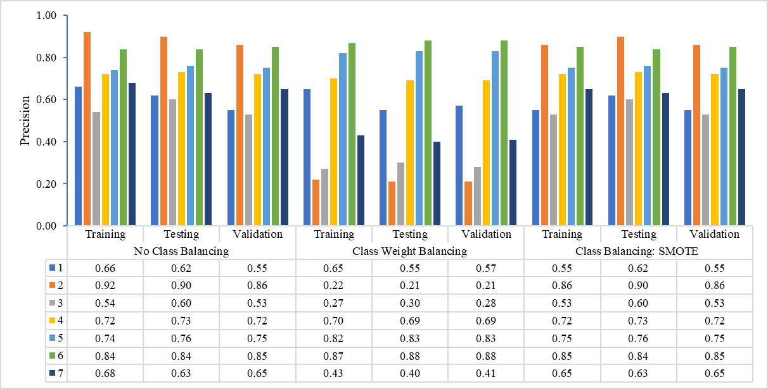

|  |  |  |  |  |  |  |  |  |  |  |
| --- | --- | --- | --- | --- | --- | --- | --- | --- | --- | --- |
|  | | | | | | | | | | |
|  | Training | Testing | Validation | Training | Testing | Validation | Training | Testing | Validation |  |
|  | No Class Balancing | | | Class Weight Balancing | | | Class Balancing: SMOTE | | | |

1.2 Recall of LR

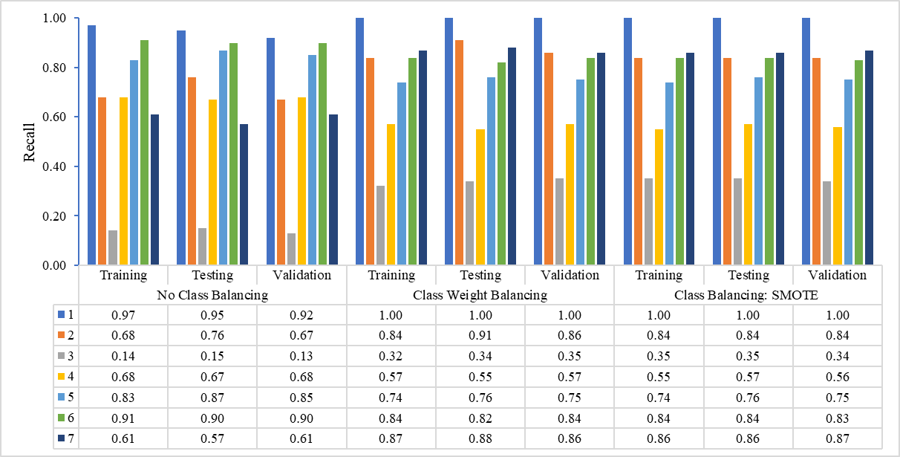

|  |  |  |  |  |  |  |  |  |  |  |
| --- | --- | --- | --- | --- | --- | --- | --- | --- | --- | --- |
|  | | | | | | | | | | |
|  | Training | Testing | Validation | Training | Testing | Validation | Training | Testing | Validation |  |
|  | No Class Balancing | | | Class Weight Balancing | | | Class Balancing: SMOTE | | | |

1.3 F1-Score of LR

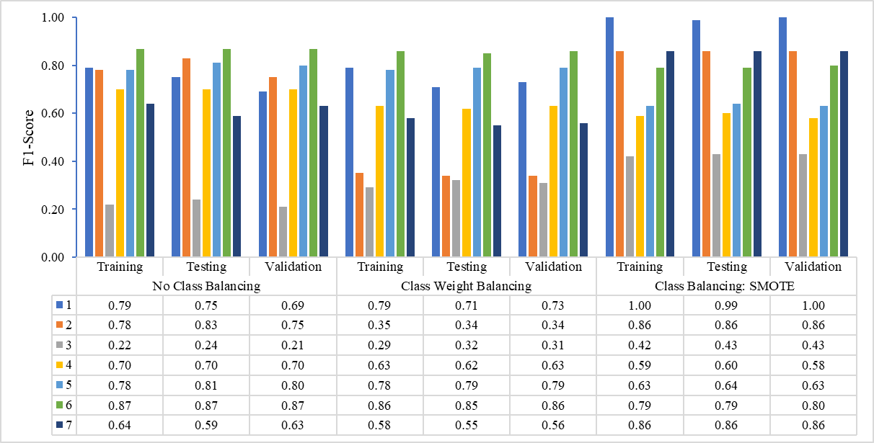

|  |  |  |  |  |  |  |  |  |  |  |
| --- | --- | --- | --- | --- | --- | --- | --- | --- | --- | --- |
|  | | | | | | | | | | |
|  | Training | Testing | Validation | Training | Testing | Validation | Training | Testing | Validation |  |
|  | No Class Balancing | | | Class Weight Balancing | | | Class Balancing: SMOTE | | | |

**Model 2 - Gaussian Naïve Bayes (GNB):**

2.1 Precision of GNB

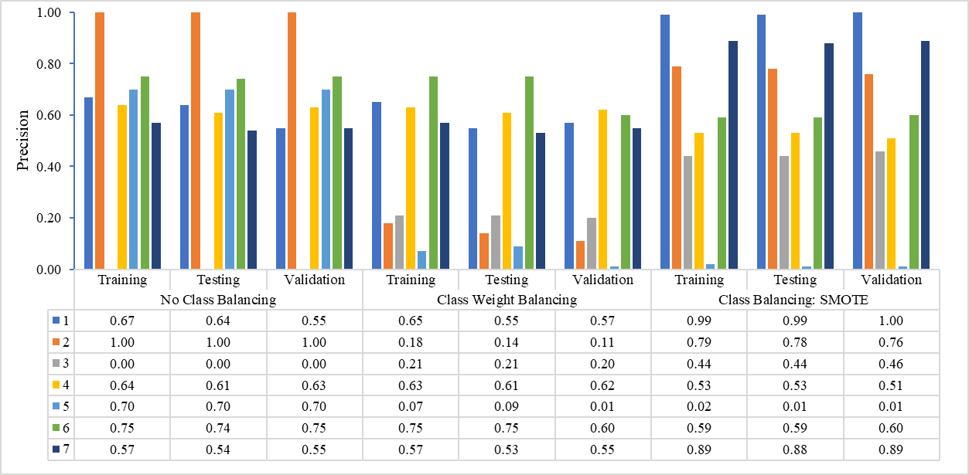

|  |  |  |  |  |  |  |  |  |  |  |
| --- | --- | --- | --- | --- | --- | --- | --- | --- | --- | --- |
|  | | | | | | | | | | |
|  | Training | Testing | Validation | Training | Testing | Validation | Training | Testing | Validation |  |
|  | No Class Balancing | | | Class Weight Balancing | | | Class Balancing: SMOTE | | | |

2.2 Recall of GNB

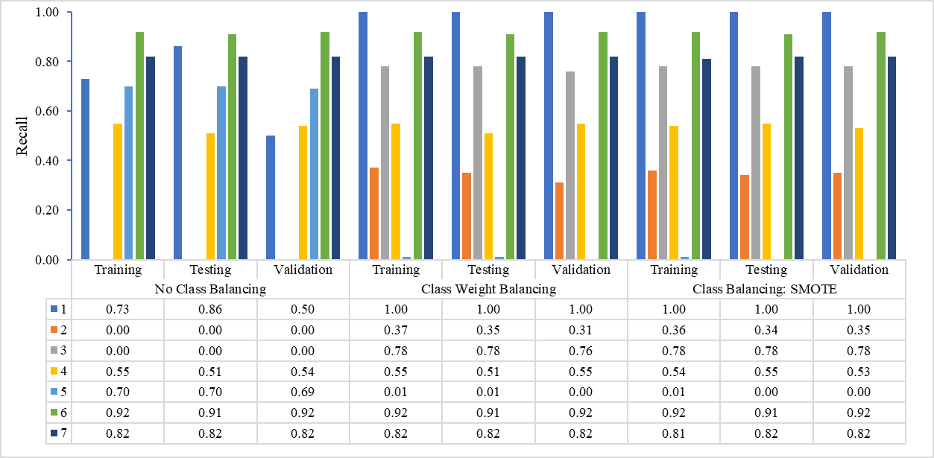

|  |  |  |  |  |  |  |  |  |  |  |
| --- | --- | --- | --- | --- | --- | --- | --- | --- | --- | --- |
|  | | | | | | | | | | |
|  | Training | Testing | Validation | Training | Testing | Validation | Training | Testing | Validation |  |
|  | No Class Balancing | | | Class Weight Balancing | | | Class Balancing: SMOTE | | | |

2.3 F1-Score of GNB

|  |  |  |  |  |  |  |  |  |  |  |
| --- | --- | --- | --- | --- | --- | --- | --- | --- | --- | --- |
|  | | | | | | | | | | |
|  | | | | | | | | | | |
|  | Training | Testing | Validation | Training | Testing | Validation | Training | Testing | Validation |  |
|  | No Class Balancing | | | Class Weight Balancing | | | Class Balancing: SMOTE | | | |

**Model 3 - Support Vector Machine (SVM):**

3.1 Precision of SVM

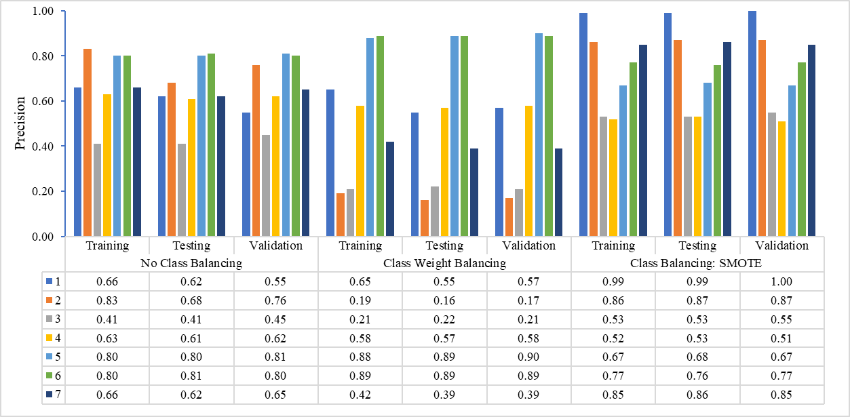

|  |  |  |  |  |  |  |  |  |  |  |
| --- | --- | --- | --- | --- | --- | --- | --- | --- | --- | --- |
|  | | | | | | | | | | |
|  | Training | Testing | Validation | Training | Testing | Validation | Training | Testing | Validation |  |
|  | No Class Balancing | | | Class Weight Balancing | | | Class Balancing: SMOTE | | | |

3.2 Recall of SVM

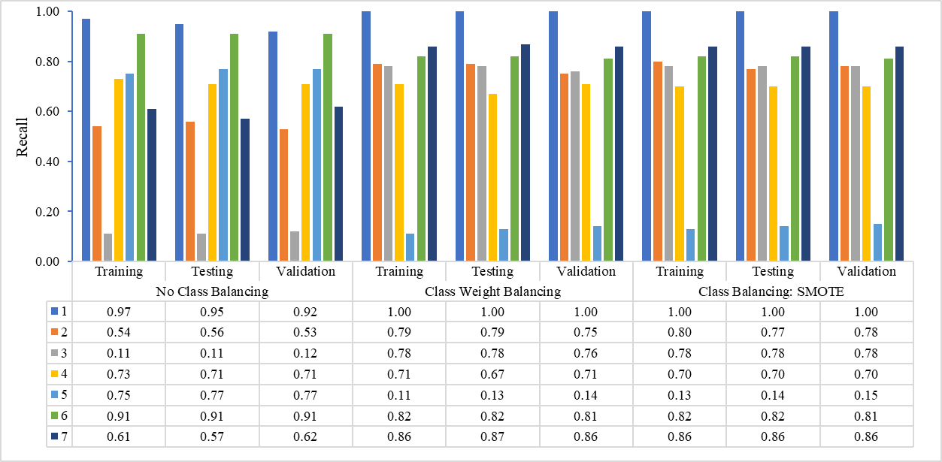

|  |  |  |  |  |  |  |  |  |  |  |
| --- | --- | --- | --- | --- | --- | --- | --- | --- | --- | --- |
|  | | | | | | | | | | |
|  | Training | Testing | Validation | Training | Testing | Validation | Training | Testing | Validation |  |
|  | No Class Balancing | | | Class Weight Balancing | | | Class Balancing: SMOTE | | | |

3.3 F1-Score of SVM

|  |  |  |  |  |  |  |  |  |  |  |
| --- | --- | --- | --- | --- | --- | --- | --- | --- | --- | --- |
|  | | | | | | | | | | |
|  | | | | | | | | | | |
|  | Training | Testing | Validation | Training | Testing | Validation | Training | Testing | Validation |  |
|  | No Class Balancing | | | Class Weight Balancing | | | Class Balancing: SMOTE | | | |

**Model 4 - K-Nearest Neighbours (KNN):**

4.1 Precision of KNN

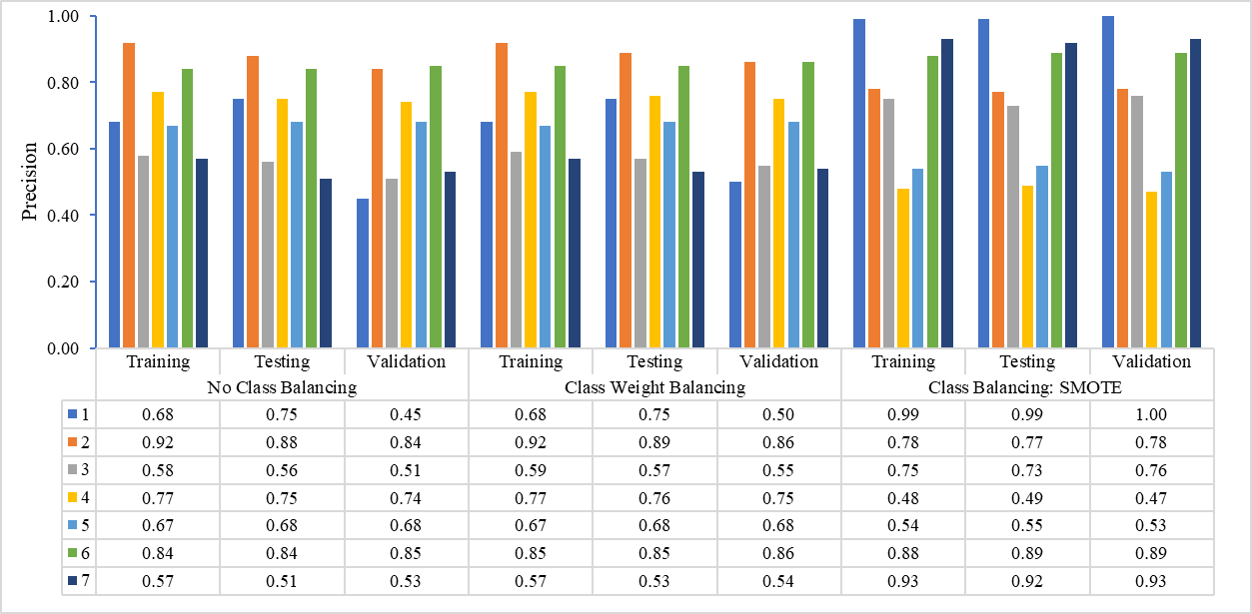

|  |  |  |  |  |  |  |  |  |  |  |
| --- | --- | --- | --- | --- | --- | --- | --- | --- | --- | --- |
|  | | | | | | | | | | |
|  | Training | Testing | Validation | Training | Testing | Validation | Training | Testing | Validation |  |
|  | No Class Balancing | | | Class Weight Balancing | | | Class Balancing: SMOTE | | | |

4.2 Recall of KNN

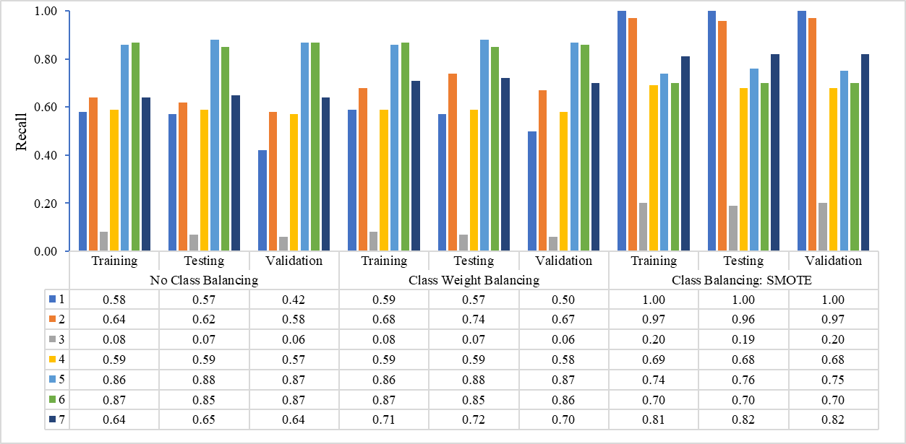

|  |  |  |  |  |  |  |  |  |  |  |
| --- | --- | --- | --- | --- | --- | --- | --- | --- | --- | --- |
|  | | | | | | | | | | |
|  | Training | Testing | Validation | Training | Testing | Validation | Training | Testing | Validation |  |
|  | No Class Balancing | | | Class Weight Balancing | | | Class Balancing: SMOTE | | | |

4.3 F1-Score of KNN

|  |  |  |  |  |  |  |  |  |  |  |
| --- | --- | --- | --- | --- | --- | --- | --- | --- | --- | --- |
|  | | | | | | | | | | |
|  | Training | Testing | Validation | Training | Testing | Validation | Training | Testing | Validation |  |
|  | No Class Balancing | | | Class Weight Balancing | | | Class Balancing: SMOTE | | | |

**Model 5 – Decision Tree (DT):**

5.1 Precision of DT

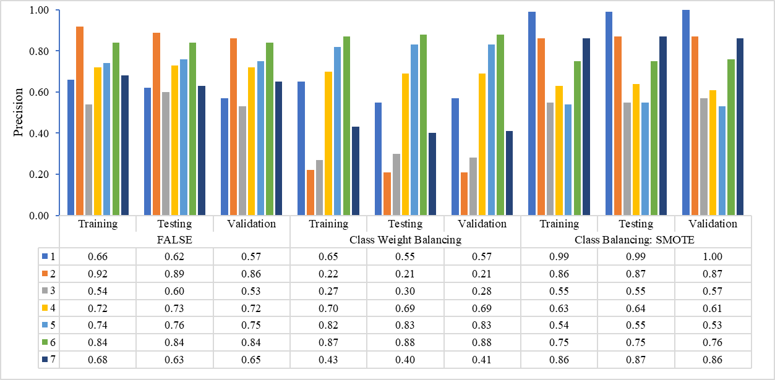

|  |  |  |  |  |  |  |  |  |  |  |
| --- | --- | --- | --- | --- | --- | --- | --- | --- | --- | --- |
|  | | | | | | | | | | |
|  | Training | Testing | Validation | Training | Testing | Validation | Training | Testing | Validation |  |
|  | No Class Balancing | | | Class Weight Balancing | | | Class Balancing: SMOTE | | | |

5.2 Recall of DT

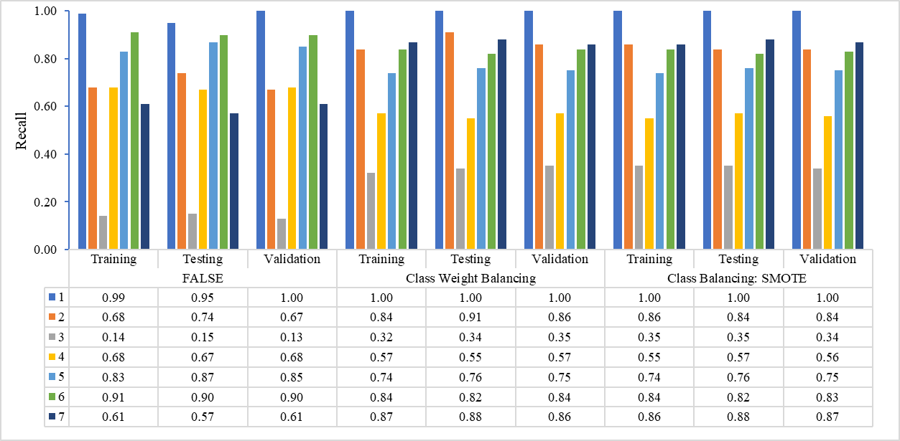

|  |  |  |  |  |  |  |  |  |  |  |
| --- | --- | --- | --- | --- | --- | --- | --- | --- | --- | --- |
|  | | | | | | | | | | |
|  | Training | Testing | Validation | Training | Testing | Validation | Training | Testing | Validation |  |
|  | No Class Balancing | | | Class Weight Balancing | | | Class Balancing: SMOTE | | | |

5.3 F1-Score of DT

|  |  |  |  |  |  |  |  |  |  |  |
| --- | --- | --- | --- | --- | --- | --- | --- | --- | --- | --- |
|  | | | | | | | | | | |
|  | Training | Testing | Validation | Training | Testing | Validation | Training | Testing | Validation |  |
|  | No Class Balancing | | | Class Weight Balancing | | | Class Balancing: SMOTE | | | |

**Model 6 – Random Forest (RF):**

6.1 Precision of RF

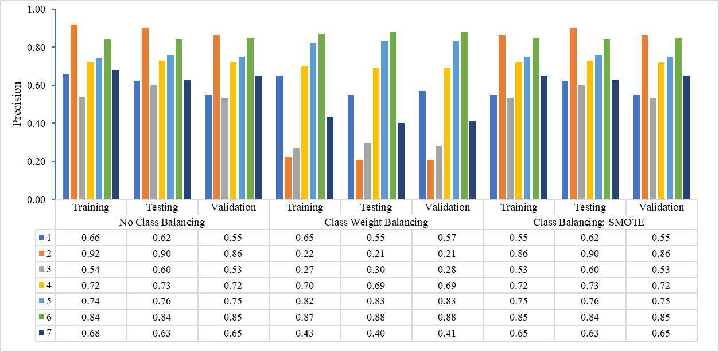

|  |  |  |  |  |  |  |  |  |  |  |
| --- | --- | --- | --- | --- | --- | --- | --- | --- | --- | --- |
|  | | | | | | | | | | |
|  | Training | Testing | Validation | Training | Testing | Validation | Training | Testing | Validation |  |
|  | No Class Balancing | | | Class Weight Balancing | | | Class Balancing: SMOTE | | | |

6.2 Recall of RF

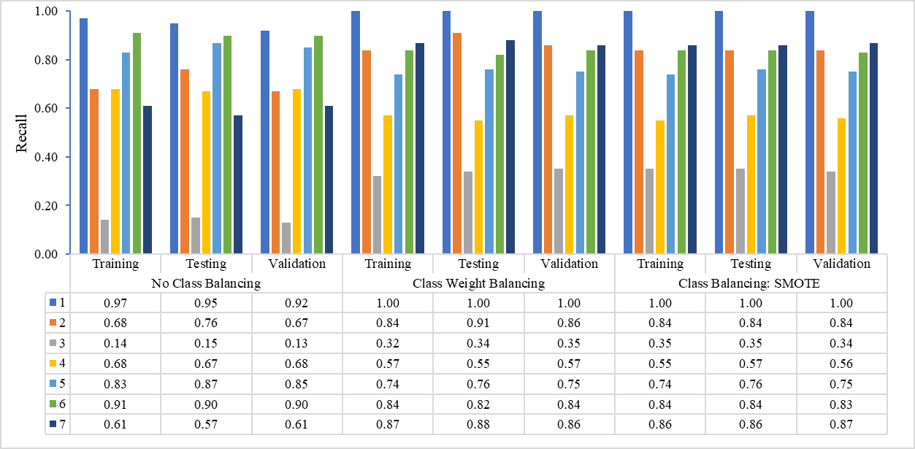

|  |  |  |  |  |  |  |  |  |  |  |
| --- | --- | --- | --- | --- | --- | --- | --- | --- | --- | --- |
|  | | | | | | | | | | |
|  | Training | Testing | Validation | Training | Testing | Validation | Training | Testing | Validation |  |
|  | No Class Balancing | | | Class Weight Balancing | | | Class Balancing: SMOTE | | | |

6.3 F1-Score of RF

|  |  |  |  |  |  |  |  |  |  |  |
| --- | --- | --- | --- | --- | --- | --- | --- | --- | --- | --- |
|  | | | | | | | | | | |
|  | Training | Testing | Validation | Training | Testing | Validation | Training | Testing | Validation |  |
|  | No Class Balancing | | | Class Weight Balancing | | | Class Balancing: SMOTE | | | |

**Model 7 – Gradient Boosting Machine (GBM):**

7.1 Precision of GBM

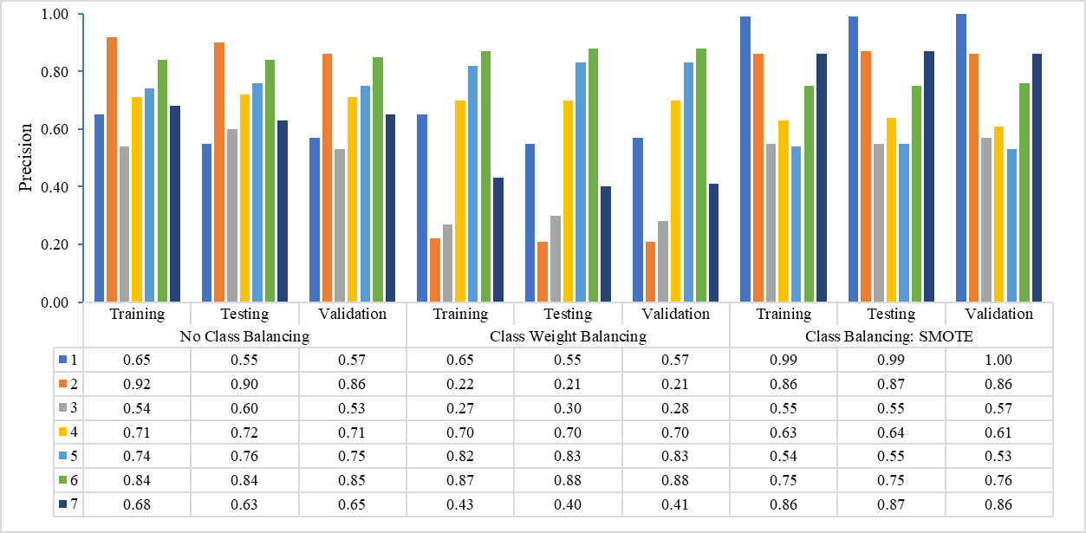

|  |  |  |  |  |  |  |  |  |  |  |
| --- | --- | --- | --- | --- | --- | --- | --- | --- | --- | --- |
|  | | | | | | | | | | |
|  | Training | Testing | Validation | Training | Testing | Validation | Training | Testing | Validation |  |
|  | No Class Balancing | | | Class Weight Balancing | | | Class Balancing: SMOTE | | | |

7.2 Recall of GBM

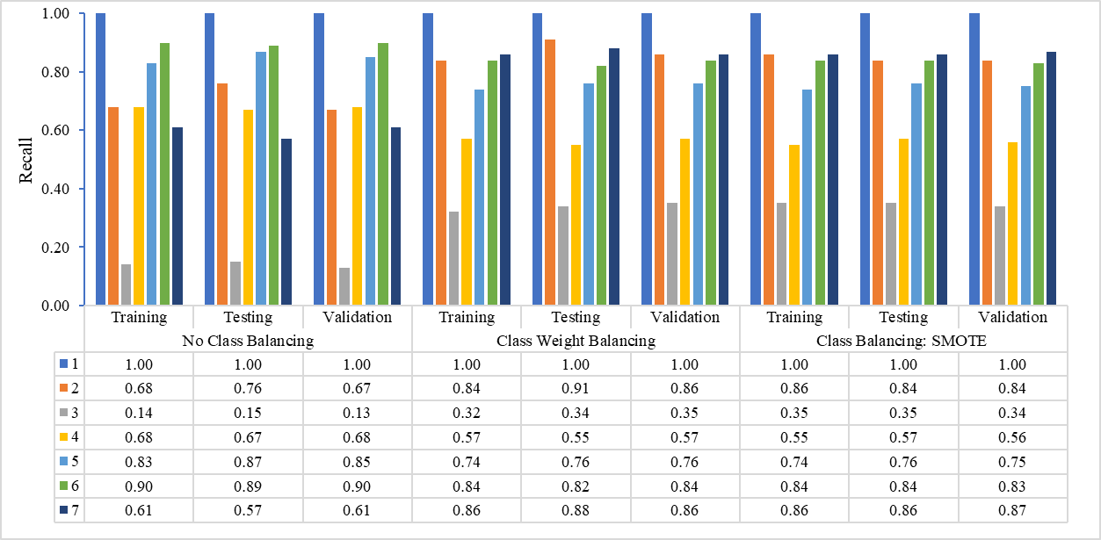

|  |  |  |  |  |  |  |  |  |  |  |
| --- | --- | --- | --- | --- | --- | --- | --- | --- | --- | --- |
|  | | | | | | | | | | |
|  | Training | Testing | Validation | Training | Testing | Validation | Training | Testing | Validation |  |
|  | No Class Balancing | | | Class Weight Balancing | | | Class Balancing: SMOTE | | | |

7.3 F1-Score of GBM

|  |  |  |  |  |  |  |  |  |  |  |
| --- | --- | --- | --- | --- | --- | --- | --- | --- | --- | --- |
|  | | | | | | | | | | |
|  | Training | Testing | Validation | Training | Testing | Validation | Training | Testing | Validation |  |
|  | No Class Balancing | | | Class Weight Balancing | | | Class Balancing: SMOTE | | | |

**Model 8 – Adaptive Boosting (AdaBoost):**

8.1 Precision of AdaBoost

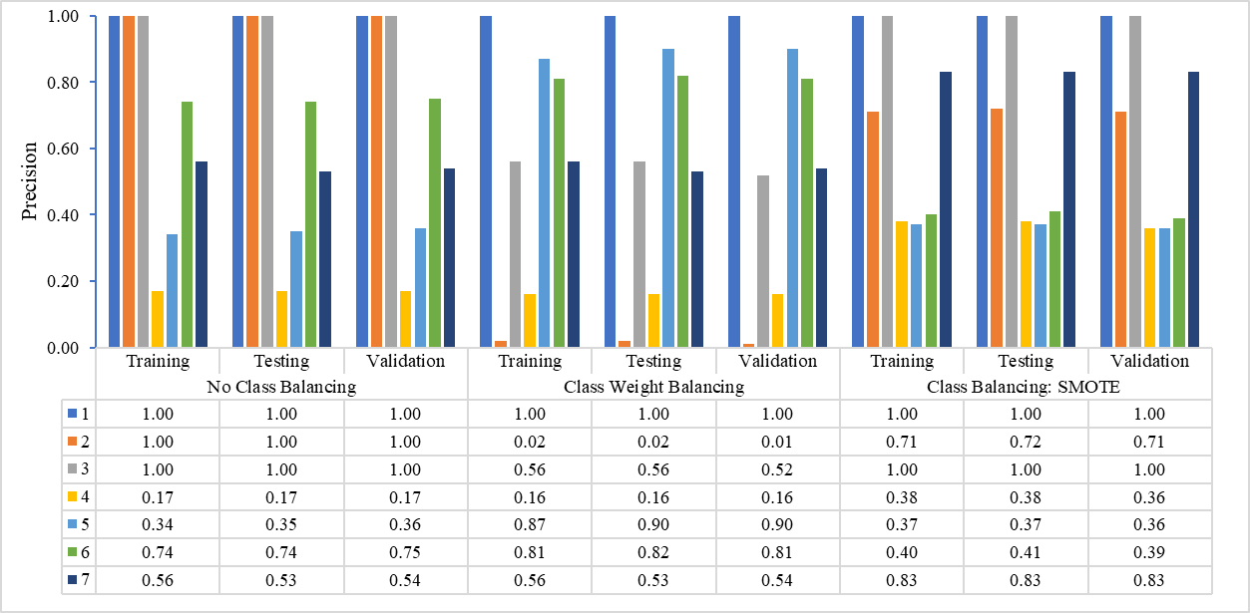

|  |  |  |  |  |  |  |  |  |  |  |
| --- | --- | --- | --- | --- | --- | --- | --- | --- | --- | --- |
|  | | | | | | | | | | |
|  | Training | Testing | Validation | Training | Testing | Validation | Training | Testing | Validation |  |
|  | No Class Balancing | | | Class Weight Balancing | | | Class Balancing: SMOTE | | | |

8.2 Recall of AdaBoost

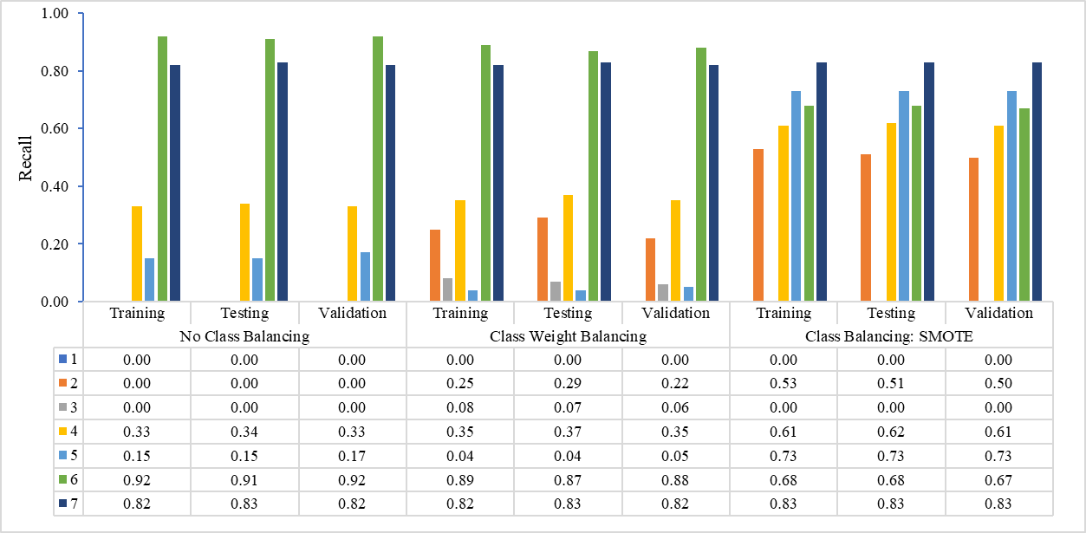

|  |  |  |  |  |  |  |  |  |  |  |
| --- | --- | --- | --- | --- | --- | --- | --- | --- | --- | --- |
|  | | | | | | | | | | |
|  | Training | Testing | Validation | Training | Testing | Validation | Training | Testing | Validation |  |
|  | No Class Balancing | | | Class Weight Balancing | | | Class Balancing: SMOTE | | | |

8.3 F1-Score of AdaBoost

|  |  |  |  |  |  |  |  |  |  |  |
| --- | --- | --- | --- | --- | --- | --- | --- | --- | --- | --- |
|  | | | | | | | | | | |
|  | Training | Testing | Validation | Training | Testing | Validation | Training | Testing | Validation |  |
|  | No Class Balancing | | | Class Weight Balancing | | | Class Balancing: SMOTE | | | |

**Model 9 – eXtreme Gradient Boosting (XGBoost):**

9.1 Precision of XGBoost

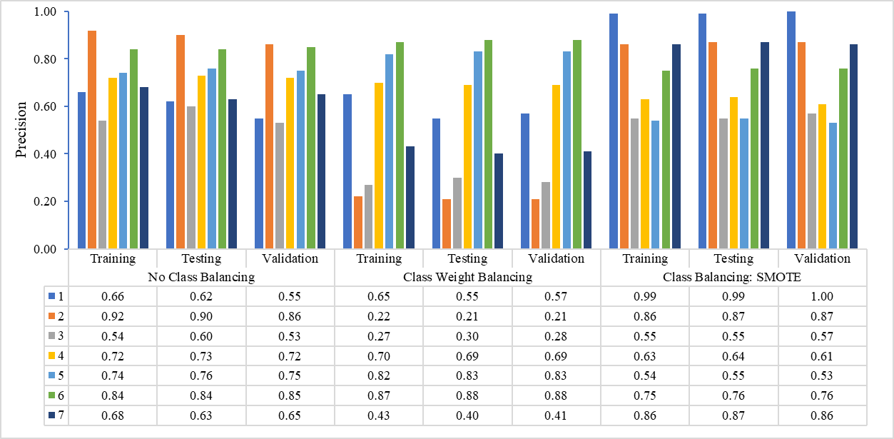

|  |  |  |  |  |  |  |  |  |  |  |
| --- | --- | --- | --- | --- | --- | --- | --- | --- | --- | --- |
|  | | | | | | | | | | |
|  | Training | Testing | Validation | Training | Testing | Validation | Training | Testing | Validation |  |
|  | No Class Balancing | | | Class Weight Balancing | | | Class Balancing: SMOTE | | | |

9.2 Recall of XGBoost

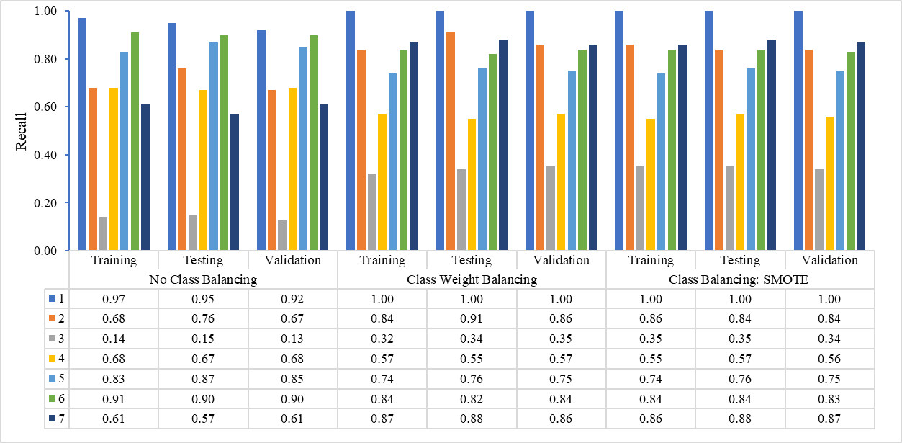

|  |  |  |  |  |  |  |  |  |  |  |
| --- | --- | --- | --- | --- | --- | --- | --- | --- | --- | --- |
|  | | | | | | | | | | |
|  | Training | Testing | Validation | Training | Testing | Validation | Training | Testing | Validation |  |
|  | No Class Balancing | | | Class Weight Balancing | | | Class Balancing: SMOTE | | | |

9.3 F1-Score of XGBoost

|  |  |  |  |  |  |  |  |  |  |  |
| --- | --- | --- | --- | --- | --- | --- | --- | --- | --- | --- |
|  | | | | | | | | | | |
|  | Training | Testing | Validation | Training | Testing | Validation | Training | Testing | Validation |  |
|  | No Class Balancing | | | Class Weight Balancing | | | Class Balancing: SMOTE | | | |