**Stock Market Prediction System**

Gaurav Sharma (18103050)

* **Introduction:**

Our Stock market prediction system aims to provide professional to beginner traders/investors a basic analysis and prediction of the stock the user wants to possibly invest in or just want to enquire about, system will be able to display that particular prediction on a systematic graph and will predict future low and high points too with the help of machine learning and display them on an interactive graphical user interface. Our System will be able to Store this analysis onto a database to reduce future computations related to that particular stock and also utilizing that prior analysis to improve future predictions.

We will also be implementing a separate additional feature for user to inculcate his/her intuition into the prediction and possibly improving the accuracy based on that.

* **Need for this System:**

We discussed a similar case-study in our class where a system analyst developed a new system for managing a company’s multi-million dollars investment in stocks and bonds, and investment mangers were responsible to these investments.

Investment managers were not involved in the development of the system which caused an operation feasibility in this whole process, this made the investment managers a little hesitant to use the system because the system was just prediction and suggesting on the basis of mathematical computation and pattern analysis whereas the investors were accustomed to their usual pattern of thinking and analysis based upon their intuition and experience, one of the permissible answer to this problem can be to put this system into parallel conversion to show the benefits to the investors, but this is still not able to remove the awkwardness they face while using the system.

We propose to include the investors intuition into the picture and based on that providing a unique and possibly more beneficial prediction for the investor.

* **Features of the system:**
* Future trajectory prediction for stocks.
* Dataset storing for user to analyse.
* Preparing and managing a watchlist.
* Predicting a day’s High and Low for upcoming days.
* Updating the database.
* Displaying opportunities in profitable Stocks from the database. (Target price to sell at, Buy-in price and CMP)
* **How we’re including intuition:**

Usually in a lot of machine algorithm which are used for prediction and analysis, we split the dataset into 70% train and 30% test, majority of the dataset is provided to train so as to improve predicting capability of our

system while we are in the training phase and after completing this phase we test our system with the 30% reserved test dataset and compare the accuracy of the system.

We’ll be providing the user with the option to choose the general direction for prediction i.e. up or down and based on that it will include new data points into the test dataset (30% of that 70% test dataset) they will either be local maxima’s or minima’s based on the direction, the user will be able to choose from how back it wants to include the datapoints by default it will take 1 month. User can also specify his/her intuitive High or Low. After training the system on the new train dataset it will test it on the reserved segment and predict the accuracy, if the user finds better accuracy then general predicting algorithm then the user can choose to do what he/she wants.

* **Zero-Level Diagram**

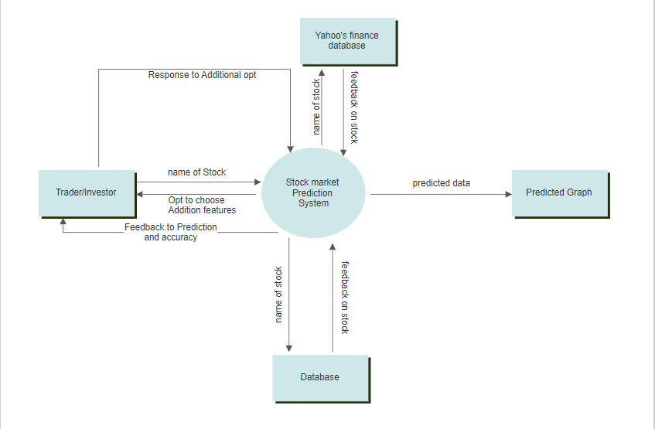

*Here the Database is acting as a pseudo entity

* **How to use the system:**

User can import data by choosing from yahoo’s finance website by browsing the website historical data section or using the already imported dataset from Kaggle or any other dataset specified by the user.

the user is prompted by an option to include his/her intuition or just predict it by normal machine learning computations.

* If the user decides to include intuitive analysis ability: -

He/she decides the general direction of a stock’s trajectory.

User can choose to opt to include High and Low and time period to be included for enhancing the dataset.

System displays an interactive graph of the predicted model.

* **Database used:**

<https://www.kaggle.com/minatverma/nse-stocks-data> or

<https://in.finance.yahoo.com/>

or

Any specified by the user.