VISVESVARAYA TECHNOLOGICAL UNIVERSITY
“JNANA SANGAMA” BELGAUM-590018

2017-2018
A
Mini Project Report
On

“Cyber Cafe Management”
Submitted in partial fulfillment of the requirements in 5th Semester of
BACHELOR OF ENGINEERING
IN

COMPUTER SCIENCE AND ENGINEERING
By
GAURAV SHARMA
[1JB15CS051]
UNDER THE GUIDANCE OF

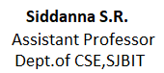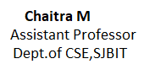

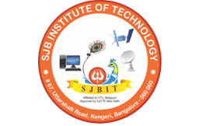

DEPARTMENT OF COMPUTER SCIENCE AND ENGINEERING

S. J. B INSTITUTE OF TECHNOLOGY
B G S HEALTH AND EDUCATION CITY
Kengeri, Bengaluru-560060.

|| Jai Sri Gurudev ||
Sri Adichunchanagiri Shikshana Trust ®

S. J. B INSTITUTE OF TECHNOLOGY

BGS Health & Education City, Kengeri, Bengaluru-560060.

DEPARTMENT OF COMPUTER SCIENCE AND ENGINEERING

CERTIFICATE
Certified that the mini project work entitled “Cyber Cafe Management” carried out by Gaurav Sharma [1JB15CS051] is a bonafide student of S J B Institute of Technology in partial fulfillment for the award of “BACHELOR OF ENGINEERING” in COMPUTER SCIENCE AND ENGINEERING as prescribed by VISVESVARAYA TECHNOLOGICAL UNIVERSITY, BELGAUM during the academic year 2017-2018. It is certified that all corrections/suggestions indicated for internal assessment have been incorporated in the report deposited in the departmental library. The mini project report has been approved as it satisfies the academic requirements in respect of mini project work.

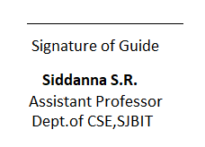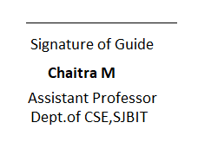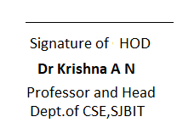
EXTERNAL VIVA
Name of the Examiners Signature
with Date
1.

2.

