Data Visualization Practical

Practical 1
- Name: Bar Chart
- Aim: To track and compare mobile phone sales across different months.
- Description: Uses vertical blue bars to show exact sales numbers from January to December, making it easy to spot that December had the highest sales and April the lowest.
- Code:
import pandas as pd
import matplotlib.pyplot as plt
data = {
'Month': ['January', 'February', 'March', 'April', 'May', 'June',
'July', 'August', 'September', 'October', 'November', 'December'],
'Sales': [26, 32, 41, 21, 35, 48, 52, 45, 38, 42, 50, 65]
}

df = pd.DataFrame(data)
plt.bar(height='Sales', x='Month', data=df, color="#0C527A")
plt.xlabel('Month')
plt.ylabel('Sales (Units)')
plt.title('Monthly sales of mobile phone')
plt.tight_layout()
plt.show()

- Output:
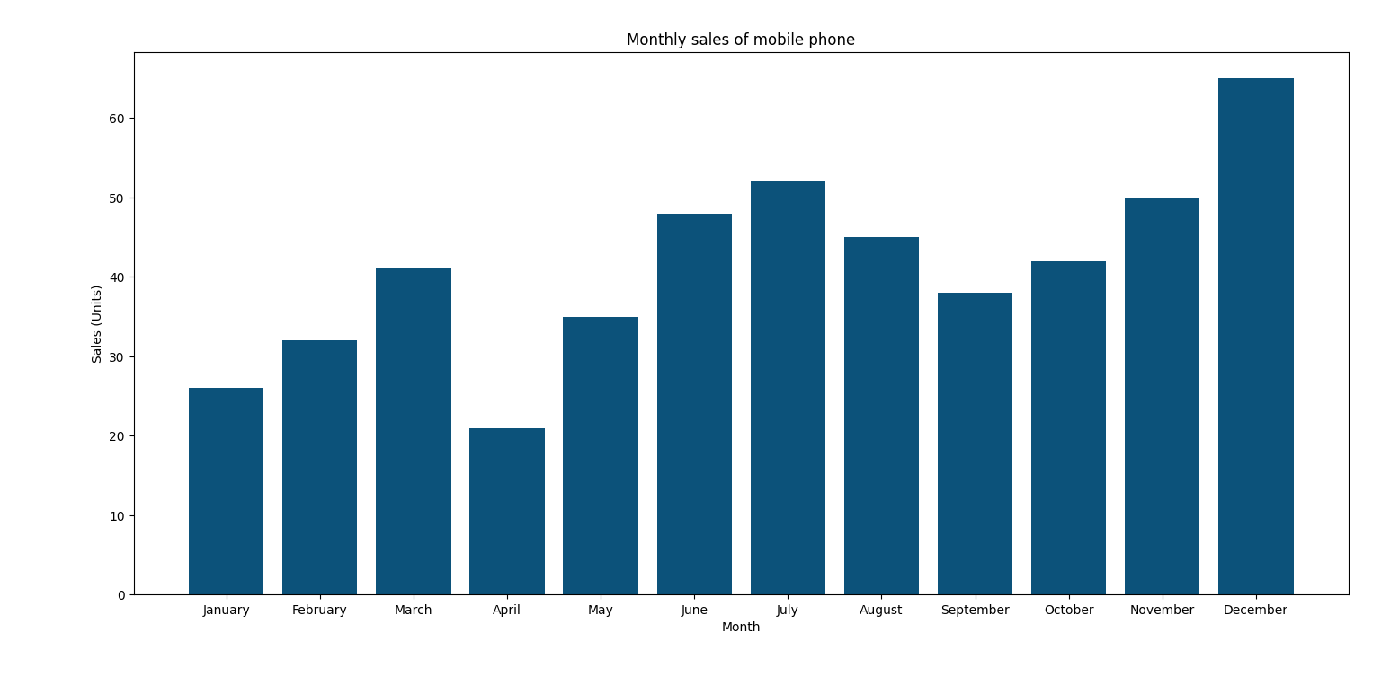

Practical 2
- Name: Line Chart
- Aim: To identify trends and fluctuations in sales over a 12-month period.
- Description: Connects monthly data points with a sharp blue line to reveal upward and downward trends, highlighting major sales peaks in February and June.
- Code:
import numpy as np
import matplotlib.pyplot as plt

months = ['Jan', 'Feb', 'Mar', 'Apr', 'May', 'Jun', 'Jul', 'Aug', 'Sep', 'Oct', 'Nov', 'Dec']
sales = 100 + np.random.randn(12) * 15

plt.figure()
plt.plot(months, sales, color='blue', marker='o', label='Sales')
plt.title('Monthly Sales Trend')
plt.xlabel('Month')
plt.ylabel('Sales')
plt.legend()
plt.show()

- Output:
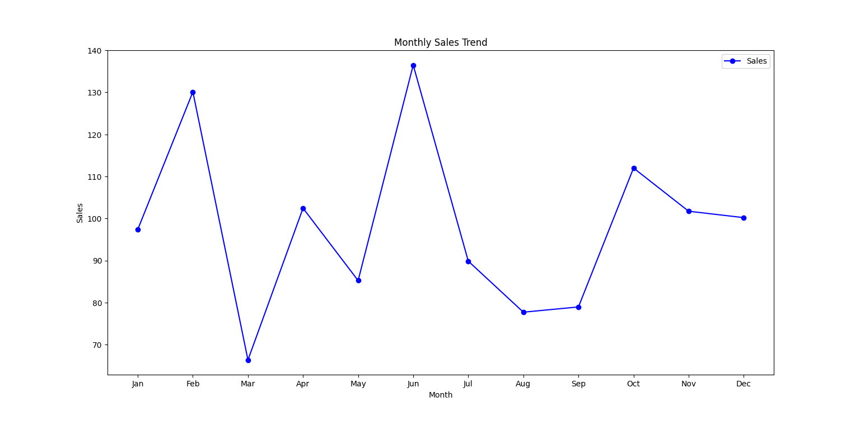

Practical 3
- Name: Pie Chart
- Aim: To display the global market share breakdown of desktop operating systems.
- Description: Divides a circle into color-coded slices with percentage labels, clearly showing that Windows dominates the market at 62.2%.
- Code:
import matplotlib.pyplot as plt

os_labels = ['Windows', 'macOS', 'Linux', 'ChromeOS', 'Others']
market_share = [62.16, 14.58, 3.09, 1.42, 18.75]
colors = ['#1f77b4', '#ff7f0e', '#2ca02c', '#d62728', '#9467bd']

plt.figure(figsize=(6, 6))
plt.pie(market_share, labels=os_labels, colors=colors, autopct='%1.1f%%', startangle=140)
plt.title('Global Desktop Operating System Market Share')
plt.show()

- Output:
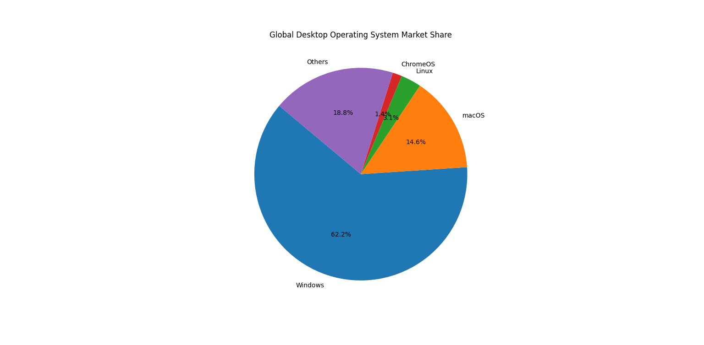

Practical 4
- Name: Scatter Plot
- Aim: To find relationships between sepal length and width for three Iris flower species.
- Description: Plots individual data points as colored dots (red, blue, green) on a grid, revealing how different species cluster based on their physical measurements.
- Code:
import matplotlib.pyplot as plt
import seaborn as sns

df = sns.load_dataset('iris')

setosa = df[df['species'] == 'setosa']
versicolor = df[df['species'] == 'versicolor']
virginica = df[df['species'] == 'virginica']

plt.scatter(setosa['sepal_length'], setosa['sepal_width'], color='red', label='Setosa')
plt.scatter(versicolor['sepal_length'], versicolor['sepal_width'], color='blue', label='Versicolor')
plt.scatter(virginica['sepal_length'], virginica['sepal_width'], color='green', label='Virginica')

plt.title('Iris Dataset Scatter Plot')
plt.xlabel('Sepal Length')
plt.ylabel('Sepal Width')
plt.legend()
plt.show()
- Output:
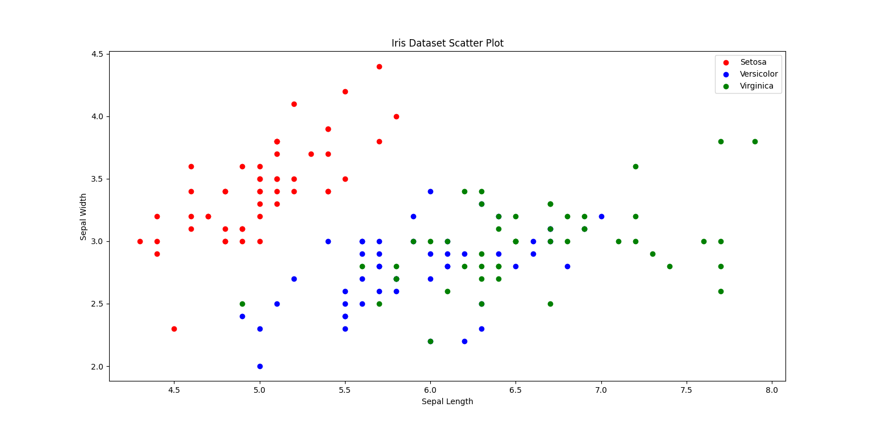

Practical 5
- Name: Histogram
- Aim: To show how often different sepal lengths occur in a dataset.
- Description: Groups continuous measurements into adjacent purple blocks, showing the count for each range and revealing which flower size is the most common.
- Code:
import matplotlib.pyplot as plt
import seaborn as sns

df = sns.load_dataset('iris')

plt.hist(df['sepal_length'], bins=10, color='purple', edgecolor='black')

plt.title('Distribution of Sepal Length')
plt.xlabel('Sepal Length')
plt.ylabel('Count')
plt.show()
- Output:
