Data Visualization Practical

1. Line Chart

Title: Monthly Sales Performance

Aim: To show how sales change over time

Description: A line chart connects data points with a continuous line to display trends across months or years. It helps identify growth patterns, seasonal trends, or sudden changes. Best used for time-series data like stock prices, temperature changes, or revenue growth.
Code:
import plotly.express as px
import pandas as pd
import numpy as np

np.random.seed(42)
x = np.linspace(0, 10, 50)
df = pd.DataFrame({
'X': np.tile(x, 3),
'Y': np.concatenate([
np.sin(x) + np.random.normal(0, 0.1, 50),
np.cos(x) + np.random.normal(0, 0.1, 50),
np.sin(x) * np.exp(-x/5) + np.random.normal(0, 0.05, 50)
]),
'Category': ['Sine Wave']*50 + ['Cosine Wave']*50 + ['Damped Sine']*50
})

fig = px.line(
df,
x='X',
y='Y',
color='Category',
line_dash='Category',
markers=True,
title='Line Plot',
color_discrete_sequence=px.colors.qualitative.Set2,
template='plotly_white'
)

fig.update_layout(
title_font=dict(size=24, family='Arial Black'),
hovermode='x unified',
legend=dict(
bgcolor='rgba(255, 255, 255, 0.8)',
bordercolor='gray',
borderwidth=1
)
)

fig.update_traces(
marker=dict(size=10, line=dict(width=1, color='white')),
line=dict(width=3)
)

fig.show()

Output:
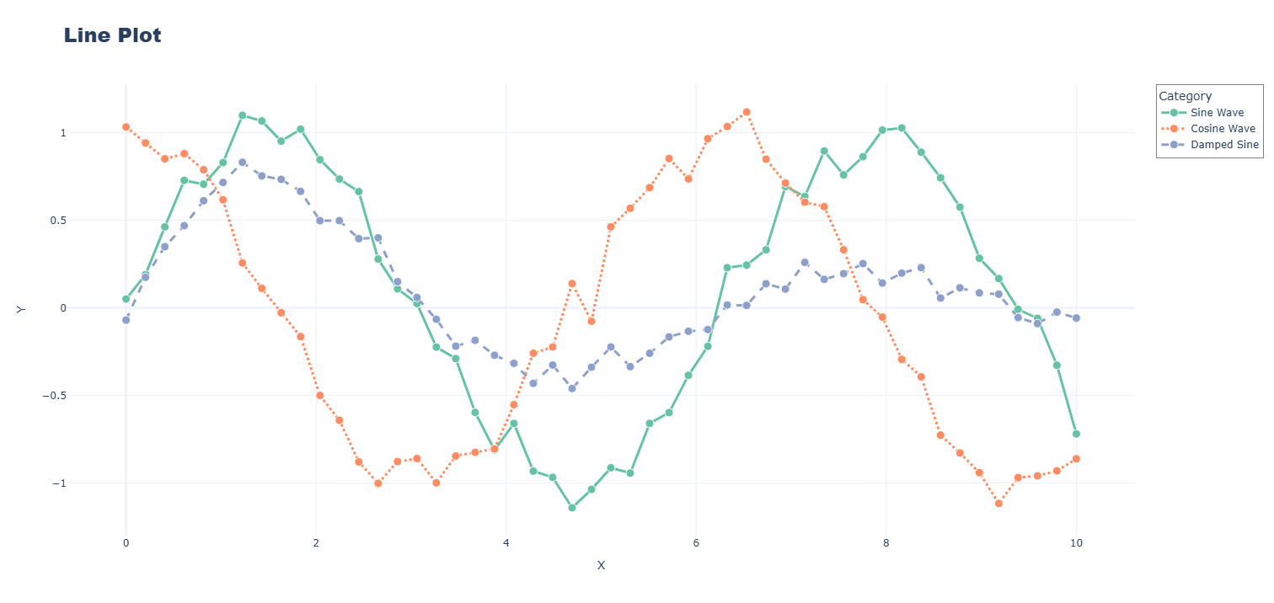

2. Bar Chart

Title: Product Sales Comparison

Aim: To compare different categories side by side

Description: A bar chart uses rectangular bars where the length represents the value. It makes comparing different items easy and clear. Perfect for showing sales by product, population by country, or scores by student. Bars can be vertical or horizontal.
Code:
import plotly.express as px
import pandas as pd

data = {
'Month': ['Jan', 'Feb', 'Mar', 'Apr', 'May', 'Jun'],
'Revenue': [25000, 28000, 32000, 29000, 35000, 38000]
}

df = pd.DataFrame(data)

fig = px.bar(
df,
x='Month',
y='Revenue',
title='💰 Monthly Revenue 2025',
text='Revenue',
color='Revenue',
color_continuous_scale='Viridis'
)

fig.update_layout(
template='plotly_white',
width=800,
height=500,
showlegend=False
)

fig.update_traces(
texttemplate='$%{text:,}',
textposition='outside',
marker=dict(line=dict(color='white', width=2))
)

fig.update_yaxes(tickprefix='$', tickformat=',d')

fig.show()

Output:
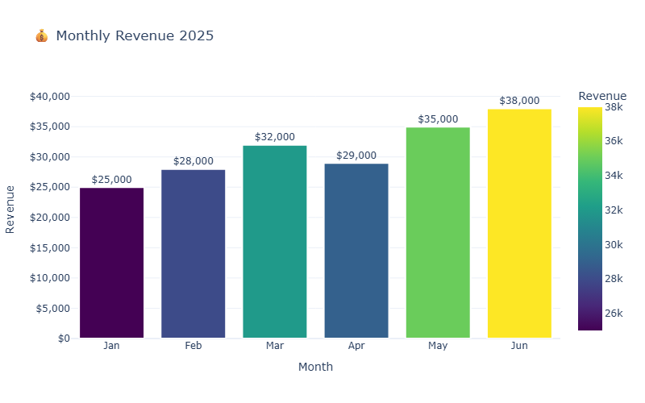

3. Scatter Plot

Title: Study Hours vs Exam Scores

Aim: To find relationships between two variables

Description: A scatter plot shows individual data points on two axes to reveal patterns or correlations. Each dot represents one observation. It helps answer questions like "Does more studying lead to higher scores?" or "Is there a link between age and income?"
Code:
import plotly.express as px
import pandas as pd

data = {
'Age': [22, 25, 28, 30, 32, 35, 38, 40, 42, 45, 48, 50, 52, 55, 58],
'Income': [30000, 35000, 40000, 45000, 48000, 52000, 58000, 62000,
65000, 70000, 72000, 75000, 78000, 80000, 85000]
}

df = pd.DataFrame(data)

fig = px.scatter(
df,
x='Age',
y='Income',
title='💰 Age vs Income with Trend',
trendline='ols',
color_discrete_sequence=['#FF6B6B']
)

fig.update_traces(marker=dict(size=12, line=dict(color='white', width=2)))

fig.update_layout(
template='plotly_white',
width=800,
height=500,
yaxis=dict(tickprefix='$', tickformat=',d')
)

fig.show()

Output:
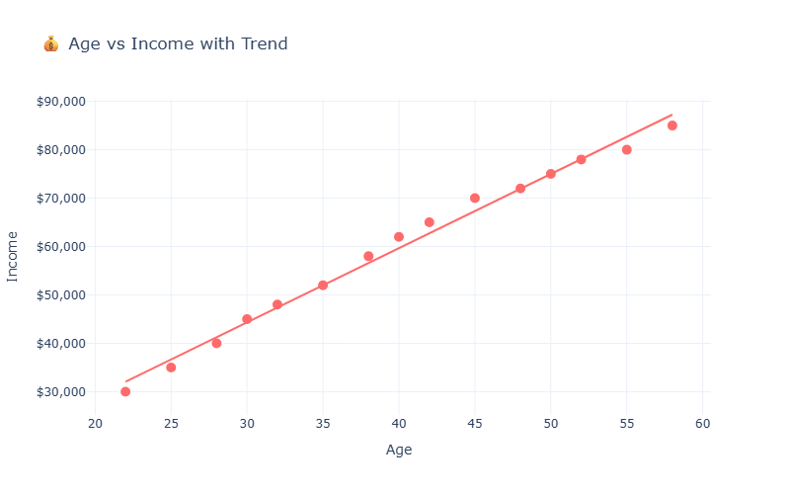

4. Histogram

Title: Age Distribution of Customers

Aim: To understand how data is spread across ranges

Description: A histogram groups numeric data into bins or intervals and shows how many items fall into each bin. It reveals the shape of data distribution - whether it's normal, skewed, or has multiple peaks. Great for seeing age ranges, salary brackets, or test score distributions.
Code:
import plotly.graph_objects as go
import numpy as np

np.random.seed(42)
satisfaction = np.random.choice([1, 2, 3, 4, 5], 200, p=[0.05, 0.1, 0.2, 0.35, 0.3])

fig = go.Figure(data=[
go.Histogram(
x=satisfaction,
nbinsx=5,
marker_color=['#FF6B6B', '#FECA57', '#FF9F43', '#54A0FF', '#5F27CD'],
marker_line_color='white',
marker_line_width=2,
texttemplate='%{y}',
textposition='outside'
)
])

fig.update_layout(
title='Customer Satisfaction Ratings',
xaxis_title='Rating (1-5)',
yaxis_title='Number of Customers',
template='plotly_white',
width=700,
height=500,
showlegend=False,
xaxis=dict(
tickmode='array',
tickvals=[1, 2, 3, 4, 5],
ticktext=['⭐', '⭐⭐', '⭐⭐⭐', '⭐⭐⭐⭐', '⭐⭐⭐⭐⭐']
)
)

fig.show()

Output:

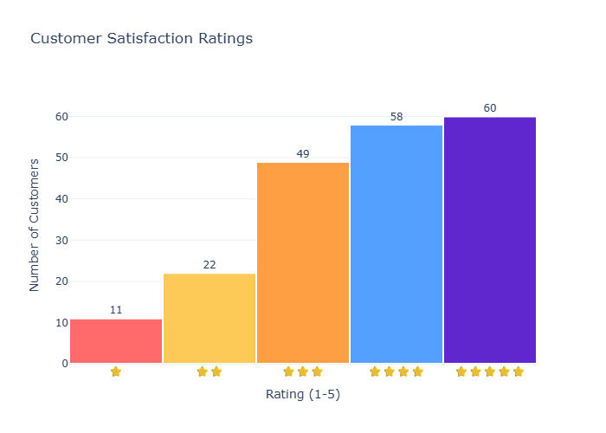

5. Pie Chart

Title: Market Share by Company

Aim: To show parts of a whole as percentages

Description: A pie chart divides a circle into slices where each slice represents a category's proportion of the total. It quickly shows which category dominates and how different parts contribute to 100%. Best for budget breakdowns, market share, or survey results with few categories.
Code:
import plotly.graph_objects as go

labels = ['Product A', 'Product B', 'Product C', 'Product D']
q1 = [1200, 900, 750, 600]
q2 = [1400, 950, 800, 700]
q3 = [1600, 1000, 850, 750]
q4 = [1800, 1100, 900, 800]

fig = go.Figure()

fig.add_trace(go.Pie(
labels=labels,
values=q1,
name='Q1',
domain={'row': 0, 'column': 0}
))

fig.add_trace(go.Pie(
labels=labels,
values=q2,
name='Q2',
domain={'row': 0, 'column': 1}
))

fig.add_trace(go.Pie(
labels=labels,
values=q3,
name='Q3',
domain={'row': 1, 'column': 0}
))

fig.add_trace(go.Pie(
labels=labels,
values=q4,
name='Q4',
domain={'row': 1, 'column': 1}
))

fig.update_layout(
title='Quarterly Sales by Product',
template='plotly_white',
width=900,
height=700,
grid={'rows': 2, 'columns': 2}
)

fig.update_traces(
textinfo='label+percent',
textfont_size=12,
marker_colors=['#FF6B6B', '#4ECDC4', '#45B7D1', '#96CEB4']
)

fig.show()

Output:

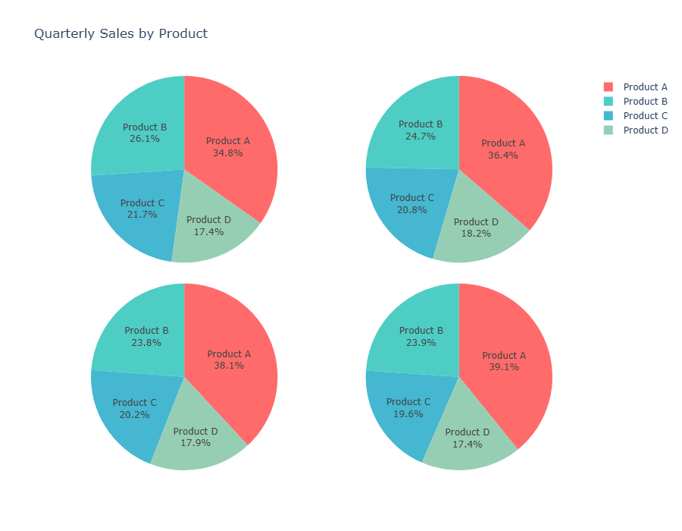

6. Box Plot

Title: Salary Distribution by Department

Aim: To summarize data spread and identify outliers

Description: A box plot shows the minimum, first quartile, median, third quartile, and maximum of data in a compact visual. It reveals the range, spread, and any unusual values. Excellent for comparing distributions across multiple groups and spotting differences in variability.
Code:
import plotly.express as px
import pandas as pd
import numpy as np

np.random.seed(42)
data = {
'Salary': np.concatenate([
np.random.normal(50000, 8000, 50),
np.random.normal(65000, 10000, 50),
np.random.normal(80000, 12000, 50),
np.random.normal(55000, 9000, 50)
]),
'Department': ['Sales']*50 + ['Marketing']*50 + ['Engineering']*50 + ['Finance']*50
}
df = pd.DataFrame(data)

fig = px.box(
df,
x='Department',
y='Salary',
color='Department',
title='Salary Distribution by Department',
color_discrete_sequence=['#FF6B6B', '#4ECDC4', '#45B7D1', '#96CEB4'],
points='outliers'
)

fig.update_layout(
template='plotly_white',
width=800,
height=500,
showlegend=False,
yaxis=dict(tickprefix='$', tickformat=',d')
)

fig.show()

Output:
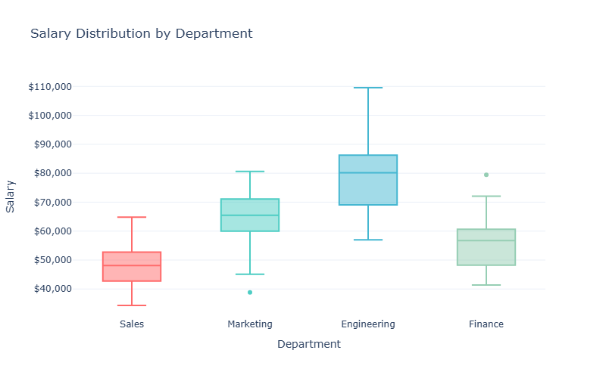

7. Violin Plot

Title: Product Ratings Analysis

Aim: To show full data distribution shape with density

Description: A violin plot combines a box plot with a density curve on both sides, showing where data is concentrated. Wider sections mean more data points at that value. It provides richer information than a box plot by revealing multiple peaks or clusters in the data.
Code:
import plotly.express as px
import pandas as pd
import numpy as np

np.random.seed(42)
data = {
'Salary': np.concatenate([
np.random.normal(50000, 8000, 150),
np.random.normal(65000, 10000, 150),
np.random.normal(80000, 12000, 150),
np.random.normal(55000, 9000, 150)
]),
'Department': ['Sales']*150 + ['Marketing']*150 + ['Engineering']*150 + ['Finance']*150
}
df = pd.DataFrame(data)

fig = px.violin(
df,
x='Department',
y='Salary',
color='Department',
title='Salary Distribution by Department',
color_discrete_sequence=['#FF6B6B', '#4ECDC4', '#45B7D1', '#96CEB4'],
box=True,
points='outliers'
)

fig.update_layout(
template='plotly_white',
width=800,
height=500,
showlegend=False,
yaxis=dict(tickprefix='$', tickformat=',d')
)

fig.show()

Output:

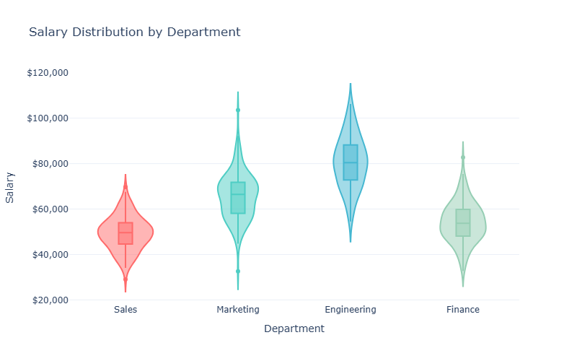

8. 3D Scatter Plot

Title: Customer Segmentation in 3 Dimensions

Aim: To visualize relationships between three variables

Description: A 3D scatter plot adds a third axis to show how three variables interact simultaneously. Each point has X, Y, and Z coordinates in a rotatable 3D space. Useful for analyzing complex data like population, GDP, and happiness index together, or age, income, and spending patterns.
Code:
import plotly.express as px
import pandas as pd
import numpy as np

np.random.seed(42)
n_customers = 300
data = {
'Age': np.random.normal(40, 15, n_customers),
'Income': np.random.normal(65000, 25000, n_customers),
'Spending': np.random.normal(5000, 2000, n_customers),
'Segment': np.random.choice(['Premium', 'Standard', 'Budget'], n_customers, p=[0.3, 0.45, 0.25])
}
df = pd.DataFrame(data)
df['Age'] = np.clip(df['Age'], 18, 80)
df['Income'] = np.clip(df['Income'], 20000, 150000)
df['Spending'] = np.clip(df['Spending'], 1000, 10000)

fig = px.scatter_3d(
df,
x='Age',
y='Income',
z='Spending',
color='Segment',
title='Customer Segmentation Analysis',
color_discrete_sequence=['#FF6B6B', '#4ECDC4', '#45B7D1'],
opacity=0.7,
size_max=10
)

fig.update_traces(marker=dict(size=6))

fig.update_layout(
scene=dict(
xaxis_title='Age',
yaxis_title='Annual Income ($)',
zaxis_title='Annual Spending ($)',
xaxis=dict(backgroundcolor='rgb(240, 240, 245)'),
yaxis=dict(backgroundcolor='rgb(240, 240, 245)'),
zaxis=dict(backgroundcolor='rgb(240, 240, 245)')
),
template='plotly_white',
width=900,
height=700
)

fig.show()

Output:

