Data Visualization Practical

Practical 1: Multi-View Distribution Analysis by Day and Bill Amount
- Aim: To analyze the relationship between day of the week, tip amounts, and total bills using dynamic visualization toggles (Scatter, Bar, and Box plots).
- Description: This practical creates an interactive graph allowing users to view tipping behavior across different days of the week. By integrating a dropdown update menu, users can switch between a Scatter Plot (showing individual data points colored by total bill), a Bar Chart (displaying cumulative values), and a Box Plot (highlighting statistical distribution and median values). Color coding via the Viridis scale provides visual depth on bill magnitudes.
- Code:
import plotly.graph_objects as go
import plotly.express as px

df = px.data.tips()

fig = go.Figure()

fig.add_trace(go.Scatter(
x=df['day'],
y=df['tip'],
mode='markers',
marker=dict(
size=9,
color=df['total_bill'],
colorscale='Viridis',
showscale=True,
opacity=0.85,
line=dict(width=0.5, color='rgba(0, 0, 0, 0.3)'),
colorbar=dict(
title=dict(
text="Total Bill ($)",
side="top"
),
thickness=14,
len=0.85
)
),
text=df['time'],
hovertemplate='<b>Day:</b> %{x}<br><b>Tip:</b> $%{y:.2f}<br><b>Time:</b> %{text}<extra></extra>',
name='Tips'
))

fig.update_layout(
title=dict(
text="<b>Tips Analysis by Day & Total Bill</b>",
font=dict(size=18, family="Arial, sans-serif", color="#212529"),
x=0.02,
y=0.95
),
xaxis=dict(
title="Day of the Week",
showgrid=False,
zeroline=False,
linecolor="#CCCCCC",
tickfont=dict(color="#495057")
),
yaxis=dict(
title="Tip Amount ($)",
showgrid=True,
gridcolor="#E9ECEF",
zeroline=False,
linecolor="#CCCCCC",
tickfont=dict(color="#495057")
),
template="plotly_white",
paper_bgcolor="#FFFFFF",
plot_bgcolor="#FAFAFA",
hovermode="closest",
updatemenus=[
dict(
buttons=list([
dict(
args=[{"type": "scatter", "mode": "markers", "textposition": "none"}],
label="Scatter",
method="restyle"
),
dict(
args=[{"type": "bar", "textposition": "none"}],
label="Bar",
method="restyle"
),
dict(
args=[{"type": "box", "textposition": "none"}],
label="Box",
method="restyle"
)
]),
direction="down",
showactive=True,
x=0.98,
xanchor="right",
y=1.18,
yanchor="top",
bgcolor="#FFFFFF",
bordercolor="#CED4DA",
borderwidth=1,
font=dict(color="#333333", size=12)
)
],
margin=dict(t=100, b=60, l=60, r=60)
)

fig.show()

- Output
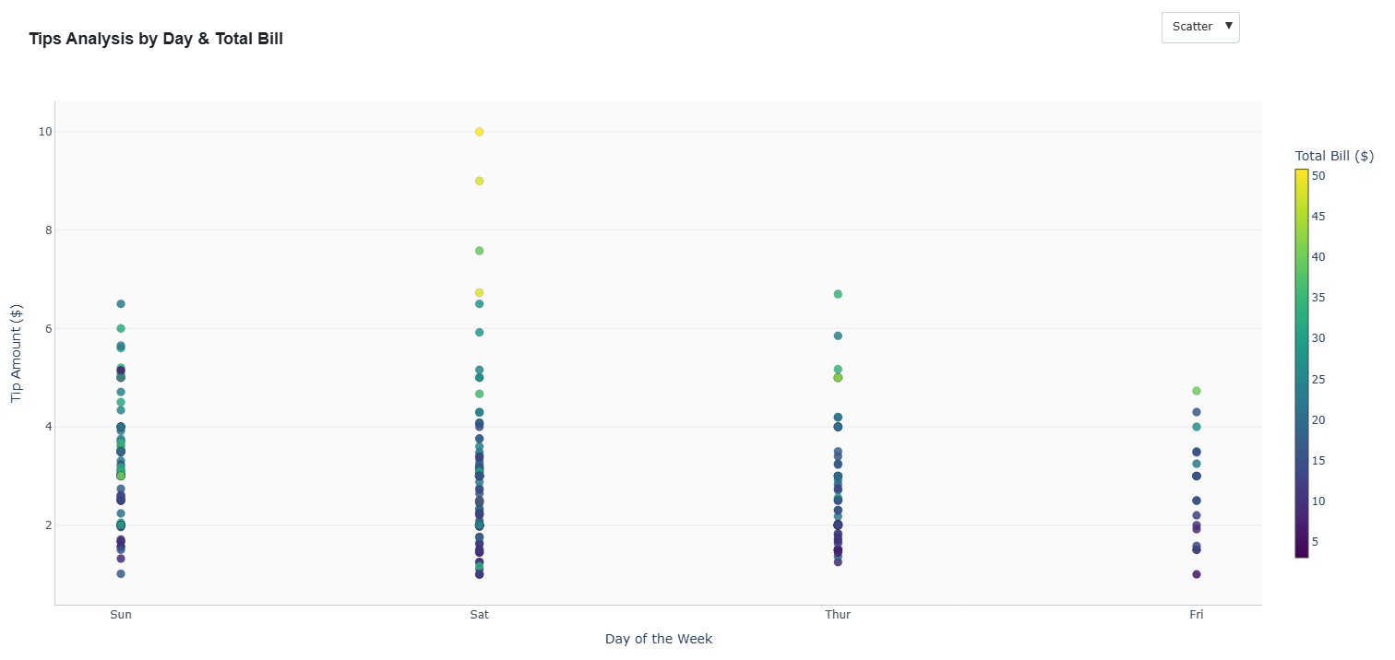
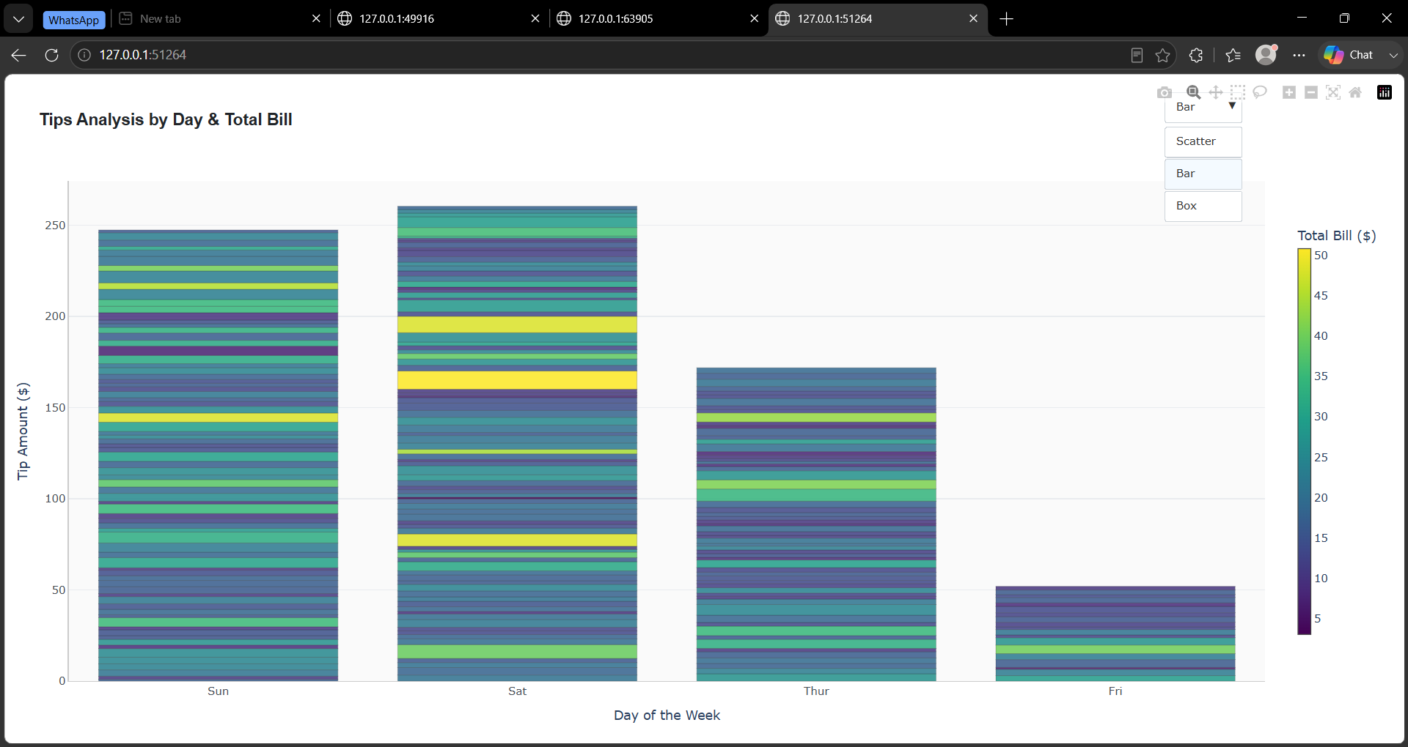
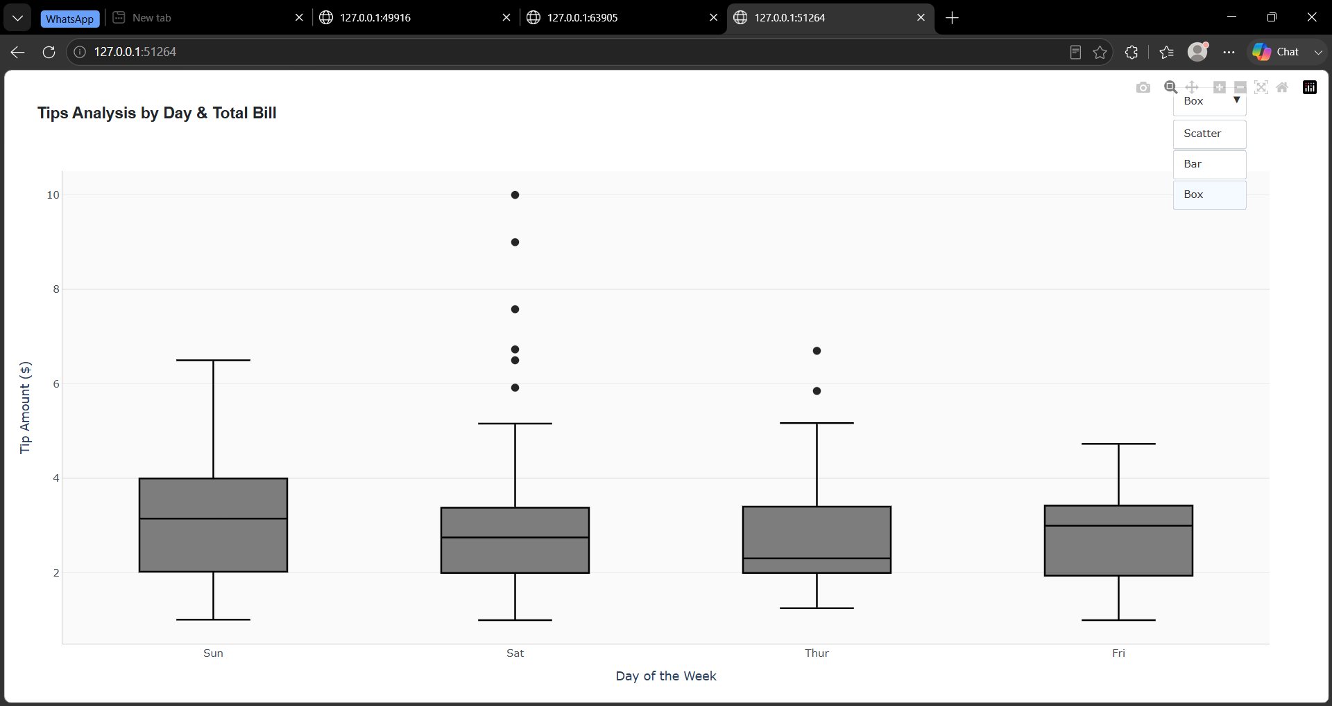

Practical 2: Party Size Impact and Attribute Inspection
- Aim: To evaluate tipping trends across days of the week segmented by party size and customer attributes using flexible trace switching (Scatter, Bar, and Violin plots).
- Description: This practical visualizes tipping patterns while highlighting party size through a color gradient and marker sizing. Custom hover tooltips present underlying categorical details such as gender, smoking status, and meal timing (Lunch/Dinner). The interactive controls allow toggling between individual observations, aggregate bar views, and density distribution via Violin plots to observe variance across dining groups.
- Code:
import plotly.graph_objects as go
import plotly.express as px
import pandas as pd

df = px.data.tips()

plot = go.Figure()

plot.add_trace(go.Scatter(
x=df['day'],
y=df['tip'],
mode='markers',
marker=dict(
size=10,
color=df['size'],
colorscale='Viridis',
showscale=True,
opacity=0.85,
colorbar=dict(
title=dict(
text="Party Size",
side="top"
),
thickness=14,
len=0.85
),
line=dict(width=0.5, color='rgba(0,0,0,0.3)')
),
text=df.apply(lambda r: f"Sex: {r['sex']}<br>Smoker: {r['smoker']}<br>Time: {r['time']}", axis=1),
hovertemplate='<b>%{x}</b><br>Tip: $%{y:.2f}<br>%{text}<extra></extra>',
name='Tips'
))

plot.update_layout(
title=dict(
text="<b>Restaurant Tips Analysis by Day & Party Size</b>",
x=0.02,
y=0.95,
font=dict(size=18, family="Arial, sans-serif", color="#212529")
),
xaxis=dict(
title="Day of the Week",
showgrid=False,
zeroline=False,
linecolor="#CCCCCC",
tickfont=dict(color="#495057")
),
yaxis=dict(
title="Tip Amount ($)",
showgrid=True,
gridcolor="#E9ECEF",
zeroline=False,
linecolor="#CCCCCC",
tickfont=dict(color="#495057")
),
template="plotly_white",
paper_bgcolor='#FFFFFF',
plot_bgcolor='#FAFAFA',
hovermode="closest",
updatemenus=[
dict(
type="buttons",
direction="left",
x=0.98,
xanchor="right",
y=1.18,
yanchor="top",
buttons=list([
dict(
args=[{"type": "scatter", "mode": "markers", "textposition": "none"}],
label="Scatter",
method="restyle"
),
dict(
args=[{"type": "bar", "textposition": "none"}],
label="Bar",
method="restyle"
),
dict(
args=[{"type": "violin", "textposition": "none"}],
label="Violin",
method="restyle"
)
]),
bgcolor='#FFFFFF',
bordercolor='#CED4DA',
borderwidth=1,
font=dict(size=12, color='#333333'),
active=0
)
],
margin=dict(t=100, b=60, l=60, r=60)
)

plot.show()

- Output
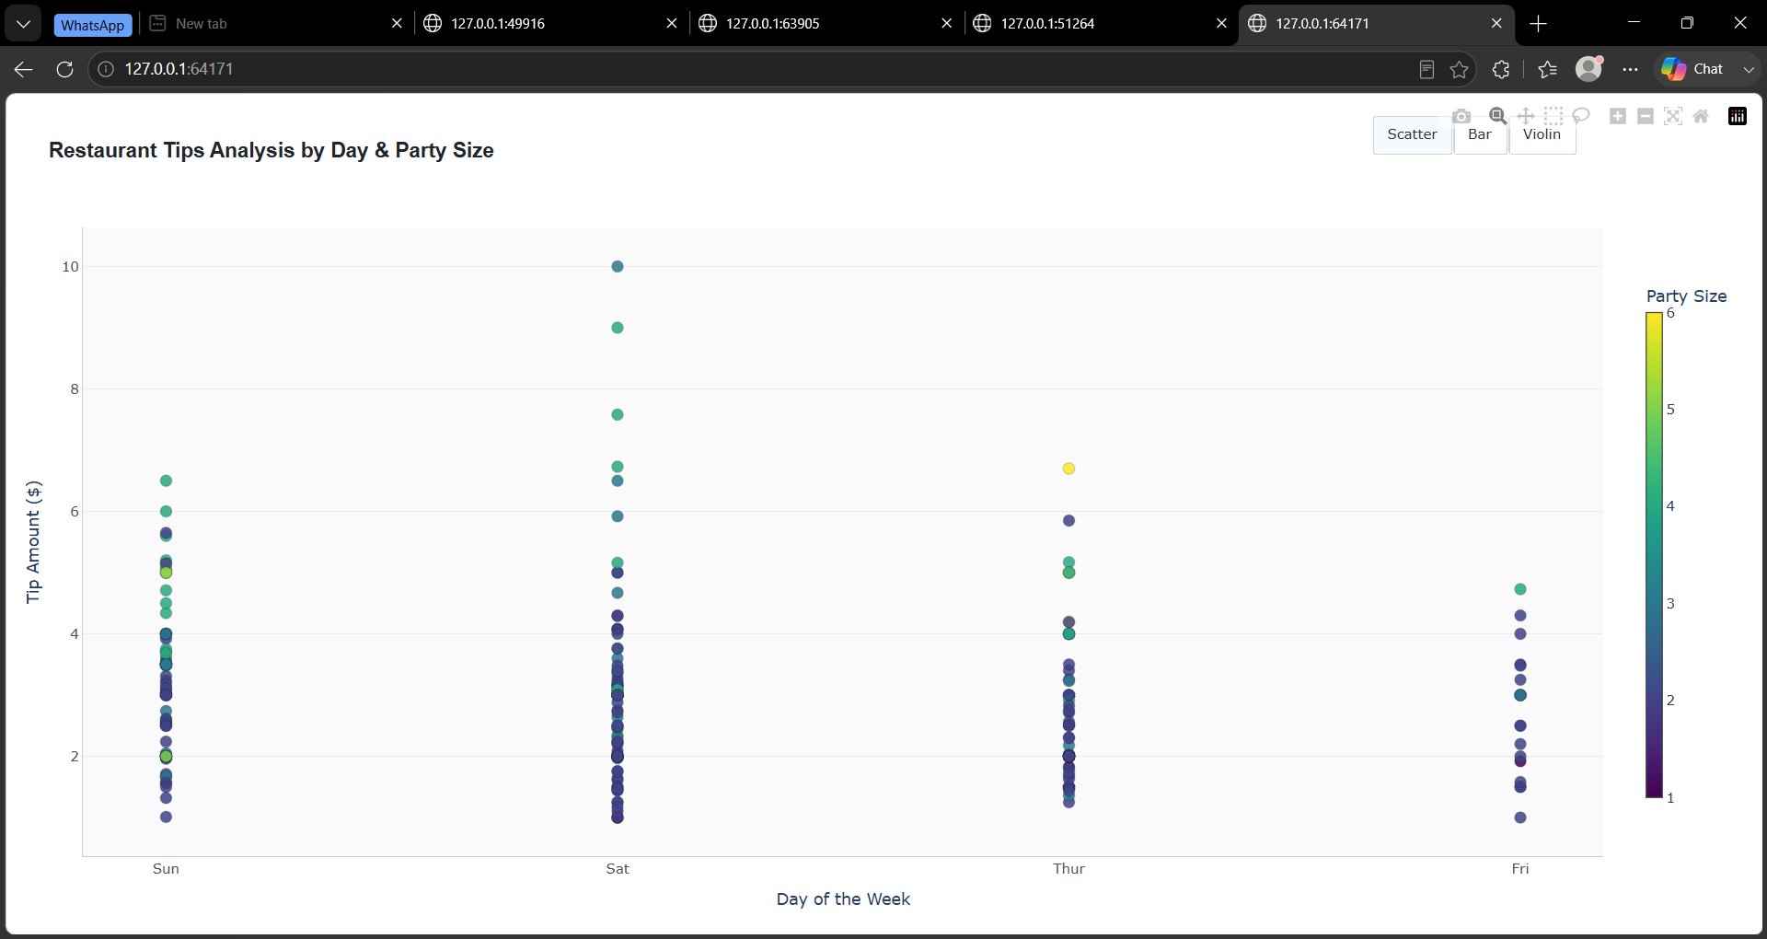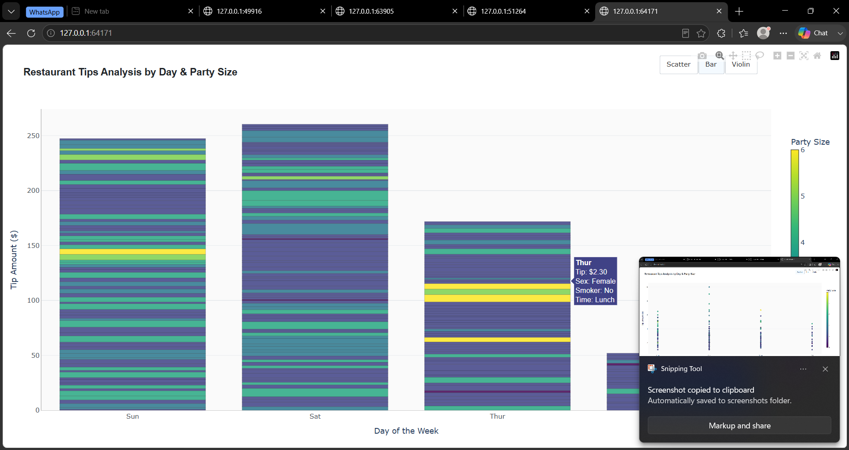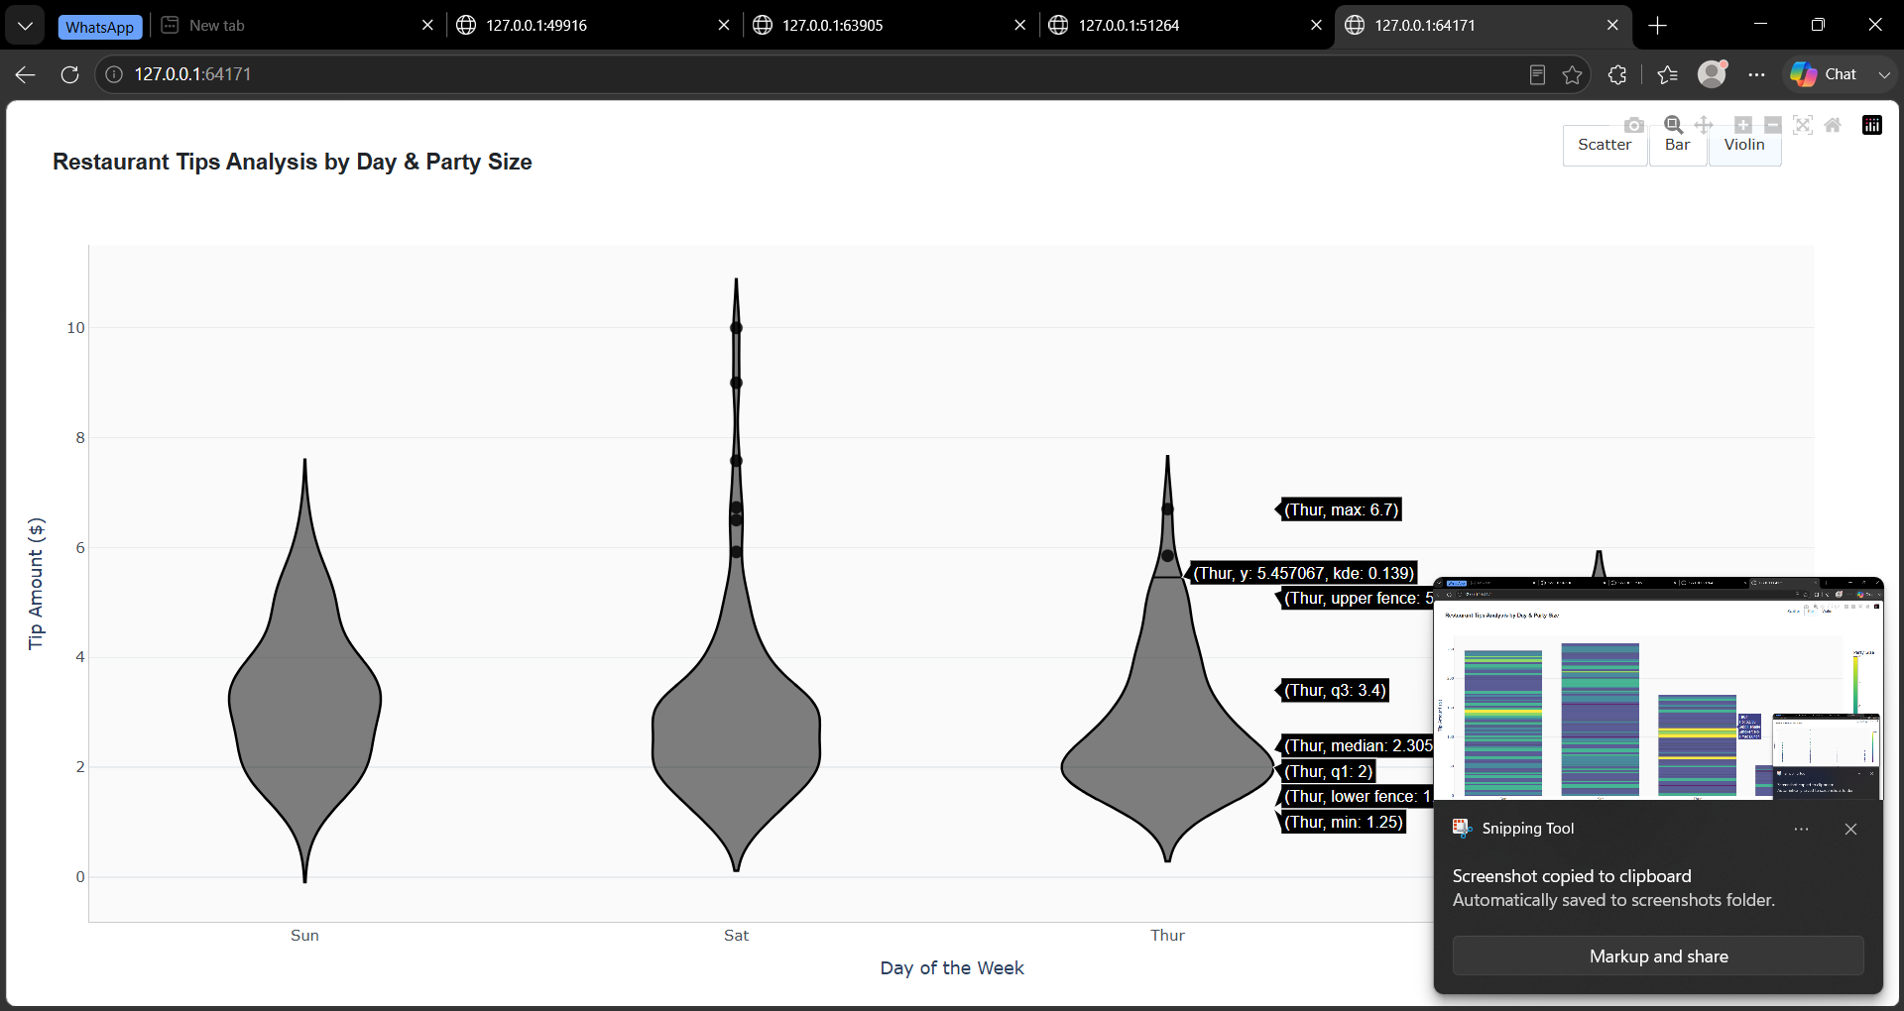

Practical 3: Interactive Bill-to-Tip Range Analysis
- Aim: To build a quantitative scatter analysis examining how tip amounts scale with total bills using continuous range sliders and selector controls.
- Description: Focused on bivariate correlation, this practical plots exact total bill amounts against corresponding tips. It includes an interactive range slider along the horizontal axis alongside preset filter buttons, enabling focused navigation into specific bill thresholds (e.g., lower bill ranges vs. higher bill ranges). The continuous slider allows fine-grained zooming to inspect outlier behavior and general trends without re-filtering the underlying dataset.

- Code:
import plotly.graph_objects as go
import plotly.express as px

df = px.data.tips()

fig = go.Figure()

fig.add_trace(go.Scatter(
x=df['total_bill'],
y=df['tip'],
mode='markers',
marker=dict(
size=8,
color='#2B5C8F',
opacity=0.8,
line=dict(width=0.5, color='rgba(0, 0, 0, 0.2)')
),
text=df.apply(lambda r: f"Day: {r['day']}<br>Size: {r['size']}", axis=1),
hovertemplate='<b>Total Bill:</b> $%{x:.2f}<br><b>Tip:</b> $%{y:.2f}<br>%{text}<extra></extra>',
name='Tips'
))

fig.update_layout(
title=dict(
text="<b>Tip Amount vs. Total Bill</b>",
x=0.02,
y=0.95,
font=dict(size=18, family="Arial, sans-serif", color="#212529")
),
xaxis=dict(
title="Total Bill ($)",
showgrid=True,
gridcolor="#E9ECEF",
zeroline=False,
linecolor="#CCCCCC",
tickfont=dict(color="#495057"),
rangeslider=dict(
visible=True,
bgcolor="#F8F9FA",
bordercolor="#CED4DA",
borderwidth=1,
thickness=0.1
),
rangeselector=dict(
buttons=list([
dict(count=10, label="$10", step="all", stepmode="backward"),
dict(count=20, label="$20", step="all", stepmode="backward"),
dict(count=30, label="$30", step="all", stepmode="backward"),
dict(step="all", label="All")
]),
bgcolor="#FFFFFF",
activecolor="#E2E8F0",
bordercolor="#CED4DA",
borderwidth=1,
font=dict(size=11, color="#333333"),
x=0.02,
y=1.08
)
),
yaxis=dict(
title="Tip Amount ($)",
showgrid=True,
gridcolor="#E9ECEF",
zeroline=False,
linecolor="#CCCCCC",
tickfont=dict(color="#495057")
),
template="plotly_white",
paper_bgcolor='#FFFFFF',
plot_bgcolor='#FAFAFA',
hovermode="closest",
margin=dict(t=90, b=60, l=60, r=60)
)

fig.show()

- Output
